Fluorescent Microscope Operation

Purpose |  | This procedure provides instruction for FLUORESCENT MICROSCOPE OPERATION.
Policy Statements |  | This procedure applies to technical staff who perform fluorescent microscopy.
Principle |  | A light emitting diode (LED) light source is used to irradiate a fluorochrome stained specimen with UV excitation light. The light is filtered through a filter cube in the microscope to excite a specific fluorochrome. Fluorescent compounds in the specimen absorb some of the excitation light and reemit (fluoresce) the remaining light at a lower wavelength. The emitted light and the reflected excitation light are collected by the objective and pass through a dichromatic mirror and emission filter which removes the excitation light and allows the longer wavelength emitted light to form an image.  Epi-fluorescence filter combinations are housed in the filter cube and include the excitation filter, dichromatic beamsplitter (mirror), and the emission filter, In order to achieve maximum fluorescence intensity, a fluorochrome is usually excited at wavelengths near or at the peak of the excitation curve, and the widest possible range of emission wavelengths that include the emission peak are selected for detection.  The fluorescence microscope is equipped with filters suitable for use with fluorescein isothiocyanate (FITC) R-phycoerythrin, auramine rhodamine and acridine orange.  Advantages of LEDs as a light source compared with traditional mercury arc lamps are less maintenance (no bulbs to change), lower electricity consumption, long lifetime (20,000) hours with minimal decrease in total optical power, instant on/off control and no mercury disposal issues.
Materials
Supplies
- Lens cleaner
- Lens paper

Special Safety Precautions | - Microbiologists/virologists are subject to occupational risks associated with specimen handling. Refer to the safety policies:  - Biohazard Containment  - Safety in the Microbiology/Virology Laboratory  - Biohazardous Spills  - Physical Hazard:  The LED emits UV light, which is damaging to the eyes and skin. Avoid eye and skin exposure to unshielded product.  Never look into the light emitting end of the LED head. The light could severely damage the cornea and retina of the eye if the light is observed directly. Eye shielding must be used at all times as well as clothing to protect exposed skin.  Always make sure the LED head is securely attached to the microscope prior to turning on power to the unit. This will minimize the risk of exposure to the UV light.
Procedure  Filters  Procedure  Notes | 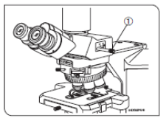Operation  - To select the light path for the desired operation adjust the light path selector knob on the right side of the scope (#1).  Light path selector knob (#1)  Pushed In Middle Position Pulled Out  - 50% for binocular eyepieces - 50% for camera 100% for binocular eyepieces 100% for camera  2. The X-CITE® 120 LEDmini is typically left on.  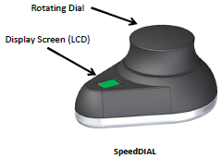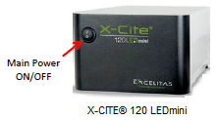  To power on:  a. Flip the rocker switch on the front of the miniCUBE to turn X-CITE® 120 LEDmini on.  b. The system will have a brief initialization period (10 seconds) and the speedDIAL display will show “X-Cite” during this time.  c. When the display show “x%”, it is ready to use.  d. Note: SpeedDIAL must be connected before turning system on. It can be damaged if it is plugged or unplugged from the system while it is powered on.  3. Select correct filter position for fluorescent stain used:  # 1 BF- Bright field- for regular light microscopy  #2 B/G- Blue-green- for FITC stain  #3 TRITC- for R-phycoerythrin, auramine rhodamine and acridine orange  4. Put slide on stage and click the dial on SpeedDIAL to turn on the excitation light.  5. Turn the dial to adjust the light intensity: clockwise to increase, counter clockwise to decrease.  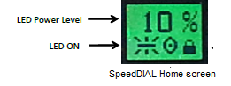  6. Click the SpeedDial to turn off when the slide on the stage is not being viewed to avoid quenching of the fluorescence and at the end of each session.  7. After each session, remove oil or mounting fluid from the objectives, condenser, and stage using lens cleaner and lens paper. Clean the dry objectives first before cleaning the oil immersion objectives.
B. Maintenance

1. Record total accumulated hours in use monthly on the Virology maintenance log. The LED is rated for 20,000 hours of use.

- To access the main menu, press and hold the SpeedDIAL for one (1) second.
- To navigate the menus, turn the dial to scroll through the options. An arrowhead will indicate the currently selected menu option; click the dial to make a selection.
- To adjust settings, turn the dial. To exit the setting adjustment, click the dial.
- To exit menu system at any time, press and hold the dial for one (1) second.

- Select “Srvc” option from main menu.
b. To obtain the LED “in use” hours:
c. Select the “Hour” menu option.
d. LED “hours of use” will be shown in one (1) hour increments from 0 to 999 hours. Due to space limitations on the LCD, when 1000 hours are logged, the format will change to “1.0k hours”, and increments will increase to 100 hours (e.g. 1142 hours will display as “1.1k hours”).
e. Click dial to return to “Srvc” menu.
f. Press and hold the dial for 1 second to exit the menu.

2. Annually, the microscope is to be cleaned and adjusted professionally.

The microscope is equipped with 2 filter sets:
- FITC and TRITC (OSF-LF488/561) optimized for 488 & 561 nm wavelengths
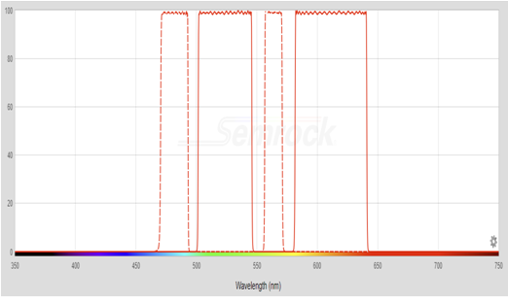
FITC/TRITC filter set 488nm/561 nm. Dotted line= excitation wavelength. Solid line = emission wavelength

- TRITC (OSF3-TRITC-B) optimized for Excitation 543/22 nm and Emission 593/40nm wavelengths.
- Olympus BX43 instruction manual
- Olympus cellSens Imaging Software user manual
- X Cite 120 LEDmini User Guide
- Mounting media (buffered glycerol) of a pH appropriate for the stain must be used for coverslipping FA slides to achieve adequate fluorescence.
- Store stained slides in the dark at 2-8°C or colder to preserve fluorescence.
- Avoid dragging the high dry objective through oil on the slide.
- Organic solvents such as alcohols and acetone should not be used on the lenses because the solvent may dissolve the optical mounting cement.
- The stage should be cleaned regularly and any spilled immersion oil and mounting fluid must be removed or slides will stick as they are moved across the stage.
_________________________________________________________________________________
References | - Olympus BX43 Microscope Instruction Manual, 5/7/2010, Olympus America, Inc., Center Valley, Pennsylvania.  - Aswani, K. (2016). Emerging LED Technologies for Fluorescence Microscopy. Microscopy Today, 24(4), 22-27.  - Spring, Kenneth, and Michael Davidson. "Introduction to Fluorescence Microscopy." Microscopy U, Nikon, 2018, www.microscopyu.com/techniques/fluorescence/ introduction-to-fluorescence-microscopy. Accessed 27 Oct. 2018.  - X-Cite 120 LEDmini User Guide,2016, Excelitas Canada Inc., Mississauga ON Canada.
Training Plan/ Competency Assessment | Training Plan |  |  |  |  |  | Competency Assessment
 | - Employee must read the procedure  - Employee will observe trainer performing the procedure.  - Employee will demonstrate the ability to perform procedure, record results and document corrective action after instruction by the trainer. |  |  |  |  |  | - Direct observation
Historical Record
 | Version |  |  | Written/Revised by: | Effective Date:
 | 1 |  |  | Becky Carlson | 07/11/1993
 | 1.2 |  |  | Helen Stefan | 08/03/2007 Formatting change ; added bulb change procedure
 | 1.3 |  |  | Helen Stefan | 09/11/2011 Added order information for mercury spill kit and FITC filter specifications.
 | 1.4 |  |  | Tina Gronquist | 08/11/2014 Reformatted to CMS version
 | 2 |  |  | Becky Carlson  Helen Stefan | 4/4/2015 Re-numbered from MC 810  Added close darkroom curtain in the event of bulb breakage, use of buffered glycerol mounting media in operation section, CHC order number for mercury bulb and updated references.
 | 3 |  |  | Helen Stefan | 7/25/17 Updated logo and lamp housing diagram in replacement and alignment section. Added R-phycoerythrin
 | 4 |  |  | Helen Stefan | 10/31/18 Removed references to mercury bulb in principle and safety and removed bulb change and alignment procedure. Added LED light source and operation for Olympus scope BX43 and X-CITE® 120 LEDmini. Added additional filter information and LED advantages in principle. Hyper linked camera and scope manual. Updated references
 | Archived by: |  |  |  | Archived Date:

