Heart Transplant Final Crossmatch
Purpose | To provide instructions for submitting final crossmatch specimens to the University of Minnesota HLA laboratory
Process | Step
 |  | Activity |  |  |  | Related Document
 | 1 | Responsible Party: Heart Transplant Care team  - Order the test “HLA FINAL CROSSMATCH, RECIPIENT” in Cerner. A pop up will alert them to call the Immunology and Histocompatibility lab at the U of MN.  - The Cerner order will print to the printer 401 in the laboratory.
 | 2 | Responsible Party: Heart Transplant Care team  - Collect all pre-transplant blood work and hold the samples on the floor until the heart arrives  - When the Heart tissue arrives they will remove the donor sample with the UNOS label from the cooler and place in the donor bag.  - Send the donor sample down in a separate bag from the recipient samples.
 | 3 | Responsible Party: Laboratory Staff  - Retrieve the Cerner order print out  - Obtain Heart Transplant Kit located behind the printer containing a shipping kit and a check list  - Receive the recipient samples collected for the final crossmatch in Sunquest. DO NOT SPIN TUBES  - Call the U of MN transplant courier at 651-484-1111  Account number UM3100.  - Request “STAT Transplant Service” |  |  |  | 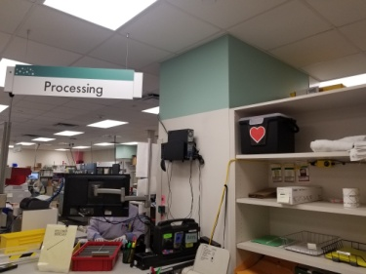
 | 4 | Responsible Party: Laboratory Staff (when the send out department is closed) and Send Out staff during open hours  - The Cerner order will have the donor UNOS number listed. Tech will review the UNOS number on the tube to ensure it matches the UNOS number on the order.
 | 5 | Responsible Party: Laboratory Staff  - Pack recipient samples in a separate bag from the donor sample(s). Both bags can be placed in the same shipping box.  - Place the box up front for courier pick up.  - When the courier picks up the box record the date a time on the check list.  - Place the check list in the send out department.
Appendices |  | Responsible Party: Send Out Staff  - Send Outs will make a new kit for the transplant box. |  |  |  | See Heart Box Contents
References
Historical Record | Version
 |  |  | Written/Revised by: | Effective Date: | Summary of Revisions
 | 1 |  | Jennifer Jacobsen | 9/27/2018 | Initial Version

