GeneXpert C. difficile/Epi Assay Quality Control

Purpose | This procedure provides instructions for Quality Control procedures required for the Xpert C. difficile/Epi Assay.
Policy Statements | This procedure applies to all employees that work in microbiology.
Sample | New Lot/Shipment and Monthly Quality control:  - Microbiologics C. difficile Control Panel (Cat. No. 8200)  - Positive: Clostridium difficile NAP1/027)  - Negative: Clostridium sordellii  Engineering control (monthly):  - Test kit swab  Instrument Performance Verification after repairs:  - One known positive and one known negative patient sample OR Positive and Negative External Control swabs
Frequency | -Every 30 days  -Receipt of new shipments  -Receipt of new lots  -Drift in results (e.g., increasing/decreasing positivity rates)  -Potential contamination (negative control)  -After Xpert check or drastic system maintenance  -Wipe testing: Monthly
Special Safety Precautions | Microbiologists/virologists are subject to occupational risks associated with specimen handling. Refer to the safety policies located in the safety section of the Microbiology and Virology Policy Manual:  - Biohazard Containment  - Safety in the Microbiology/Virology Laboratory  - Biohazardous Spills
Materials | Reagents Supplies Equipment  - Microbiologics C. difficile positive controls - Microbiologics C. difficile negative controls - 10% bleach - 70% ethanol - Xpert test kit swabs - Xpert MRSA NxG cartridges - Xpert MRSA NxG reagent vials - Transfer pipettes - Simple racks - Cartridge transfer tray - Transfer pipettes Store kits at 2-28°C. Kits are stable until the expiration date printed on the outer box. - Biosafety Hood - Cepheid GeneXpert Instrument and computer - Printer
Procedure | New Lot/Shipment and Monthly Quality control:  - Clean hood and supplies: 10% bleach followed by 70% ethanol.  - Change gloves.  - Obtain two Sample Reagent vials and test cartridges.  - Label the vials ad cartridges for the positive and negative controls.  NOTE: Set up the positive control first.  - Open the control swab.  - Insert the swab into the Sample Reagent vial, lift it up (about 2cm from the bottom), and break the shaft off using an absorbent biohazard pad (orange) as a barrier on the top of the tube.  - Vortex the vial for 10 seconds.  - Change gloves in-between processing of controls AND before moving to the instrument.  - Run cartridges as patient samples. (see Xpert C. difficile/Epi Assay procedure)  NOTE: Under the “Test Type” field select “Positive Control 1” or “Negative Control 1”.  - Clean hood with 10% bleach followed by 70% ethanol.  - Document QC in the GeneXpert Assay binder.  NOTE: Before reporting patient results, all controls must yield valid results.  Engineering control:  - Using a swab from a patient sample testing kit, swab the processing hood surface, counter around the GeneXpert instrument (including the keyboard, mouse, and scanner) and door handles on the instrument.  - Process and run as a patient sample.  - Document testing in the GeneXpert binder.  NOTE: In the event of positive result notify the tech specialist, decontaminate and re-test.
Interpretation and Documentation | - Click on View Results on the top drop-down menu bar and select View Test.  - Select the result you would like to review: Click OK.  - Review result interpretations and amplification curves for exponential growth (if applicable).  - NOTE: SPC does not need to pass for a positive result to be valid.  - NOTE: SPC needs to pass for a negative result to be valid.  - Click on the Errors tab to ensure no errors occurred during testing. (Section 9.18.2 in Operator Manual provides error code descriptions)  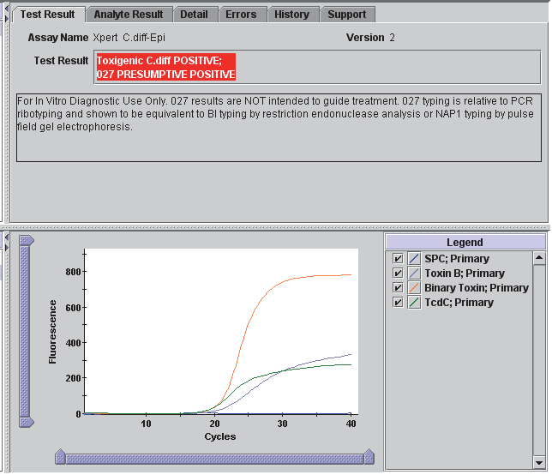  Reasons to retest:  - An INVALID result. This may indicate:  - The sample was inadequate.  - The sample was not properly processed.  - PCR was inhibited.  - An ERROR result. This may indicate:  - The reaction tube was filled improperly.  - A reagent probe integrity problem was detected.  - The maximum pressure limit was exceeded.  - A valve positioning error was detected.  - NO RESULT:  - This result indicated that insufficient data were collected. (e.g. test stopped while in progress or power failure occurred.  NOTE: Record any failures on the “GeneXpert Service and Error Log” log.  Valid Results:  - Positive: Toxigenic C. diff Positive – 027 Presumptive Positive  - Negative: Toxigenic C. diff Negative – 027 Presumptive Negative  NOTE: If there is a QC failure, document observation and correction action. Report QC problems that cannot be resolved to the tech specialist. For repeated failures contact Cepheid Technical Support, the Technical Specialist and Technical Director.  Do not report patient results until problem is resolved.  Desired Results for Engineering Control:  - Negative: Toxigenic C. diff Negative – 027 Presumptive Negative  NOTE: If Engineering Control results are positive, notify the Technical Specialist, decontaminate the space, recollect a swab and retest. Upon secondary failure discuss expanded testing with the Technical specialist
References | - Xpert C. difficile/Epi Package Insert, 200-9680 Rev. F. Cepheid; 2016.  - CAP Microbiology Checklist, College of American Pathologists, 325 Wakegan Road, Northfield, IL 60093-2750, 08/17/2016.  - Instructions for use: Helix Elite Molecular Standards. Rev A. St. Cloud, MN: Microbiologics; 2016.
Historical Record
 | Version | Written/Revised by: | Effective Date: | Summary of Revisions
 | 1 | Julie Laramie | 12/27/2018 | Initial Version
 | Archived by: |  | Archived Date:

