Xpert MRSA NxG Assay

Purpose | This procedure provides instructions for performing the Xpert MRSA NxG assay on the Cepheid GeneXpert system.
Policy Statements | This procedure applies to all technical staff performing testing on the GeneXpert.
Principle and Clinical Significance | The rapid detest of methicillin-resistant Staphylococcus aureus (MRSA) combined with an early implementation of appropriate intervention has been shown to reduce the prevalence of MRSA.^{[1, 2]} The Cepheid Xpert® MRSA NxG Assay is a qualitative in vitro diagnostic test for rapid detection of MRSA DNA directly from nasal swabs in patients at risk for nasal colonization. The test utilizes automated real-time polymerase chain reaction (PCR) for the amplification of MRSA-specific DNA targets and fluorogenic target-specific hybridization probes for the real-time detection of the amplified DNA. A negative result does not rule out MRSA nasal colonization.  Summary and Explanation  Staphylococcus aureus (SA) is a well-documented human opportunistic pathogen that causes both community and healthcare-associated infections. It is a major healthcare-associated pathogen that can cause a variety of diseases including bacteremia, pneumonia, osteomyelitis, acute endocarditis, toxic shock syndrome, food poisoning, myocarditis, scalded skin syndrome, carbuncles, boils, and abscesses.  In the early 1950s acquisition and spread of beta-lactamase-encoding plasmids thwarted the effectiveness of penicillin for treating S. aerues (SA) infections. In 1959, methicillin, a semi-synthetic penicillin, was introduced. However, by 1960, methicillin-resistant SA (MRSA) strains were identified. Resistance is now known to be conferred when SA acquires a Staphylococcal cassette chromosome (SCC) mec gene complex containing either mecA or mecC. Currently, the standard method for detecting MRSA is culture, which can require several days to generate a definitive result.  Principle  The Xpert MRSA NxG Assay is performed on the GeneXpert Instrument System. The system automates and integrates sample preparation, nucleic acid extraction and amplification, and detection of the target sequence in simple or complex samples using real-time PCR. The Xpert MRSA NxG Assay includes primers and probes to detect proprietary sequences for methicillin/oxacillin resistance (mecA and mecC genes), and SCCmec, which is inserted into the SA chromosome at the attB site.  An Early Assay Termination function provides positive results if target DNA reaches a predetermined threshold before the full 40 PCR cycles have been completed. When MRSA target levels (mecA/mecC and SCCmec) are high enough to generate very early Cts, the SPC amplification curve will not be seen and its results will not be reported.^{[3]}
Test Code | MRSAP
Sample | - Acceptable specimens:  - Anterior nares swab collected with ESwab collection kit  - SDES codes/Specimen type:  - NARE  - Specimen Collection and Transport:  - Refer to Lab Test Directory on StarNet  - Specimen assessment:  - Refer to the policy MCVI 2.1 Specimen Rejection Criteria.  - Specimen Storage  - ESwab:  - 15-30 °C for up to 24 hours  - 2-8 °C for up to 7 days
Special Safety Precautions | Microbiologists/virologists are subject to occupational risks associated with specimen handling. Refer to the safety policies located in the safety section of the Microbiology and Virology Policy Manual:  - Biohazard Containment  - Safety in the Microbiology/Virology Laboratory  - Biohazardous Spills
Materials | Reagents Supplies Equipment  - 10% bleach - 70% ethanol - Xpert MRSA NxG Assay cartridges - Xpert MRSA NxG reagent vials - Transfer pipettes - Sample racks - Cartridge transfer tray - Absorbent biohazard pads Store kits at 2-28°C. Kits are stable until the expiration date printed on the outer box. - Biosafety Hood - Cepheid GeneXpert Instrument and computer - Vortexer - Printer
Calibration | Annual “Xpert Check Kit” calibration performed by Cepheid.
Quality Control | Daily Quality Control:  Once an Xpert cartridge has been loaded and before the sample processing steps begin, the software checks the optics, the readiness of the module’s mechanical components, and the ambient temperature of the module to assure proper performance of PCR, and the physical integrity of the cartridge.  Each test includes a Sample Processing Control (SPC) and a Probe Check Control (PCC).  - SPC: Ensures the sample was correctly processed. The SPC verifies that lysis of bacteria has occurred and verifies that sample processing is adequate. Additionally, this control detects sample-associated inhibition of the real-time PCR assay, ensures the PCR conditions (temperature and time) are appropriate for the amplification reaction, and that the PCR reagents are functional. The SPC should be positive in a negative sample and can be negative or positive in a positive sample.  - PCC: Performs a check on the amplification portion of the assay. Before the PCR reaction starts, the GeneXpert instrument measures the fluorescence signal from the probes to monitor bead rehydration, reaction-tube filling, probe integrity, and dye stability. Therefore, it controls for missing or incompletely hydrated beads of enzyme and target specific reagent. It also controls for the generated fluorescence which must meet internal acceptance criteria.  External Quality Control:  - Perform QC using external positive and negative controls every 30 days. Record results in the GeneXpert assay binder on the Log.  - See IQCP document.  - See Quality Control Procedure.  New Lot/Shipment Quality control:  - Perform QC using external positive and negative controls with each new lot or shipment before putting into service. Record results in the GeneXpert assay binder on the Log.  - See Quality Control Procedure  Engineering control:  - Perform wipe testing every 30 days to monitor for contamination.  - See Quality Control Procedure.  NOTE: External quality control may be performed on an as needed basis if certain circumstances arise. Examples include:  - Drift in results (e.g., increasing/decreasing positivity rates)  - Potential contamination (negative control)  - After Xpert check or drastic system maintenance
Sample and Cartridge preparation:
- Clean hood with10% bleach (made daily) followed by 70% ethanol.
- Change gloves.
- Obtain an assay cartridge, sample reagent, absorbent biohazard pad, and transfer pipette.
- Label the side of the sample reagent with a foot-label.
- Label the side of the cartridge with a bar-coded foot-label.
- Vortex the ESwab and using a 300uL exact volume pipette, transfer 300uL of patient sample into the sample reagent vial.
- Re-cap the Eswab and sample vial.
- Vortex the sample vial on high speed for 10 seconds.
- Open the cartridge lid.
- Using a sterile 1mL transfer pipette, transfer the entire contents of the sample reagent to the sample chamber of the cartridge by inserting the pipette to the bottom of the well and empty the pipette’s content into the cartridge.

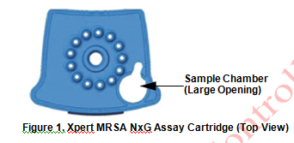

- Close the cartridge lid, and set onto the transfer tray or off to the side in the hood.
- Change gloves and proceed to prepare additional samples or start the test.

NOTES:
-Hood surfaces must be cleaned between samples with 10% bleach followed with 70% ethanol if there were any splashes, spills, or uncertainty of cleanliness.
**Start the test within 30 minutes of adding the sample to the cartridge

Starting the test:
- Ensure clean gloves are on before stepping to the computer work space.
- If instrument and computer are turned off: start up the instrument by flipping the power switch located in the back of the instrument. Turn on the computer next.
- Log onto the appropriate Windows account:
  - User: lab1
  - Password: labstaff4
- The GeneXpert software will launch automatically. If it doesn’t double-click the GeneXpert Dx software shortcut icon on the desktop.
- Log onto the software.
  - User: First 6 letters of your first and last name (combined)
  - Password: First 6 letters of your first and last name (combined)
- In the GeneXpert System window, click Create Test.
- Navigate to the Sample ID box. Scan or type in the sample ID.
- Scan the barcode on the cartridge.
NOTE: if the barcode on the cartridge does not scan, then repeat the test with a new cartridge.
- Select the appropriate test type for samples or controls.
- Enter additional information in the “notes” field (day of QC, collect date, etc.) if needed.
- Click Start Test.
- Enter your username and password, if requested.
- Open the instrument module door with the blinking green light.
NOTE: when setting up for testing you may opt to use any available module.
- With the barcode facing towards you, set the cartridge into the module and close the door.
- Wait for the test to start and the light to stop blinking. The test will run for 70 minutes.
NOTE: Early assay termination for positive samples can occur as early as 45 minutes
- Turn printer on.
- Remove the cartridge when testing is finished (the light will be off and the system will release the door lock).
- Dispose of used cartridges into bio-bags and place into biohazard sharps bins.
- Clean any equipment used (pipettes, racks, transfer tray, etc.), hood, and counters (including keyboard, scanner, and mouse) at the end of the day.
- Save secondary swabs at room temp (15-30 °C, 24 hours) or in the fridge (2-8 °C, 7 days) for potential testing.

NOTE: Sample processing, testing, and cleaning should follow a unidirectional work-flow to avoid contamination.

Interpretation/ Results | - Click on View Results on the top drop-down menu bar and select View Test.  - Select the result you would like to review: Click OK.  - Review result interpretations and amplification curves for exponential growth (if applicable).  - NOTE: SPC does not need to pass for a positive result to be valid.  - NOTE: SPC needs to pass for a negative result to be valid.  - Click on the Errors tab to ensure no errors occurred during testing. (Section 9.18.2 in Operator Manual provides error code descriptions)  Reasons to retest/trouble shooting:  - An INVALID result. This may indicate:  - The sample was inadequate.  - The sample was not properly processed.  - PCR was inhibited.  - An ERROR result. This may indicate:  - The reaction tube was filled improperly.  - A reagent probe integrity problem was detected.  - The maximum pressure limit was exceeded.  - A valve positioning error was detected.  - NO RESULT:  - This result indicated that insufficient data were collected (e.g. test stopped while in progress or power failure occurred).  NOTE: Record any failures or errors on the “GeneXpert Service and Error Log” log.  See result examples below:  Positive MRSA Result:  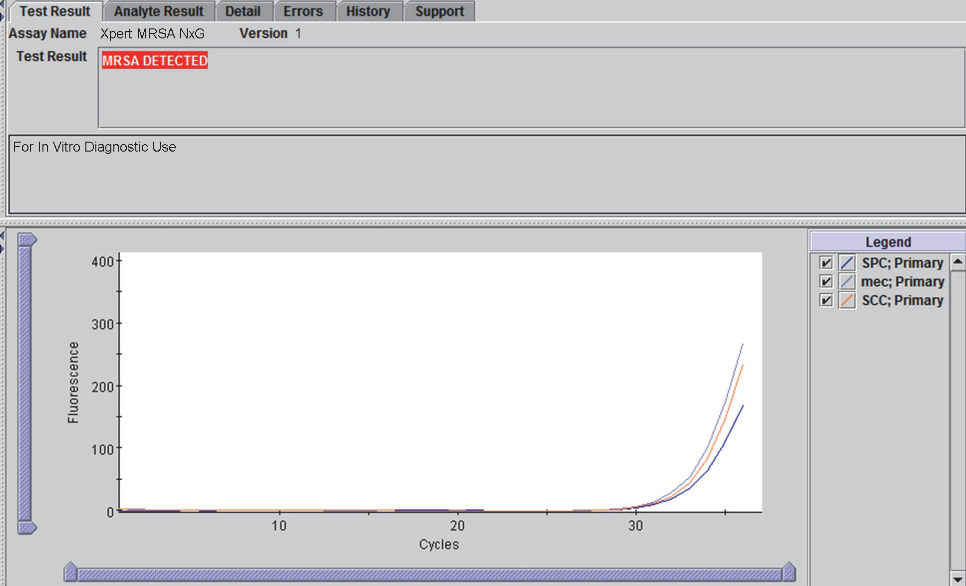  Negative MRSA Result:  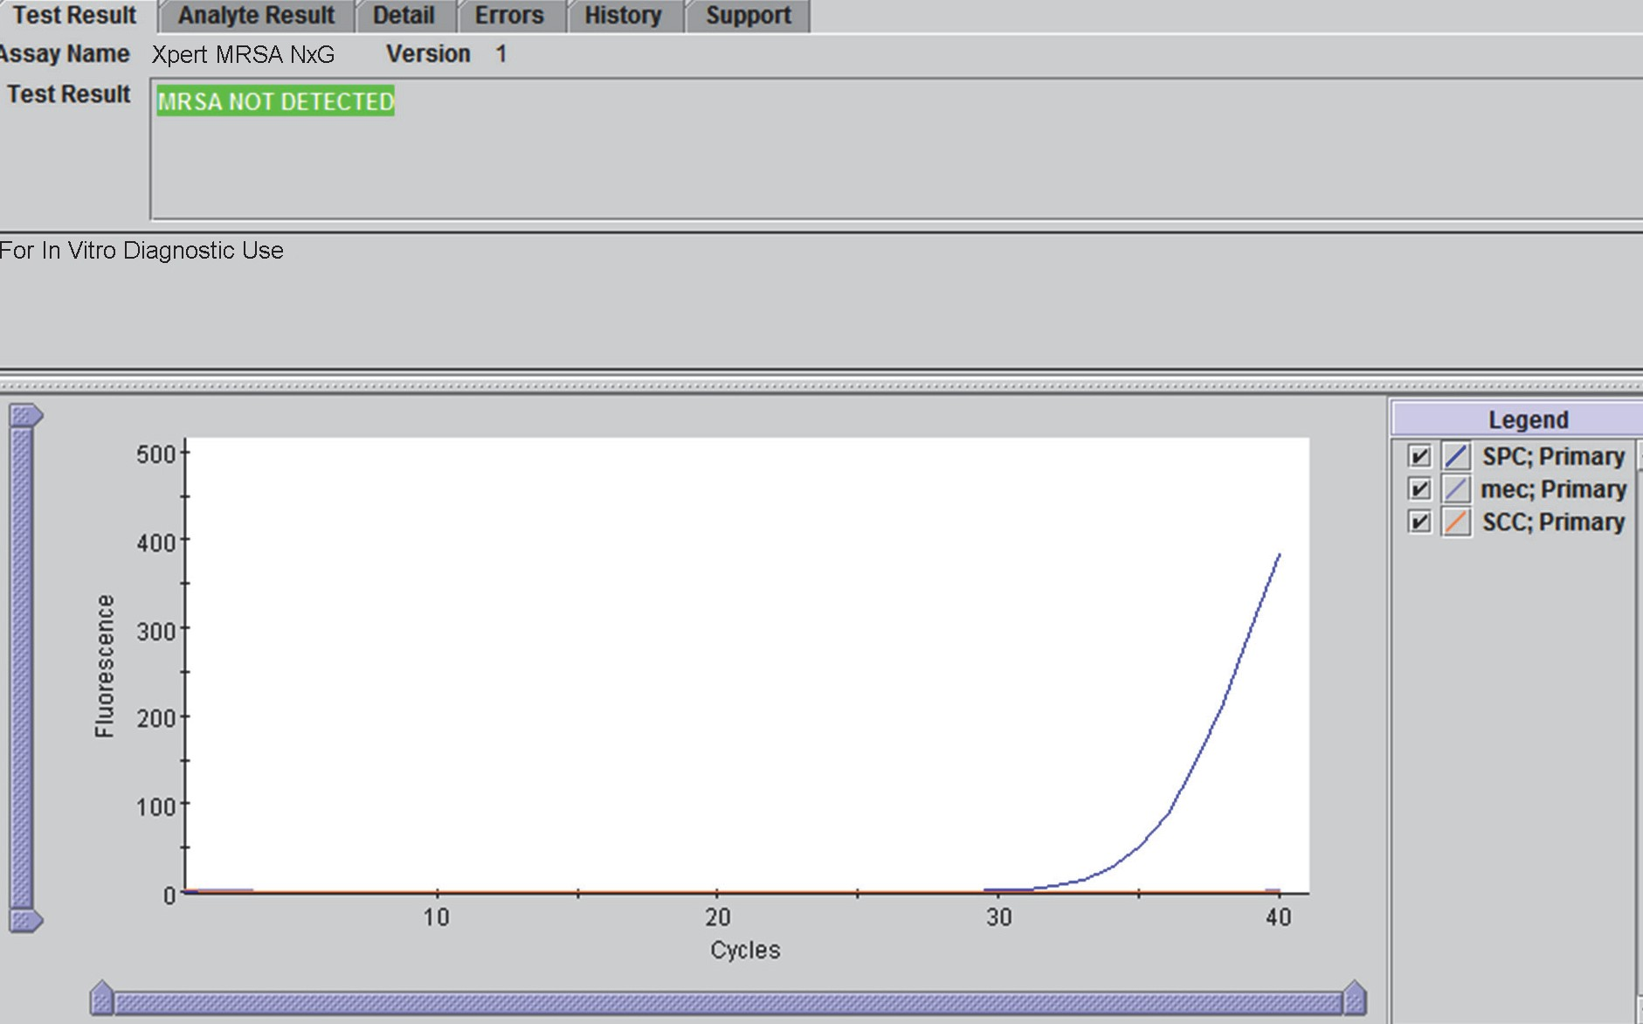  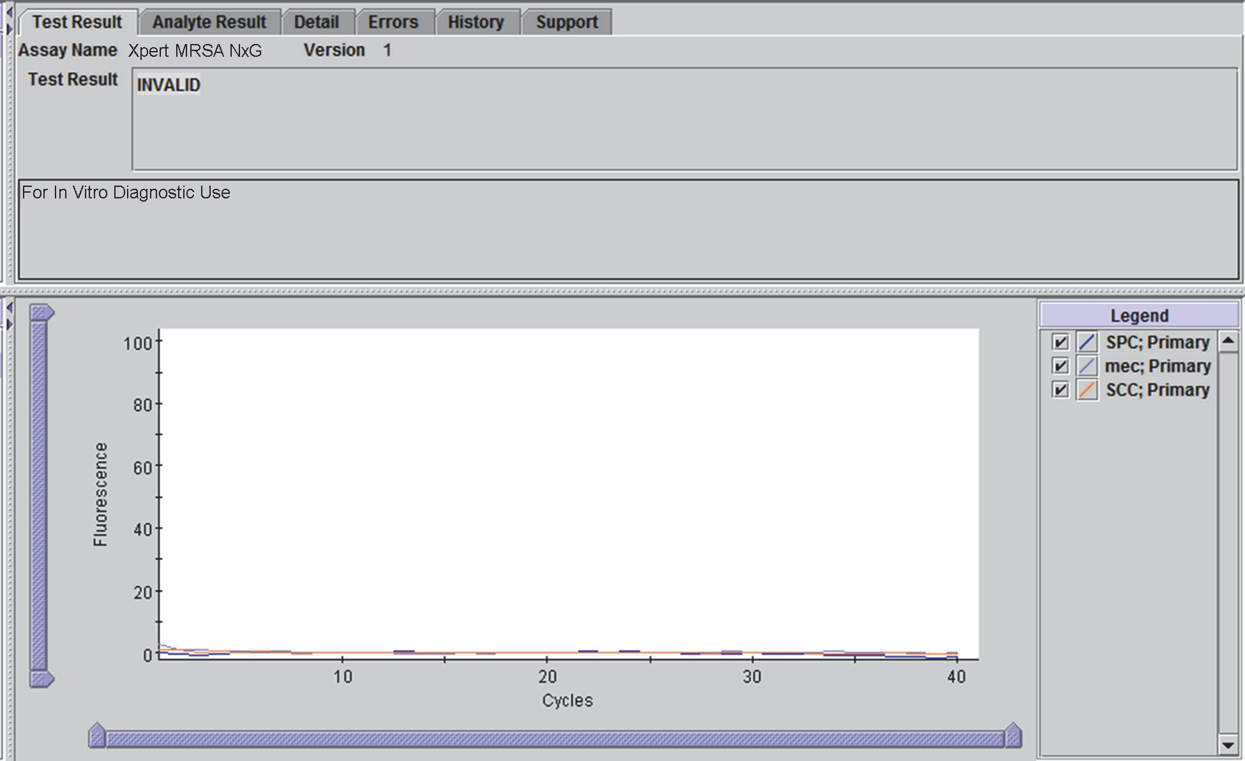  Invalid MRSA Result:
Retesting Procedure | - Repeat the test using a new cartridge and new Elution Reagent vial.  - Process the same Eswab according to the SOP above.
Result Reporting | - Ensure that the printer is turned on.  - Reports will print automatically.  - Results will automatically transmit to the LIS.  - Log into Sunquest to release results.  - Select Result Entry from Menu options 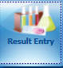  - In the Configuration field select CGX in the dropdown box.  - Select the test code order to results (MRSAP).  - Click on the button located in the lower right corner to populate the transmitted results.  - Review messages located on the top and results. Compare results to the GeneXpert report.  - Check the release box. 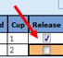.  - Click button located on the lower left corner. Click when the “Verify Release Destination” window opens.  - Call a completed worksheet, check results, and staple to GeneXpert Report. Place in the GeneXpert result binder.  - Store samples in fridge:  - Mark positive samples on top of caps.  - Discard old samples after 1 week.
Critical Results | - First time positive results must be called to the provider. If provider cannot be reached relay results to infection prevention.  - To determine if a result is a first time positive:  - Click on Laboratory Inquiry    - Type in the patient’s MRN.  - Adjust the number of days for review to 9999.  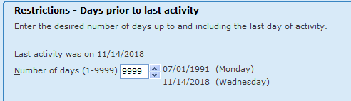  - Click , and review results for any record of a previously detected or isolated MRSA (review culture results too).  - If the result is a first time positive, add the code CAL, press tab, enter semi-colon, record who the result was relayed to and the time/date.
Invalid Results | - IF an invalid result is repeated AND a valid result is obtained, select and only release the valid result interpretation in the LIS.  - IF an invalid result is repeated AND an invalid result is obtained, select only one of the invalid results to verify. The provider must be notified of these results.  The result will be reported as unresolved (UNRE) and the following code SIA will automatically append: “This sample is inhibitory to amplification and the results are inconclusive. Consider repeat collection if clinically indicated.”  Add the code CAL, press tab, enter semi-colon record who the result was relayed to and the date/time.
Manual Entry of Results | - Open Result Entry, select the Manual resulting mode (top left corner), from the configuration drop down select the appropriate test code. Click in the lower right corner.  - Enter the Specimen ID or scroll to the correct patient if necessary (lower left corner).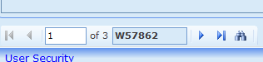  - Type in results and applicable comments when necessary.  - Check results against instrument print out and click .
Correcting Results | - Open Result Entry, select the Manual resulting mode (top left corner), from the configuration drop down select the appropriate test code. Click in the lower right corner.  - Enter the Specimen ID, enter Tab and click Yes to modify the result.  - Change the incorrect result. The corrected result comment will automatically append. Add the CAL comment, press tab, enter a semi-colon and record who was called and the time/date.  - Click . Click when the “Verify Release Destination” window opens.
Limitations | - Careful compliance with the instructions in this package insert and in Cepheid Sample Collection Device package inserts (Cepheid Sample Collection Device, Copan Dual Rayon Swab and Transport Systems, Liquid Amies Elution Swab (ESwab) Collection and Transport System) is necessary to avoid erroneous results.  - The Xpert MRSA NxG Assay performance has not been evaluated in patients less than two years of age.  - The Xpert MRSA NxG Assay is not intended to diagnose, guide or monitor treatment for MRSA infections, or determine susceptibility to methicillin.  - As with many diagnostic tests, results from the Xpert MRSA NxG Assay should be interpreted in conjunction with other laboratory and clinical data available to the clinician, and should be used as an adjunct to nosocomial infection control efforts to identify patients needing enhanced precautions. Results should not be used to guide or monitor treatment for MRSA infections.  - A positive test result does not necessarily indicate the presence of viable organisms. It is, however, presumptive for the presence of MRSA.  - A negative test result does not exclude the possibility of nasal colonization because test results may be affected by improper specimen collection, technical error, sample mix-up, or because the number of organisms in the sample is below the limit of detection of the test.  - Concomitant cultures are necessary to recover organisms for epidemiology typing or for further susceptibility testing.  - The Xpert MRSA NxG Assay provides qualitative results. No correlation can be drawn between the magnitude of the Ct value and the number of cells in an infected sample.  - Mutations or nucleotide polymorphisms in primer or probe binding regions may affect detection of new or unknown MRSA variants resulting in a false negative result.  - An Xpert MRSA NxG Assay positive result does not necessarily indicate intervention eradication failure since nonviable DNA may persist. A negative result following a previously positive test result may or may not indicate eradication success.  - Because the detection of MRSA is dependent on the quantity DNA present in the sample, reliable results are dependent on proper specimen collection, handling, and storage.  - The Xpert MRSA NxG Assay may generate a false positive MRSA (MRSA DETECTED) result when testing a nasal specimen with a mixture of organisms containing both methicillin-resistant coagulase-negative Staphylococcus and an empty cassette SA.  - The Xpert MRSA NxG Assay may generate a false negative result (MRSA NOT DETECTED) in the event of a co-colonization that contains both methicillin-resistant Staphylococcus aureus (MRSA) and an empty cassette  Staphylococcus aureus (SA). This may occur in rare cases when the titer of an empty cassette SA organism is substantially higher than that of the MRSA organism.  - Assay interference may be observed in the presence of Nasonex (≥50% v/v), Flonase (≥50% v/v), and Beconase (≥40% v/v).^{[3]}
Method Performance Specifications | According to the manufacturer (per the package insert):  Sensitivity: 91.0% (95% CI: 84.6-94.9)  Specificity: 96.9% (95% CI: 95.7-97.8)  PPV: 78.7% (95% CI:71.32-84.7)  NPV: 89.9% (95% CI: 98.0-99.4)  95% Confidence Intervals for Analytical LoD — MRSA (ESwab)  MRSA Strain PFGE IDa LoD Estimate (Logistic Regression) (CFU/Swab) LoD Estimate In Elution Reagent (CFU/mL)  Lower 95% CI LoD Point Estimate Upper 95% CI  Type I USA500 285 343 469 45  Type II USA100 184 218 293 28  Type III unknown 215 254 338 33  Type IVa USA400 134 167 245 22  Type IV (Fin 7) unknown 656 812 1145 106  Type IVa USA300 470 563 733 73  Type V USA1000 378 465 671 61  Type VI USA800 71 89 128 12  Type VII unknown 201 245 338 32  Type VIII unknown 520 631 851 82  Type IX unknown 311 377 533 49  Type X unknown 149 166 215 22  Type XI (mecC) unknown 597 734 998 96  a. PFGE = Pulsed-field gel electrophoresis  The results of this study indicated that the Xpert MRSA NxG Assay will produce a positive MRSA result 95% of the time with 95% confidence for a nasal swab (ESwab) containing 812 CFU.^{[3]}
References | 1. Rossney AS, Herra CM, Brennan GI, Morgan PM, O'Connell B. Evaluation of the Xpert methicillin-resistant Staphylococcus aureus (MRSA) assay using the GeneXpert real-time PCR platform for rapid detection of MRSA from screening specimens. Journal of clinical microbiology 2008; 46(10):3285-3290.  2. Wassenberg M, Kluytmans JA, Box A, Bosboom R, Buiting A, Van Elzakker E, et al. Rapid screening of methicillin‐resistant Staphylococcus aureus using PCR and chromogenic agar: a prospective study to evaluate costs and effects. Clinical Microbiology and Infection 2010; 16(12):1754-1761.  3. Xpert MRSA NxG Package Insert, 301-4055 Rev. A. In: Cepheid; 2016.
Alternate Methods | - Bacteriology culture
Proficiency Testing | CAP: 3 shipments a year with 5 samples
Training Plan/ Competency Assessment | Training Plan |  |  | Initial Competency Assessment
 | - Employee must read the procedure.  - Employee will demonstrate the ability to perform procedure, record results, and document corrective action after instruction by the trainer. |  |  | - Direct observation
Historical Record
 | Version | Written/Revised by: | Effective Date: |  | Summary of Revisions
 | 1 | Julie Laramie | 12.27.2018
 | Archived by: |  | Archived Date:

