Vitek 2 Quality Control for ID and AST

Purpose | This procedure provides instruction for how to perform: VITEK 2XL QUALITY CONTROL for ID and AST cards.
Policy Statements | Vitek QC is performed on each new lot and/or shipment of ID and AST cards before put into use.  AST QC is performed weekly thereafter.  Vitek QC (all types AST cards and GN ID card) is performed after biennial Preventative Maintenance (PM), and/or repairs or replacement of critical components, major maintenance or service, to ensure the cards perform according to expectations.  If there is a QC failure, document observation, notify supervisor and call bioMérieux technical service at  1-800-682-2666.
Materials
 | Reagents |  | Supplies |  | Equipment |  |  | Media
 | - AST -GP67 bioMérieux product number 22226  - AST-GP74 bioMérieux product number 414971  - AST-GN95 bioMerieux product number 421982  - AST-GNXN08 bioMerieux product number 421983  - GN ID cards, bioMérieux product number 21341  - GP ID cards, bioMérieux product number 21342  - YST ID cards, bioMérieux product number 21343  - NH ID cards, bioMérieux product number 21346  - ANC ID cards, bioMérieux product number 21347 |  | - 0.45% Saline, Cardinal Healthcare product number 3D0775  - 0.45% IV saline, Cardinal Healthcare product number 2B16314X  - 10 mm x 75 mm polystyrene tubes, bioMérieux product number 69285  - Sterile, cotton-tipped applicator swabs, warehouse product |  | - Vitek 2 instrument, bioMérieux product number 530052-1  - DensiChek, bioMerieux product number 27207  - Adjustable volume dispenser, bioMérieux product number V1200  - Smart Carrier Cassette with button memory, bioMérieux product number 27700  - Vortex Mixer, Barnstead International, model # M37615 |  |  | - CHOC  - SB  - SAB  - MAC
Storage | - Cards should be stored in factory sealed pouches at 2-8 °C.  - All other supplies are stored at room temperature.
Special Safety Precautions | Microbiologists/virologists are subject to occupational risks associated with specimen handling.  - Biohazard Containment  - Biohazardous Spills  - Safety in the Microbiology/Virology Laboratory
QC Organisms | AST-GP67:  - Enterococcus faecalis, ATCC 29212  - Enterococcus faecalis, ATCC 51299  - Staphylococcus aureus, ATCC 29213  - Staphylococcus aureus, ATCC BAA-976  - Staphylococcus aureus, ATCC BAA-977  - Staphylococcus aureus, ATCC BAA-1026  AST-GP74:  - Streptococcus pneumoniae, ATCC 49619  AST-GN69:  - Escherichia coli, ATCC 25922  - Escherichia coli, ATCC 35218  - Pseudomonas aeruginosa, ATCC 27853  - Klebsiella pneumoniae, ATCC 700603  AST-GNXN08:  - Escherichia coli, ATCC 25922  - Escherichia coli, ATCC 35218  - Pseudomonas aeruginosa, ATCC 27853  - Klebsiella pneumoniae, ATCC 700603  GN ID cards:  - Escherichia coli, ATCC 25922  - Escherichia coli, ATCC 35218  - Pseudomonas aeruginosa, ATCC 27853  - Klebsiella pneumoniae, ATCC 700603  GP ID cards:  - Enterococcus casseliflavus, ATCC 700327  - Streptococcus thermophilus, ATCC 19258  YST ID cards  - Candida albicans, ATCC 14053  NH ID cards  - Eikenella corrodens, ATCC BAA-1152  ANC ID cards:  - Clostridium septicum, ATCC 12464  - Bacteroides ovatus, ATCC BAA-1296
Procedure-Add cards to Inventory | - Vitek 2 directory → QC icon (has line graph symbol).  - Click the truck icon.  - When the “enter new shipment window” appears, enter the lot number and fill in the fields on the window.  - Enter the number of boxes in the lot received. Press <enter>.  - Click “add” to make another entry.
Procedure-Sample Preparation | - Refer to the Vitek 2 Systems Product Information document for organism media and incubation requirements.  - Organisms subcultured from frozen stock should be sub-cultured twice prior to testing.  - Allow test cards and saline to reach room temperature.  - Obtain Smart Carrier Cassette and place on bench top.  - Enter Vitek 2 Web Viewer. Log in at user name with labadmin and password with labadmin.  - Click on Vitek 2 FLEXprep icon  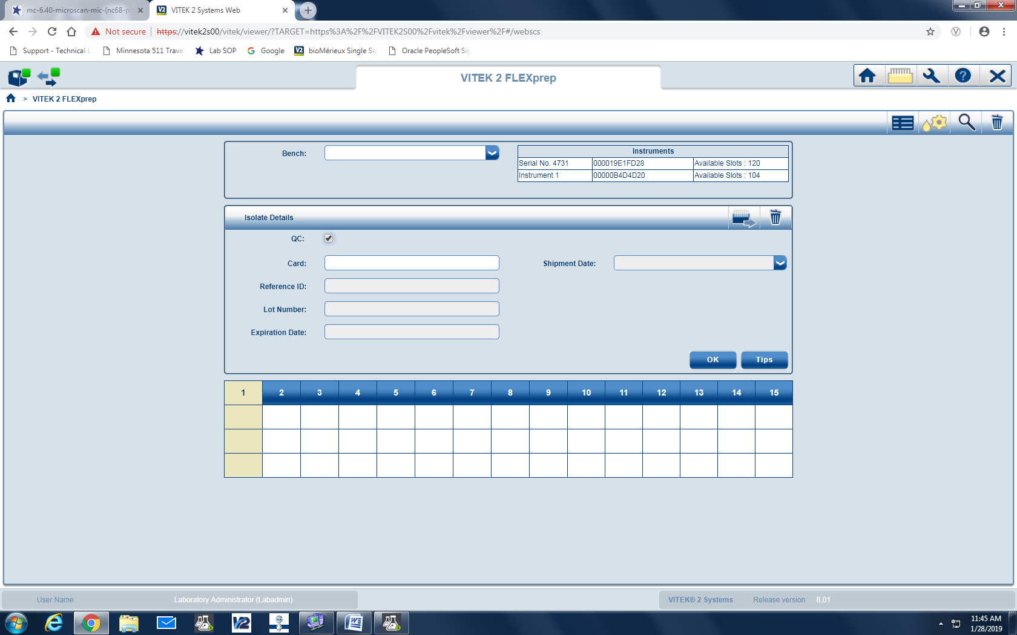  - Click on the QC box  - Scan the barcode of the QC card being tested.  - Scan the barcode of the QC organism or select in the drop down box in the Reference ID box.  - Lot number and Expiration date will appear.  - Refer to Vitek 2 procedure MC 7.00 for further information on suspension preparation.  - Once all setup is complete, click on the icon to send the cassette to Vitek 2 System  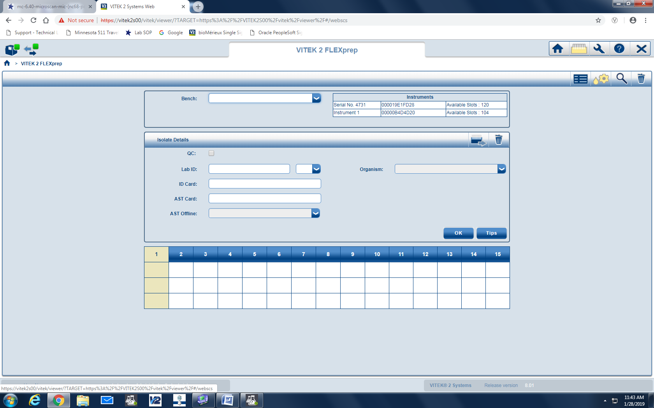  - Record card setup with panel type and date and initials on Vitek Weekly and New Lot QC Review Log  - Refer to MC 7.00 Vitek 2XL Procedure for placement of cassette in the Vitek 2XL.
Verifying and Printing QC Results | - Vitek 2 directory → QC icon. (has line graph symbol).  - Click on the drop down ‘Filter by:’ → ‘deviation’  - If any deviations are noted, click on the ‘comment’ field and explain occurrence and next steps.  - Record “Pass/Fail” Read tech, date, and description of problem (if “Fail”) and Problem resolution.  - It must be noted if the failure affected patient test results. Notify micro staff and Micro Supervisor.  - Vitek 2 directory → QC icon  - Click on the drop down ‘Filter by:’ → ‘custom’.  - Fill in date range for desired results.  - Click the printer icon near the upper right corner of the screen.  - Click ‘Print’ to generate report.  - Initial and date each organism column, double-checking for deviations. Acceptable ranges are listed along side actual result.  - Monthly Review: Each month QC data will be reviewed and assessed by the Micro Supervisor or designee.  - Person assessing initials the log for monthly review and notifies Lab Director of any ongoing or critical issues.
Out of Control Results due to obvious error | - Document the reason and retest the strain on the day  - If the repeated result is within range, no further corrective action is necessary.  - Examples of obvious error include: Use of wrong card, Use of wrong control strain, Contamination, Wrong incubation temperature or conditions.
Out of Control Results not due to obvious error | - Investigate possible procedural problems: Standardization of the inoculum, Storage and expiration dates of the cards, incubation conditions, control strain was not contaminated, and control organism was more than 24 h old.  - Retest the strain on the same day.  - If the repeated result is within range, no further corrective action is necessary.  - If QC fails second day, test the antimicrobial agent for 5 consecutive days. Record all results.  - If all 5 results are within range, no additional corrective action is necessary.  - If the problem is not resolved (1 or more parameters out of range), daily QC testing must be done until the problem is resolved.  - It may be necessary to obtain a new QC organism either from the frozen stock or from BD.  - Call BD technical service at 1-800-638-8663 if it may be a manufacturer problem.  - Perform alternate test method until the problem is resolved.  - Suppress the results for the individual antimicrobial agent.
References | - Vitek 2 Instrument User Manual, bioMérieux, 2008.  - Vitek 2 Product Information Manual, 2009.  - Vitek 2 Customer Training Course manual, bioMérieux, 2014.
Training Plan/ Competency Assessment | Training Plan |  |  |  |  | Initial Competency Assessment
 | - Employee must read the procedure.  - Employee will observe trainer performing the procedure.  - Employee will demonstrate the ability to perform procedure, record results and document corrective action after instruction by the trainer. |  |  |  |  | - Direct observation.
Historical Record
 | Version | Written/Revised by: |  | Effective Date: |  |  | Summary of Revisions
 | 1 | Kristin Renner |  | 10/1/2005 |  |  | Initial Version
 | 1.1 | Kristin Renner |  | 7/17/2006 |  |  | Added hyperlinks
 | 1.2 | Becky Carlson |  | 10/6/2009 |  |  | Updated product information and organism information
 | 1.3 | Brian Howell |  | 6/18/2011 |  |  | Reworded sections to reflect new software.
 | 1.4 | Becky Carlson |  | 5/15/2003 |  |  | Updated product information
 | 2 | Becky Carlson |  | 4/7/2015 |  |  | Updated product information; Re-formatted to CMS; Re-numbered from MC 1002
 | 3 | Becky Carlson |  | 9/28/2015 |  |  | Added Vitek Weekly and New Lot QC Review Log for recording of QC results
 | 3 | Becky Carlson |  | 3/23/2017 |  |  | Added biennial PM required QC statement to Policy Statement section.
 | 3 | Susan DeMeyere |  | 5/23/2017 |  |  | Removed XN06 cards, discontinued
 | 3 | Susan DeMeyere |  | 5/31/2017 |  |  | Removed 30 day QC for Vitek ID cards per Cap requirement COM.50500-Does not apply to ID systems.
 | 4 | Susan DeMeyere |  | 3/2/2018 |  |  | Biennial Review
 | 5 | Susan DeMeyere |  | 2/15/2019 |  |  | Add AST 95 and XN08, remove AST 69 and 79 and update Vitek Web Viewer.

