Using Hemotemp Indicators

Purpose | This procedure provides instructions for the calibration and use of Hemotemp indicators on red cell units issued in coolers or to surgery.
Policy Statements | - Hemotemp indicators should not be the sole method of determining the clinical acceptability of blood.  - Hemotemp indicators shall be used on all red cell units issued in cooler or to a remote blood bank storage refrigerator.  - Hemotemp indicators are not appropriate for use for red cell products issued in syringes.  - Indicators may be stored at 38-42°C for up to 4 weeks.  - The irreversible “flower” portion is dependent on both temperature and time.  - The blood bag must be stored at 1-3°C for t least 10 hours prior to activation of the HemoTemp® II indicator.  - Each new lot of HemoTemp indicators will be calibrated before use.
Materials | - Hemotemp indicator  - 40°C heated block
Procedure
 | Step | Action
 | 1 | Pull strip from the box and tear off the required number of individual indicators at the perforation leaving the backing on.
 | 2 | Confirm that the irreversible flower portion is non-blue.
 | 3 | Write today’s date on bottom of indicator.
 | 4 | Heat the indicator to 38-42°C for 60 seconds or longer by placing the irreversible flower portion facing down into the heating block.  - Do not use a microwave oven or other heat source  Note: Indicators may be stored up to 4 weeks in incubator.
 | 5 | Confirm that the flower is blue and you see the outline of the irreversible “flower” portion..
 | 6 | Remove the backing from the indicator and placed on a refrigerated blood bag.  Note: The Hemotemp should be placed on the refrigerated blood bag immediately when it is removed from the BB refrigerator. All other processing and issuing steps should occur immediately after the Hematemp has been applied.
 | 7 | Press the indicator onto the center or near the bottom of the refrigerated blood bag. For proper activation:  - The blood bag must contain 100 mLs  - The blood bag should be refrigerated at 3°C for at least 10 hours  - The blood bag should be free of moisture and oils
 | 8 | Place the blood bag with the face of the indicator down on a flat surface and rotate the bag back and forth to ensure proper adhesion.
 | 9 | Confirm color of the flower on the indicator.
 |  | If |  | Then
 |  | Flower is blue |  | Indicator is activated and acceptable
 |  | Flower in Non-blue |  | Remove the indicator and repeat the above procedure with a new indicator.
Calibration  Instructions | 1 Assemble a control bag simply fill a blood bag with distilled water the same weight as blood units are filled.  2 Place water filled bag into the refrigerator for at least 10 hours before calibration of hemotemps.  3 Attached infrared probe to the infrared thermometer. 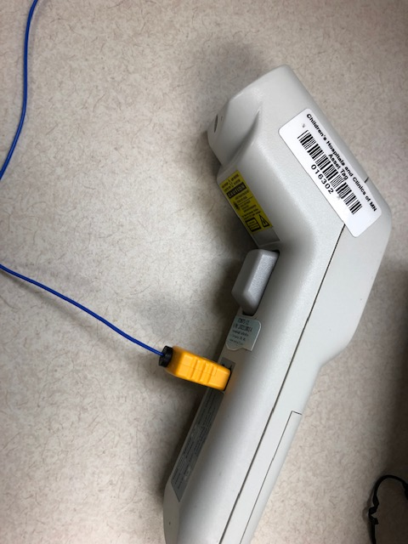  4 Set thermometer to probe reading by click on the mode button. 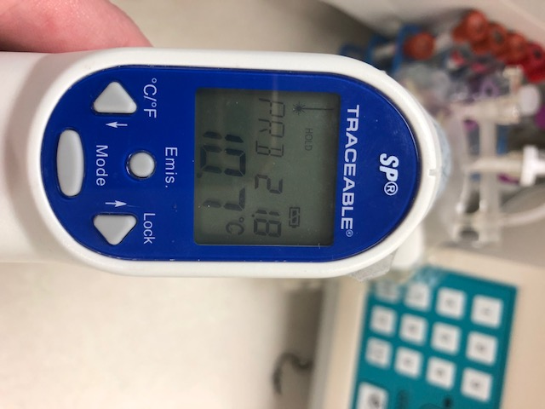
5 | Remove water filled bag from refrigerator.
6 | Insert the infrared probe into the center port and slide the probe into the bag so that the tip is in the center of the blood bag. Make sure the probe is in the center of the bag measuring the liquid temperature and not touching either side of the bag.  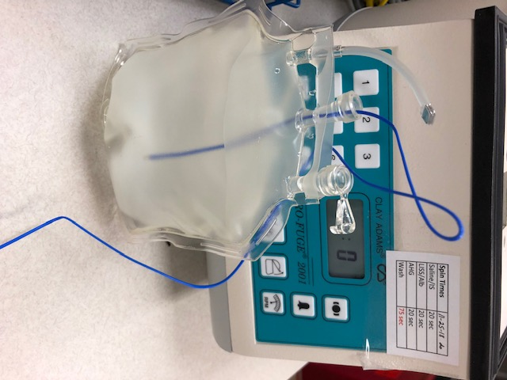
7 | Remove a HemoTemp indictor and activate it. After heat activating the indicator, wait until you see the outline of the flower and then place it on the center of the blood bag.
8 | Compare the temperature on the infrared to the temperature on the indicator.
9 | Record temperatures on Hemotemp Calibration Logsheet
10 | Add a “This Lot is Ready for Use” sticker with date and your initials.  

Interpretation | Upon return of the red cell unit from issue the following table may be used a part of the unit’s acceptability to return to inventory check.  Duration of indicator Reversible numbers in any color - Tan temp is in the lower range - Green-temp in mid range - Blue-temp in higher range Irreversible flower General Acceptability of blood  0-72 hours Visible Visible Invisible Invisible Blue Non-blue Non-blue Blue Yes No No No * stored below 1°C  >72 hours Visible Visible Invisible Invisible Blue Non-blue Non-blue Blue Yes No No No* stored below 1°C
References | Hemotemp II product insert. Biosynergy, Inc.
Approval  Workflow | Transfusion Service/Technical Specialist
Historical Record | Version |  | Written/Revised by: |  | Effective Date: | Summary of Revisions
 | 1 |  | J. Wenzel |  | 6/99 | Initial Version
 | 2 |  | J. Wenzel |  | 8/31/2002
 | 3 |  | J. Wenzel |  | 5/01/03
 | 4 |  | J Wenzel |  | 11/13/2009 | Separate from cooler SOP  Activation time from 30 to 60 seconds
 | 5 |  | S. Cassidy |  | 11/18/09 | Added heat block instructions
 | 6 |  | J. Wenzel |  | 4/10/2012 | CMS format. Previous TS 12.15
 | 7 |  | S. Cassidy |  | 6/14/2012 | Temperature of blood bags change from 4°C to 3°C. added note regarding placement of Hematemp on refrigerated blood bag immediately after removing from the refrigerator.
 | 8 |  | S. Cassidy |  | 03/15/2019 | Added hemotemp calibration

