BioFire FilmArray Blood Culture Identification Panel

Purpose | This procedure provides instructions for performing Blood Culture Identification on the BioFire FilmArray system.
Policy Statements | This procedure applies to all technical staff performing testing on the BioFire FilmArray.
Principle and Clinical Significance | The FilmArray Blood Culture Identification (BCID) panel is a qualitative multiplexed nucleic acid-based in vitro diagnostic test intended for the use with the FilmArray systems. The FilmArray BCID panel is capable of simultaneous detection and identification of multiple bacterial and yeast nucleic acids and select genetic determinants of antimicrobial resistance. The BCID assay is performed directly on blood culture samples identified as positive by a continuous blood culture system that demonstrates the presence of organisms as determined by Gram Stain. FilmArray BCID Panel results are available in about an hour. Timely diagnosis and administration of effective treatment can significantly reduce mortality, duration of hospital stays, and costs due to sepsis  The following bacteria and yeast are identified using the FilmArray BCID panel: Enterococcus spp., Listeria monocytogenes, Staphylococcus spp. (including specific differentiation of Staphylococcus aureus), Streptococcus spp. (with specific differentiation of Streptococcus agalactiae, Streptococcus pneumoniae, and Streptococcus pyogenes), Acinetobacter baumannii, Enterobacteriaceae (including specific differentiation of Enterobacter cloacae complex, Escherichia coli, Klebsiella oxytoca, Klebsiella pneumoniae, Proteus, and Serratia marcescens), Haemophilus influenzae, Neisseria meningitidis, Pseudomonas aeruginosa, Candida albicans, Candid glabrata, Candida krusei, Candida parapsilosis and Candida tropicalis.  The FilmArray BCID panel also detects genetic determinants of resistance to methicillin (mecA), vancomycin (vanA and vanB), and carbapenems (blaKPC) to aid of the identification of multi-drug resistant organisms in positive blood culture samples. The antimicrobial resistance gene detected may or may not be associated with the agent responsible for disease. Negative results for these select antimicrobial resistance gene assays do not indicate susceptibility, as multiple mechanisms of resistance to methicillin, vancomycin, and the carbapenems exist.  The FilmArray BCID panel is indicated as an aid in the diagnosis of specific agents of bacteremia and fungemia and results should be used in conjunction with other clinical and laboratory findings. Positive FilmArray results do not rule out co-infection with organisms not included in the FilmArray BCID panel.  Subculture of positive blood cultures is necessary to recover organisms for susceptibility testing, to identify organisms in the blood culture that are not detected by the FilmArray BCID panel, and for species determination of some Staphylococcus spp., Enterococcus spp., Streptococcus spp., and Enterobacteriaceae that are not specifically identified by the FilmArray BCID Panel.  The FilmArray BCID is a closed disposable system that houses all the chemistry required to isolate, amplify, and detect nucleic acid from multiple blood stream pathogens within a single blood culture sample. The rigid plastic component of the BCID pouch contains reagents in freeze-dried form. The flexible plastic portion of the pouch is divided into discrete segments where the required chemical processes are carried out. The user of the FilmArray BCID Panel loads the sample in the BCID pouch, places the pouch in the FilmArray instrument/Module and starts the run. All other operations are automated.
Workup Code | BCID
Materials
 | Reagents |  | Supplies |  | Equipment |  | Reagent storage
 | - Individually packaged FilmArray BCID panel pouches  - Single–use Sample Buffer ampoule  - Single-use pre-filled Hydration Injection Vials (blue)  - Single-use Sample Injection Vials (red)  - External positive control: Microbiologics cat no. 8215  - External negative control: blood culture media |  | - 1 ml syringes  - Individually packaged Transfer Pipettes |  | - FilmArray Torch and software  - FilmArray Pouch Loading Station  - Biosafety Hood  - FilmArray Torch Printer |  | - Store kit at room temperature-Do Not Freeze.  - Avoid storage near heating or cooling vents.  - All kit components should be stored and used together. Do not mix components from one kit with another kit.
Sample | Positive Blood Culture samples that demonstrate the presence of organisms as determined by Gram stain. Sample volume is 0.2 mL. Samples should be processed and tested as soon as possible after being flagged as positive by the culture instrument. However, samples may be stored for up to 8 hours at room temperature prior to testing.  Do not perform if patient has had previous positive blood cultures identified on BioFire FilmArray with same Gram stain morphology per hospital admission.  Do not perform on related bottle (other bottle with same accession number) with the same Gram stain morphology.  Do not perform if no organisms are seen on the Gram Stain.
Special Safety Precautions | Microbiologists are subject to occupational risks associated with specimen handling. Refer to the safety policies located in the safety section of the Microbiology and Virology Policy Manual:  - Biohazard Containment  - Safety in the Microbiology/Virology Laboratory  - Biohazardous Spills  - Wear appropriate personal protective equipment (PPE) including disposable gloves and lab coats.  - Handle all samples and waste materials as if they were capable of transmitting infectious agents.  - Change gloves often when handling reagents or samples.  - Dispose of materials used in this assay, including reagents, used buffer vials in biohazardous waste.  - Sample buffer will form hazardous compounds and fumes when mixed with bleach or other disinfectants.
Organisms Identified/Result codes | Gram Positive Cocci Gram Negative Rods Gram Positive Rods Yeast  Enterococcus-ES Acinetobacter baumannii-ABAU - Listeria Monocytogenes-LMON Candida albicans-CALB  Staphylococcus-STSP Enterobacteriaceae-EBAC Candida glabrata-TGLA  - Staphylococcus aureus-SAUR - Enterobacter cloacae complex-ENCLC Antimicrobial resistance genes Candida krusei- CKRU  Streptococcus-STRE - Escherichia coli-EC mecA -methicillin resistance-MECA Candida parapsilosis-CPAR  - Streptococcus agalactiae-BSB - Klebsiella oxytoca-KLOX vanA/B -vancomycin resistance-VAND Candida tropicalis-CTRP  - SPNE Streptococcus pneumoniae - Klebsiella pneumoniae-KLPN KPC –Carbapenem resistance-KPCD  - Streptococcus pyogenes-BSA - Proteus-PROT No Organism detected - NODP  Gram Negative Cocci - Serratia marcescens-SMAR Invalid results - UNRB  - Neisseria meningitidis (encapsulated)-NMEN Haemophilus influenzae-HFLU Further id to follow - FID  Pseudomonas aeruginosa-PSAR - BioFire PCR results BPCR Detected by BioFire - DETBC  Table 1. Organisms Identified/Result codes  Use code NODP-FID when no organism is detected by the BioFire FilmArray PCR Panel.
Quality Control | There are two internal process controls included in each pouch.  - DNA Process Control-The DNA Process Control assay targets DNA from the yeast Schizosaccharomyces pombe. The control material is carried through all stages of the test process, including lysis, nucleic acid purification, 1st stage PCR, Diluation, 2nd stage PCR, and DNA melting. A positive control result indicated that all steps carried out in the pouch were successful.  - PCR2 Control-The PCR2 Control assay detects a DNA target that is dried into the wells of the array along with the corresponding primers. A positive result indicated that 2nd stage PCR was successful.  Both control assays must be positive for the test run to pass. If either control fails, the Controls field of the test report will display FAILED and all results will be listed as INVALID. The sample should be retested using a new pouch.  External Quality Controls:  Perform QC using external positive (Microbiologics cat. No. 8215) and negative (blood culture media) controls every 30 days  - Rotate use of torch modules for testing  - Clean hood and supplies with 10% bleach followed by water  - Aliquot approximately 1-2 mL blood culture media into a sterile snap cap falcon tube.  NOTE: This will be used as rehydration fluid AND negative control material  - Ensure pellet is at the bottom of the positive control tube.  - With a sterile transfer pipette rehydrate the inactivated positive control pellet with approximately 200uL blood culture media (can use transfer pipettes included in kit)  - Vortex for 10 seconds at full speed to mix.  - Quick spin the vial to ensure all target material is on the bottom.  - Aspirate the controls using the FilmArray transfer pipette and analyze as a patient sample.  - Record results on the FilmArray BCID Quality Control worksheet and Log. File results in the binder.  Acceptable results:  Positive: all organisms and resistance markers detected  Negative: all organisms and resistance markers NOT detected  New Lot/Shipment Quality Control:  Perform QC using external positive and negative controls with each new lot or shipment before putting into service.  - Record and file results on the FilmArray BCID Quality Control Log  Acceptable results:  Positive: all organisms and resistance markers detected  Negative: all organisms and resistance markers NOT detected  Wipe Testing:  To be performed every 30 days to monitor for contamination.  - Clean the hood and supplies with 10% bleach followed by water  - Prepare a sterile cryovial or conical by aliquoting approximately 500µL nuclease free water.  - Set up the loading block as if testing a patient specimen  - Soak a culturette swab in the nuclease free water for approximately 1 minute.  - Swab working areas including processing hood surface, vortex and any other high touch surfaces in the sample prep area.  - Using a biohazard pad as a barrier, break swab off into the red sample injection vial, add the sample buffer to the vial and test as a patient specimen.  - Positive results are cause for alert and decontamination. Stop reporting patient results, and consult Technical Specialist to discuss contaminant testing.  - See the FilmArray Torch Operator’s Manual for decontamination instructions  - Record and file results on the wipe testing log in the FilmArray binder  Desirable results:  All organisms and resistance markers NOT detected  Notify Supervisor, Technical Specialist or Technical Director with unacceptable or undesirable results.
Laboratory Precautions | - Prevent organism contamination  - All samples contain high concentrations of organisms and should be processed in a bio-safety hood.  - Prior to processing a sample, thoroughly clean both the work area and FilmArray Pouch Loading Station using freshly prepared 10% bleach. Wipe disinfected surfaces with water.  - Use clean gloves to remove materials from bulk packaging bags and reseal bulk packaging bags when not in use.  - Samples and pouches should be handled one at a time under the hood.  - Change gloves and clean work area between each sample.  - Prevent amplicon contamination  - Discard pouches in a zipped biohazard bag placed into a biohazard container that is not near the instrument immediately after the run has completed.  - Avoid excessive handling of pouches after test runs.  - Change gloves immediately after handling used pouches.  - Avoid exposing pouches to sharp edges or anything that might cause a puncture.  - If liquid is observed on the exterior of a pouch, immediately contain and discard in a biohazard container. The instrument/Module and work space must be decontaminated.  - Prevent resin beads from entering the FilmArray BCID Panel Pouch  - Some blood culture media contain resin beads. The presence of resin beads in the FilmArray BCID Panel has been shown to cause pouch control failures and affect test performance.  - Collect blood culture sample in a manner that prevents resin beads from entering sample.  - A filter in the FilmArray Sample Injection Vial will further prevent resin beads from entering the FilmArray Test.  - Blood Culture media may contain non-viable organisms and /or nucleic acids at levels that can be detected by the FilmArray BCID Panel.  - The presence of non-viable organisms or nucleic acids may lead to false positive test results. Typically, these false positives will present with more than one positive result because the BCID panel will also detect the organism that is growing in the culture bottle.  - Do not use media that contains charcoal.  - Do not use bioMerieux BacT/ALERT SN standard anaerobic blood culture bottles.
Procedure-Prepare the Pouch | - Thoroughly clean the work area, the vortex and the FilmArray Pouch Loading Station with freshly prepared 10% bleach (or suitable disinfectant) followed by a water rinse.  - Change gloves.  - Remove FilmArray Pouch, Sample Injection Vial (RED), Hydration Injection Vial (BLUE), and a Sample Buffer ampoule from the box. Avoid touching the open well of the Sample Injection vial and the tip of the Sample Buffer ampoule as this may introduce contamination.  - Remove the pouch from its vacuum-sealed package by tearing or cutting the notched outer packaging and opening the protective aluminum canister.  - Place the blue-capped hydration injection vial in the blue well of the FilmArray Pouch Loading Station.  - Place the red-capped sample injection vial in the red well of the FilmArray pouch loading station.  - Label the pouch with the small accession label. Do not cover the bar code. Slide the pouch into the FilmArray pouch loading station.
Procedure-Hydrate Pouch | - Twist counterclockwise and lift the hydration injection vial, leaving blue cap in the well of the FilmArray pouch loading station.  - Insert the cannula tip into the port in the pouch located directly below the blue arrow of the FilmArray pouch loading station. Push down forcefully in a firm and quick motion until you hear a faint “pop” and feel an ease in resistance. The correct volume of liquid will be pulled into the pouch by vacuum. Check to ensure the pouch has hydrated.  - Discard tip into the sharps container.  - Verify that the pouch has been hydrated:  Flip the barcode label down and check to see that fluid has entered the reagent wells (located at the base of the rigid plastic part of the pouch). Small air bubbles may be seen. If the pouch fails to hydrate (dry reagents appear as white pellets), repeat Step 2 to verify that the seal of the port was broken or retrieve a new pouch and repeat from Step 2 of the prepare pouch section.  NOTE: record any hydration failures in the problem log.
Procedure-Prepare Sample Mix | - Hold the Sample Buffer ampoule so that the tip is facing up.  - Gently pinch the textured plastic tab on the side of the ampoule until the seal snaps.  - Invert the ampoule over the red-capped sample injection vial and re-position thumb and forefinger to grip the bottom of the ampoule. Dispense sample buffer using a slow, forceful squeeze, followed by a second squeeze. Squeezing the ampoule additional times will generate excessive bubbles, which should be avoided.  - Invert the positive blood culture bottle several times to mix.  - Wipe the bottle septum with alcohol and air dry.  - Tilt the bottle and hold in the tilted position to allow the bottle resin to settle (~10 seconds).  - Using a blood transfer device and syringe, withdraw 1 ml of blood culture sample through the bottle septum, taking care to avoid drawing resin beads into the sample, or the formation of bubbles. Retain 0.2ml of blood in the syringe.  - Alternately, use remaining blood in sterile labeled snap cap tube used during sub culturing.  - Add 0.2 ml of sample directly to sample buffer in the sample injection vial. Discard syringe in an appropriate biohazard sharps container and tightly close the lid of the sample injection vial.  - Remove the sample injection vial from the FilmArray pouch loading station and gently invert the vial at least three times to mix.  - Return the sample injection vial to the FilmArray pouch loading station.
Procedure-Load Sample Mix | - Slowly twist the sample injection vial counter clockwise so it loosens from its red cap and pause for 3-5 seconds to let any drops fall. Lift the sample injection vial, leaving the red cap in the well of the FilmArray pouch loading station.  - Insert the cannula tip into the port in the pouch fitment located directly below the red arrow of the FilmArray pouch loading station. Push down forcefully in a firm and quick motion until you hear a faint “pop” and feel an ease in resistance. The correct volume of the liquid will be pulled into the pouch by vacuum.  - Verify that the sample has been loaded. Flip the barcode label down and check to see that fluid has entered the reagent well next to the sample loading port. If the pouch fails to pull sample from the sample injection vial, the pouch should be discarded. Retrieve a new pouch and repeat from the prepare pouch section.  NOTE: record any hydration failures in the problem log.  - Discard the sample injection vial and the hydration injection vial in an appropriate biohazard sharps container.  - Change gloves.  - Remove the pouch from the FilmArray pouch loading station.
Procedure – Run Pouch | - With clean gloves select an available module on the touch screen.  - Scan the barcode on the FilmArray pouch.  - Enter or Scan the Sample ID.  - Insert the pouch into the module; the module will grab onto the pouch and pull it into the chamber.  NOTE: make sure that the pouch fitment label is lying flat and not folded.  - Enter the username and password, then select Next.  - Review the information on the screen, verify correctness and select Start Run.  - Discard gloves.
Procedure – Completion of Run | - At the end of the run, the status of the module changes to “Finished” and the pouch is partially ejected.  - Place pouch in a zipped biohazard bag and discard in Biohazard waste bin that is not located near the instrument.  - The report will print automatically upon completion of the run.  NOTE:  - If the report does not print, proceed to Select the “Finished” module to review the report (or select the Browse Runs tab to view the report) and select Print.  - If for any reason the report needs to be printed on a different printer, insert a thumb drive, view the report and save the report to print from another computer.
Organism Interpretation/  Antimicrobial Resistance Interpretation | - The Enterococcus spp. target detects E. faecium, E. faecalis, E. avium, E. cassseliflavus, E. durans, E. gallinarum, and E. hirae. E. dispar and E. saccharolyticus are detected with reduced sensitivity and E. raffinosis will not be detected by the BCID Panel.  - The Acinetobacter baumannii will be detected and does not differentiated from A. calcoaceticus, A. pittii and A. nosocomialis, other species in the A. calcoaceticus-baumannii (ACB) complex. It will also detect some strains of the non-baumanii species with varying sensitivity. Discrepancies between the BCID Panel test result and microbial identification may be caused by misidentification of non-baumannii members of the ACB complex.  - Listeria monocytogenes has 12 known serovars and the BCID Panel will detect all serovars.  - The BCID Panel detects encapsulated strain of N. meningitidis. Unencapsulated strains are not detected.  - The BCID Panel detects P. aeruginosa and does not cross-react with other Pseudomonas species of closely related bacteria.  - Candida albicans is detected. Candida dubliniensis is closely related and cross-reactivity is possible.  - Candida parapsilosis is detected but it also cross-reacts with Candida orthopsilosis.  - Haemophilus influenzae is detected.  - Staphylococcus aureus assay detects all strains of S. aureus and does not cross-react with other organisms, including other species of Staphylococcus.  - The BCID Panel detected the most commonly encountered Coagulase Negative Staphylococcus species. This is a large and diverse group and detection is variable. S. aureus, S. caprae, S. cohnii, S. epidermidis, s. haemolyticus, S. hominis, S. xylosus and S. lugdunensis are detected. S. capitis, S. pasteuri, S. saprophyticus, S. simulans, S. warneri are detected with reduced sensitivity. S. auricularis, S. carnosus, S. lentus, S. pettenkoferi, S. pseudointermedius, S. schleiferi, S. xylous and S. sciuri are not detected.  - Streptococcus pyogenes, S. agalactiae, S. pneumoniae are detected. There is no cross-reactivity with other streptococci.  - The Streptococcus spp. target detects S. anginosis, S. bovis, S. constellatus, S. dysgalactiae, S. equinis, S. gallolyticus, S. gordonii, S. intermedius, S. mitis, S. mutans, S. oralis, S. parasanguinis, S. pseudopneumoniae, S. salivarius. and S. sanguinis. Streptococci not listed here are rare and have not been tested.  - The BCID panel includes seven targets to detect members of the Enterobacteriaceae family. Six specific assays are included for the detection of Enterobacter cloacae complex, Escherichia coli, Klebsiella oxytoca, Klebsiella pneumoniae, Proteus, and Serratia marcescens. A seventh target will react with some, but not all species detected by the other six targets, while its primary function is to detect other less common members of the Enterobacteriaceae family. A positive for any seven targets will generate an Enterobacteriaceae Detected result.  - Enterobacter cloacae complex, Escherichia coli, Klebsiella oxytoca, Klebsiella pneumoniae, Proteus, and Serratia marcescens are detected.  - The BCID Panel detected E. cloacae, E. asburuae and E. hormaechei. Cross-reactivity with closely related E. cancerogenus is possible.  - The BCID Panel detected E. coli and cross-reacts with Shigella sonnei, S. boydii, S. dysenteriae and S. flexneri. These organisms are practically indistinguishable and very rarely isolated from blood culture. Cross reactivity may also occur with E. fergusonii.  - Klebsiella oxytoca is detected and does not cross-react with other Klebsiella or Enterobacteriaceae. However, K. pneumoniae and Raoultella ornithinolytica can be misidentified as K. oxytoca by standard laboratory methods leading to instances of false negative K. oxytoca results.  - The BCID Panel detects K. pneumoniae and K. variicola (closely related to K. pneumoniae). It does not cross-react with K. oxytoca; however, Raoultella ornithinolytica can be misidentified as K. oxytoca and exhibits cross-reactivity with assay.  - The Proteus spp. target detects P. mirabilis, P. hauseri, P. penneri, and P. vulgaris.  - The BCID Panel detects Serratia marcescens but will exhibit variable reactivity with select Serratia species as well. S. liquefaciens, S plymuthica, S. fonticola, S. grimesii amd S. proteamaculans will not be detected. Some cross-reactivity has been observed between P. aeruginosa ATCC25619, P. putida, some Pantoea species and Raoultella ornithinolytica.  - BCID panel does not detect Cedeceae davisiae, Citrobacter spp. Cronobacter sakazakii, Enterobacter spp (including E. aerogenes), Escherichia spp. Kluyvera ascorbata, Lecleria adecarboxylata, Raoultella spp. Salmonella spp, Shigella spp, and Yokenella regensburgei.  - Results for the antimicrobial resistance genes are only reported when an associated organism if detected in the same test.
Interpretation of FilmArray printout/ Results | - Run Summary: Organisms Detected: Any organism with a Detected result will be listed in the field. If all of the tests were negative, None will be displayed in the Detected field. Antimicrobial resistance genes with a result of Detected or Not Detected will be listed in the corresponding field. Controls are listed as Passed, Failed, or Invalid.  - Result Summary-Interpretations: Lists the result for each target tested by the panel. Possible results are Detected, Not Detected, N/A and Invalid.  - Run Details: Provides additional information about the run including: pouch information (type, lot number, serial number), run status  - Result speciated organisms with appropriate codes that correlate with Gram stain morphology. Refer to table 1. Organisms Identified/Result Codes for appropriate codes. See Troubleshooting/Resulting if gram stain does not correlate with FilmArray results.  - Do not add code for genus identification if the organism is speciated. Example: Organisms Detected: Streptococcus-Streptococcus pneumoniae. Only report the Streptococcus pneumoniae  - Add code DETBC after results.  - Non speciated results will have the code FID (Further identification to follow) added.  - Result Streptococcus Detected with codes STRE-DETBC-FID.  - Result Staphylococcus Detected with codes STSP-DETBC-FID.  - Result Enterococcus Detected with code ES-DETBC-FID.  - Results Enterobacteriaceae Detected with code EBAC-DETBC-FID.  - Use code NODP-FID when no organism are detected by the BioFire FilmArray Multi-Plex PCR.
Critical Values | All BioFire Film Array results, positive, negative or invalid are critical and will be called to the provider (MD, DO, CNP, PA) and to Pharmacy at 6-8532.
Troubleshooting/Resulting Invalids | If gram stain does not correlate with FilmArray results, staining reaction does not match or organism is absent from gram stain, re-stain the slide once. Do not enter results from FilmArray that do not correlate with the gram stain.  Record all issues on the FilmArray Torch Problem Log  Invalid results:  - Repeat test.  - If results are invalid on repeat, call provider to notify them of invalid FilmArray results.  - Add code UNRB on Observations line 3.  - Document phone call code on Observations line 4.  Example:  Observations 1. Gram Negative Rods being isolated and identified.  2. Called to and read back by Rachel L RN at 1400 1/23/2019. Gram Stain  3. Unresolved: This sample is inhibitory to amplification.  4. Called to and read back by Dr Arms at 1515 1/23/2019.  5. Called to and read back by Pharmacy at 1515 1/23/2019.  Broken or leaked pouch:  - Follow the decontamination procedure outline in the instrument manual.  - Perform wipe testing before patient testing  - If wipe test is negative proceed with testing  NOTE: See the FilmArray Torch User manual for additional scenarios that may require Troubleshooting.
Limitations | - In mixed cultures, the FilmArray BCID Panel may not identify all detectable organisms in the specimen.  - The FilmArray BCID Panel may not distinguish mixed cultures when two or more species of the same genes of organisms group are present (e.g. S. aureus and S. epidermis)  - This test is a qualitative test and does not provide a quantitative value for the organism in the sample.  - This product should not be used to test blood culture media that contains charcoal.  - Antimicrobial resistance can occur via multiple mechanisms. A Not Detected result for the FilmArray antimicrobial resistance genes assays does not indicate antimicrobial susceptibility. Subculturing and standard susceptibility testing of isolates is required to determine antimicrobial susceptibility.  - The results for the FilmArray antimicrobial resistance gene assays do not specifically link the resistance gene to the associated organism.  - The FilmArray BCID Panel do not contain assays for the obligate anaerobic organisms that might be recovered in the blood culture,  - Resin beads contained in blood culture media have been shown to cause pouch control failures and affect assay performance.  - Blood cultures must be tested within 8 hours of being flagged as positive by a continuous monitoring blood culture instrument.  - This test has not been validated for testing samples other than positive blood culture samples that demonstrate the presence of organisms by gram stain.  - Results of this test must be correlated with the clinical history, epidemiological data and other data available to the clinician evaluated the patient.  - The FilmArray BCID Panel does not detect all species in the Enterobacteriaceae family. Morganella spp, Providencia spp, Rahnella spp, and Yersinia spp, will not be detected.  - Based on sequence analysis, the BCID Panel may not detect S. pneumoniae serotypes 11A and 19, or may detect those serotypes with reduced sensitivity compared to other species.  - The FilmArray BCID Panel will not detect encapsulated Neisseria meningitidis containing the variant ctrA gene sequences.  - The FilmArray BCID Panel does not detect all species of Enterococcus, Proteus, Staphylococcus or Streptococcus.
Method Performance Specifications | - For in vitro diagnostic use only  - FilmArray BCID panel pouches are only for use with FilmArray systems.  - A trained healthcare professional should carefully interpret the results from the FilmArray BCID Panel in conjunction with patient signs and symptoms and results from other diagnostic tests.  - Clinical performance characteristics of the FilmArray BCID panel have only been determined with positive blood culture samples using the BD BACTEC™ Plus Aerobic /F Medium that demonstrated the presence of organisms by gram stain.  - FilmArray pouches are stored under vacuum in individually-wrapped canister. To preserve the integrity of the pouch vacuum for proper operation, be sure that a FilmArray instrument/module is available and operational before unwrapping any pouches for loading.  - Always check the expiration date on the pouch and do not use a pouch after its expiration date.
Result Reporting | - When an organism(s) is/are detected, record culture results in Sunquest Microbiology Result Entry in Observations.  - Read Run Summary on FilmArray BCID Panel printout. If Gram stain correlates, replace gram stain results with FilmArray results by adding codes from Table 1: Organisms Identified/Result Codes shown above. Add code FID if organism is not speciated.  Figure 4. BioFire FilmArray printout  Example 1: Use code SPNE-DETBC on line 1.  Use code CPAR-DETBC on line 2.  Do not add genus code if organism is speciated. Add code BPCR  after call statement.  Observations: 1. Streptococcus pneumoniae Detected by BioFire FilmArray PCR  2. Candida parapsilosis Detected by BioFire FilmArray PCR  3. Called to and read back by Dr Arms at 1600 3/6/2019. BioFire PCR  results.  4. Called to Pharmacy at 1600 3/6/2019. BioFire PCR results.  Figure 5. MRE Observations results  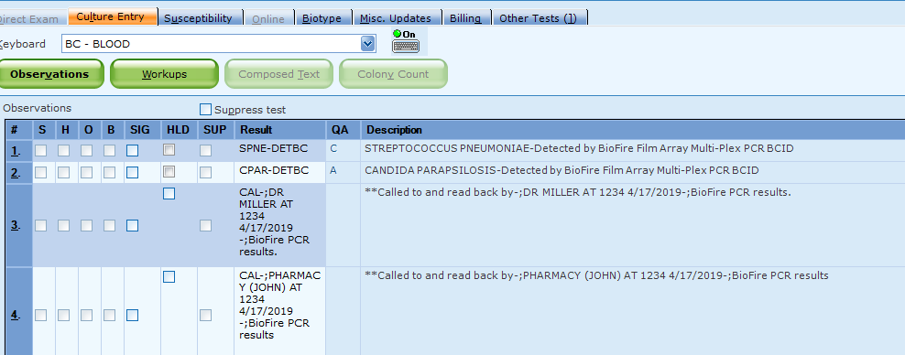  Example 2: If only the genus is detected, use code PROT-DETBC. Add code FID on line 2. Add code BPCR after call statement.  Observations: 1. PROTEUS SPECIES Detected by BioFire FilmArray PCR  2. Further identification to follow  3. Called to and read back by Dr Arms at 1615 3/6/2019. BioFire PCR  Results.  4. Called to Pharmacy at 1600 3/6/2019 BioFire PCR results.  Figure 11. Only species detected  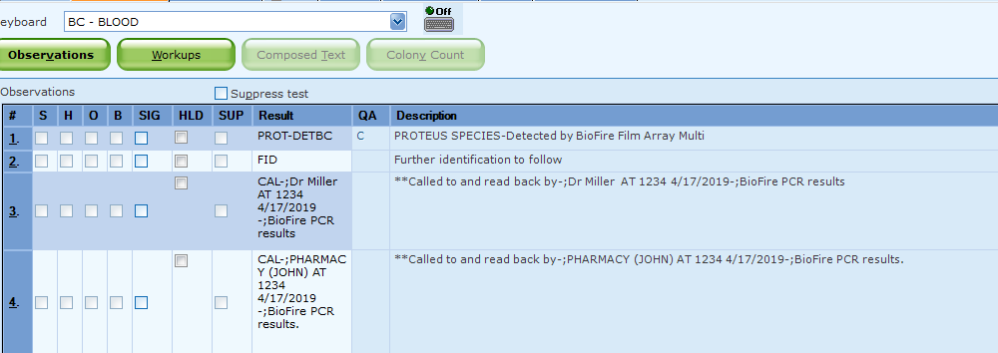  5. The next day, after organism is speciated, enter results on line 2 and add  Isolated code.  Figure 12. Only species detected next day results  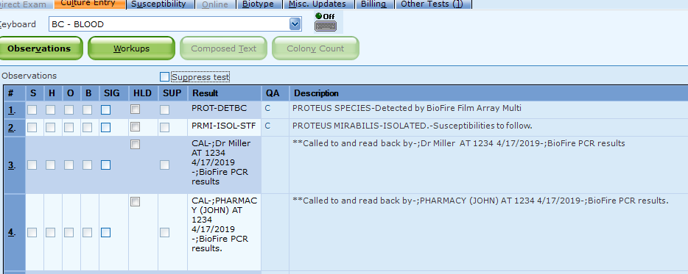  Example 3: If resistance genes are positive: Use code KLPN-DETBC on line 1. Use KPCD-DETBC on line 2. Add code BPCR after call statement.  Observations: 1. KLEBSIELLA PNEUMONIAE-Detected by BioFire Film Array PCR  2. KPC Detected- Detected by BioFire Film Array PCR  3. Called to and read back by L6 (Dr Monica Ray) at 1320 3/15/19  BioFire PCR results  4. Called to and read back by L6 (Dr Monica Ray) at 1206 3/15/19  BioFire PCR results  Figure 6. MRE Observations results with KPC  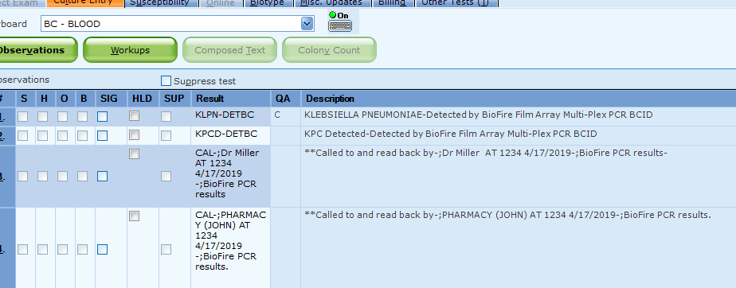  Example 4: If mecA is detected and the result is Staphylococcus aureus, enter code MRSA on line 1. Add code MECA–DETBC on line 2. Add code BPCR after call statement.  Observations: 1. Methicillin Resistant Staph aureus ***MDRO*** -Detected by BioFire  FilmArray PCR.  2. mecA detected-Detected by BioFire FilmArray PCR  4. Called to and read back by L6 (Dr Monica Ray) at 1320 3/15/19  BioFire PCR results  5. Called to and read back by L6 (Dr Monica Ray) at 1206 3/15/19  BioFire PCR results  Figure 7. MRE Observations with mecA results  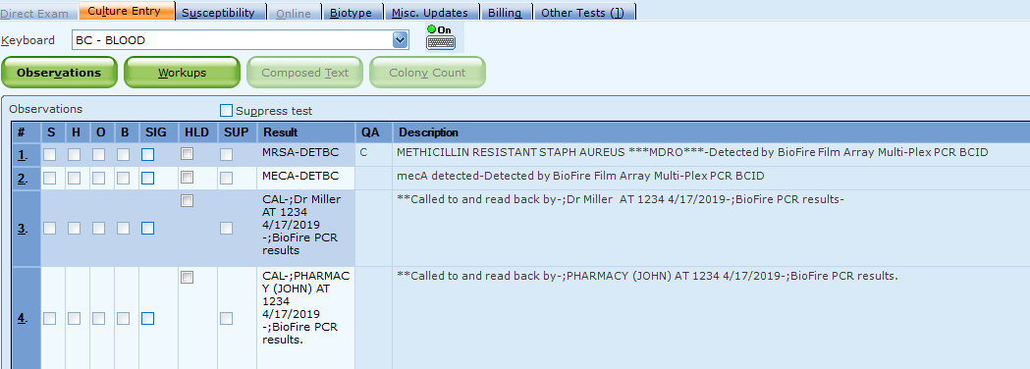  5. If no organisms are detected by BioFire FilmArray, enter code NODP-FID on observation line 2. Call provider with both Gram Stain and BioFire result.  Example 3: 1. Gram Negative Rods being isolated and identified.  2. No Organism detected by BioFire FilmArray Multi-Plex PCR  3. Called to and read back by Dr Arms at 1615 3/6/2019.  4. Called to Pharmacy at 1615 3/6/2019.  Figure 8. MRE Observation with No Organisms Detected  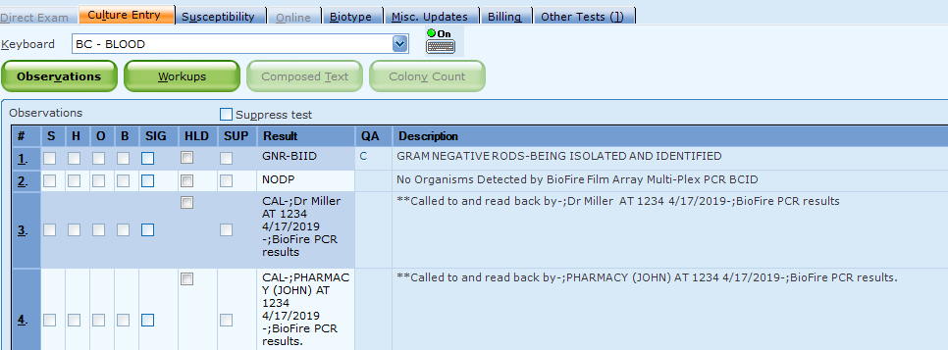  - Call all results to provider (MD, DO, CNP, PA)  - Call all results to pharmacy at 6-8532. This is the St Paul PICU pharmacist that will relay the results to the pharmacist on either campus.  - Do not final. Click on Save twice when all results and calls are documented. After Save is clicked, you will see the Delete Online Data box. Click on Cancel. Do not delete the online data.  Figure 9. Delete Online Data  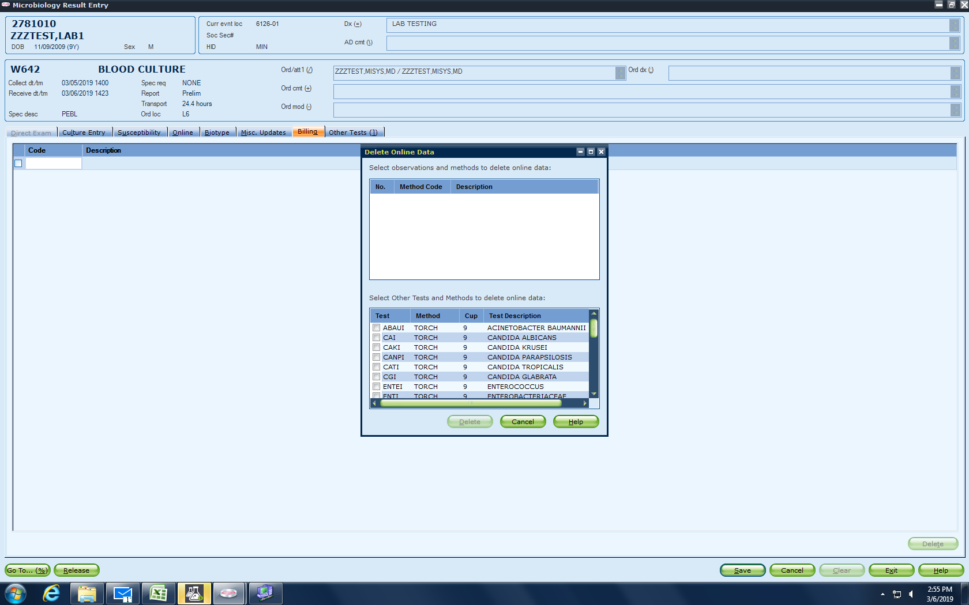  - Document your initials, tech code and which bottle the panel was performed on the FilmArray Report.  - Staple BioFire FilmArray report to Bactec printout.  - Day shift: use workup code BCID and enter organism codes.  - Day shift: add code BCIDC to Billing tab whenever a FilmArray is performed. This will be added instead of an ID1 code.  Figure 10. Workup  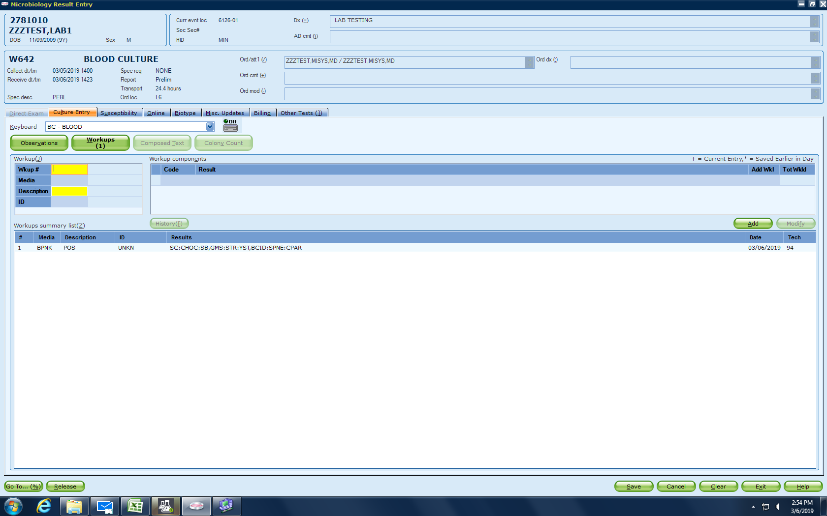
References | BioFire FilmArray Application and Training Guide BioFire Diagnostics, LLC 390 Wakara Way Salt Lake City UT 84108 May 2016
Alternate Methods | - Perform identification on Vitek MS or Vitek2 from subcultures.
Customer and Technical Support | Web information at www.biofiredx.com. Email at support@biofiredx.com. Call at 1-800-735-6544 or fax to 801-588-0507.
Training Plan/ Competency Assessment | Training Plan Initial Competency Assessment  - Employee must read the procedure. - Employee will demonstrate the ability to perform procedure, record results, and document corrective action after instruction by the trainer. - Direct observation
Proficiency Testing | CAP: GNBC and GPBC, 2 shipments - 3 samples each.
Historical Record
 | Version | Written/Revised by: |  | Effective Date: |  | Summary of Revisions
 | 1 | Susan DeMeyere/ Julie Laramie |  | 6/6/2019 |  | Initial Version
 | Archived by: |  |  | Archived Date:

