MRD Childrens Oncology Group ( COG ) Application

Purpose | This procedure was developed in order to perform MRD testing for B-ALL patients that are enrolled in COG ALL trials.
Policy Statements | • Applies to Becton Dickinson FACSCanto II Flow Cytometer and technologist analyzing flow cytometry  specimens.
Principle and Clinical Significance | Minimal Residual Disease (MRD) is the name given to small numbers of leukemic blasts persistent after chemotherapy. Immunophenotyping by flow cytometry offers a detection tool that can be applied in clinical practice. MRD helps in identifying high risk patients.  Detection and monitoring of MRD is becoming the standard of care, considering its importance in predicting the treatment outcome.  MRD levels >0.01% at follow-up time points during and after first induction and at the end of treatment has significantly lower disease free survival by comparison to patients with values <0.01%.  Day 29 MRD >0.01% is the most strongly correlated parameter that we currently have with outcome.  Day 8 MRD in peripheral blood is also associated with outcome (the rate of leukemic cells disappearing from blood).  Day 8 MRD and day 29 MRD are not duplicative. There is some additional information that can be gained when looking at day 8 in the blood over that of just looking at day 29 in the bone marrow.

Test Code | [INSERT TEST CODE(s) HERE, AS NEEDED
Materials | Reagents Supplies Equipment  • Prepare NH4Cl Lyse – Stock; Weigh out the following and add to a 1000ml volumetric flask; NH4Cl ( chc# 29138) – 80g KHCO3 (chc# 29141)– 10g NaEDTA ( chc# 29139) – 3.7g Add RO water to a final volume of 1000ml. Check pH on i-STAT (7.2-7.4) Adjust pH by using 1N HCl or 1N NaOH (usually 6-8ml NaOH). Check pH on i-STAT Point of care analyzer. Validate by staining 100ul of normal whole blood with CD45 APC-Cy7 using the Surface staining, all types procedure, check for acceptable staining. Store at 2-8°C. Stability – 2 years. • Prepare NH4Cl Lyse working solution; Add 90ml RO water to glass bottle. Add 10ml NH4Cl stock solution. Invert to mix. Remove 2.5ml and discard. Add 2.5ml 10% Ultrapure Formaldehyde (chc# 22479). Invert to mix. Prepare fresh daily. Store at room temp. • Monoclonal Antibodies (MoAbs): Follow manufacturer's insert instructions in handling antibodies. In general, protect from light and store at 2 to 10° C. Maintain sterile technique to [prevent bacterial or cross contamination of reagents. • Working dilution for Syto16: Prepare 1:50 dilution; 10ul stock Syto16 and 490ul DMSO. This preparation can be aliquoted and frozen for later use.(No more than 4 freeze/thaw cycles). Prepare working dilution; 10ul of 1:50 dilution to 190ul PBS/FCS. ● Dulbecco’s Phosphate Buffered saline (DPBS) ● 5% Fetal Calf Serum Working 5% FCS 9.5ml DPBS + 0.5ml FCS. • Various pipettes, tips and glassware • Plastic 12 X 75 mm snap cap tubes • Centrifuge • Vortex mixer • BD FACS CANTO II Flow Cytometer • Lyse Wash Assistant, BD Biosciences
Sample  Procedure | 1. Peripheral blood, 2mL, freshly drawn and collected in EDTA, heparinized bone marrow.  2. Samples that have an anticipated delay in processing should be refrigerated until testing can be completed. Specimens exposed to extreme temperatures may yield inadequate results.  3. Clotted, grossly hemolyzed specimens or under-filled tubes are not acceptable for  analysis.  4. Any specimens not properly labeled should be rejected.  5. Specimen should be processed within 72 hours of draw per CDC recommendations and our  validation studies. (5/13/03).  Step Action Related Document  1 Verify six color compensation values. Hyperlink  2 Add the specimen or working dilution to each tube. Assess the WBC count. If </= to 10,000 use straight, no working dilution is necessary. Use 100ul of specimen, for counts < 5,000, 200ul may be used. For samples >10,000, prepare a working dilution. (To make a 1ml dilution using 5% FCS, with a count of 10x10^9/L) ● Divide 10,000 by the WBC count of the specimen ● The resulting number is the volume in microliters of the specimen required. EXAMPLE; If the WBC count is 35000 ( 35x10^9/L ) 10000/35 = 286ul (calculated specimen volume) 1000 – 286 = 714ul (calculated diluent volume) EXAMPLE; If the WBC count is 5000 ( 5x10^9/L ) 2000/5 = 400ul ( calculated specimen volume ) 1000 – 400 = 600ul ( calculated diluents volume )  3 Add the antibodies (100ul of working dilution).  4 Antibody Combinations ( Bone Marrow Day 29 )  FL1 FL2 FL3 FL4 FL5 FL6  FITC PE Per Cp-Cy 5.5 PC7 APC APC-Cy7 or APC-H7  Tube 1 CD20 CD10 CD38 CD19 CD58 CD45  Tube 2 CD9 CD13/ CD33 CD34 CD19 CD10 CD45  Tube 3 * CD3 CD19 CD71 CD45  Antibody Combinations ( EDTA Whole Blood day 8 )  FL1 FL2 FL3 FL4 FL5 FL6  FITC PE Per Cp- Cy 5.5 PC7 APC APC-Cy7  Tube 1 * CD20 CD34 CD19 CD10 CD45  5 Vortex to mix (5 seconds).  6 Incubate in the dark 15 minutes.  7 Add 2 ml of working lyse solution to each tube. Vortex each tube for 5 seconds. If a 200ul sample is used add 4ml of working lyse solution.  8 Set timer for 10 minutes, during this time vortex once more.  9 Centrifuge 5 minutes.  10 Remove supernate to line on tube.  11 Place in LWA, select (DPBS) with 0.3% FCS. Use MRD Wash setting. Samples with extremely low WBC counts should be washed manually using the Serofuge.  12 In tubes 1 and 2 re-suspend in 0.5ml DPBS.  13 *In tube 3 add 1ul of working dilution of Syto 16. Incubate in the dark 10 minutes. Add 0.5 ml DPBS.
Special Safety Precautions | MSDS Search | MSDSonline Childrens Star Net
Quality Control | [DESCRIBE QUALITY CONTROL REQUIREMENTS HERE, AS APPROPRIATE]
Analyzer  Setup | Assay Set up:  1.) Click on user name.  2.) Experiment, left click, select new experiments.  3.) Select 6 color experiment template.  4.) Select COG MRD experiment, O.K.  Rename COG experiment with patient ID, sample.  Delete test that is currently not being performed.  5.) Select computer setting, right click.  6.) Select link setup.  7.) Compensation setup page is displayed, left click on date created.  8.) Select 6 color compensation on bottom (current date).  9.) Select link.  10.) Verify link on cytometer settings.  11.) Display tubes in Day 29 file.  12.) Select arrow in front of tube.  13.) Change FSC threshold to 25,000.  14.) Fill three tubes with 2ml DI water in each tube to be used as flush.  15.) Select tube 1, place on analyzer, select acquire.  16.) Collect 750,000 events. Adjust singlet gate to remove doublets, check that B cell gate is  Around lymphocytes, look for abnormal scatter and gate accordingly, using “snap to” gate.  17.) Remove tube 1, flush with DI water, proceed to next tube.  18.) When gating tube 3 adjust to exclude granulocytes. Measure 150,000-200,000 events.  Examples of gating strategies for MRD and identifying Hematogone maturation patterns;  COG MRD Gating Primer  The Maturation Pattern of Hematogones
Calculations/  Interpretation | MRD Day 29 Protocol;  Tube1 and 2:  Time -> Singlets (FS-A vs FS-H) -> Viable Cells (FS vs SC) -> B Cells (CD19 vs SS) -> B Cells (CD19 vs CD45) -> Many dot plots of possible fluorochrome combinations.  Viable cells gate: includes all events that show up in the sample. Because the denominator includes NRBC’s, FCS should be low enough to include NRBC’s in the assay.  Tube 3 used to generate the denominator:  Time -> Singlets (FS-A vs FS-H) -> Syto 16+ -> B Cells (CD19 vs SS) -> B Cells (CD19 vs CD45) ->  Mononuclear gate.  ● CD71 is used to assess hemodilution and CD3 for lymphocyte quality.  ● The B Cell gates are linked together to make sure the gating is the same in all three tubes.  ● Denominator: Nucleated (Syto 16+) and Mononuclear (all events except high SS myeloid).  ● MRD%= [Leukemia/ B Cells (tube 1 or 2)] x [B Cells (tube3) / Syto16+ mononuclear cells] x 100.  Example:  Tube 1 MRD 250 Total B cells 14,000  Tube 2 MRD 300 Total B cells 16,700  Tube 3 Total B cells 10,000 Mononuclear cells 100,000  Tube 1 (250/14,000) x (10,000/100,000) x 100  MRD = 0.179% of mononuclear cells  Tube 2 (300/16,700) x (10,000/100,000) x 100  MRD = 0.180% of mononuclear cells  The final result is the average MRD% of Tube 1 and Tube 2.  MRD Day 8 Protocol;  Time -> Singlets (FS-A vs FS-H) -> Syto 16+ -> B Cells (CD19 vs SS) -> B Cells (CD19 vs CD45) ->  Many dot plots of possible fluorochrome combinations.  ● Denominator: Nucleated Syto16+ Cells (Including Granulocytes).  ● MRD%= [Leukemia / Syto16+] x 100.  Example:  Day 8 Tube MRD 10,188 Syto16+ 891,219  Day 8 Tube (10,188/891,219) x 100  MRD = 1.14% of Syto 16+ cells
Result Reporting  In Sunquest | Results are entered in Sunquest in order to perform the calculations.  Manual entry mode (MEM):  Function: MEM <CR>  Worksheet: Flow <CR>  For MRD8: ABN8 - MRD Population  SY16 - Syto 16+ Cells  MRDP - MRD percentage is calculated  MRE8 - Comments  For MRD29: 3TBC - Tube 3 Total B Cells  3TMC - Tube 3 Total Mononuclear Cells  ABNT1 - Tube 1 MRD Population  BCE1 - Tube 1 Total B Cells  MRD1 - Tube 1 MRD percentage is calculated  ABNT2 - Tube 2 MRD Population  BCE2 - Tube 2 Total B Cells  MRD2 - Tube 2 MRD percentage is calculated  MRE29 - Comments  See Examples Below;  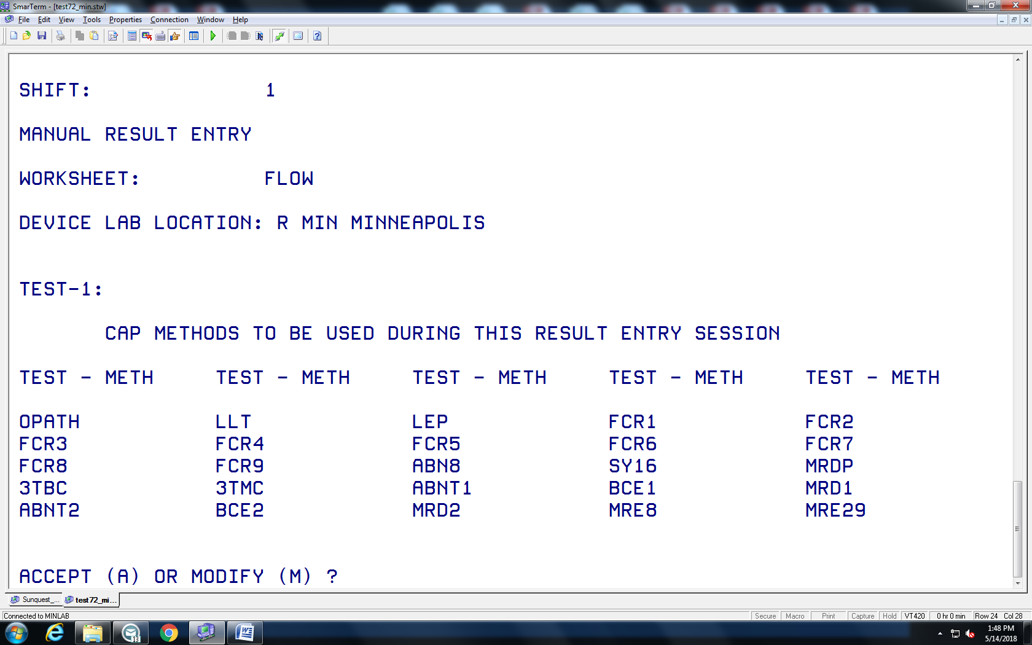  MRD8 MRD29  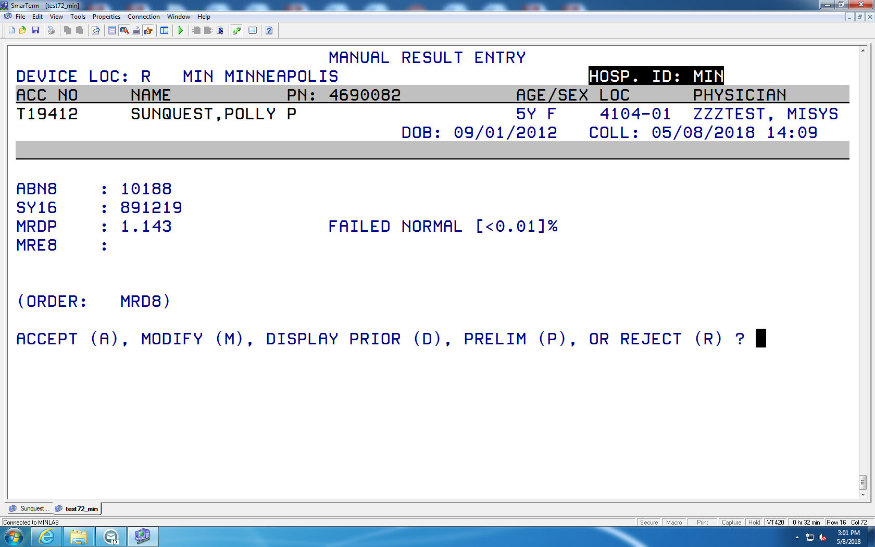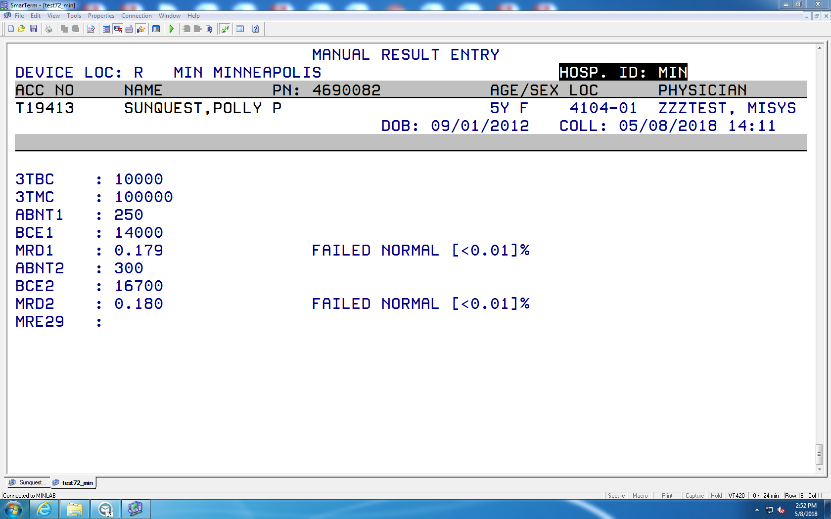  After results have been calculated in Sunquest an Interim report ( Function IRA ) is printed and included with the Scatterplots from the analyzer for the Pathologist.
References | BD Bioscience FACSCanto Training Manual. 23-9575-00 Rev. A. 2007, Becton, Dickinson and Company, San José, CA  BD FACSLyse Wash Assistant User’s Guide,Rev.23-11113-00 Rev. A ,Becton Dickenson, San José, San José, CA  Children’s Oncology Group Flow Cytometry Reference Laboratory Protocol.
Historical Record
 | Version | Written/Revised by: | Effective Date: | Summary of Revisions
 | 1 | Al Quigley | 08/08/18 | Initial Version (COG Application)
 | 2 | Al Quigley | 06/30/19 | Added Hyperlinks

