Issuing Blood Products in Sunquest

Purpose | This procedure provides instructions for the issue of tissue products through the Sunquest computer system.
Related  Documents | TSja 15.0.1 Sunquest Crib Sheet.
Procedure
 | Step | Action
 | 1 | Log into the Gateway.  Choose Location: R for Mpls, L for STP
 | 2 | Under the All tab or the Blood Bank tab, double-click on the Blood Product Issue folder .  Note: Step 1-2 are not required if branching from Blood Order Processing.
 | 3 | Click on the Lookup by: drop down arrow and select the accession number or unit number.  - Select accession number if issuing more than one unit.  - Use unit number if issuing only one unit.  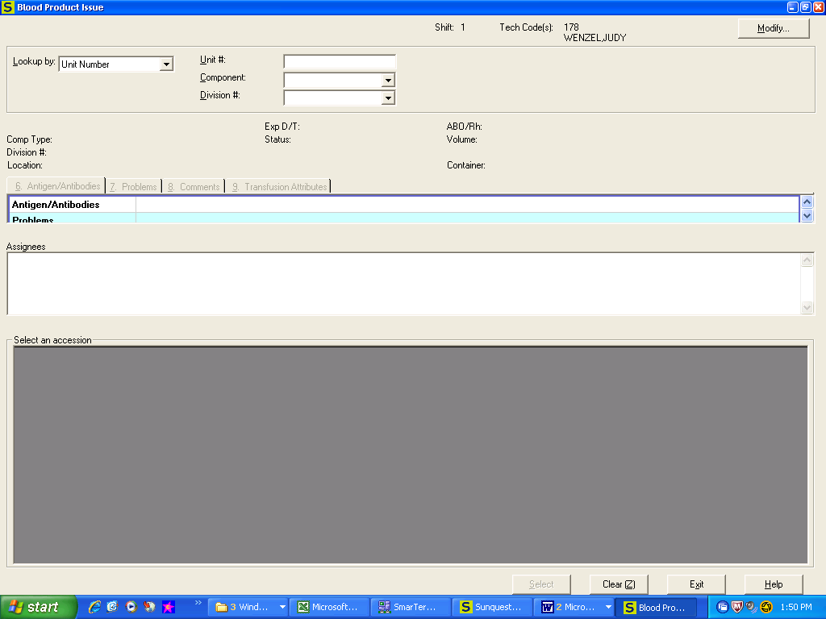
 | 4 | - If entering by Unit #:  - Scan or enter the product ID number in the Unit # box  - Enter of select the component code if required  - Enter division # if required  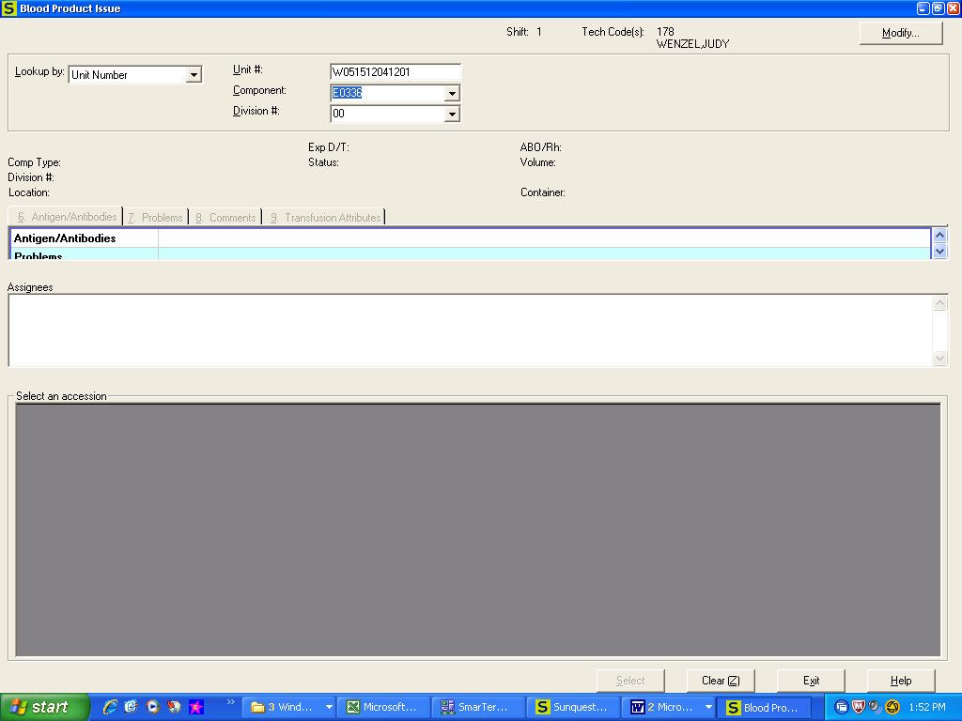  b. If entering by Accession #:  - Check in the Select column box for each product to issued, or  - Click on Select All if all products are to be issued  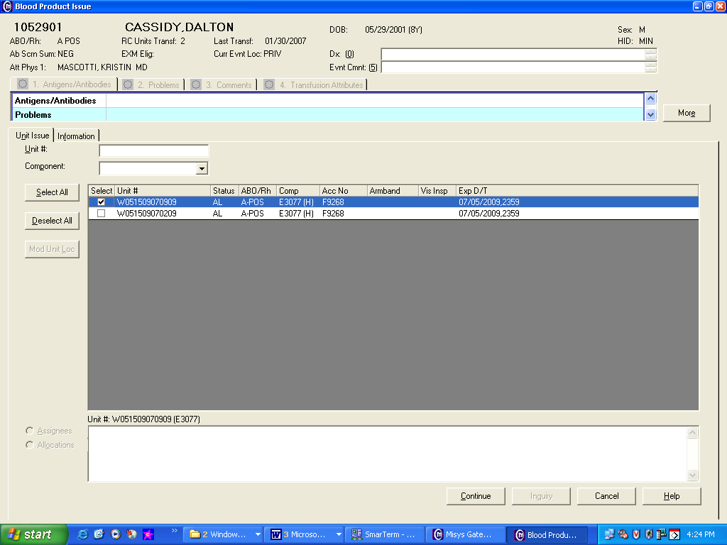  - Press Continue
 | 4 | - Compare the following on the computer screen and the unit tag:  - Patient identify information (Full name and MRN)  - Product information (Unit #, product type, expiration)  - Patient/product special requirement and instructions  - Compare the following on the unit tag, product order & release slip:  - Patient identify information (Full name and MRN)  - Product type  - Quantity/volume requested
 |  | If |  |  |  | Then
 |  | No discrepancies |  |  |  | Proceed to step 5
 |  | Any discrepancy noted |  |  |  | Resolve prior to issue.
 | 5 | Document label check and visual inspection of product.  A. If issuing by Accession Number, by doing one of the following:  - Pressing the Pass All  - Clicking Inspect Unit tab then the appropriate radio buttons indicating Yes or *No.  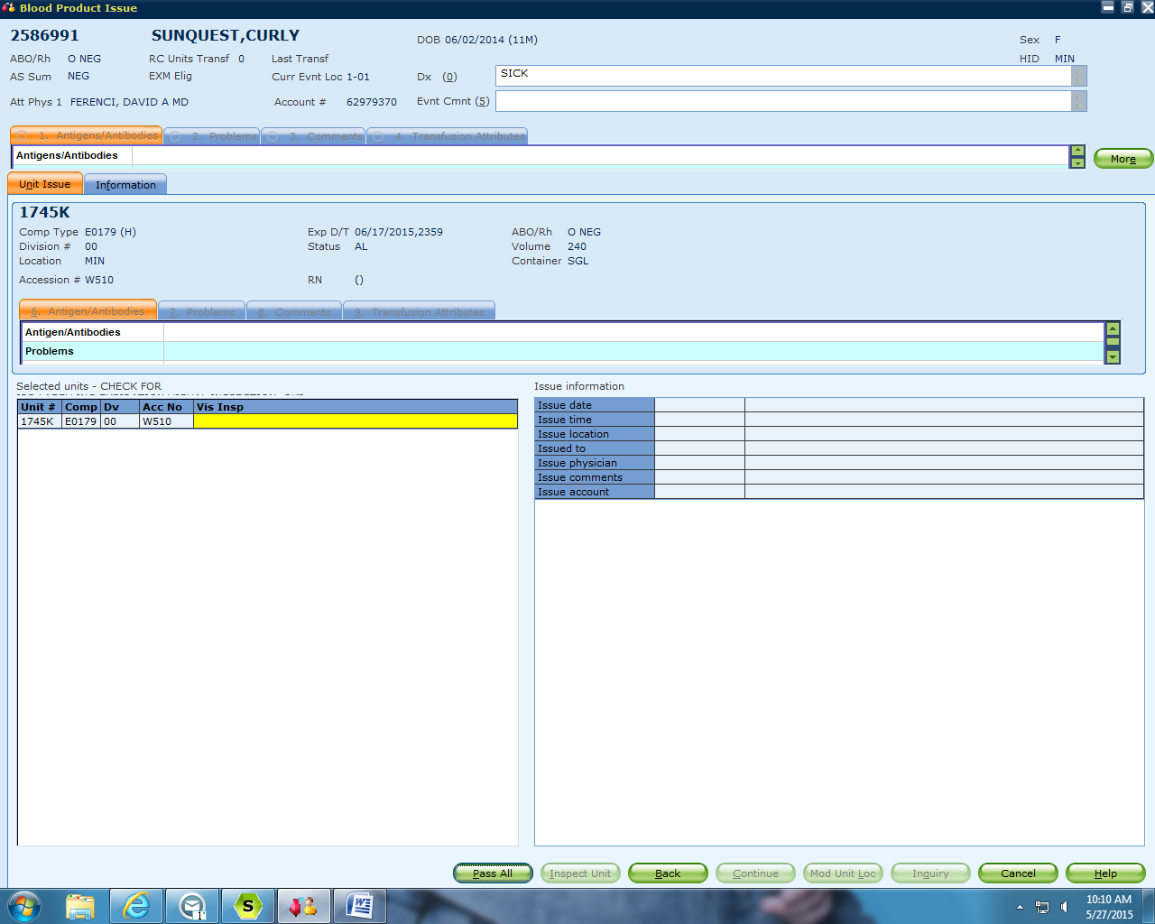  B. If issuing by Unit Number, document label check and visual inspection of product by clicking appropriate Yes or *No radio button.  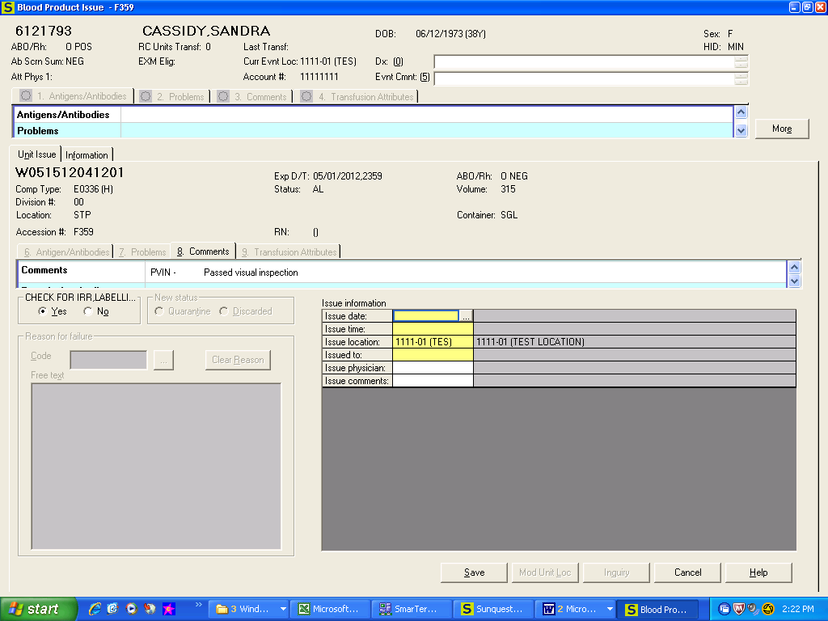
 |  | If |  |  | Then
 |  | *Unit fails label and or visual check |  |  | 1. Click on the *No radio button  2. Select the appropriate product status prompt.  - Quarantine product if cause of failure can be  Corrected. Refer to TS 9.2.  - Discard product is product is definitely  unacceptable for use. Document discard on daily  QC form. Refer to TS 9.3.
 | 6 | ALL QA failures have to be reviewed and responded by a second tech  - Override to continue to issue.  - Cancel to terminate the issue.  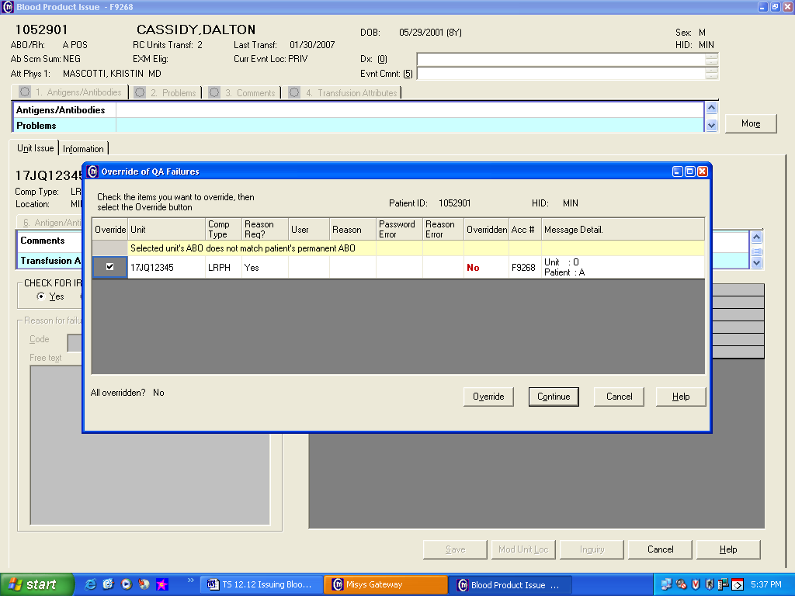  To Override:  - Click in the Override box to the left of the unit display  - Enter tech ID User name and password  - Enter Reason Code (refer to TSja 15.0.1or use the search option)  - Enter Free Text additional information as needed.  - Click on the Add tab, then OK  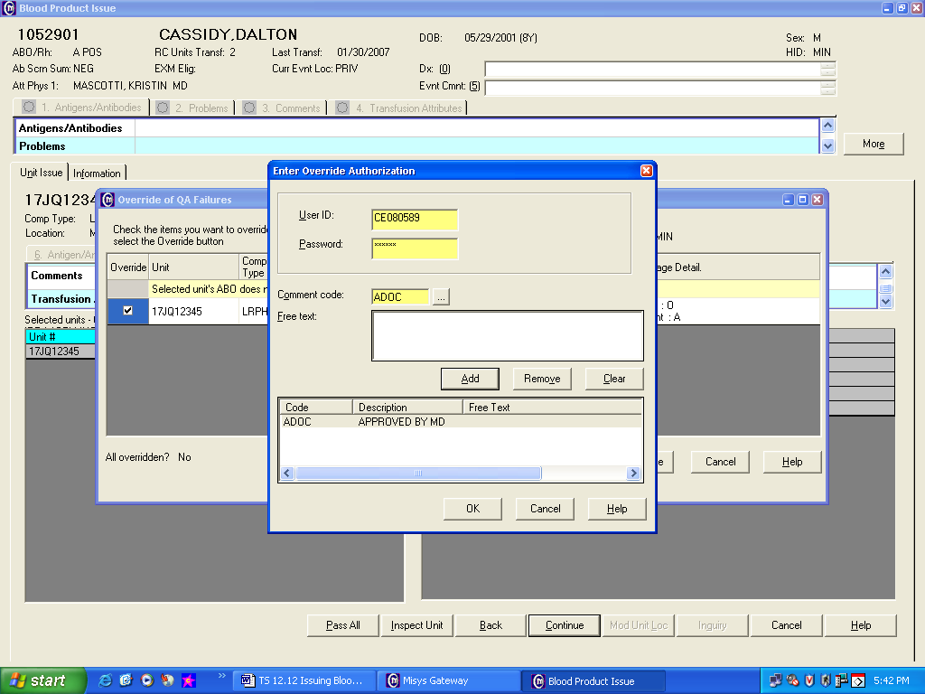  - Click on the Continue tab.
 | 7 | a. Tab through Issue date and Issue time fields or enter the specific time if in the past.  - Issue Location: Enter in location code (refer to TSja 15.0.1 )  - Issued to: Enter in employee CE number from the release slip.  - Issue physician: Enter ordering provider or surgeon name. Perform a search and select.  - Issue Comments: Enter the English text code corresponding to the transfusion indication and any other comment codes corresponding to the issue. (refer to TSja 15.0.1 and TSja 12.12.01 Transfusion Codes)  - Issue Account: Click on search box and choose the current account number.  - Confirm the entry and click on the Save or Cancel tab.  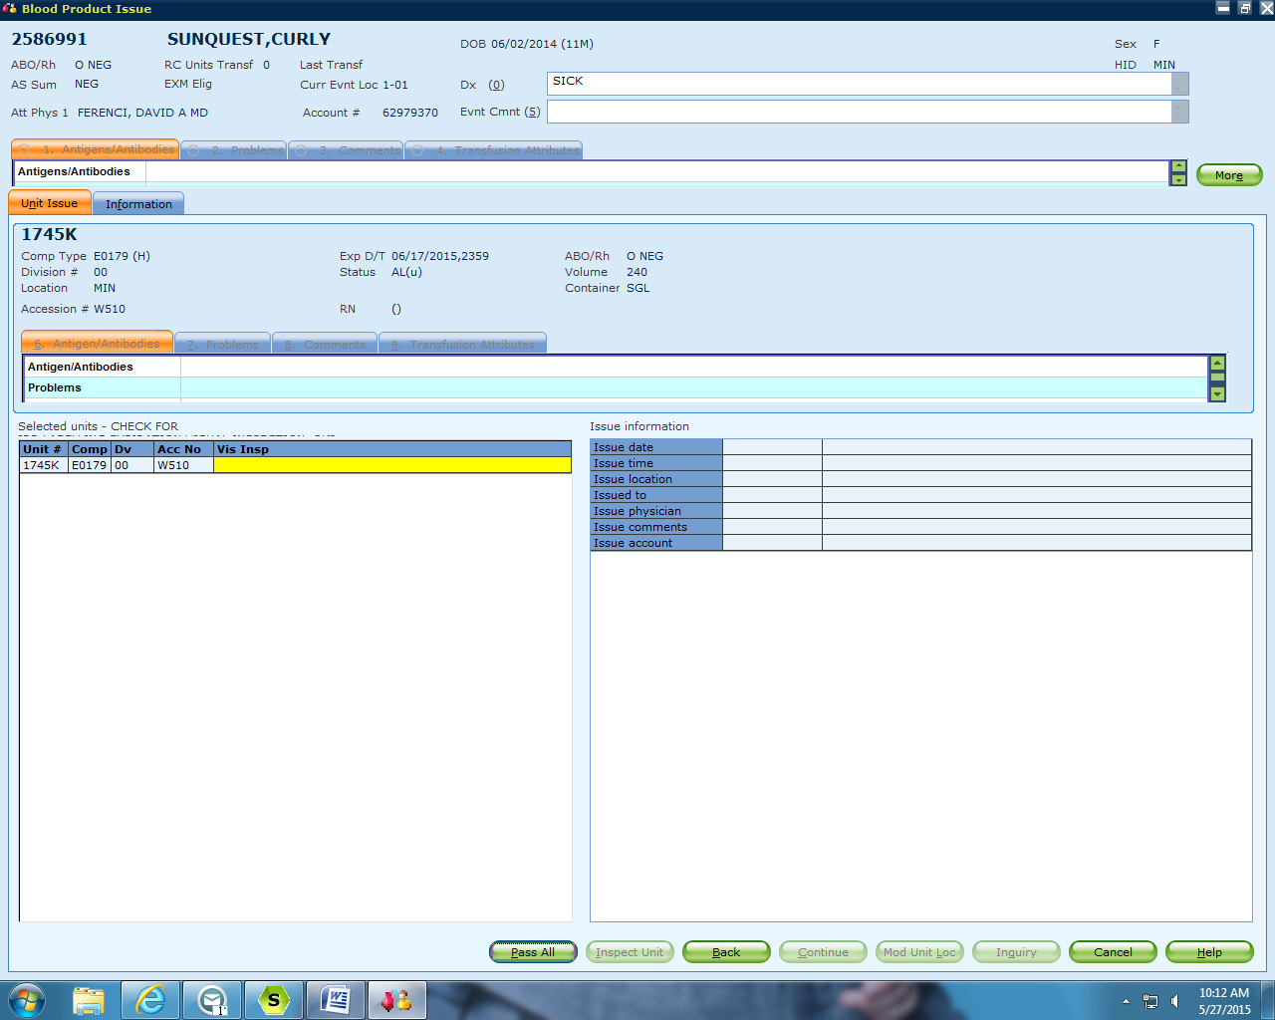
 | 8 | - Enter additional billing as required. (Refer to TSja 15.0.1 for common codes)  - Review, click OK and SAVE  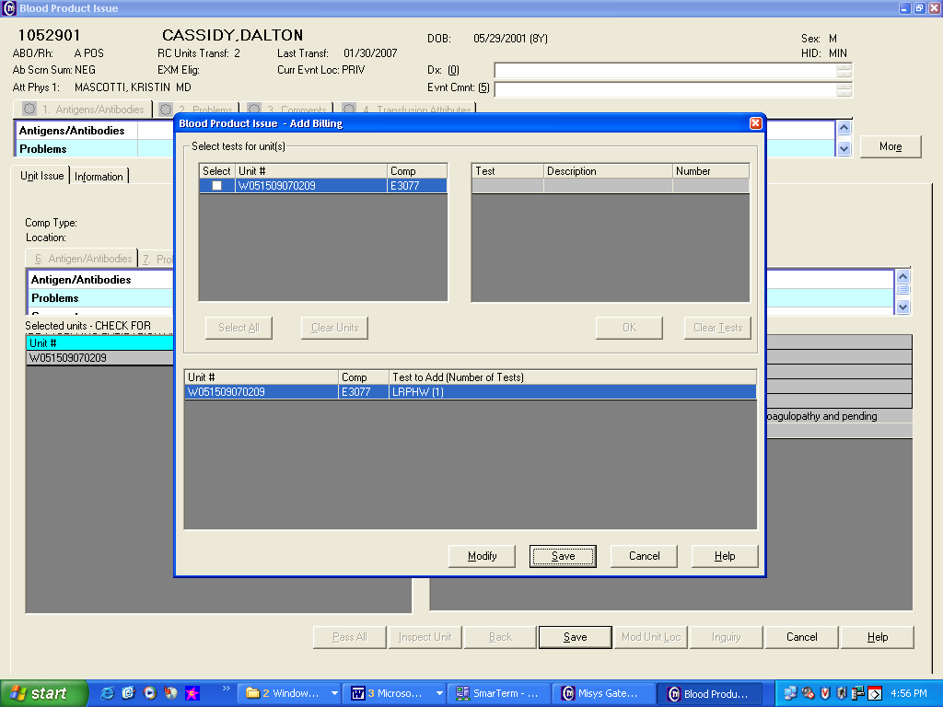
References | Sunquest Users Manual, current edition
Approval  Workflow | Transfusion Service/Technical Specialist
Historical Record | Version |  | Written/Revised by: | Effective Date: |  |  | Summary of Revisions
 | 1 |  | K Hartley | 5/1982 |  |  | Initial Version
 | 2 |  | C Berglund | 5/1987
 | 3 |  | J Wenzel | 12/1991
 | 4 |  | J Wenzel | 8/1993
 | 5 |  | J Wenzel | 9/1994
 | 6 |  | J Wenzel | 9/1997 |  |  | Post-merger
 | 7 |  | J Wenzel | 9/1999
 | 8 |  | J Wenzel | 5/22/2001
 | 9 |  | J Wenzel | 7/9/2009 |  |  | New format
 | 10 |  | J Wenzel | 4/16/2012 |  |  | Added Related Document.Removed Appendices. Reference to selection of division numbers. Previous TS 12.12. Added instruction if product does not pass final inspection.
 | 11 |  | S Cassidy | 5/27/2015 |  |  | Added change account number during issue to current account number.
 | 12 |  | S. Cassidy | 07/03/19 |  |  | Added statement that a second tech needs to review and respond to QA failures.

