Entering Results for Repeat Antibody Screen

Purpose | This procedure provides instruction for entering a second/repeat antibody screening results performed on one specimen collection into Sunquest grids.
Test Codes | RPAS-Repeat Antibody screen
Related  Documents | TS 5.2 Blood Order Processing  TS 4.8 Grading and Interpretation of Tube Reactions  TS 4.9 Grading and Interpretation of Gel Card Reactions  TS 5.3 Making Changes to a Blood Administration Record
Procedure
 | Step | Action
 | 1 | Enter Blood Order Processing by the patient sample accession number.
 | 2 | Click on the Patient Specimen tab.
 | 3 | Enter test PREWA in the Add Spec. Test box as ;RPAS or press key r.  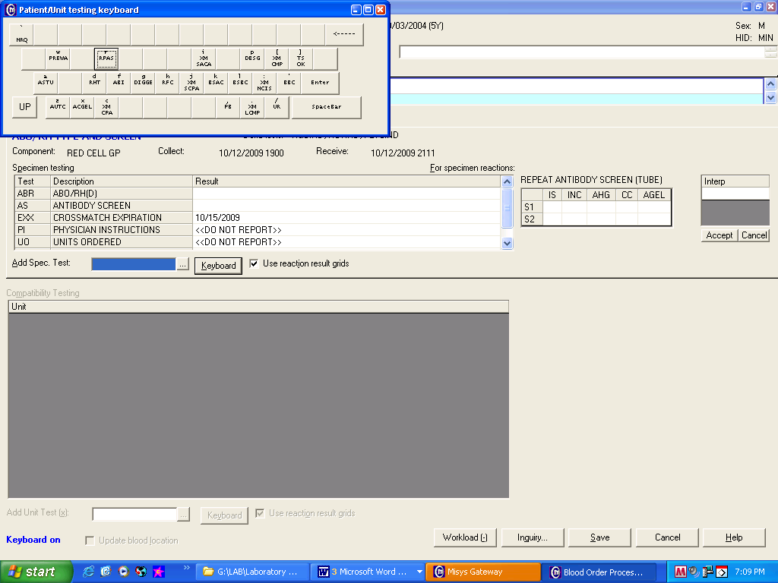
 | 4 | Press the Home key or Click in the first cell of the repeat antibody screen grid.  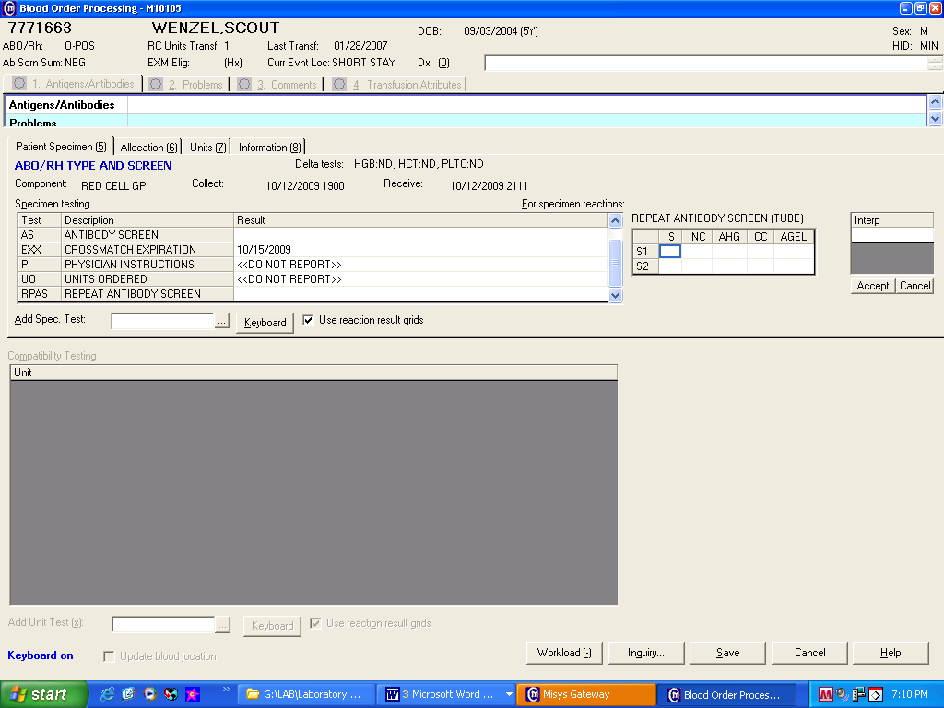
 | 5 | Enter the graded reaction results in the appropriate grid cell.  Enter NT (key N) if phase is Not Tested.  Enter ICLR (key I) if phase is Inconclusive  GRID CELL  S1= Screening Cell 1  S2= Screening Cell 2  IS= Immediate Spin (tube)  INC= 37°C Incubation with LISS (tube)  AHG= Coombs reaction (tube)  CC= Coombs Control Cells (tube)  AGEL= Gel testing
 | 6 | Record the Antibody Screen interpretation as Pos (Key P), Negative (key N) or Inconclusive (key S or ;ICLR) in the grid entry interpretation field.  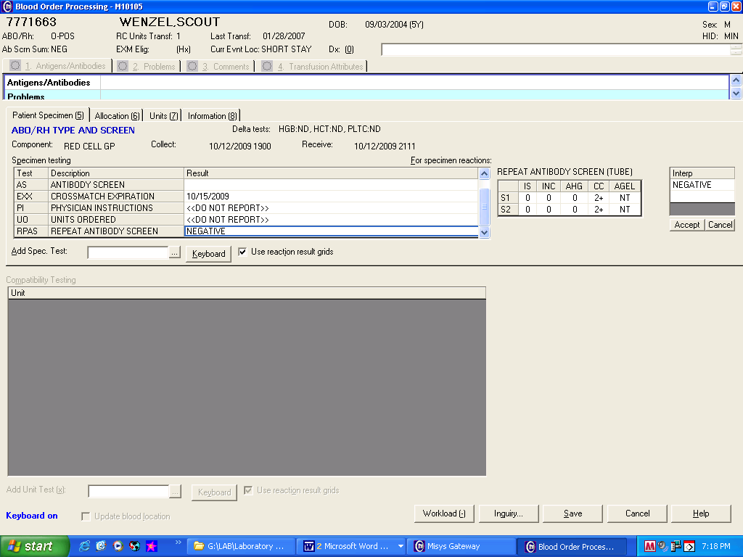
 | 7 | Review reaction results and interpretation entry if QA failures occurs.  If Then  An enter error was made Re-enter results reactions and/or interpretation.  Entry confirmed - Acknowledge QA warnings. All QA failures have to be reviewed and responded by a second tech. - Respond to QA failures with a reason code or free text entry
 | 8 | If special testing such a prewarming or use of 22% Albumin is performed document using the Add Spec Test BBC comment (key ‘)  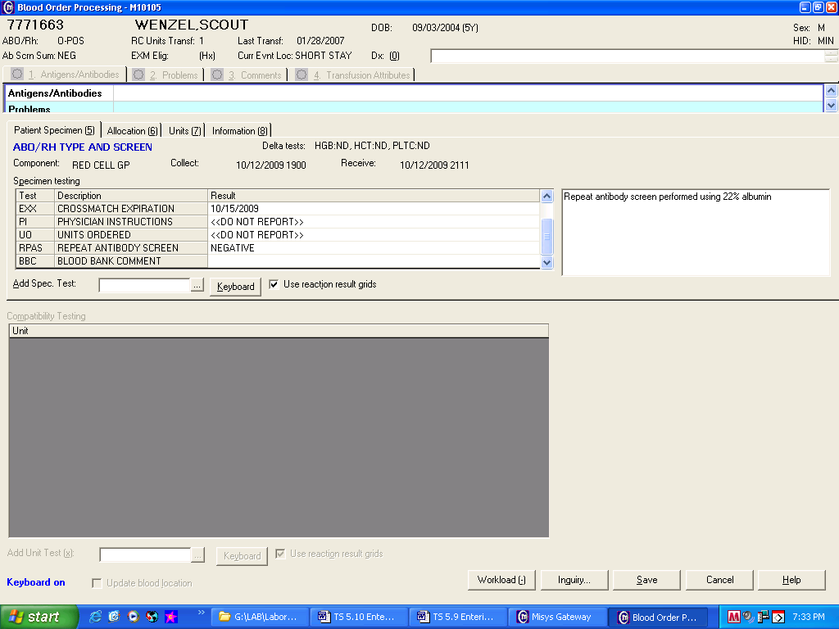
 | 9 | Save results.
 | 10 | Enter the Blood Bank Administrative Data Entry folder to enter additional information regarding testing into the patient’s permanent record.
Approval  Workflow | Transfusion Service/Laboratory Director
Historical Record | Version |  | Written/Revised by: | Effective Date: | Summary of Revisions
 | 1 |  | J. Wenzel | 9/86 | Initial Version
 | 2 |  | J. Wenzel | 7/90
 | 3 |  | J. Wenzel | 5/94 | LISS in STP
 | 4 |  | D. Hansen | 12/95 | Merger
 | 5 |  | J. Wenzel | 9/96
 | 6 |  | D. Hansen | 1/6/97
 | 7 |  | J. Wenzel | 12/99
 | 8 |  | D. Hansen | 1/4/00
 | 9 |  | J. Wenzel | 5/22/01
 | 10 |  | J. Wenzel | 10/19/2009 | Online version
 | 11 |  | J. Wenzel | 4/10/2012 | Added Inconclusive as an Interpretation result option.
 | 12 |  | S. Cassidy | 07/03/2019 | Added statement that all QA failures need to be reviewed and responded by a second tech

