Entering Results for Antibody Screening

Purpose | This procedure provides instruction for entering a specimen’s initial antibody screening results in Sunquest grids.
Test Codes | %AS  CASC-Credit Antibody Screen
Related  Documents | TS 5.2 Blood Order Processing  TS 4.8 Grading and Interpretation of Tube Reactions  TS 5.3 Making Changes to a Blood Administration Record
Procedure
 | Step | Action
 | 1 | Enter Blood Order Processing by the patient sample accession number.
 | 2 | Click on the Patient Specimen tab.
 | 3 | Click in the ANTIBODY SCREEN Result field. Test may be added in the Add Spec. Test box as ;AS or press key Q.  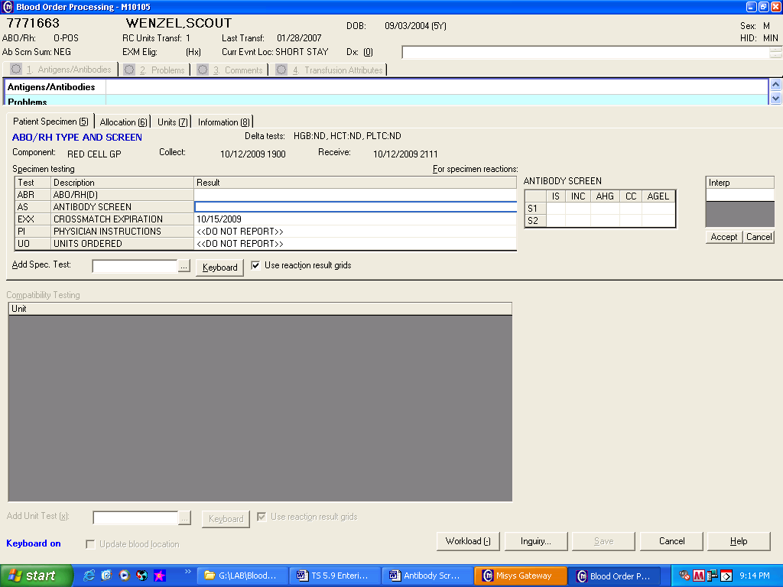
 | 4 | Press the Home key or Click in the first cell of the grid entry field.
 | 5 | Record the graded reactions of the gel and/or tube testing in the appropriate grid cell.  Enter NT (key N) if phase is Not Tested.  Enter ICLR (key I) if phase reaction is Inconclusive  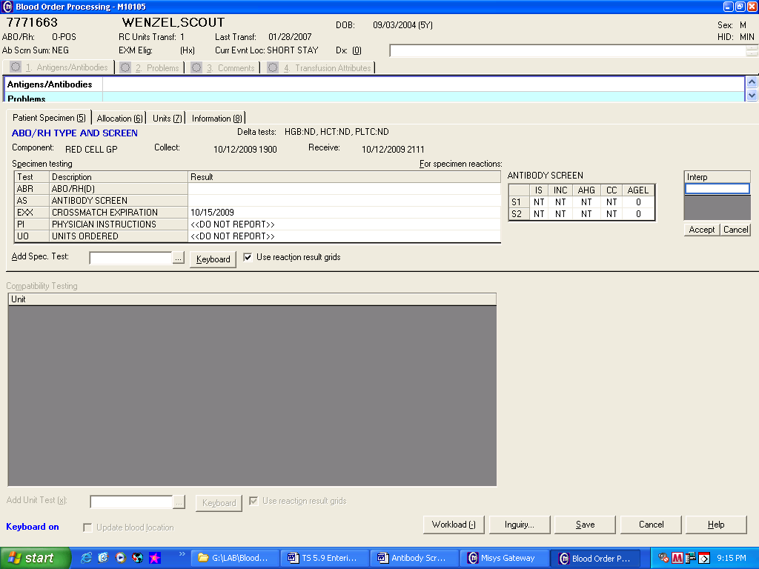  GRID CELL  S1= Screening Cell 1  S2= Screening Cell 2  IS= Immediate Spin (tube)  INC= 37°C Incubation with LISS (tube)  AHG= Coombs reaction (tube)  CC= Coombs Control Cells (tube)  AGEL= Gel testing
 | 6 | Record the antibody screen interpretation based on the test reaction pattern.  Cell IS INC AHG CC GEL Interpretation  Reaction in SI and/or S2 NT NT NT NT O Negative  NT NT NT NT + Positive  0 0 0 + NT Negative  0 0 0 + ICLR Negative  NT 0 0 + ICLR Negative  NT 0 0 + NT Negative  NT NT NT NT ICLR Inconclusive  0 0 + NT NT Positive  0 + 0 or+ NT NT Positive  + 0 or+ 0 or+ NT NT Positive  NT NT NT NT NT Not Required  0 Inconclusive  0=no agglutination or hemolysis += graded agglutination or hemolysis NT=Not Tested  Interpretation entry:  Negative= key N  Positive=key P  Not Required= ;NRQ  Inconclusive= ;ICLR  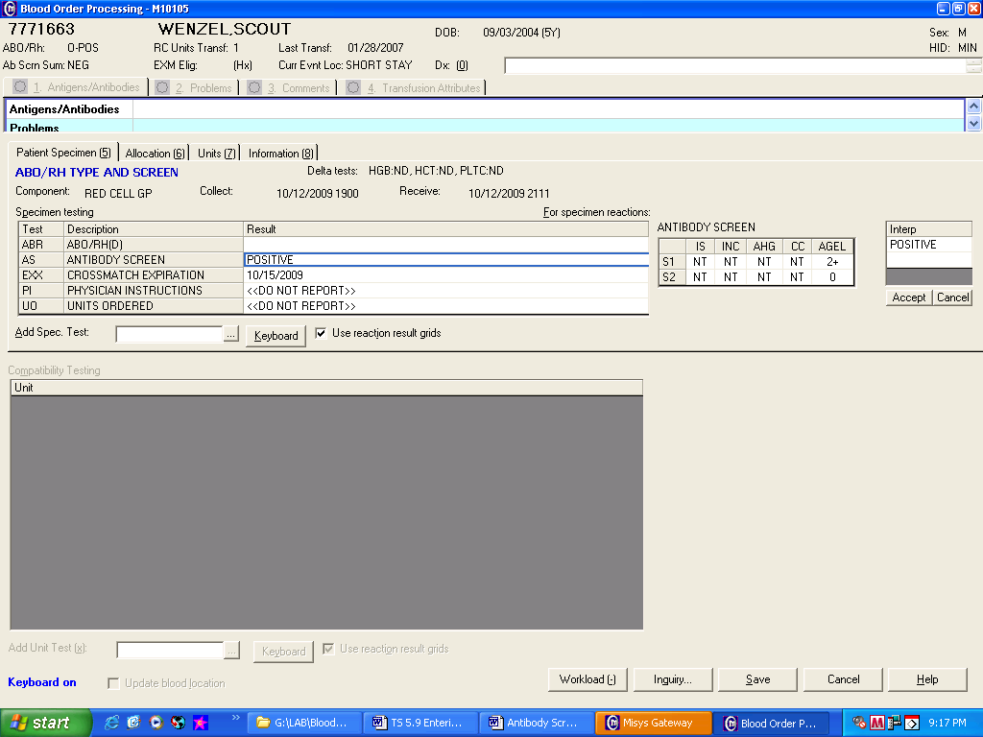
 | 7 | Review tube reaction results and interpretation entry if QA failures occurs.  If Then  An enter error was made re-enter results reactions and/or interpretation.  Entry confirmed - Acknowledge QA warnings. All QA failures have to be reviewed and responded by a second tech. - Respond to QA failures with a reason code or free text entry
 | 8 | If special testing is performed document using the Add Spec Test BBC comment (key ‘)  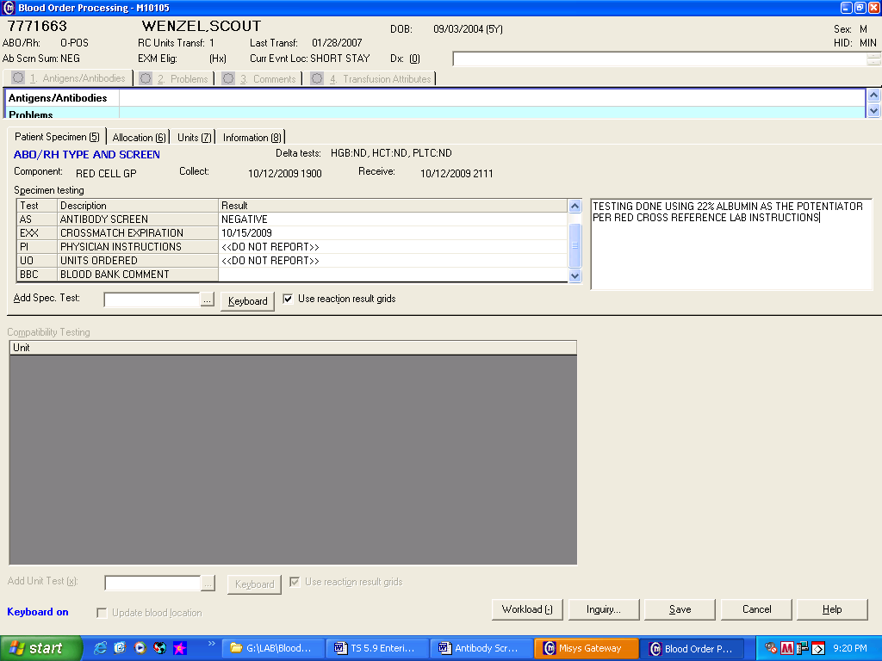
 | 9 | Save results.
 | 10 | Enter the Blood Bank Administrative Data Entry folder to enter additional information regarding testing into the patient’s permanent record.
Approval  Workflow | Transfusion Service/Lab Director
Historical Record | Version |  | Written/Revised by: | Effective Date: | Summary of Revisions
 | 1 |  | J. Wenzel | 9/86 | Initial Version
 | 2 |  | J. Wenzel | 7/90
 | 3 |  | J. Wenzel | 5/94 | LISS in STP
 | 4 |  | D. Hansen | 12/95 | Merger
 | 5 |  | J. Wenzel | 9/96
 | 6 |  | D. Hansen | 1/6/97
 | 7 |  | J. Wenzel | 12/99
 | 8 |  | D. Hansen | 1/4/00
 | 9 |  | J. Wenzel | 5/22/01
 | 10 |  | J. Wenzel | 10/19/2009 | Online version
 | 11 |  | J. Wenzel | 4/10/2012 | Change Interpretation table to match BMA4.
 | 12 |  | S Cassidy | 07/03/2019 | Added statement that a second tech needs to review and respond all QA failures

