Entering Results for Rh Only

Purpose | This procedure provides instruction for entering Rh Typing results in Sunquest grids. Rh only results must be entered directly into the patient’s Blood Administration Record.
Test Codes | RH  Children's of Minnesota - Rh Only
Related  Documents | TS 5.2 Blood Order Processing  TS 4.8 Grading and Interpretation of Tube Reactions  TS 5.3 Making Changes to a Blood Administration Record
Procedure
 | Step | Action
 | 1 | Enter Blood Order Processing by the patient sample accession number.
 | 2 | Click on the Patient Specimen tab.
 | 3 | Press the Home key or Click in the first cell of the grid entry field.
 | 4 | - Enter the grading of the tube agglutination reading in the appropriate grid cell.  - Enter NT (key N) if tube/phase is Not Tested.  GRID CELL  D= Anti D tube  DIN=Anti D tube after incubation  DIA =Anti D tube at AHG  DCC= Anti D tube with Coombs Control Cells  RHC=Rh control  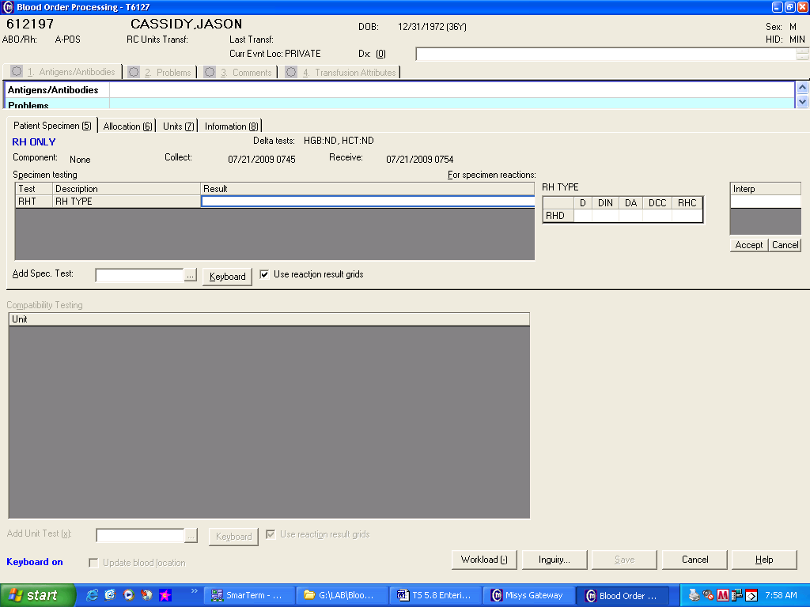
 | 5 | Record the Rh type interpretation in the grid entry interpretation field then press Tab.  Interpretation entries: Positive = P key Negative = N key  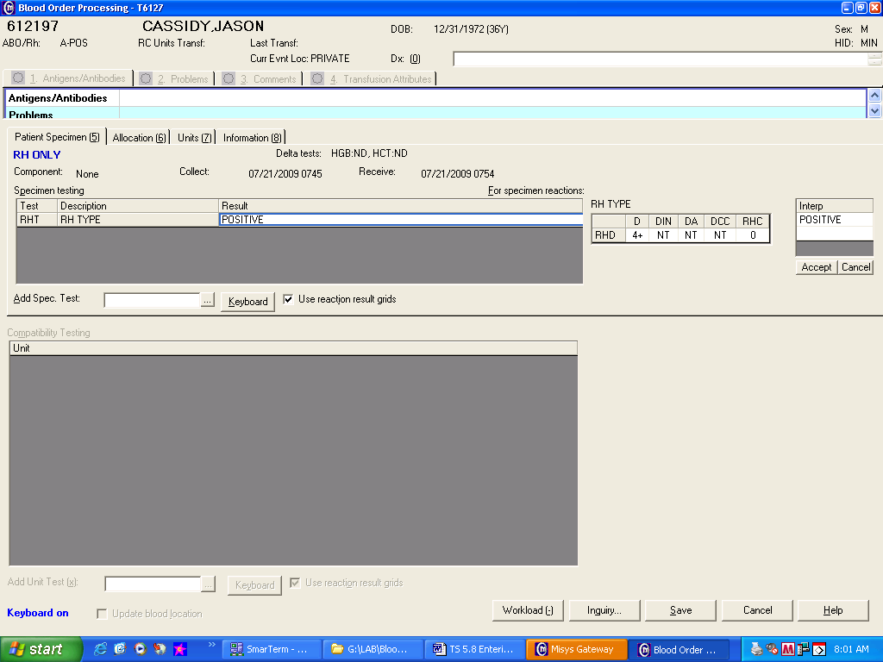
 | 6 | Review tube reaction results and interpretation entry if QA failures occurs.  If Then  An enter error was made Re-enter tube reading results and/or interpretation.  Entry confirmed - Acknowledge QA warnings. All QA failures have to be reviewed and responed by a second tech. - Respond to QA failures with a reason code or free text entry
 | 7 | Save results.
 | 8 | Enter the Blood Bank Administrative Data Entry folder to enter the patient’s Rh Type into the permanent record.  Note: If the patient’s Rh is interpreted as D (Rh) Positive after weak D testing, add Problem Patient comment WDP (patient weak D-use Rh Negative products unless approved by pathology) to patient’s BAD file.
Approval  Workflow | Transfusion Service/Laboratory Director
Historical Record | Version |  | Written/Revised by: | Effective Date: | Summary of Revisions
 | 1 |  | J Wenzel | 1/05/2009 | Initial Version
 | 2 |  | S Cassidy | 5/12/09 | Change Rh grids
 | 3 |  | J Wenzel | 4/10/2012 | Added Purpose statement regarding entry of Rh into the BAD file.
 | 4 |  | S Cassidy | 07/03/2019 | Added statement that all QA failures have to be reviewed and responed by a second tech.

