Entering Results for ABO Only

Purpose | This procedure provides instruction for entering ABO grouping results in Sunquest grids. ABO only results must be entered directly into the patient’s Blood Administration Record.
Test Codes | ABOGR  Children's of Minnesota - ABO Only
Related  Documents | TS 5.2 Blood Order Processing  TS 4.8 Grading and Interpretation of Tube Reactions  TS 5.3 Making Changes to a Blood Administration Record
Procedure
 | Step | Action
 | 1 | Enter Blood Order Processing by the patient sample accession number.
 | 2 | Click on the Patient Specimen tab.
 | 3 | Press the Home key or Click in the first cell of the grid entry field.
 | 4 | - Enter the grading of the tube agglutination reading in the appropriate grid cell.  - Enter NT (key N) if tube/phase is Not Tested.  GRID CELL  A = Anti-A tube  B = Anti-B tube  A1C= A1 cells tube  BC= B cells tube  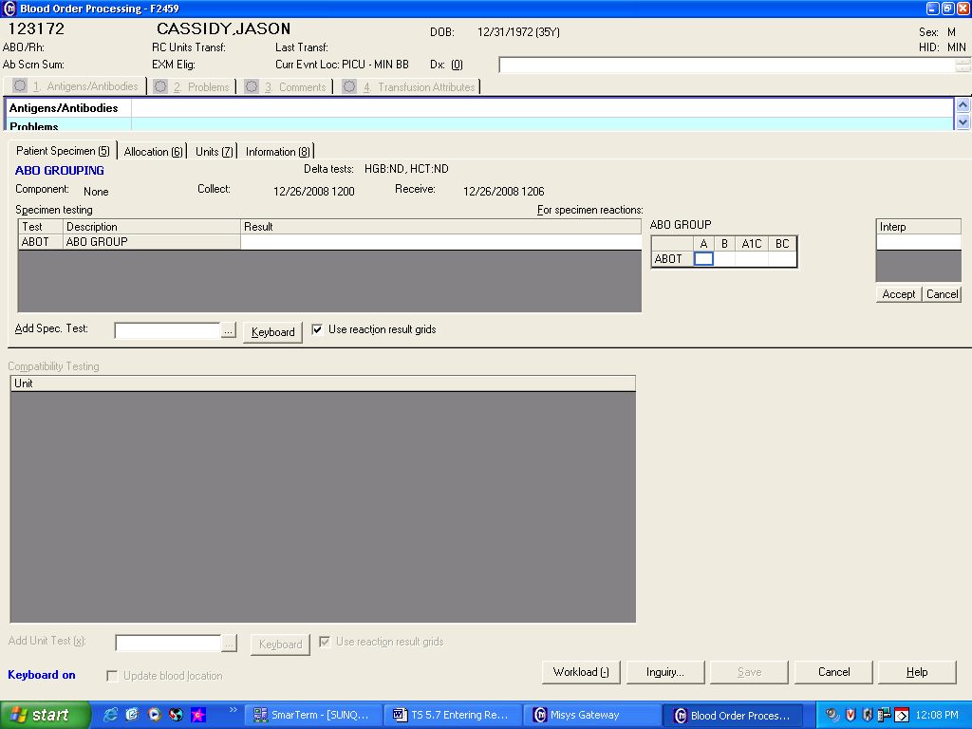
 | 5 | Record the ABO group interpretation in the grid entry interpretation field then press Tab.  Interpretation entries:  - ABO: O = O key A = A key B = B key AB = L key  - Enter ;ICL (Inconclusive) as the interpretation if an inconclusive reaction pattern occurs.  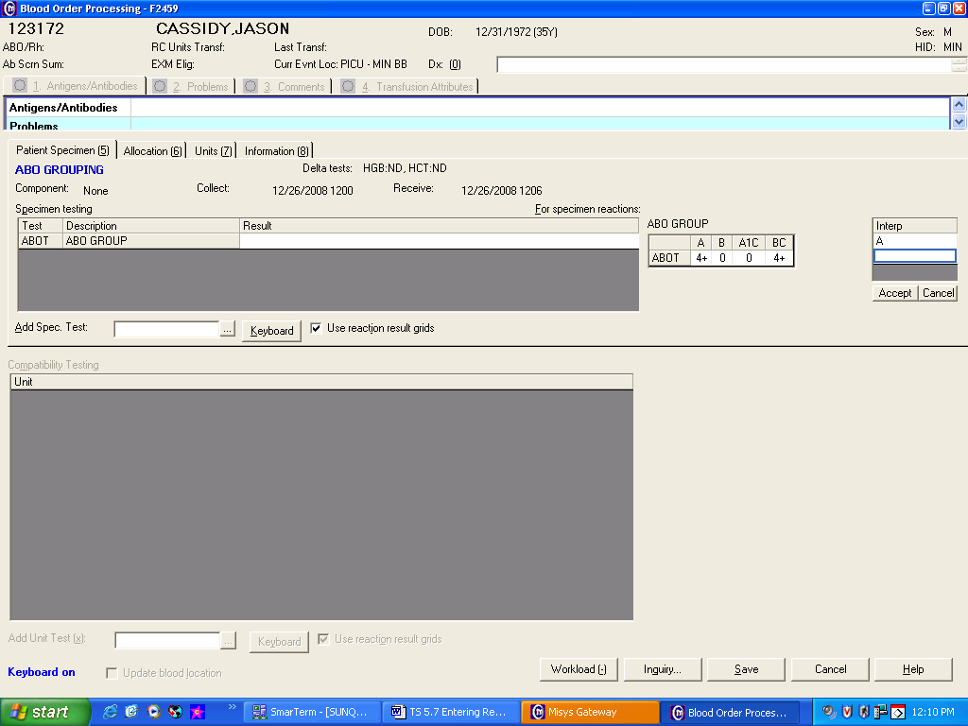
 | 6 | Review tube reaction results and interpretation entry if QA failures occurs.  If Then  An enter error was made Re-enter tube reading results and/or interpretation.  Entry confirmed - Acknowledge QA warnings. All QA failures have to be reviewed and responded by a second tech. - Respond to QA failures with a reason code or free text entry - IRPA-Inconclusive reverse type due to patient age or immune status
 | 7 | Save results.
 | 8 | Enter the Blood Bank Administrative Data Entry folder to enter the patient’s ABO group into the permanent record.
Approval  Workflow | Transfusion Service/Laboratory Director
Historical Record | Version |  | Written/Revised by: | Effective Date: | Summary of Revisions
 | 1 |  | J Wenzel | 1/05/2009 | Initial Version-separate out of ABO/Rh procedure
 | 2 |  | J Wenzel | 4/10/2012 | Added Purpose statement regarding entering results into the BAD file.
 | 3 |  | S Cassidy | 07/03/2019 | Added statement that a second tech needs to review and respond to QA failures.

