Entering Results for ABO and RH Testing and Rechecks

Purpose | This procedure provides instruction for entering ABO and Rh typing results and ABO/RH rechecks results in Sunquest grids.
Test Codes | ABR-as part of specific orderable tests or may be added through the keyboard.  ARC-as part of specific orderable tests or may be added through the keyboard.  CABR-credit for ABO and Rh
Related  Documents | TS 5.2 Blood Ordering Processing  TS 4.8 Grading and Interpretation of Tube Reactions  TS 5.3 Making Changes to a Blood Administration Record
Procedure
 | Step | Action
Entering results for ABO and Rh typing | 1 | Enter Blood Order Processing by the patient sample accession number.
 | 2 | Click on the Patient Specimen tab.
 | 3 | If Then  Test ABR already part of the order Proceed to step 4  Needing to add test ABR in the Add Spec. Test box enter ;ABR or press key T.
 | 4 | Press the Home key or Click in the first cell of the ABO/RH(D) grid entry field.
 | 5 | - Enter the grading of the tube agglutination reading in the appropriate grid cell.  - Enter NT (key N) if grid cell is Not Tested.  - Enter ICLR (key I) if ABO backtyping grid cell result is inconclusive due RT or 4C control  reactivity.  GRID CELL  A = Anti-A tube  B = Anti-B tube  D= Anti D tube  DIN=Anti D tube after incubation  DIA =Anti D tube at AHG  DCC= Anti D tube with Coombs Control Cells  RHC=Rh Control  A1C= A1 cells tube  BC= B cells tube
 | 6 | Record the ABO and Rh interpretations in the interpretation field according to the testing procedure.  Interpretation entries:  - ABO: O = O key A = A key B = B key AB = L key  - Rh(D): Positive = P key Negative = N key  - ;ICL (Inconclusive) as the interpretation if an inconclusive reaction pattern for ABO and/or Rh testing occurs.  - ;NN (Not Necessary) as the interpretation if testing not performed in any tube or phase. *Credit testing by adding test code CABR to the Add Spec. Test field.  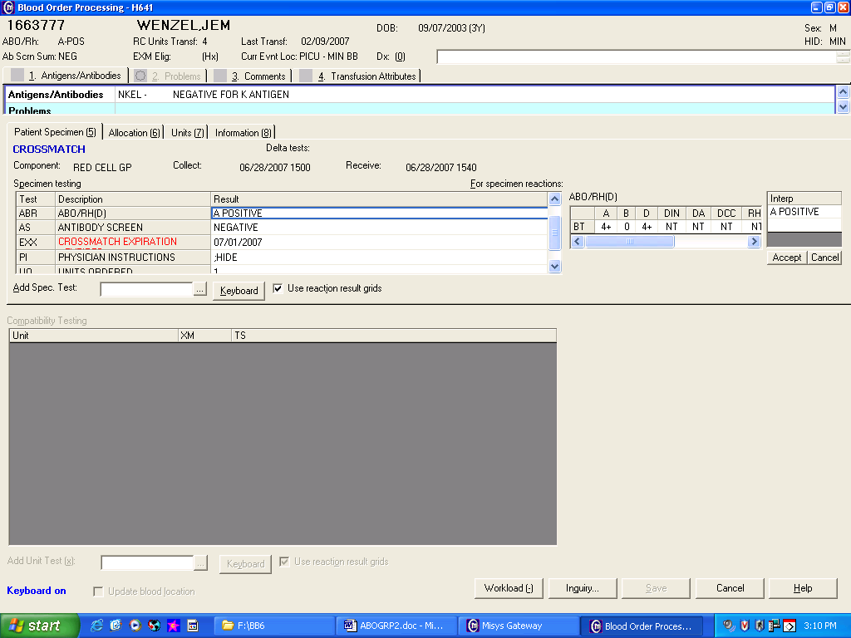
 | 7 | Review tube reaction results and interpretation entry if QA failures occurs.  If Then  An enter error was made Re-enter tube reading results and/or interpretation.  Entry confirmed - Acknowledge QA warnings. All QA failures have to be reviewed and responded by a second tech. - Respond to QA failures with a reason code or free text entry - BMT-BMT recipient - IRPA-Inconclusive reverse type due to patient age or immune status
 | 8 | Save results.  If Then  the patient’s Rh is interpreted as D (Rh) Positive at the AHG phase of weak D testing. Add Problem Patient comment WDP (patient weak D-use Rh Negative products unless approved by pathology) to patient’s BAD file.  A change to the patient’s ABO or Rh record is deemed required after a thorough investigation of ABO and Rh result discrepancies, E.g. BMT- Bone Marrow Transplant recipient or recipient of O Neg RBC prior to original typing. **Changes must be made directly in the patient’s BAD file
 | Step | Action
Entering results for ABO and Rh typing recheck | 1 | Enter Blood Order Processing by the patient sample accession number.
 | 2 | Click on the Patient Specimen tab.
 | 3 | If Then  Test ARC already part of the order Proceed to step 4  Needing to add test ARC In the Add Spec. Test box enter ;ARC or press key X.
 | 4 | Press the Home key or Click in the first cell of the ABO/RH(D) RECHECK grid entry field.
 | 5 | - Enter the grading of the tube agglutination reading in the appropriate grid cell.  - Enter NT (key N) if grid cell is Not Tested.  - Enter ICLR (key I) if ABO backtyping grid cell result is inconclusive due RT or 4C control  reactivity.  GRID CELL  A = Anti-A tube  B = Anti-B tube  D= Anti D tube  DIN=Anti D tube after incubation  DIA =Anti D tube at AHG  DCC= Anti D tube with Coombs Control Cells  RHC=Rh Control  A1C= A1 cells tube  BC= B cells tube
 | 6 | Record the ABO and Rh interpretation in the interpretation field according to the testing procedure.  Interpretation entries:  - ABO: O = O key A = A key B = B key AB = L key  - Rh(D): Positive = P key Negative = N key  - ;ICL (Inconclusive) as the interpretation if an inconclusive reaction pattern for ABO and/or Rh testing occurs.  - ;NN (Not Necessary) as the interpretation if testing not performed in any tube or phase. Testing must be credited by adding test code CABR to the Add Spec. Test field.  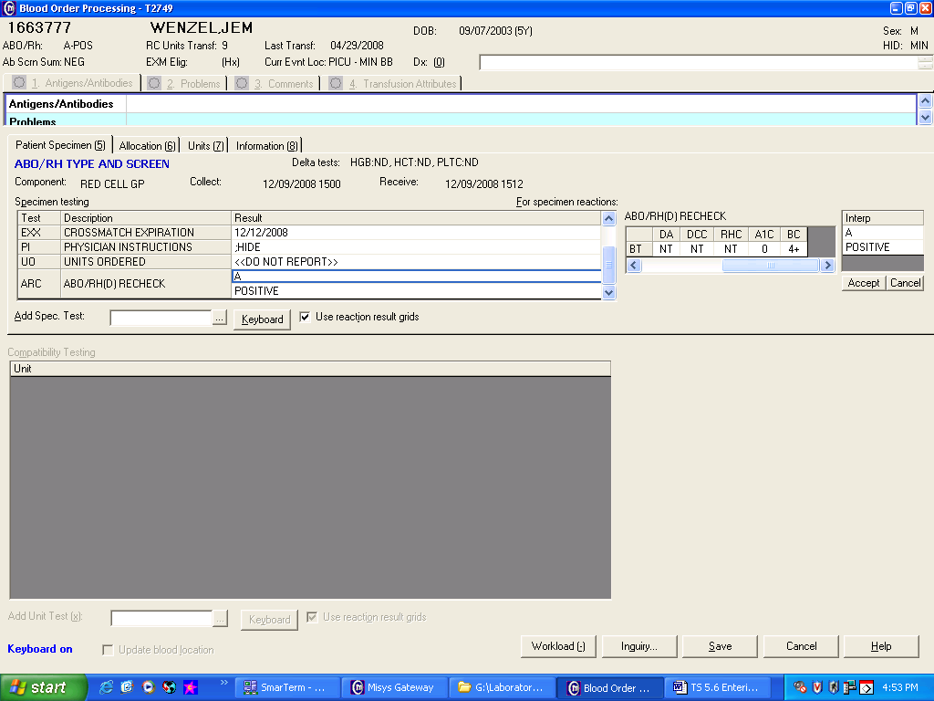
 | 7 | Review tube reaction results and interpretation entry if QA failures occurs.  If Then  An enter error was made re-enter tube reading results and/or interpretation.  Entry confirmed - Acknowledge QA warnings. All QA failures have to be reviewed and responded by a second tech. - Respond to QA failures with a reason code or free text entry
 | 8 | Save results.  Note: Test ARC results are compared to the patient’s ABR results and the patient’s BAD ABO/Rh record; however test ARC is not filed as the patient’s BAD permanent blood type.
Approval  Workflow | Transfusion Service/Laboratory Director
Historical Record | Version |  | Written/Revised by: | Effective Date: | Summary of Revisions
 | 1 |  | Hartley | 1982 | Initial Version
 | 2 |  | Berglund | 1985
 | 3 |  | McGee | 1990
 | 4 |  | Dawn Hansen | 1995 | Merger
 | 5 |  | J Wenzel | 12/1996
 | 6 |  | J Wenzel | 9/1998
 | 7 |  | J Wenzel | 5/2001
 | 8 |  | J Wenzel | 6/5/2003
 | 9 |  | J Wenzel/S Cassidy | 7/30/07 | ABO Discrepancy added
 | 10 |  | J Wenzel | 12/10/2008 | New format
 | 11 |  | J Wenzel | 4/10/2012 | Merged old TS 5.5 and 5.6  Added information for entry of ICLR result for ABO backtyping in grid cell.
 | 12 |  | S Cassidy | 07/03/2019 | Added statement that a second tech needs to review and respond to all QA failures

