GeneXpert C. difficile/Epi Assay

Purpose | This procedure provides instructions for performing the Xpert C. difficile/Epi assay on the Cepheid GeneXpert system.
Policy Statements | This procedure applies to all technical staff performing testing on the GeneXpert.
Principle and Clinical Significance | C. difficile is the most common cause of health care-associated diarrhea.^{[1]} The spectrum of disease can range from uncomplicated diarrhea to pseudomembranous colitis, toxic megacolon, sepsis with associated organ failure and even death.^{[2]} The Cepheid Xpert® C. difficile/Epidemiological Assay is a qualitative in vitro diagnostic test for rapid detection of toxin B gene sequences and for presumptive identification of 027/NAP1/BI strains of toxigenic Clostridium difficile from unformed (liquid or soft) stool specimens collected from patients suspected of having C. difficile infection (CDI).  Summary and Explanation  Clostridium difficile (C. difficile) is a Gram-positive, spore-forming anaerobic bacillus that was first linked to disease in 1978. Clostridium difficile infection (CDI) ranges from diarrhea to severe life-threatening pseudomembranous colitis. The most common risk factor is exposure to antibiotics. C. difficile’s primary virulence factor is cytotoxin B. The genes coding for toxin A (tcdA; the enterotoxin) and toxin B (tcdB) are parts of the pathogenicity locus (PaLoc). Most pathogenic strains are toxin A-positive, toxin B-positive (A+B+) strains. However, toxin A-negative, toxin B-positive (A-B+) variant isolates have been recognized as pathogenic. Some strains of C. difficile also produce an actin-specific ADP-ribosyltransferase called CDT or binary toxin. The binary toxin locus contains two genes (cdtA and cdtB) and is located outside the PaLoc.  In the last several years, there have been outbreaks of CDI attributed to a number of emerging “hypervirulent” strains that include fluoroquinoline resistant strains belonging to PCR ribotype 027, PFGE type NAP1 and REA type BI. Strains of 027/NAP1/BI exhibit increased toxin production, which is being attributed to deletions in the regulatory gene tcdC and they are thought to produce more spores, leading to enhanced persistence in the environment. The identification of a presumptive positive or negative 027/NAP1/BI result may aid in the identification of possible sources of an 027/NAP1/BI outbreak. C. difficile diagnosis has been traditionally based on the detection of toxin A or B. Both the labor intensive culture procedure, followed by cell cytotoxicity testing on the isolates, and cytotoxicity cell assay on stool specimens are still considered to be the “gold standard” because of high specificity. Several rapid enzyme immunoassays have been developed for detection of toxin A and B. However, these tests have reduced sensitivity and specificity compared to the cell cytotoxicity assay. Recently, PCR methods for the detection of toxin A and/or toxin B have been developed with high sensitivity and specificity as compared to the cell cytotoxicity and immunoassays.  Principles of the Procedure  The GeneXpert Dx System automates and integrates sample purification, nucleic acid amplification, and detection of the target sequence in simple or complex samples using real-time PCR to detect DNA. The system employs single-use disposable cartridges that hold the PCR reagents and host the PCR process, which greatly reduces the chances of cross contamination between samples.  The Xpert C. difficile/Epi Assay includes reagents for the detection of toxigenic C. difficile and the presumptive detection of sequences found in 027/NAP1/BI strains. A Sample Processing Control (SPC) and a Probe Check Control (PCC) are present to ensure validity of sample runs.  The assay detects the toxin B gene (tcdB), the binary toxin gene (CDT), and the single-base-pair deletion at nucleotide 117 within the gene encoding a negative regulator of toxin production (tcdC∆117). The combined presence of the genes encoding toxin B and binary toxin and the tcdC∆117 deletion have been associated with a hypervirulent C. difficile strain known as 027/NAP1/BI, which has been associated with severe disease outbreaks in healthcare facilities worldwide.^{[3]}
Test Code | CDTP
Sample | - Acceptable specimens:  - Unformed or liquid stool in a sterile container, stool aspirates  NOTE - cancel code for hard and formed stool: CDTC (C. diff testing canceled, stool must be soft/liquid. Hard formed stool are unacceptable.)  - SDES codes/Specimen type:  - Stool: STO  - Specimen Collection and Transport:  - Refer to Lab Test Directory on StarNet  - Specimen assessment:  - Refer to the policy MCVI 2.1 Specimen Rejection Criteria.  - Specimen Storage  - Stable for up to 5 days at 2-8 °C  - Stable at room temperature (20-30 °C) for up to 24 hours
Special Safety Precautions | Microbiologists/virologists are subject to occupational risks associated with specimen handling. Refer to the safety policies located in the safety section of the Microbiology and Virology Policy Manual:  - Biohazard Containment  - Safety in the Microbiology/Virology Laboratory  - Biohazardous Spills
Materials | Reagents Supplies Equipment  - 10% bleach - 70% ethanol - Xpert C. difficile/Epi Assay cartridges - Xpert C. difficile/Epi reagent vials - Transfer pipettes - Single-use disposable swabs - Sample racks - Cartridge transfer tray - Absorbent biohazard pads - Sterile swabs (Cepheid) Store kits at 2-28°C. Kits are stable until the expiration date printed on the outer box. - Biosafety Hood - Cepheid GeneXpert Instrument and computer - Vortexer - Printer
Calibration | Annual “Xpert Check Kit” calibration performed by Cepheid.
Quality Control | Daily Quality Control:  Once an Xpert cartridge has been loaded and before the sample processing steps begin, the software checks the optics, the readiness of the module’s mechanical components, and the ambient temperature of the module to assure proper performance of PCR, and the physical integrity of the cartridge.  Each test includes a Sample Processing Control (SPC) and a Probe Check Control (PCC).  - SPC: Ensures the sample was correctly processed. It contains DNA from Bacillus globigii and verifies the sample processing and target amplification. The SPC verifies that lysis of C. difficile bacteria and spores have occurred, if the organisms are present and verifies that specimen processing is adequate. This control also detects specimen-associated inhibition of the real-time PCR assay. The SPC should be positive in a negative sample and can be negative or positive in a positive sample.  - PCC: Performs a check on the amplification portion of the assay. Before the PCR reaction starts, the GeneXpert instrument measures the fluorescence signal from the probes to monitor bead rehydration, reaction-tube filling, probe integrity, and dye stability. Therefore, it controls for missing or incompletely hydrated beads of enzyme and target specific reagent. It also controls for the generated fluorescence which must meet internal acceptance criteria.  External Quality Control:  - Perform QC using external positive and negative controls every 30 days. Record results in the GeneXpert assay binder on the Log.  - See IQCP document.  - See Quality Control Procedure.  New Lot/Shipment Quality control:  - Perform QC using external positive and negative controls with each new lot or shipment before putting into service. Record results in the GeneXpert assay binder on the Log.  - See Quality Control Procedure  Wipe testing:  - Perform wipe testing every 30 days to monitor for contamination.  - See Quality Control Procedure.  NOTE: External quality control may be performed on an as needed basis if certain circumstances arise. Examples include:  - Drift in results (e.g., increasing/decreasing positivity rates)  - Potential contamination (negative control)  - After drastic system maintenance
Procedure | Sample and Cartridge preparation:  - Clean hood with10% bleach (made daily) followed by 70% ethanol.  - Change gloves.  - Obtain an assay cartridge, sample reagent, disposable swab, absorbent biohazard pad, and transfer pipette.  - Label the side of the sample regent with a foot-label.  - Label the cartridge with a bar-coded foot-label.  - Briefly place swab in the unformed stool sample (does not need to be completely saturated).  - Insert swab into the sample reagent vial.  - With a sterile absorbent biohazard pad hold the swab near the rim of the vial, lift the swab a few millimeters from the bottom of the tube and push the stem against the edge of the vial to break it. Close the cap tightly.  - Vortex on high speed for 10 seconds.  - Open the cartridge lid.  - Using a clean transfer pipette, transfer the entire contents of the sample reagent to the sample chamber of the cartridge by inserting the pipette to the bottom of the well and empty the pipette’s content into the cartridge.  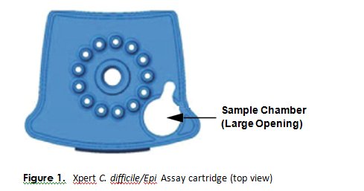  - Close the cartridge lid, and set onto the transfer tray or off to the side in the hood.  - Change gloves and proceed to prepare additional samples or start the test.  NOTES:  -Hood surfaces must be cleaned between samples with 10% bleach followed with 70% ethanol if there were any splashes, spills, or uncertainty of cleanliness.  **Start the test within 30 minutes of adding the sample to the cartridge  Starting the test:  - Ensure clean gloves are on before stepping to the computer work space.  - If instrument and computer are turned off: start up the instrument by flipping the power switch located in the back of the instrument. Turn on the computer next.  - Log onto the appropriate Windows account:  - User: lab1  - Password: labstaff4  - The GeneXpert software will launch automatically. If it doesn’t double-click the GeneXpert Dx software shortcut icon on the desktop.  - Log onto the software.  - User: First 6 letters of your first and last name (combined)  - Password: First 6 letters of your first and last name (combined)  - In the GeneXpert System window, click Create Test.  - Navigate to the Sample ID box. Scan or type in the sample ID.  - Scan the barcode on the cartridge.  NOTE: if the barcode on the cartridge does not scan, then repeat the test with a new cartridge.  - Select the appropriate test type for samples or controls.  - Enter additional information in the “notes” field (day of QC, collect date, etc.) if needed.  - Click Start Test.  - Enter your username and password, if requested.  - Open the instrument module door with the blinking green light.  NOTE: when setting up for testing you may opt to use any available module.  - With the barcode facing towards you, set the cartridge into the module and close the door.  - Wait for the test to start and the light to stop blinking. The test will run for 47 minutes.  - Turn printer on.  - Verify the validity of results BEFORE removal of the cartridge. If valid results were NOT obtained – see the retesting procedure.  - Remove the cartridge when testing is finished (the light will be off and the system will release the door lock).  - Dispose of used cartridges into bio-bags and place into biohazard sharps bins.  - Clean any equipment used (pipettes, racks, transfer tray, etc.), hood, and counters (including keyboard, scanner, and mouse) at the end of the day.  NOTE: Sample processing, testing, and cleaning should follow a unidirectional work-flow to avoid contamination.
Interpretation/ Results | - Click on View Results on the top drop-down menu bar and select View Test.  - Select the result you would like to review: Click OK.  - Review result interpretations and amplification curves for exponential growth (if applicable).  - NOTE: SPC does not need to pass for a positive result to be valid.  - NOTE: SPC needs to pass for a negative result to be valid.  - Click on the Errors tab to ensure no errors occurred during testing. (Section 9.18.2 in Operator Manual provides error code descriptions)  Reasons to retest/troubleshooting:  - An INVALID result – the SPC failed. Retest according to the procedure below.  This may indicate:  - The sample was not properly processed.  - PCR was inhibited.  - An ERROR result – the Probe Check control failed. Retest the original sample.  This may indicate:  - The reaction tube was filled improperly.  - A reagent probe integrity problem was detected.  - The maximum pressure limit was exceeded.  - A valve positioning error was detected.  - NO RESULT:  - This result indicated that insufficient data were collected (e.g. test stopped while in progress or power failure occurred). Retest the original sample.  NOTE: Record any failures or errors on the “GeneXpert Service and Error Log” log.  See result examples below:  Positive for C. difficile toxin B  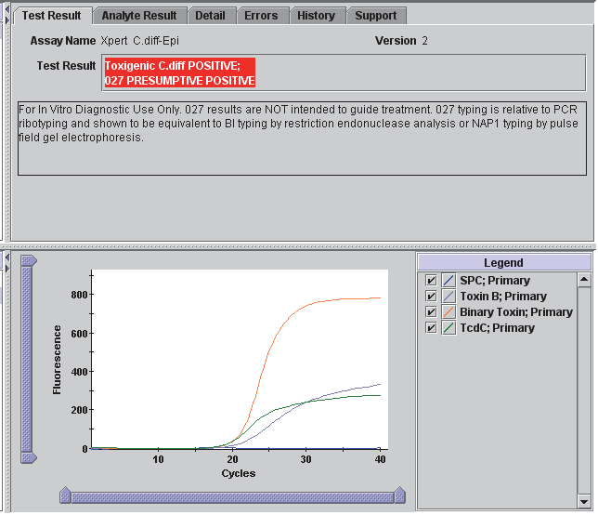  Positive for C. difficile toxin B  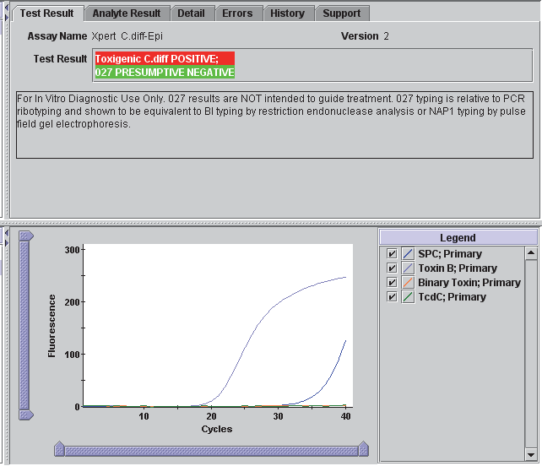  Negative for C. difficile toxin B  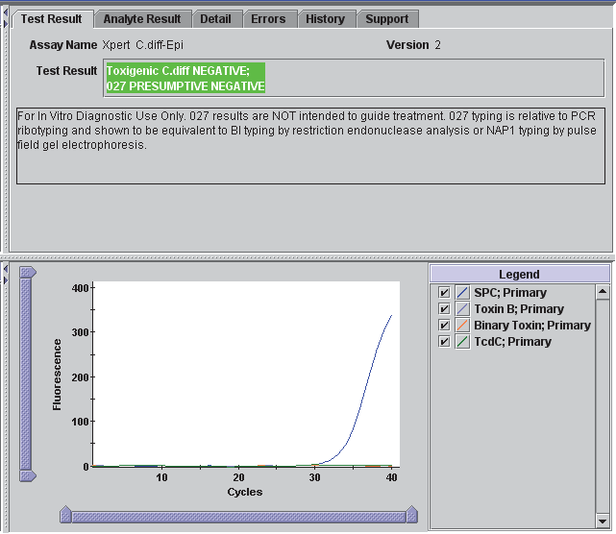  NOTE: the “027 Presumptive” result is NOT reported at this institution.  Invalid Result  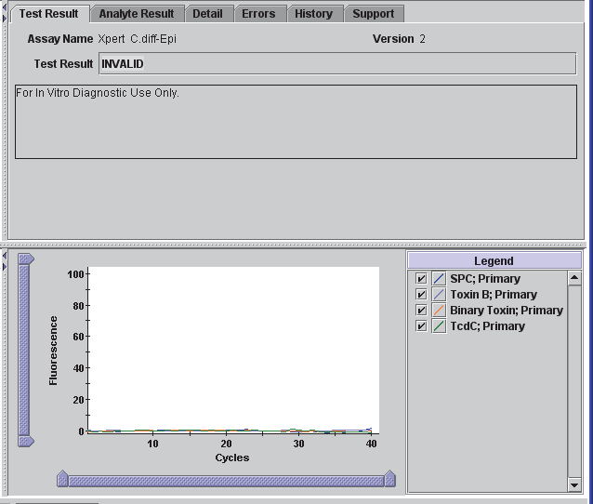
Retesting Procedure | - Remove cartridge from the instrument and place into the hood with NO other samples present. Change gloves.  - Obtain a new sample vial and cartridge.  - Transfer remaining contents from the Sample Chamber to a new Sample Reagent vial using a sterile disposable transfer pipette.  - Vortex and add the entire contents of the Sample Reagent to the Sample Chamber of the new Xpert C. difficile/Epi Assay cartridge.  - Close the lid, change gloves and start a new test.  - Dispose of old cartridge by placing in a small biohazard bag to be put into the biohazard sharps container.  - Change gloves and clean hood with 10% bleach and 70% ethanol.  NOTE: Retesting from a cartridge must occur within 3 hours. If unable to retest in 3 hours repeat the test from the original sample.
Result Reporting | - Ensure that the printer is turned on.  - Reports will print automatically.  - Results will automatically transmit to the LIS.  - Log into Sunquest to release results.  - Select Result Entry from Menu options 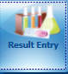  - In the Configuration field select CGX in the dropdown box.  - Select the test code order to results (CDTP).  - Click on the button located in the lower right corner to populate the transmitted results.  - Review messages located on the top and results. Compare results to the GeneXpert report.  NOTE the comment NGIF: “Children less than 2 years may carry toxigenic C. difficile as part of their normal GI flora without having disease.” will automatically append when a positive results is obtained on a patient that is < 2 years of age.  - Check the release box. 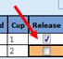  - Click button located on the lower left corner. Click when the “Verify Release Destination” window opens.  - Call a completed worksheet, check results, and staple to GeneXpert Report. Place in the GeneXpert result binder.  - Store samples in fridge:  - Mark positive samples on tops of caps.  - Discard old samples after 48 hours.
Critical Results | N/A: No alert values reported.
Invalid Results | - IF an invalid result is repeated AND a valid result is obtained, select and only release the valid result interpretation in the LIS.  - IF an invalid result is repeated AND an invalid result is obtained, select only one of the invalid results to verify. The provider must be notified of these results.  The result will be reported as unresolved (UNRE) and the following code SIA will automatically append: “This sample is inhibitory to amplification and the results are inconclusive. Consider repeat collection if clinically indicated.”  Add the code CAL, press tab, enter semi-colon record who the result was relayed to and the date/time.
Manual Entry of Results | - Open Result Entry, select the Manual resulting mode (top left corner), from the configuration drop down select the appropriate test code. Click in the lower right corner.  - Enter the Specimen ID or scroll to the correct patient if necessary (lower left corner).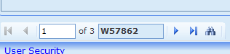  - Type in results and applicable comments when necessary.  - Check results against instrument print out and click .
Correcting Results | - Open Result Entry, select the Manual resulting mode (top left corner) from the configuration drop down select the appropriate test code. Click in the lower right corner.  - Enter the Specimen ID, enter Tab and click Yes to modify the result.  - Change the incorrect result. The corrected result comment will automatically append. Add the CAL comment, press tab, enter a semi-colon and record who was called and the time/date.  - Click . Click when the “Verify Release Destination” window opens.
Limitations | - Non-027/NAP1/BI isolates representing toxinotype XIV will be reported “Toxigenic C. diff POSITIVE; 027 PRESUMPTIVE POSITIVE” using the Xpert C. difficile/Epi Assay.  - Occasionally, non-027/NAP1/BI isolates representing toxinotypes IV, V and X will be reported “Toxigenic C. diff POSITIVE; 027 PRESUMPTIVE POSITIVE” using the Xpert C. difficile/Epi Assay.  - The performance of the Xpert C. difficile/Epi Assay was validated using the procedures provided in this package insert only.  - Modifications to these procedures may alter the performance of the test.  - Positive results observed with immunocompromised pediatric patients may reflect asymptomatic carriage of C. difficile/Epi.  - Detection of C. difficile nucleic acid in stools confirms the presence of these organisms in diarrheal patients but may not indicate that C. difficile are the etiologic agents of the diarrhea.  - Results from the Xpert C. difficile/Epi Assay should be interpreted in conjunction with other laboratory and clinical data available to the clinician.  - Erroneous test results might occur from improper specimen collection, failure to follow the recommended sample collection, handling and storage procedures, technical error, sample mix-up, or because the number of organisms in the specimen is too low to be detected by the test. Careful compliance with the instructions in this insert is necessary to avoid erroneous results.  - Because of the dilution factor associated with the retest procedure, it is possible that C. difficile positive specimens, very near or at the limit of detection (LoD) of the C. difficile/Epi Assay, may result in a false negative result upon retest.  - Inhibition of the Xpert C. difficile/Epi Assay has been observed in the presence of the following substances: Zinc oxide paste and Vagisil® cream.  - Outbreaks of CDI may be caused by strains other than 027/NAP1/BI.  - False-negative results may occur when the infecting organism has genomic mutations, insertions, deletions, or rearrangements or when performed very early in the course of illness.^{[3]}
Method Performance Specifications | According to the manufacturer (per the package insert):  Toxigenic C. difficile – Assay Performance vs. Direct Culture and PCR-Ribotyping  Sensitivity: 98.8%  Specificity: 90.9%  PPV: 56.4%  NPV:99.8%  Toxigenic C. difficile / 027/NAP1/BI  Percent positive agreement: 98.9%  Percent negative agreement: 98.4%  The LODs of C. difficile that can be detected by the Xpert C. difficile/Epi Assay are listed below.  Strain ID Toxinotype LOD_{95%} (CFU/swab) Lower 95% CI Upper 95% CI  VPI 10463 (CCUG19126) 0 255 190 632  90556-M6S (ATCC9689) 0 460 419 587  LUMC-1 (027/NAP1/BI) III 23 19 31  LUMC-5 (027/NAP1/BI) III 75 45 178  LUMC-7 V 45 34 104  LUMC-6 VIII 60 50 74  9101 XII 41 34 49
References | 1. Babady NE, Stiles J, Ruggiero P, Khosa P, Huang D, Shuptar S, et al. Evaluation of the Cepheid Xpert Clostridium difficile Epi assay for diagnosis of Clostridium difficile infection and typing of the NAP1 strain at a cancer hospital. Journal of clinical microbiology 2010; 48(12):4519-4524.  2. Kaltsas A, Simon M, Unruh LH, Son C, Wroblewski D, Musser KA, et al. Clinical and laboratory characteristics of Clostridium difficile infection in patients with discordant diagnostic test results. Journal of clinical microbiology 2012:JCM. 05711-05711.  3. Xpert C. difficile/Epi Package Insert, 200-9680 Rev. F. In: Cepheid; 2016.
Alternate Methods | 1. Send specimens to Mayo Medical Laboratory  2. Mayo Order code: CDFRP, Clostridium difficile Toxin, Molecular detection from feces  3. Sunquest Order code: MBAT  4. Logistics:  - Liquid or soft stool, minimum volume 1 ml  - Transport  - Acceptable: Unpreserved representative sample in screw top container, RT  - Preferred: Preserved representative sample in 15 ml Cary-Blair media with phenol red, RT
Proficiency Testing | CAP materials: 3 shipments a year with 5 samples.
Training Plan/ Competency Assessment | Training Plan |  |  | Initial Competency Assessment
 | - Employee must read the procedure.  - Employee will demonstrate the ability to perform procedure, record results, and document corrective action after instruction by the trainer. |  |  | - Direct observation
Historical Record
 | Version | Written/Revised by: | Effective Date: |  | Summary of Revisions
 | 1 | Julie Laramie | 12/27/2018 |  | Initial Version
 | 2 | Julie Laramie | 6/14/2019 |  | Updated retesting notes to specify when to test original sample vs. follow the repeat procedure
 | 3 | Julie Laramie | 08/05/2019 |  | Removed Stool Aspirates as an acceptable sample type
 | Archived by: |  | Archived Date:

