Chemical Hazardous Waste Management

Purpose |  | This process provides guidance for CHEMICAL HAZARDOUS WASTE MANAGEMENT.
Policy Statements |  | The Chemical Hazardous Waste Management plan establishes and maintains a program to ensure all chemicals used by the laboratory are purchased, stored and disposed in accordance with all federal, state and local regulations. The laboratory makes every effort to minimize the use of hazardous chemicals and minimize the potential for spills, leaks or other incidents using one or more of the following practices:  - Purchase reagents in small quantities  - Minimize patient sample size  - Change process or procedure  - Employ recovery, recycling or redistribution of chemicals  - Dispose of all chemicals and hazardous waste according to regulations
Definitions |  | - Hazardous material – any substance that may cause significant damage to people, property, or the environment. Examples found in the laboratory include acetone, acids, alcohols, formalin, and xylene.  - Hazardous waste – material that can no longer be used for its intended purpose (expired, contaminated) and must be discarded. This is enforced by the Environmental Protection Agency, Minnesota Pollution Control Agency, and local authorities.  - Dual waste – both a chemical hazardous waste and a biohazard waste.
Precautions |  | - Notify the Safety department if you have questions about disposal of any chemical or product.  - Do not dispose chemicals into the sewer, trash or biohazard waste unless approved by the Safety department.  - Do not use biohazard bags to dispose of non-biohazard waste.
Process |  | Step Action  1 Purchasing and Tracking - Purchasing is done through the Children’s Purchasing department. Any item ordered which requires a safety data sheet (SDS) will be researched and documented before being delivered. - Department leadership staff will notify the Safety department of new products to be evaluated for hazards and for the determination of proper disposal procedures prior to product delivery. - The laboratory safety officer will annually submit an updated list of all hazardous chemicals used in the laboratory to the hospital safety officer.
Process |  | Step Action  2 Collection & Transport - Hazardous waste may be collected in appropriately labeled containers, e.g. satellite accumulation, that are leak proof and kept closed unless waste is being added. - Inspect hazardous waste containers and log weekly for proper labeling, no leakage, and closed lids. - Clean any spillage on the outside of a hazardous waste container immediately. - Label hazardous waste and hazardous waste containers with the following: - Hazardous waste label - HAZARDOUS WASTE - SATELLITE ACCUMULATION (if appropriate) - CONTENTS DESCRIPTION (e.g. hydrochloric acid, formalin) - DATE – start date and fill/disposal date - Hazardous waste labels are available in the laboratory and the hazardous waste storage room. - GHS label - GHS labels alert lab staff and waste haulers to the hazards associated with the chemicals in the containers. - GHS labels are available in the Sendouts department in Mpls and in the Core lab in Stp. - Transport hazardous waste containers within three days of becoming full (¾ full is considered full) to the hazardous waste storage room for disposal. - Mpls: B2 030 - Stp: L122 - Transport hazardous waste using transport canisters and/or carts. - Do not leave any hazardous waste in the hazardous waste storage room without affixing a properly completed hazardous waste label and GHS label. - Place all hazardous waste in the designated gray bin within the storage room.  Hazardous Waste Containers in Use in the Laboratory  Satellite Accumulation Hazardous Waste – examples include but are not limited to acetone, alcohols, sodium azide, xylene, unrecyclable 10% formalin, liquid from Sani-Cloth containers, ethyl acetate, stains containing Evans blue, mercury-containing reagents.  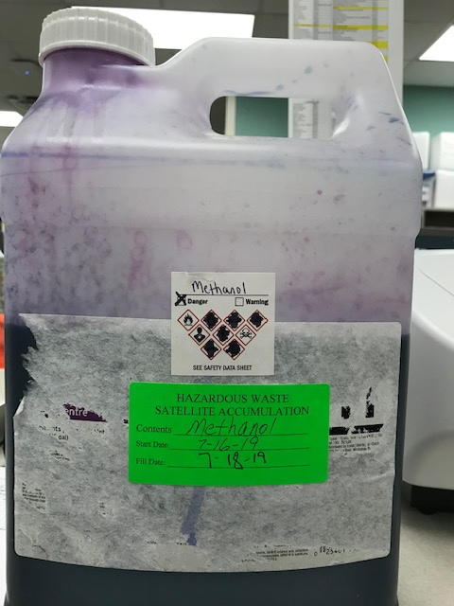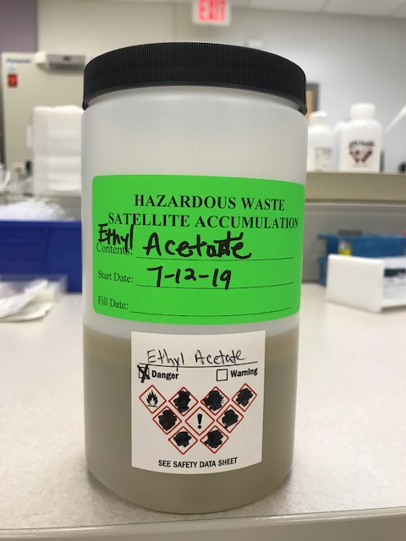
Process | Hazardous Waste Containers in Use in the Laboratory  Acid Waste – examples include but are not limited to acidic reagent cartridges (ABS, ACTM, DBIL, PHOS, etc.), calibrators (ECO2, IRON, etc.).  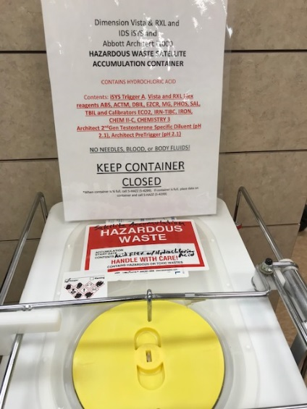  Base/Caustic Waste – examples include but are not limited to caustic reagent cartridges (iSYS Trigger B, T4, TP, etc.).  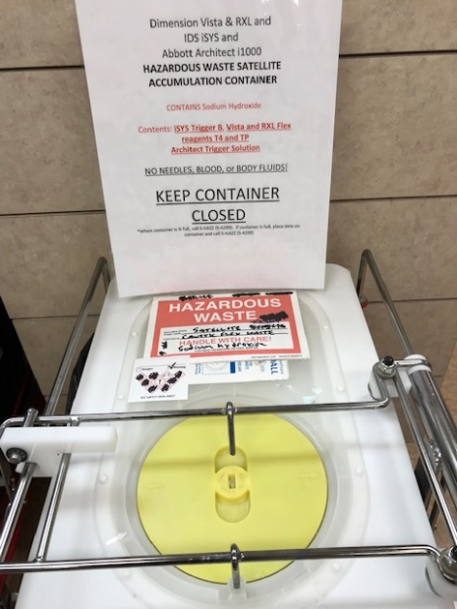  Dual Waste – both a chemical hazardous waste and a biohazard waste (HemoCue cuvettes).  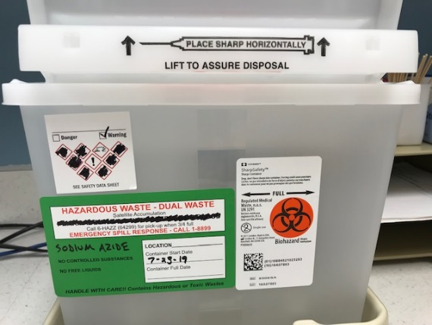
Process | Step Action  3 Additional wastes - Label as ‘Hazardous Waste’ along with the description of the contents, and the date (start date and fill/disposal date). Place in the hazardous waste storage room: - Unused or expired chemicals or reagents - Hand sanitizers (gel or liquid) still containing visible product - Compressed gas cylinders from ABL instruments - Aerosol containers - Do not throw into trash unless completely empty (no product and no pressure). - Label and handle as stated above if any product or pressure remains. - Spill cleanup debris - Dispose of waste into yellow bags and label as hazardous waste. - For complete instructions for a chemical spill see SA 7.06 Hazardous Chemical Spill Cleanup.  Battery disposal – used batteries for recycling. Includes all rechargeable batteries and batteries with silver oxide and mercury oxide (button or coin shaped). Tape exposed contacts or place in small plastic bag (not a biohazard bag) prior to placing in battery disposal container. Do not throw alkaline batteries into this container. Alkaline batteries may be disposed in regular trash.  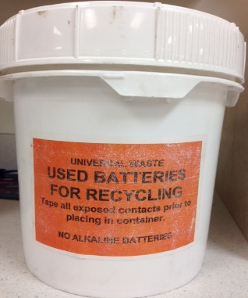  Electronic waste – contain metals which are hazardous to the environment.  Includes electronic thermometers, calculators, computers, pagers, power cords and anything with a circuit board.  - Do not dispose in the trash.  - Contact Safety for disposal.  Appliances – managed like electronic wastes.  4 Recycling - 100% and 95% Alcohol: recycled when possible on Mpls campus, disposed on Stp campus - Xylene: recycled when possible on Mpls campus, disposed on Stp campus - 10 % Formalin: recycled when possible on Mpls campus, disposed on Stp campus  5 Transport and Ultimate Disposal - The Safety department arranges for the transport of hazardous waste for ultimate disposal on a regular basis with a licensed hazardous waste hauler. - The Safety department maintains the manifests of the hazardous waste transported for ultimate disposal.
Supporting Documents | 912.00 Hazardous Materials and Waste Plan  912.04 Waste Management  SA 7.06 Hazardous Chemical Spill Cleanup
References | CLSI. Clinical Laboratory Waste Management; Approved Guideline-Third Edition. CLSI document GP05-A3. Wayne, PA: Clinical and Laboratory Standards Institute; 2011.  EPA Final Rule: Hazardous Waste Generator Improvements  https://www.epa.gov/hwgenerators/final-rule-hazardous-waste-generator-improvements
Historical Record |  |  | Version | Written/Revised by: | Effective Date: | Summary of Revisions
 |  |  | 1 | Carol Cram |  | Initial
 |  |  | 2 | Kerstin Halverson | 07/17/2003
 |  |  | 2.1 | Kerstin Halverson | 08/10/2005
 |  |  | 3 | Carol Buhl and Daniel Olson | 09/30/2010 | Reformatted.  Updated hazardous waste storage location.  Deleted reference to Mercury (B-5 solution)
 |  |  | 4 | Carol Buhl | 10/28/2011 | Renumbered.
 |  |  | 5 | Carol Buhl | 10/23/2014 | Added reference section.  Renumbered from 4.4.
 |  |  | 6 | Carol Buhl | 11/30/2015 | Added definitions.  Added pictures of hazardous waste containers and examples of waste.  Added Additional wastes, Battery disposal, and Electronic waste.
 |  |  | 7 | Carol Buhl & Laboratory Safety Committee | 06/28/2017 | Clarified DATE on hazardous waste label as start date and fill/disposal date.
 |  |  | 8 | Carol Buhl & Laboratory Safety Committee | 07/31/2019 | Added GHS labels needed on hazardous waste satellite accumulation containers.  Updated images.  Removed mercury bulb disposal information.  Updated references.

