Isolate Send-out to Mayo Medical Laboratories (MML)

Purpose | The purpose of this procedure is to provide guidance on sending out isolates for identification/ susceptibility testing to Mayo Medical Laboratories (MML). The procedure explains ordering, shipping, and billing.
Principle | This procedure discusses the process for properly sending out patient isolates that require special identification/susceptibility testing. Having a process and guidelines in place will ensure for maximum efficiency so that patient results can become obtained in a timely manner.
Test Code | MBAT (Miscellaneous Battery)  ZMMLS (Antimicrobial Susceptibility, Aerobic Bacteria, MIC) - MAYO  IDENT (Organism Referred for Identification, Aerobic Bacteria) – MAYO  ANIDE (Organism Referred for Identification, Anaerobic Bacteria) – MAYO  MMLSA (Antimicrobial Susceptibility, Anaerobic Bacteria, MIC) – MAYO  CTBID (Culture Referred for Identification, Mycobacteria and Nocardia) – MAYO
Procedure | - Obtain a pure isolate of the organism.  - Organisms must be subbed to an agar slant. MML does not accept agar plates.  - A chunk of agar may be cut off a plate and placed into an agar slant, if necessary. This method is recommended for sending Mycobacterial and Nocardia isolates that need further identification.  - Login to Sunquest Order Entry.  - Enter patient MRN and select correct encounter.  - Enter collect date and time of the original specimen. Add ordering provider that has made the request for additional testing.  - Order the test code, MBAT.  - Fill in the ‘Results’ boxes with the appropriate information (Example: Figure 1).  - NAM: free-text specifics of testing being ordered (i.e. aerobic ID, specific drugs desired for susceptibility testing, etc.)  - RLAB: MML (site being sent to)  - SRCE: use Sunquest codes to provide source  - TSTCD: free-text appropriate Mayo test code  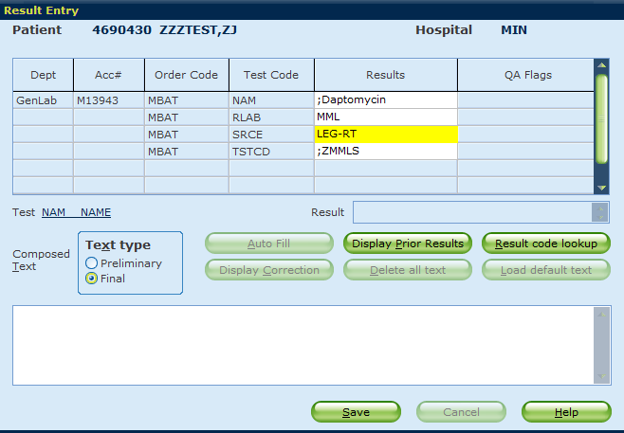  Figure 1. Example of MBAT order.  - Save order and collect printed labels.  - Document the MML test code on the label.  - Write an isolate description onto the large label for the Send-outs staff. Items that can be included are: gram stain reaction, morphology and/or tests performed. The easiest description to document is the gram stain reaction (i.e. Gram positive cocci).  - Indicate on the large label if the patient encounter is through Minneapolis or St. Paul.  - Place the large label onto the isolate tube.  - Bring the isolate to the Send-outs department during day shift hours. Send-outs staff will prepare and ship the isolate by performing the necessary steps.  - MBAT testing requires a manual billing form to be completed. Forms can be located in the send-out drawer (desk 3) or electronically (Sendout Manual Billing Request Form). Microbiology staff will complete the necessary fields at the top of the form. Send the form to LIS staff members. Scanning and emailing to “LIS Staff DL” is an option.  - Once Send-outs has ordered the specimen for shipment to MML, the Microbiology technologist that completed the order will login to MayoACCESS and request a faxback for results as they become available.  - Locate order in MayoACCESS.  - Select ‘Set Faxback’.  - Select ‘New Fax Number’ (Children’s number will be added). Click ‘Close’.  - Click ‘Refresh Grid’ to ensure that a faxback icon displays for the order.  - For in-depth directions on requesting a faxback and/or retrieving orders in MayoACCESS, visit the MayoACCESS Report Retrieval & Updates section in the  Acid-Fast Bacilli Resulting & Susceptibility Add-On procedure.  - Obtain result and enter under the appropriate accession number in Sunquest Micro Result Entry.  - Do NOT add additional billing. This will be taken care of through the Manual Billing form in LIS.  - Add scanned comment to the Sunquest report (SCAND). Submit the Mayo report to the front desk to be scanned.
Training Plan/  Competency Assessment | Training Plan Initial Competency Assessment  1. Employee must read the procedure. 2. Employee will observe trainer performing the procedure. 3. Employee will demonstrate the ability to perform procedure, record results and document corrective action after instruction by the trainer. 1. Direct Observation
Historical Record | Version | Written/Revised by: | Effective Date: | Summary of Revisions
 | 1 | Andrew Fangel/Susan DeMeyere | 8/8/2019 | Initial Version
 | Archived by: |  | Archived Date:

