GeneXpert TV Assay

Purpose | This procedure provides instructions for performing the Xpert TV assay on the Cepheid GeneXpert system.
Policy Statements | This procedure applies to all technical staff performing testing on the GeneXpert.
Principle and Clinical Significance | The Xpert TV Assay is intended to aid in the diagnosis of trichomoniasis in symptomatic or asymptomatic individuals.  The protozoan Trichomonas vaginalis is responsible for trichomoniasis, which is a common sexually transmitted infection that can infect both men and women. There are 7.4 million cases of trichomoniasis annually in the United States. Trichomoniasis infections can be symptomatic or asymptomatic. In women, trichomoniasis is one of a range of conditions that comprise vaginal discharge. Symptoms in females can include itching, burning, redness, or soreness of the genitals, unusual odor, discomfort with urination, or a thin clear, white, yellow, or green discharge. In men, trichomoniasis may cause non-gonococcal urethritis (NGU). Symptoms in males can include itching or burning inside the penis, burning after ejaculation or urination, or penile discharge.(1) Infection can increase the risk of getting or spreading HIV, and pregnant women are more likely to have their babies too early and with a low birth weight.(2)  The Cepheid Xpert TV Assay, performed on the GeneXpert Instrument Systems, is a qualitative in vitro diagnostic test for the detection of Trichomonas vaginalis genomic DNA. The test utilizes automated nucleic acid extraction and real-time polymerase chain reaction (PCR) to detect Trichomonas vaginalis genomic DNA. An Early Assay Termination function provides positive results if target DNA reaches a predetermined threshold before the full 45 PCR cycles have been completed.(1)
Test Code | TVPCR
Sample | - Acceptable specimens:  - First-catch male and female urine specimens in urine Xpert Collection Tube  - Endocervical and vaginal swabs collected with the Xpert Vaginal/Endocervical Specimen Collection Kit or Xpert Vaginal/Endocervical Collection Kit  - SDES codes/Specimen type:  - UR- Urine, collect method not specified  - VOID- Voided urine  - VAG-Vagina  - CERV-Cervix  - Specimen Collection and Transport:  - Refer to Lab Test Directory on StarNet  - Specimen assessment:  - Refer to the policy MCVI 2.1 Specimen Rejection Criteria.  - Specimen Storage  - First-catch male and female urine:  - Stability, NEAT:  - Room temp (2-28°C): 4 hours  - 4°C: 4 days  - Stability, in Cepheid Sample Transport Reagent (7mL):  - Room temp (2-28°C): 14 days  - 2-15°C: 28 days  - Transfer NEAT urines to Cepheid Sample Transport Reagent as soon as possible after collection.  - Endocervical and vaginal swabs collected with the Xpert Vaginal/Endocervical Specimen Collection Kit, and the Xpert Vaginal/Endocervical Collection Kit  - Stability in Cepheid Sample transport reagent:  - 2-30°C: 60 days  - Specimens should be stored at 4-8°C (refrigerated)
Special Safety Precautions | Microbiologists/virologists are subject to occupational risks associated with specimen handling. Refer to the safety policies located in the safety section of the Microbiology and Virology Policy Manual:  - Biohazard Containment  - Safety in the Microbiology/Virology Laboratory  - Biohazardous Spills
Materials | Reagents Supplies Equipment  - 10% bleach - 70% ethanol - Xpert Vaginal/Endocervical Specimen Collection Kits - Xpert Urine Specimen Collection Kits - Xpert TV Assay cartridges - Transfer pipettes - Simple racks - Cartridge transfer tray Store kits at 2-28°C. Kits are stable until the expiration date printed on the outer box. - Biosafety Hood - Cepheid GeneXpert Instrument and computer - Printer
Calibration | Annual “Xpert Check Kit” calibration performed by Cepheid.
Quality Control | Daily Quality Control:  Once an Xpert cartridge has been loaded and before the sample processing steps begin, the software checks the optics, the readiness of the module’s mechanical components, and the ambient temperature of the module to assure proper performance of PCR, and the physical integrity of the cartridge.  Each test includes a Sample Processing Control (SPC), a Sample Adequacy Control (SAC), and a Probe Check Control (PCC).  - SPC: Ensures the sample was correctly processed. It contains DNA from Bacillus globigii and verifies the sample processing and target amplification. The SPC verifies that binding and elution of target DNA have occurred if the organisms are present and verifies that sample processing is adequate. Additionally, this control detects sample-associated inhibition of the real-time PCR assay. The SPC should be positive in an analyte negative sample and can be negative OR positive in an analyte positive sample.  - SAC: Ensures that the sample contains human cells or human DNA. The SAC signal is only to be considered in an analyte negative sample. A negative SAC indicates that no human cells are present in the sample due to insufficient mixing of the sample or because of an inadequately taken sample.  - PCC: Performs a check on the amplification portion of the assay. Before the PCR reaction starts, the GeneXpert instrument measures the fluorescence signal from the probes to monitor bead rehydration, reaction-tube filling, probe integrity, and dye stability. Therefore, it controls for missing or incompletely hydrated beads of enzyme and target specific reagent. It also controls for the generated fluorescence which must meet internal acceptance criteria.  NOTE: When TV levels are high enough to generate very early Cts, neither the SAC nor SPC amplification curves will be seen and their results will not be reported.  External Quality Control:  - Perform QC using external positive and negative controls every 30 days. Record results in the GeneXpert assay binder on the Log.  - See IQCP document.  - See Quality Control Procedure.  New Lot/Shipment Quality control:  - Perform QC using external positive and negative controls with each new lot or shipment before putting into service. Record results in the GeneXpert assay binder on the Log.  - See Quality Control Procedure  Wipe testing control:  - Perform wipe testing every 30 days to monitor for contamination.  - See Quality Control Procedure.  NOTE: External quality control may be performed on an as needed basis if certain circumstances arise. Examples include:  - Drift in results (e.g., increasing/decreasing positivity rates)  - Potential contamination (negative control)  - After drastic system maintenance
Procedure | Cartridge preparation:  - Clean hood with10% bleach (made daily) followed by 70% ethanol.  - Change gloves.  - Obtain a TV Assay cartridge, transfer pipette, and sample transport tube to be tested.  - Label the side of the cartridge with a bar-coded foot-label.  - Open the cartridge lid.  - Gently invert the transport tube 3 to 4 times.  - Open the transport tube lid and draw up specimen in the transfer pipette until the fill mark is reached (500uL).  - Insert the pipette to the bottom of the well in the cartridge and empty the pipette’s content into the cartridge.  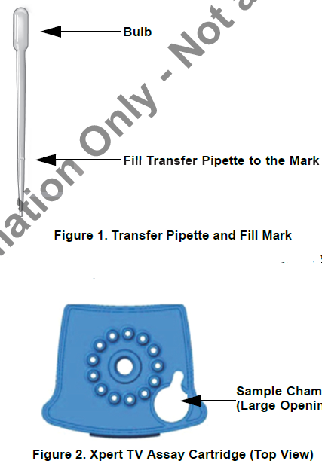  - Close the cartridge lid, and set onto the transfer tray.  - Change gloves and proceed to prepare additional samples or start the test.  NOTES:  -Hood surfaces must be cleaned between samples with 10% bleach followed with 70% ethanol if there were any splashes, spills, or uncertainty of cleanliness.  -**Start the test within 30 minutes of adding the sample to the cartridge  Starting the test:  - Ensure clean gloves are on before stepping to the computer work space.  - If instrument and computer are turned off: start up the instrument by flipping the power switch located in the back of the instrument. Turn on the computer next.  - Log onto the appropriate Windows account:  - User: lab1  - Password: labstaff4  - The GeneXpert software will launch automatically. If it doesn’t double-click the GeneXpert Dx software shortcut icon on the desktop.  - Log onto the software.  - User: First 6 letters of your first and last name (combined)  - Password: First 6 letters of your first and last name (combined)  - In the GeneXpert System window, click Create Test.  - Navigate to the Sample ID box. Scan or type in the sample ID.  - Scan the barcode on the cartridge.  NOTE: if the barcode on the cartridge does not scan, then repeat the test with a new cartridge.  - If prompted, select Xpert TV from the Select Assay MENU.  - Select the appropriate test type for samples or controls.  - Enter additional information in the “notes” field (day of QC, collect date, etc.) if needed.  - Click Start Test.  - Enter your username and password, if requested.  - Open the instrument module door with the blinking green light.  NOTE: when setting up for testing you may opt to use any available module.  - With the barcode facing towards you, set the cartridge into the module and close the door.  - Wait for the test to start and the light to stop blinking. The test will run for 90 minutes.  NOTE: Early assay positive call out can happen as early as 40 minutes into the run  - Turn printer on.  - Remove the cartridge when testing is finished (the light will be off and the system will release the door lock).  - Dispose of used cartridges into bio-bags and place into biohazard sharps bins.  - Clean any equipment used (pipettes, racks, transfer tray, etc.), hood, and counters (including keyboard, scanner, and mouse) at the end of the day.  NOTE: Sample processing, testing, and cleaning should follow a unidirectional work-flow to avoid contamination.
Interpretation/ Results | - Click on View Results on the top drop-down menu bar and select View Test.  - Select the result you would like to review: Click OK.  - Review result interpretations and amplification curves for exponential growth.  - NOTE: SAC and SPC do not need to pass for a positive result to be valid.  - NOTE: SAC and SPC do need to pass for a negative result to be valid.  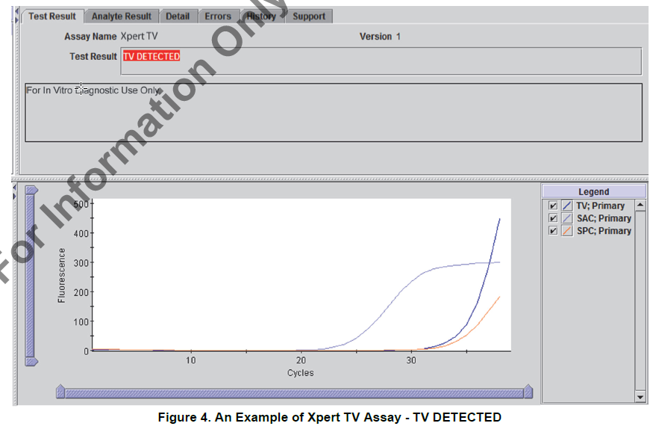  - Click on the Errors tab to ensure no errors occurred during testing. (Section 9.18.2 in Operator Manual provides error code descriptions)  Reasons to retest the original sample:  - An INVALID result (SPC and/or SAC failure). This may indicate:  - The sample was inadequate.  - The sample was not properly processed.  - PCR was inhibited.  - An ERROR result. This may indicate:  - The reaction tube was filled improperly.  - A reagent probe integrity problem was detected.  - The maximum pressure limit was exceeded.  - A valve positioning error was detected.  - NO RESULT:  - This result indicated that insufficient data were collected (e.g. test stopped while in progress or power failure occurred).  NOTE: Record any failures on the “GeneXpert Service and Error Log” log.
Result Reporting | - Ensure that the printer is turned on.  - Reports will print automatically.  - Results will automatically transmit to the LIS.  - Log into Sunquest to release results.  - Select Result Entry from Menu options 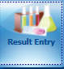  - In the Configuration field select CGX from the dropdown box.  - Click on the button located in the lower right corner to populate the transmitted results.  - Review messages located on the top and results. Compare results to the GeneXpert report.
- Check the release box. 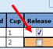
- Click button located on the lower left corner. Click when the “Verify Release Destination” window opens.

- Call a completed worksheet for TVPCR, check results, and staple to GeneXpert Report. Place in the GeneXpert TV result binder.

- Store samples in fridge:
  - Mark positive samples on side of caps (red marker line for TV positive).

- Discard old samples after 2 weeks.

Critical Results | No critical result values.
Invalid Results | - IF an invalid result is repeated AND a valid result is obtained, select and only release the valid result interpretation in the LIS.  - IF an invalid result is repeated AND an invalid result is obtained, select only one of the invalid results to verify. The provider must be notified of these results.  The result will be reported as unresolved (UNRE) and the following code SIA will automatically append: “This sample is inhibitory to amplification and the results are inconclusive. Consider repeat collection if clinically indicated.”  Add the code CAL, press tab, enter semi-colon record who the result was relayed to and the date/time.
Correcting Results | - Open Result Entry, select the Manual resulting mode (top left corner), from the configuration drop down select the TV test. Click in the lower right corner.  - Enter the Specimen ID, enter Tab and click Yes to modify the result.  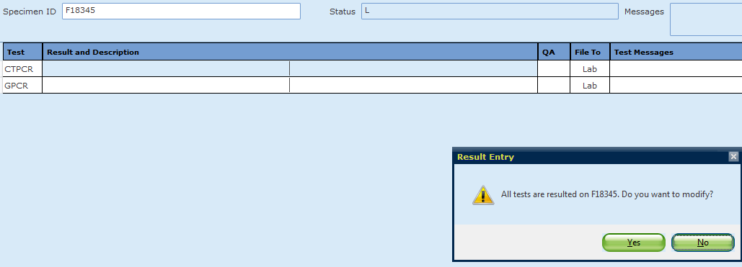
- Change the incorrect result. The corrected result comment will automatically append. Add the CAL comment, press tab, enter a semi-colon and record who was called and the time/date.

- Click . Click when the “Verify Release Destination” window opens.

Limitations | - The Xpert TV Assay has only been validated with the following specimen types, collected with the Xpert Vaginal/Endocervical Specimen Collection Kit or the Xpert Urine Specimen Collection Kit: Endocervical swabs, Patient-collected vaginal swabs, Female and male first-catch urine  - A negative test result does not exclude the possibility of infection because test results may be affected by improper specimen collection, technical error, sample mix-up, or because the number of organisms in the sample is below the limit of detection of the test.  - Careful compliance with the instructions in this package insert and in the Xpert Vaginal/Endocervical Specimen Collection Kit and Xpert Urine Specimen Collection Kit package inserts is necessary to avoid erroneous results.  - The Xpert TV Assay has been validated using the procedures provided in this package insert only. Modifications to these procedures may alter the performance of the test.  - Because the detection of Trichomonas vaginalis is dependent on the organism’s DNA present in the sample, reliable results are dependent on proper sample collection, handling, and storage.  - Trichomonas tenax was found to cross-react with the Xpert TV Assay at levels above 1.0 x 102 cells/mL. T. tenax is a commensal of the oral cavity. See Xpert TV Analytical Specificity for details.  - With endocervical and patient-collected vaginal specimens, assay interference may be observed in the presence of blood (>60% v/v).  - As with many diagnostic tests, results from the Xpert TV Assay should be interpreted in conjunction with other laboratory and clinical data available to the clinician.  - The patient-collected vaginal swab specimens are an option for screening women when a pelvic exam is not otherwise indicated.  - The Xpert TV Assay has not been validated for use with vaginal swab specimens collected by patients at home. The patient collected vaginal swab specimen application is limited to healthcare facilities where support/counseling is available to explain procedures and precautions.  - The Xpert TV Assay provides qualitative results. No correlation can be drawn between the magnitude of the Ct value and the number of cells in an infected sample.  - The Xpert TV Assay should not be used for the evaluation of suspected sexual abuse or for other medico-legal indications.  - The predictive value of an assay depends on the prevalence of the disease in any particular population.  - Mutations or nucleotide polymorphisms in primer or probe binding regions may affect detection of new or unknown Trichomonas vaginalis variants resulting in a false negative result.  - Xpert TV Assay performance has not been evaluated in pregnant women, or in patients with a history of hysterectomy.  - Xpert TV Assay performance has not been evaluated in patients less than 18 years of age or older than 78 years of age.
Method Performance Specifications | According to the manufacturer (per the package insert) – Overall specifications (both symptomatic and asymptomatic):  Sensitivity (95% CI) Specificity (95% CI)  Endocervical Swab 98.9% (96.0 - 99.9%) 98.9% (98.3 - 99.3%)  Pt. Collected Vaginal Swab 96.4% (92.7 – 98.5%) 99.6% (99.1 – 99.8%)  Urine: Female 98.4% (95.3 – 99.7%) 99.7% (99.3 -99.9%)  Urine: Male 89.6% (83.0 -93.8%) 99.3% (99.0 – 99.5%)
References | 1. Xpert TV Package Insert 301-2887, Rev. C. Sunnyvale, CA: Cepheid; June 2019.  2. Trichomoniasis Statistics GA: CDC; [updated January 2017. Available from: https://www.cdc.gov/std/trichomonas/stats.htm.
Alternate Methods | - Mayo Medical Laboratory send out: Hologic Trichomonas vaginalis Amplified RNA Assay (Mayo Medical Laboratories, collected in Aptima Collection Kit)
Proficiency Testing | CAP materials: 2 shipments a year with 3 samples.
Training Plan/ Competency Assessment | Training Plan |  |  | Initial Competency Assessment
 | - Employee must read the procedure.  - Employee will demonstrate the ability to perform procedure, record results, and document corrective action after instruction by the trainer. |  |  | - Direct observation
Historical Record
 | Version | Written/Revised by: | Effective Date: |  | Summary of Revisions
 | 1 | Julie Laramie | 08/05/2019 |  | Initial Version
 | Archived by: |  | Archived Date:

