Cancelation, Crediting and Notification of Ordered Tests

Purpose | This process provides instruction for canceling, crediting and documentation of test cancellations done by laboratory staff and the importance of notifying a caregiver.
Policy Statements | • All orders received by lab that cannot be performed because they do not meet lab-testing criteria or have not been collected should be canceled in a timely manner. The lab staff will investigate unreceived orders and determine the best course of action. A pending log for unreceived samples should be reviewed at the end of each shift to determine if there are orders to be canceled. The cancel reason should be documented and the provider (outpatients) or patient care unit (inpatients) notified if the laboratory is unable to perform testing.  The ability to credit and cancel tests is set up according to position in the laboratory.  Technical staff will be able to credit or cancel testing if:  - No results have been entered  - Only result at request (RAR) entries have been made  - Results need be retained, but credited (Similar to CRW)  - Results need to be replaced with a credit reason in situations such as specimen or patient mixups  Clerical or phelebotomy staff will be able to credit or cancel testing if:  - No results are present for the test(s)  - Only Result at Order Entry (RAR) entries have been made  Results that have been filed other than RAR,
Sample | Any laboratory Specimen or order.
Procedure
 | Step | Action |  |  |  | Related Document
 | 1 | Determine which orders need to be canceled  If results have been entered, the orders need to be credited and not canceled  If results are reported in correctly a corrected report needs to be issued |  |  |  | Correcting a Result
 | 2 | From the MAIN GUI Menu Screen, select General Laboratory  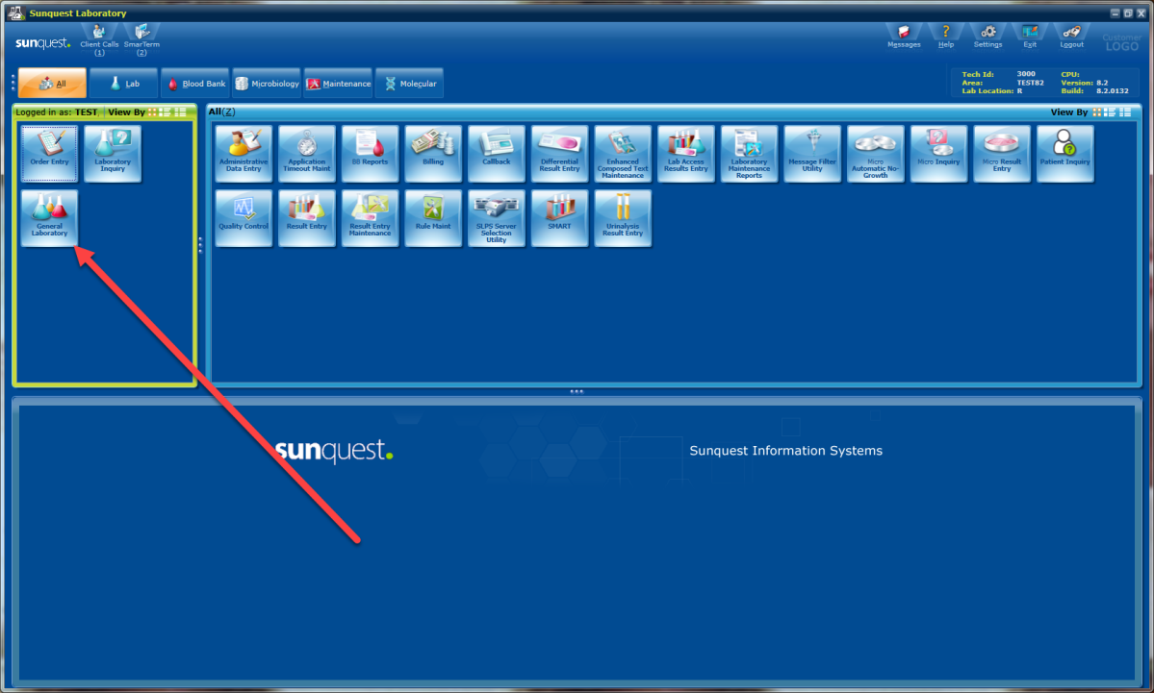
 | 3 | Another window will open and select Orders in the upper left hand corner.  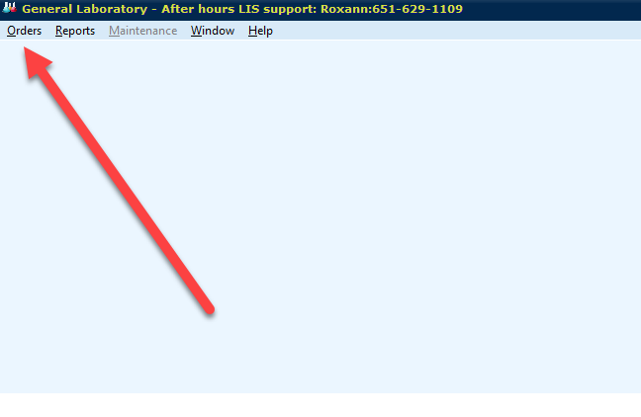
 | 4 | From the drop down options, select Order Receipt/Modify (ORM)  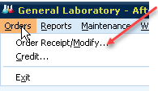
 | 5 | The Order Access window will now open  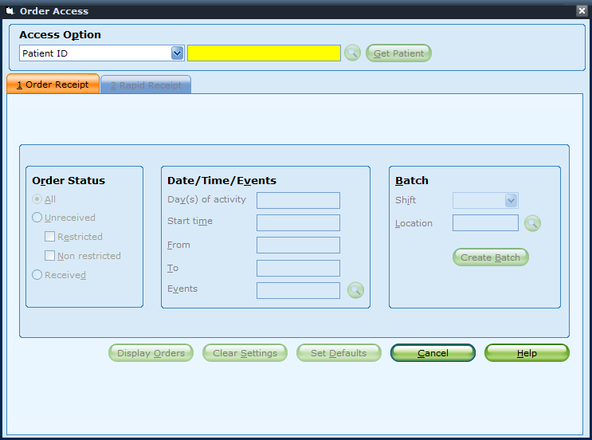
 | 6 | You can enter the Patient ID (Medical Record Number) or use the Drop Down option to select another option.  Most commonly you would look up orders by the Patient ID or Accession Number. Once you make a selection, select Get Patient.
 | 7 | You can further make choices to look at Received and Unreceived orders, the Number of Days of Activity or limiting the time frame for review.  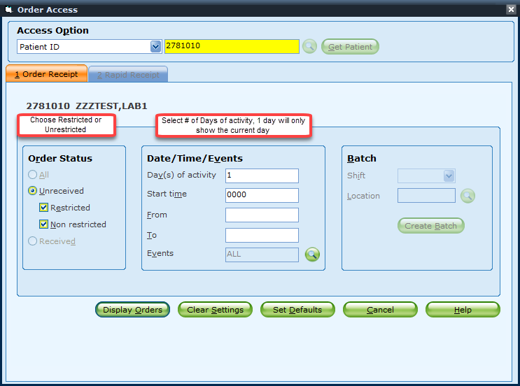
 | 8 | Select the Accession you would like to Credit in the ORM Display.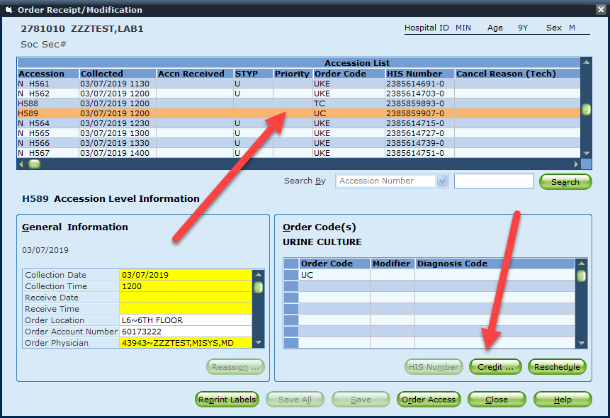
 | 9 | Another window will display with you ONLY option to Remove Results, Select the test or tests you want to credit  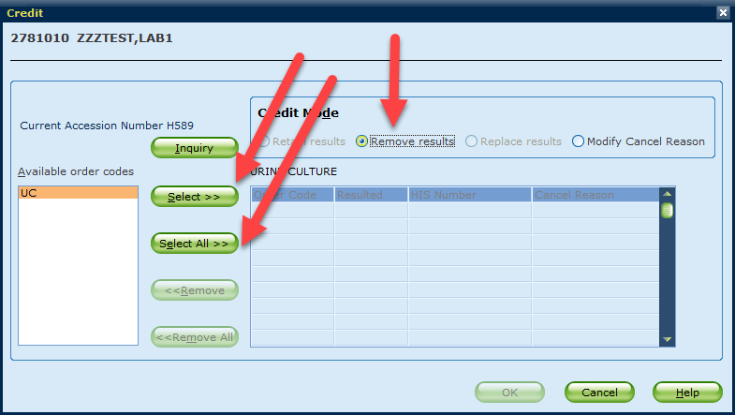
 | 10. | You will only be able to finish the credit if the test has NOT been resulted OR if the only results are those indicated as RAR\AA. Finish the Credit/Cancel by entering the appropriate reason in the orange box. A search of possible codes can be done with clicking on the SEARCH icon in yellow below.  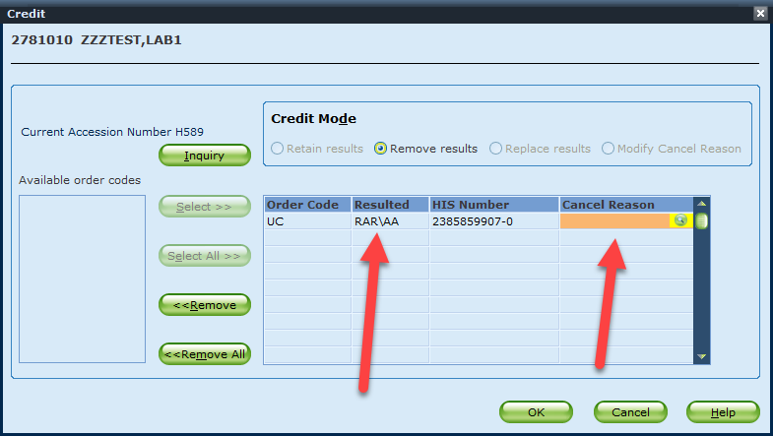
 | 11 | Other Credit options for Technical staff include, Retain Results (similar to CRW), Replace Results and Modify Cancel Reason. The Credit selection should be used when doing more than crediting an order when no results are present. These options are invoked by selecting Credit from the menu under General Laboratory.  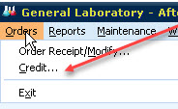
 | 12. | The Credit box will automatically open with the default of Retain Results selected  If you want to perform a different Credit Option, change the radio button selection to that option before entering your Accession Number.  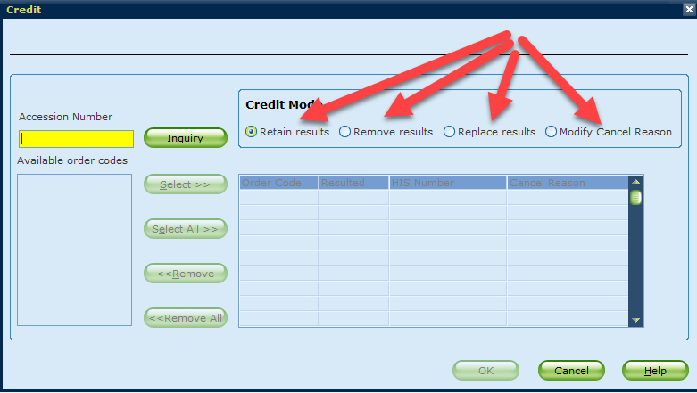 |  |  |  | Cancel Reason Codes
 | 13 | Retain results: Use this option if results are present and the lab needs to credit the order due to an unforeseen issue or other reasons after result entry has occurred. No Cancel Reason is required for this option. Select OK to complete the credit. This works for accessions that have been resulted and also for those yet to be resulted.  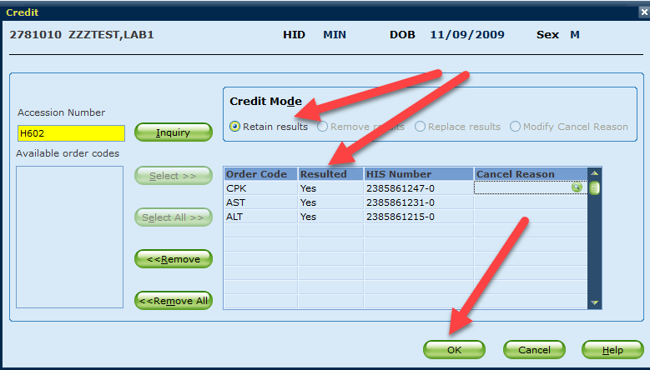
 | 14 | Replace results: Used for situations where the cancel reason will replace the result, create a correction statement automatically and perform the credit (CRW) all at the same time. To copy the cancel reason placed in the top box, just click on each box it applies to below it.  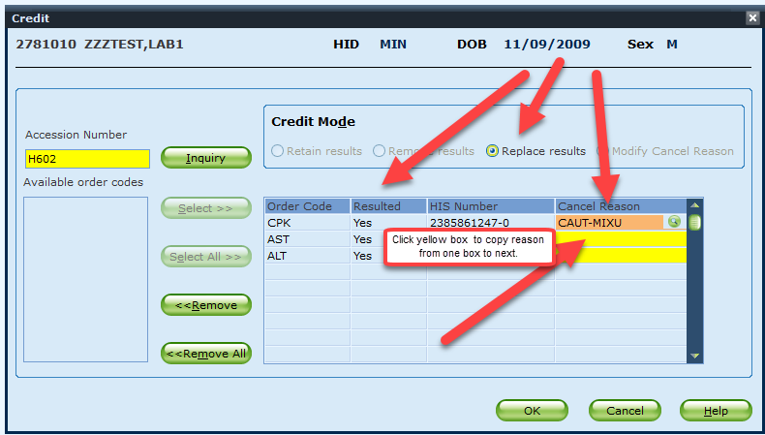
 | 15 | Click OK to apply the cancel reason code as the result. The system will apply a correction statement and the cancel will be complete.  Note: the replace results option can only be performed once for any accession. Once complete any further modification must occur in MEM or result entry.  The RP – result phoned and read back by must also be added in a result entry function.
 | 16 | Modify Cancel Reason: The example below was previously resulted with the Cancel Code HEM (HEMOLYSIS). The staff wanted to change the cancel reason to another code as they found it was the incorrect reason.  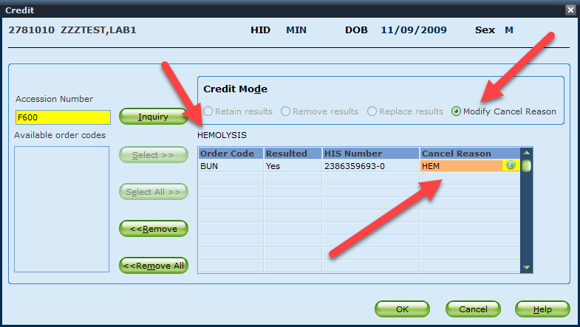
 | 17 | Click in the Cancel Reason cell and enter a new Code or lookup a code using the Search. Once you type, the original English Text code will disappear. You cannot append to the existing code here. If you want the original reason to stay, you will need to reenter it, ie, L-HEM and click OK to Save..  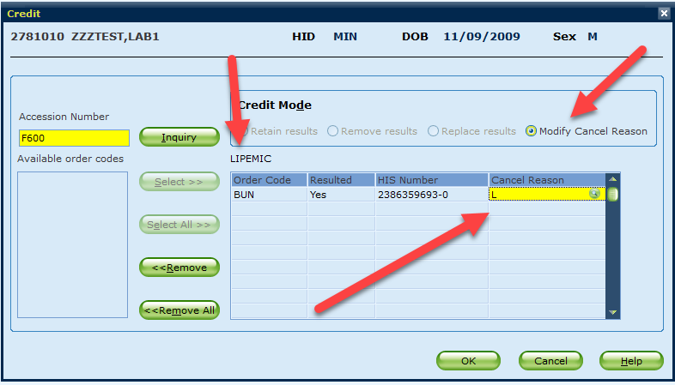
 | 18 | Notify the ordering provider or nursing unit of tests that will not be performed.  Discuss the need to re-collect the sample  - If an order needs to be rescheduled or re-ordered and that decision can be made during the cancellation notification, lab can replace the order. If the provider needs to be consulted, the nurse will re-enter the order after speaking with the provider.
References | Sunquest Manual
Historical Record | Version |  | Written/Revised by: | Effective Date: | Summary of Revisions
 | 1 |  | R Gulke | 05/09/2009 | Initial Version
 | 2 |  | R. Gulke | 04/01/2013 | Online version
 | 3 |  | Paula Mattson | 8/09/2019 | ORM in place of CR,CRW,OER

