GeneXpert Xpress Flu and Flu-RSV Assay

Purpose | This procedure provides instructions for performing the Xpert Xpress Flu and Flu-RSV assay on the Cepheid GeneXpert system.
Policy Statements | This procedure applies to all technical staff performing testing on the GeneXpert.
Principle and Clinical Significance | The Xpert Xpress Flu and Flu-RSV Assay is intended to aid in the diagnosis of Influenza (Flu) and Respiratory Syncytial virus (RSV) in patients with signs and symptoms of respiratory infection. The results are intended to be used in conjunction with clinical and epidemiological risk factors.  Influenza is a contagious viral infection of the respiratory tract. Transmission of the flu is primarily airborne, and the peak of transmission typically occurs in the winter months. Symptoms commonly include fever, chills, headache, malaise, cough, and sinus congestion. Gastrointestinal symptoms (i.e., nausea, vomiting or diarrhea) may also occur, primarily in children, but are less common. Symptoms generally appear within two days of exposure to an infected person. Pneumonia may develop as a complication due to influenza infection, causing increased morbidity and mortality in pediatric, elderly, and immunocompromised populations.  Influenza viruses are classified into types A, B, and C. Influenza A is the most common type of influenza virus in humans, and is generally responsible for seasonal flu epidemics and potentially pandemics. Influenza A viruses can also infect animals such as birds, pigs, and horses. Infections with influenza B virus are generally restricted to humans and less frequently cause epidemics. Influenza A viruses are further divided into subtypes on the basis of two surface proteins: hemagglutinin (H) and neuraminidase (N). Seasonal flu is normally caused by subtypes H1, H2, H3, N1 and N2. In addition to seasonal flu, a novel H1N1 strain was identified in humans in the United States in early 2009.  Respiratory Syncytial Virus (RSV), a member of the Pneumoviridae family (formerly Paramyxoviridae), consisting of two strains (subgroups A and B) is also the cause of a contagious disease. RSV primarily affects infants, and the elderly who are immunocompromised. The virus can remain infectious for hours on countertops and toys and can cause both upper respiratory infections, such as colds, and lower respiratory infections manifesting as bronchiolitis and pneumonia. By the age of two years, most children have already been infected by RSV and because only weak immunity develops, both children and adults can be reinfected. Symptoms appear four to six days after infection and are usually self-limiting, lasting approximately one to two weeks in infants. In adults, infection lasts about 5 days and presents as symptoms consistent with a cold, such as rhinorrhea, fatigue, headache, and fever. The RSV season mirrors influenza somewhat as infections begin to rise during the fall through early spring.  The Xpert Xpress Flu/RSV Assay is an automated in vitro diagnostic test for qualitative detection of influenza A, influenza B, and RSV viral RNA from nasopharyngeal (NP) swab and nasal swab (NS) specimens collected from patients with signs and symptoms of respiratory infection. The assay is performed on Cepheid GeneXpert Instrument Systems. The GeneXpert Instrument Systems automate and integrate sample extraction, nucleic acid purification and amplification, and detection of target sequences from clinical specimens by using reverse transcription (conversion of RNA templates into DNA) followed by real-time PCR. The primers and probes in the Xpert Xpress Flu/RSV Assay are designed to amplify and detect unique sequences in the genes that encode the following proteins: influenza A matrix (M), influenza A basic polymerase (PB2), influenza A acidic protein (PA), influenza B matrix (M), influenza B non-structural protein (NS), and the RSV A and RSV B nucleocapsid. The Xpert Xpress Flu/RSV Assay is intended as an aid in the diagnosis of influenza and respiratory syncytial virus infections in conjunction with clinical and epidemiological risk factors.
Test Code | FABP: Flu  RIP: Flu/RSV
Sample | - Acceptable specimens:  - Nasopharyngeal (NP) swabs: Mini-tip flocked swabs placed in 3mL UTM  - Nasal swabs: Flocked swabs placed in 3mL UTM  - SDES codes/Specimen type:  - NP – Nasopharyngeal Swab  - NARE – Nasal Swab  - Specimen Collection and Transport:  - Refer to Lab Test Directory on StarNet  - Specimen assessment:  - Refer to the policy MCVI 2.1 Specimen Rejection Criteria  - Specimen Storage  - Specimens should be refrigerated (2–8 °C) up to seven days until testing is performed  - Specimens can be stored at room temperature (15–30 °C) for up to 24 hours if required
Special Safety Precautions | Microbiologists/virologists are subject to occupational risks associated with specimen handling. Refer to the safety policies located in the safety section of the Microbiology and Virology Policy Manual:  - Biohazard Containment  - Safety in the Microbiology/Virology Laboratory  - Biohazardous Spills
Materials | Reagents Supplies Equipment  - 10% bleach - 70% ethanol - Xpert Xpress Flu/RSV Assay cartridges - Transfer pipettes - Simple racks - Cartridge transfer tray - Gloves Store kits at 2-28°C. Kits are stable until the expiration date printed on the outer box. - Biosafety Hood - Cepheid GeneXpert Instrument and computer - Printer
Calibration | Annual “Xpert Check Kit” calibration performed by Cepheid.
Quality Control | Daily Quality Control:  Once an Xpert cartridge has been loaded and before the sample processing steps begin, the software checks the optics, the readiness of the module’s mechanical components, and the ambient temperature of the module to assure proper performance of PCR, and the physical integrity of the cartridge.  Each test includes a Sample Processing Control (SPC) and a Probe Check Control (PCC).  - SPC: Ensures the sample was correctly processed. The SPC is an Armored RNA® that is included in each cartridge to verify adequate processing of the sample. The SPC verifies that release of RNA from the influenza and RSV viruses has occurred if the organism is present and verifies that the specimen processing is adequate. Additionally, this control detects specimen-associated inhibition of the RT-PCR and PCR reactions. The SPC should be positive in a negative sample and can be negative or positive in a positive sample. The SPC passes if it meets the validated acceptance criteria.  - If the sample is negative for Flu and RSV viruses and the SPC fails, the result will be INVALID. The assay result is INVALID if all targets are reported negative and the SPC does not meet the validated acceptance criteria.  - PCC: Performs a check on the amplification portion of the assay. Before the start of the PCR reaction, the GeneXpert Instrument System measures the fluorescence signal from the first PCC (QC1 and QC2) performed before the reverse transcription step.  - QC1 checks for the presence of the EZR bead and QC2 checks for the presence of the TSR bead.  - The second PCC (Flu A 1, Flu A 2, Flu B, RSV, and SPC) is performed after the reverse transcription step and before PCR begins. The PCC monitors bead rehydration, reaction tube filling, probe integrity, and dye stability.  - The PCC passes if it meets the validated acceptance criteria. If any of the PCC criteria fail, the test results in an ERROR.  External Quality Control:  - Perform QC using external positive and negative controls every 30 days. Record results in the GeneXpert assay binder on the Log.  - See IQCP document.  - See Quality Control Procedure.  New Lot/Shipment Quality control:  - Perform QC using external positive and negative controls with each new lot or shipment before putting into service. Record results in the GeneXpert assay binder on the Log.  - See Quality Control Procedure  Wipe testing control:  - Perform wipe testing every 30 days to monitor for contamination.  - See Quality Control Procedure.  NOTE: External quality control may be performed on an as needed basis if certain circumstances arise. Examples include:  - Drift in results (e.g., increasing/decreasing positivity rates)  - Potential contamination (negative control)  - After drastic system maintenance
Procedure | Cartridge preparation:  - Clean hood with10% bleach (made daily) followed by 70% ethanol.  - Change gloves.  - Obtain an Assay cartridge, transfer pipette, and sample transport tube to be tested.  - Label the side of the cartridge with a bar-coded foot-label.  - Open the cartridge lid.  - Mix the sample by inverting 5-10 times.  - Open the transport tube lid and draw up specimen in the transfer pipette by completely squeezing the fill bulb (bulb closer to the shaft of the pipette).  - Insert the pipette to the bottom of the well in the cartridge (see Figure 1) and empty the pipette’s content into the cartridge.  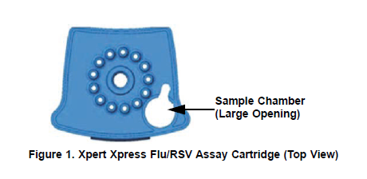  - Close the cartridge lid, and set onto the transfer tray.  - Change gloves and proceed to prepare additional samples or start the test.  NOTES:  -Hood surfaces must be cleaned between samples with 10% bleach followed with 70% ethanol if there were any splashes, spills, or uncertainty of cleanliness.  -**Start the test within 30 minutes of adding the sample to the cartridge  Starting the test:  - Ensure clean gloves are on before stepping to the computer work space.  - If instrument and computer are turned off: start up the instrument by flipping the power switch located in the back of the instrument. Turn on the computer next.  - Log onto the appropriate Windows account:  - User: lab1  - Password: labstaff4  - The GeneXpert software will launch automatically. If it doesn’t double-click the GeneXpert Dx software shortcut icon on the desktop.  - Log onto the software.  - User: First 6 letters of your first and last name (combined)  - Password: First 6 letters of your first and last name (combined)  - In the GeneXpert System window, click Create Test.  - Navigate to the Sample ID box. Scan or type in the sample ID.  - Scan the barcode on the cartridge.  NOTE: if the barcode on the cartridge does not scan, then repeat the test with a new cartridge.  - If prompted, select the appropriate assay from the Select Assay MENU.  - Select the appropriate test type for samples or controls.  - Enter additional information in the “notes” field (day of QC, collect date, etc.) if needed.  - Click Start Test. Tests will run for approximately 30 minutes.  - Enter your username and password, if requested.  - Open the instrument module door with the blinking green light.  NOTE: when setting up for testing you may opt to use any available module.  - With the barcode facing towards you, set the cartridge into the module and close the door.  - Wait for the test to start and the light to stop blinking. The test will run for approximately 30 minutes.  NOTE: Early assay positive call out may occur prior to 30 minutes.  - Remove the cartridge when testing is finished (the light will be off and the system will release the door lock).  - Dispose of used cartridges into bio-bags and place into biohazard sharps bins.  - Clean any equipment used (pipettes, racks, transfer tray, etc.), hood, and counters (including keyboard, scanner, and mouse) at the end of the day.  NOTE: Sample processing, testing, and cleaning should follow a unidirectional work-flow to avoid contamination.
Interpretation/ Results | - Click on View Results on the top drop-down menu bar and select View Test.  - Select the result you would like to review: Click OK.  - The results reported are interpreted automatically by the GeneXpert Instrument System.  - Review result interpretations and amplification curves for exponential growth. See Figure 2.  - NOTE: SPC does not need to pass for a positive result to be valid.  - NOTE: the SPC does need to pass for a negative result to be valid.  - Click on the Errors tab to ensure no errors occurred during testing. (Section 9.18.2 in Operator Manual provides error code descriptions)  Figure 2: Amplification curves  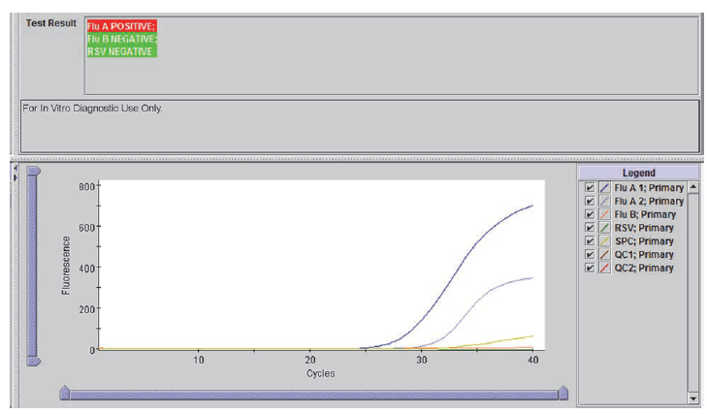  Influenza Interpretation:  - The Xpert Xpress Flu/RSV Assay has two channels (Flu A 1 and Flu A 2) to detect most influenza A strains.  - All influenza A strains detected by the Xpert Xpress Flu or Flu/RSV Assay are reported as Flu A POSITIVE.  NOTE: Either the Flu A 1 or Flu A 2 channel need to be positive in order for a Flu A POSITIVE test result to be reported.  - Table 1 below lists all the possible test results for Flu A.  Table 1: Possible Flu A Results  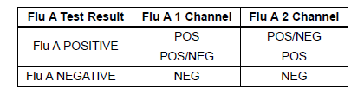  - Table 2 below lists possible results and interpretations.  Table 2: Flu/RSV Instrument Results and Interpretations  Result Interpretation  Flu A POSITIVE Flu B NEGATIVE RSV NEGATIVE Flu A target RNA is detected; Flu B target RNA is not detected; RSV target RNA is not detected. - SPC – N/A; SPC is ignored because the Flu A target amplification may compete with this control - Probe Check – PASS; all probe check results pass  Flu A POSITIVE Flu B POSITIVE RSV NEGATIVE** Flu A target RNA is detected; Flu B target RNA is detected; RSV target RNA is not detected. - SPC – N/A; SPC is ignored because the Flu A and Flu B target amplification may compete with this control - Probe Check – PASS; all probe check results pass - **Repeat test to confirm dual positivity  Flu A POSITIVE Flu B NEGATIVE RSV POSITIVE Flu A target RNA is detected; Flu B target RNA is not detected; RSV target RNA is detected. - SPC – N/A; SPC is ignored because the Flu A and RSV target amplification may compete with this control - Probe Check – PASS; all probe check results pass  Flu A POSITIVE Flu B POSITIVE RSV POSITIVE** Flu A target RNA is detected; Flu B target RNA is detected; RSV target RNA is detected. - SPC – N/A; SPC is ignored because the Flu A, Flu B and RSV target amplification may compete with this control - Probe Check – PASS; all probe check results pass - **Repeat test to confirm dual positivity  Flu A NEGATIVE Flu B POSITIVE RSV NEGATIVE Flu A target RNA is not detected; Flu B target RNA is detected; RSV target RNA is not detected. - SPC – N/A; SPC is ignored because the Flu B target amplification may compete with this control - Probe Check – PASS; all probe check results pass  Flu A NEGATIVE Flu B NEGATIVE RSV POSITIVE Flu A target RNA is not detected; Flu B target RNA is not detected; RSV target RNA is detected. - SPC – N/A; SPC is ignored because the RSV target amplification may compete with this control - Probe Check – PASS; all probe check results pass  Flu A NEGATIVE Flu B POSITIVE RSV POSITIVE** Flu A target RNA is not detected; Flu B target RNA is detected; RSV target RNA is detected. - SPC – N/A; SPC is ignored because the Flu B and RSV target amplification may compete with this control - Probe Check – PASS; all probe check results pass - **Repeat test to confirm dual positivity  Flu A NEGATIVE Flu B NEGATIVE RSV NEGATIVE Flu A target RNA is not detected; Flu B target RNA is not detected; RSV target RNA is not detected. - SPC – PASS; SPC has a Ct within the valid range and endpoint above the threshold setting - Probe Check – PASS; all probe check results pass  INVALID SPC does not meet acceptance criteria. Presence or absence of the target RNAs cannot be determined. Repeat testing.  ERROR Presence or absence of the target RNAs cannot be determined. Repeat testing. Flu A – NO RESULT Flu B – NO RESULT RSV – NO RESULT SPC – NO RESULT Probe Check – FAIL*; all or one of the probe check results failed. *If the probe check passes, the error was caused by the maximum pressure limit exceeding the acceptable range or by a system component failure.  NO RESULT Presence or absence of the target RNAs cannot be determined. A NO RESULT indicated that insufficient data were collected. For example, the operator stopped a test that was in progress or power failure occurred. Repeat testing. Flu A – NO RESULT Flu B – NO RESULT RSV – NO RESULT SPC – NO RESULT Probe Check – N/A  **If repeat testing yields the same results – report sample as a dual positive  Reasons to retest the original sample:  - An INVALID result (SPC failure). This may indicate:  - The sample was not properly processed.  - PCR was inhibited.  - An ERROR result. This may indicate:  - The reaction tube was filled improperly.  - A reagent probe integrity problem was detected.  - The maximum pressure limit was exceeded.  - A valve positioning error was detected.  - NO RESULT:  - This result indicated that insufficient data were collected (e.g. test stopped while in progress or power failure occurred).  - A dual positive result was obtained upon initial testing  Retesting procedure:  - Obtain the original sample and a new cartridge.  - Retest the sample according to the instructions in this SOP.  - Report results according to Table 3 below.  Table 3: Retesting results and interpretation  Initial result Repeat Result Report  INVALID INVALID Unresolved  VALID Valid results  ERROR ERROR or INVALID Unresolved  VALID Valid results  NO RESULT NO RESULT, ERROR or INVALID N/A – repeat testing  Dual Positive Dual Positive (matches) Report dual positive  Single positive Consult Technical Specialist or Technical Director  - See the instructions below for reporting unresolved results.  NOTE: Record any failure, errors, and repeat testing on the “GeneXpert Service and Error Log” log.
Result Reporting

- Ensure that the printer is turned on.
  - Reports will print automatically.

- Valid results will automatically transmit to the LIS and be auto-verified.
NOTE: you must check your results upon completion of testing to ensure validity of results
NOTE: samples positive for Flu A and Flu B will NOT auto-verify. The provider must be notified that there is a delay in testing. These samples must be retested before verifying results.

- At the end of the shift call a completed worksheet for RIP check results, and staple to GeneXpert Report. Place in the GeneXpert Flu, Flu/RSV result binder.

- Store samples in fridge:
  - Put in rack according to day of the week
  - Mark positive samples with X on the cap, and write results on the tube.

- Write results on the label and place in the bin.

- Discard old samples after 7 days.

Critical Results | No critical result values.
Reporting confirmed Flu A and Flu B dual positive results | - Log into Sunquest to release results.  - Select Result Entry from Menu options 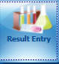  - In the Configuration field select CGX from the dropdown box.  - Click on the button located in the lower right corner to populate the transmitted results.  - Review messages located on the top and results. Compare results to the GeneXpert report.
Reporting Invalid (unresolved) Results | - Notify the care provider of the unresolved result.  - Log into Sunquest to release results.  - Select Result Entry from Menu options  - In the Configuration field select CGX from the dropdown box.  - Click on the button located in the lower right corner to populate the transmitted results.  - Review messages located on the top and results. Compare results to the GeneXpert report.  - The result will be reported as unresolved (UNRE) and the following code SIA will automatically append: “This sample is inhibitory to amplification and the results are inconclusive. Consider repeat collection if clinically indicated.”  - Add the code CAL, press tab, enter semi-colon record who the result was relayed to and the date/time.
Correcting Results | - Open Result Entry, select the Manual resulting mode (top left corner), from the configuration drop down select the appropriate test. Click in the lower right corner.  - Enter the Specimen ID, enter Tab and click Yes to modify the result.  - Change the incorrect result. The corrected result comment will automatically append. Add the CAL comment, press tab, enter a semi-colon and record who was called and the time/date.  - Click . Click when the “Verify Release Destination” window opens.
Limitations | Xpress Flu Assay Limitations:  - The performance of the Xpert Xpress Flu Assay was validated using the procedures provided in the package insert only. Modifications to the procedures may alter the performance of the test.  - Results from the Xpert Xpress Flu Assay should be interpreted with other laboratory and clinical data available to the clinician.  - Erroneous test results might occur from improper specimen collection; failure to follow the recommended sample collection, handling, and storage procedures; technical error; sample mix-up; or because the number of organisms in the specimen is too low to be detected by the test.  - Negative results do not preclude influenza virus infection and should not be used as the sole basis for treatment or other patient management decisions.  - Results from analytical studies show potential for competitive inhibition in specimens with both influenza A and influenza B viruses present. However, numerous studies have shown that infections with combinations of only these specific viruses (FluA, and Flu B) occur in <1.6% of patients.  - The Xpert Xpress Flu Assay uses EAT. In the event of a mixed Flu A and Flu B infection, the target with the higher titer of the two infections may be reported as POSITIVE and the lower titer target may be reported as NEGATIVE.  - Results from the Xpert Xpress Flu Assay should be correlated with the clinical history, epidemiological data, and other data available to the clinician evaluating the patient.  - Viral nucleic acid may persist in vivo, independent of virus viability. Detection of analyte target(s) does not imply that the corresponding virus(es) are infectious or are the causative agents for clinical symptoms.  - This test has been evaluated for use with human specimen material only.  - If the virus mutates or there are other sequence changes in the target region, influenza virus may not be detected, or may be detected less predictably.  - Positive and negative predictive values are highly dependent on prevalence. The performance may vary depending on the prevalence of the different viruses and population tested.  - This test is a qualitative test and does not provide the quantitative value of detected organism present.  - This test has not been evaluated for patients without signs and symptoms of influenza infection.  - This test has not been evaluated for monitoring treatment of influenza infection.  - This test has not been evaluated for screening of blood or blood products for the presence of influenza.  - This test cannot rule out diseases caused by other bacterial or viral pathogens.  - The effect of interfering substances has only been evaluated for those listed within the labeling. Interference by substances other than those described can lead to erroneous results.  - Cross-reactivity with respiratory tract organisms other than those described herein can lead to erroneous results.  - This assay has not been evaluated for immunocompromised individuals.  - Recent patient exposure to FluMist® or other live attenuated influenza vaccines may cause inaccurate positive results.  - Although this test has been shown to detect A/H1N1 (pre-2009 pandemic), A/H7N9 (detected in China in 2013) and A/H3N2v viruses cultured from positive human respiratory specimens, the performance characteristics of this device with clinical specimens that are positive for the A/H1N1 (pre-2009 pandemic), A/H7N9 (detected in China in 2013) and A/H3N2v viruses have not been established.  - This test is not intended to differentiate Influenza A subtypes or Influenza B lineages. If differentiation of specific influenza subtypes and strains is needed, additional testing, in consultation with state or local public health departments, is required.  Xpress Flu/RSV Assay Limitations:  - The performance of the Xpert Xpress Flu/RSV Assay was validated using the procedures provided in the package insert. Modifications to the procedures may alter the performance of the test.  - Results from the Xpert Xpress Flu/RSV Assay should be interpreted with other laboratory and clinical data available to the clinician.  - Erroneous test results might occur from improper specimen collection; failure to follow the recommended sample collection, handling, and storage procedures; technical error; sample mix-up; or because the number of organisms in the specimen is too low to be detected by the test. Careful compliance with the instructions in this insert is necessary to avoid erroneous results.  - Negative results do not preclude influenza virus or RSV infection and should not be used as the sole basis for treatment or other patient management decisions.  - Results from analytical studies show potential for competitive inhibition in specimens with two different viruses.  - When using the Xpert Xpress Flu/RSV Assay in the Flu Only mode, in the event of a mixed infection one of two infections may be reported as NEGATIVE.  - Results from the Xpert Xpress Flu/RSV Assay should be correlated with the clinical history, epidemiological data, and other data available to the clinician evaluating the patient.  - Viral nucleic acid may persist in vivo, independent of virus viability. Detection of analyte target(s) does not imply that the corresponding virus(es) are infectious or are the causative agents for clinical symptoms.  - This test has been evaluated for use with human specimen material only.  - If the virus mutates or there are other sequence changes in the target region, influenza virus and/or RSV may not be detected, or may be detected less predictably.  - Positive and negative predictive values are highly dependent on prevalence. The performance may vary depending on the prevalence of the different viruses and population tested.  - This test is a qualitative test and does not provide the quantitative value of detected organism present.  - This test has not been evaluated for patients without signs and symptoms of influenza or RSV infection  - This test has not been evaluated for monitoring treatment of influenza or RSV infection.  - This test has not been evaluated for screening of blood or blood products for the presence of influenza or RSV.  - This test cannot rule out diseases caused by other bacterial or viral pathogens.  - The effect of interfering substances has only been evaluated for those listed within the labeling. Interference by substances other than those described can lead to erroneous results.  - Cross-reactivity with respiratory tract organisms other than those described herein can lead to erroneous results.  - This assay has not been evaluated for immunocompromised individuals.  - Recent patient exposure to FluMist® or other live attenuated influenza vaccines may cause inaccurate positive results.  - Although this test has been shown to detect A/H1N1 (pre-2009 pandemic), A/H7N9 (detected in China in 2013) and A/H3N2v viruses cultured from positive human respiratory specimens, the performance characteristics of this device with clinical specimens that are positive for the A/H1N1 (pre-2009 pandemic), A/H7N9 (detected in China in 2013) and A/H3N2v viruses have not been established.  - This test is not intended to differentiate RSV subgroups, Influenza A subtypes or Influenza B lineages. If differentiation of specific RSV or influenza subtypes
Method Performance Specifications | According to the manufacturer (per the package insert) – see Tables 4 and 5 Below.  Table 4: Overall specifications for NP specimens  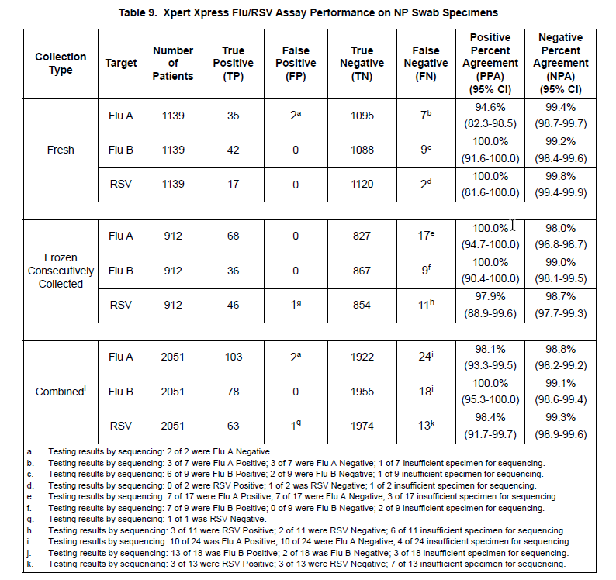  Table 5: Overall specifications for Nasal specimens  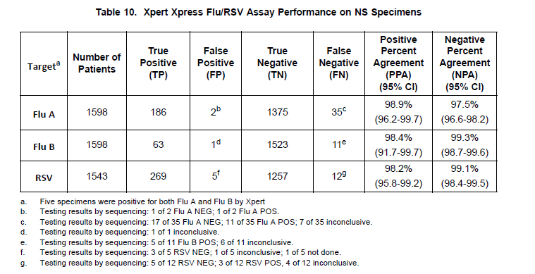
References | Xpert Xpress Flu Package Insert, 301-7268, Rev. D, August 2018. Sunnyvale, CA: Cepheid.  Xpert Xpress Flu/RSV Package Insert, 301-7239, Rev. B, August 2018. Sunnyvale, CA: Cepheid.  Influenza (Flu) Atlanta, GA: Centers for Disease Control and Prevention; 2019 [Available from: https://www.cdc.gov/flu/index.htm.]  Respiratory Syncytial Virus Infection (RSV) Atlanta, GA: Centers for Disease Control and Prevention; 2018 [Available from: https://www.cdc.gov/rsv/index.html.]
Alternate Methods | - Molecular - Respiratory Viral Panel testing
Proficiency Testing | CAP materials: 3 shipments a year with 5 samples: ID3
Training Plan/ Competency Assessment | Training Plan |  |  | Initial Competency Assessment
 | - Employee must read the procedure.  - Employee will demonstrate the ability to perform procedure, record results, and document corrective action after instruction by the trainer. |  |  | - Direct observation
Historical Record
 | Version | Written/Revised by: | Effective Date: |  | Summary of Revisions
 | 1 | Julie Laramie | 9/30/2019 |  | Initial Version
 | Archived by: |  | Archived Date:

