Order Entry in Sunquest

Purpose | This procedure provides instructions for ORDER ENTRY IN SUNQUEST, for those situations in which the lab must place the order in the system.
Policy  Statements | - This procedure applies to all laboratory staff.
Procedure | Follow the activities in the table below to ENTERING ORDERS IN SUNQUEST.
 | Step | Action | Related Documents
 | 1 | Log into the Sunquest Gateway.
 | 2 | Select the folder Order Entry by double clicking. A new window appears.
 | 3 | To order lab tests, select the Order option. The default order option is Orders. To select another option, click the down arrow.
 | 4 | At the Lookup By window, select a patient search option from the drop-down list, and type the search data in the Value field. To search, click the Search button.  - If the patient is new, the demographics window will appear so that you can register the patient.  - If you are adding tests to an existing order, select Accession Number. | LIS 1.1 ADT
 | 5 | Patient(s) matching the search criteria display(s) in the Patient window. Single-click the desired patient. Patient events display in Event Selection in reverse chronological order, the most current event displaying first. Click the correct event to highlight it, and then click Select (bottom of screen).  Verify the patient location. The location of reference lab patients should match the ordering facility on the requisition.
 | 6 | In General Information, enter:  - Collect date  - Collect time  - Ordering physician (yellow highlighted fields are mandatory)  If you are working on a past order, enter:  - Receive date & time  - Phlebotomist code  - Workload
 | 7 | If the testing is to be done at no charge, enter NC in the Bill to field
 | 8 | Enter the ordering physician:  - Check the requisition and enter the ordering physician.  - To search for a physician in the system, click the ellipsis next to the Order Physician field.  - Type the physician’s last name in the physician field.  - In Search Value, click the radio button for Description.  - In Search Type, click the radio button for Both.  - If you do not find the physician listed, click the button NEW on the right hand side of the search box.  - A box opens to allow you to enter this provider as an OUTSIDE physician.  - Enter the physician’s full name and address.  - Send a mailbox to LIS with the information for the provider you have just entered as an OUTSIDE physician. LIS will submit the physician to DRS to assign a community number if necessary.
 | 9 | In the Order Code field, enter the order code.  - If you don’t know the order code, click the order code field. The look up button will appear; click it to open the Select Test window. Choose the Description radio button and in the Test field enter the first few letters of the test name, then click search.  - A list of tests will display. Highlight the correct test, and then click Select at the bottom of the screen. Either enter the appropriate modifier in the Modifier field or click the look up button to obtain the appropriate modifier.
 | 10 | To generate an accession number, click the Assign Acc button.  - If at any time in steps above you realize that some data is incorrect, click the Clear button to clear the unsaved data and start again.
 | 11 | To save the data entered, click Save.
 | 12 | If placing orders for a time in the past, you will see a pop-up listing all container IDS that you shold have received.  You will need to make sure you havbe allcontainers or remove the container.  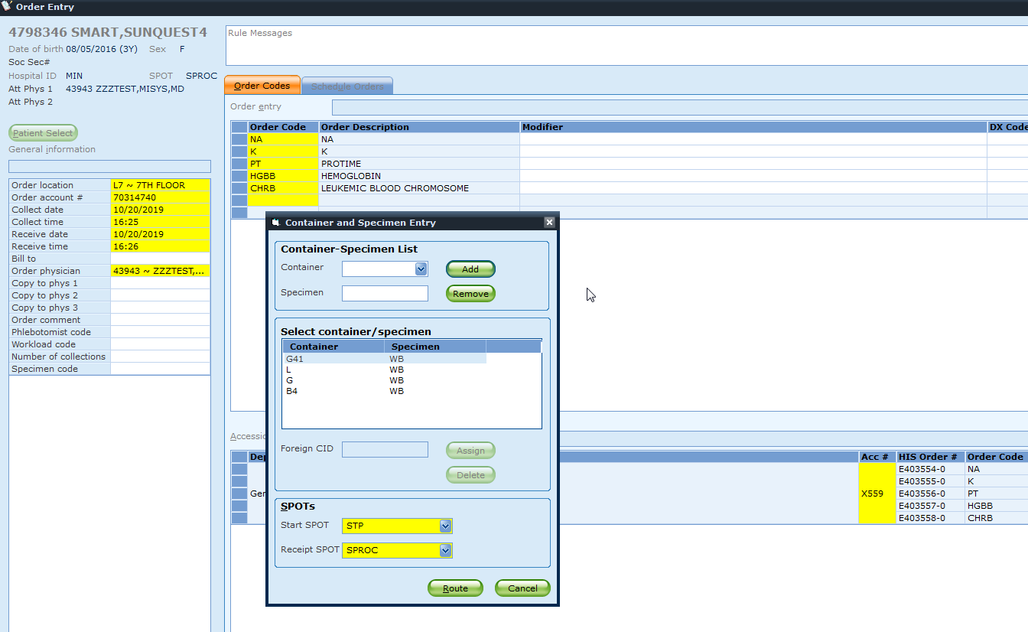
 | 13 | Additional Notes:  - To place an order in the lab system, lab staff must have either a written order, or they must follow the procedure for obtaining written orders  - For outpatients at the lab for testing, lab staff must check for electronic orders in Sunquest, future on hold orders in Powerchart, and paper orders.  - Future (On Hold) orders can be activated + or – 30 days from the requested date/time. If the patient arrives outside of the 30 days, you must call the provider to see if the testing is still necessary.  - Pay special attention to the special instructions field for any special collection requirements entered by the provider as some orders need to be drawn at a more specific time frame than 30 days.  - Clinical Billing account orders do not go back to the HIS. The medical record number for these patients is created by using the location code - #######. The number can be either the medical record number for the referring facility or a number assigned by the system.
References | Sunquest 7.2 Manual
Training Plan/  Competency  Assessment | iMentor self-paced classes  New employee training  Upgrade Training  LIS Competencies
Historical record | Version Written/Revised by: Effective Date: Summary of revisions  1 P. Mattson 03/01/1990 Initial version  3 R. Gulke 08/11/2005 Move from RNS to windows  4 R. Gulke 08/07/2007  5 R. Gulke 07/08/2008 Added Procedural Notes  6 R. Gulke 03/14/2013 Online format Add future orders comments about special instructions.

