Adding Orders To A Past Draw Procedure

Purpose | This document provides instructions for ADDING ORDERS TO A PAST DRAW.
Policy  Statements | This document applies to any laboratory staff who adds testing to a previously drawn sample.
Procedure | Follow the activities in the table below for instructions on ADDING ORDERS TO A PAST DRAW.
 | Step | Action | Related Documents
 | 1 | Hospital staff place ADDTO order:  - Hospital staff place an order in the HIS selecting ADD to Sample (ADDTO) priority.  - Hospital staff enter in special instructions date/time of original sample.  - The ADDTO priority causes a label to print on the STAT label printer as notification to the lab of an additional order to be added to an already collected sample.
 | 2 | Lab receives notification of an ADDTO order and checks for specimen:  - The printed label is your alert that an ADDTO order has been placed. Orders placed with an Add to Sample priority are set immediately to InProcess status to prevent them from being canceled due to discharge.  Since the specimen type is replaced with a 1, orders on different specimen types maybe combined so check the orders carefully.  - Check for a valid specimen for testing (2 ways).  1) Go to ANIQ and enter the accession number  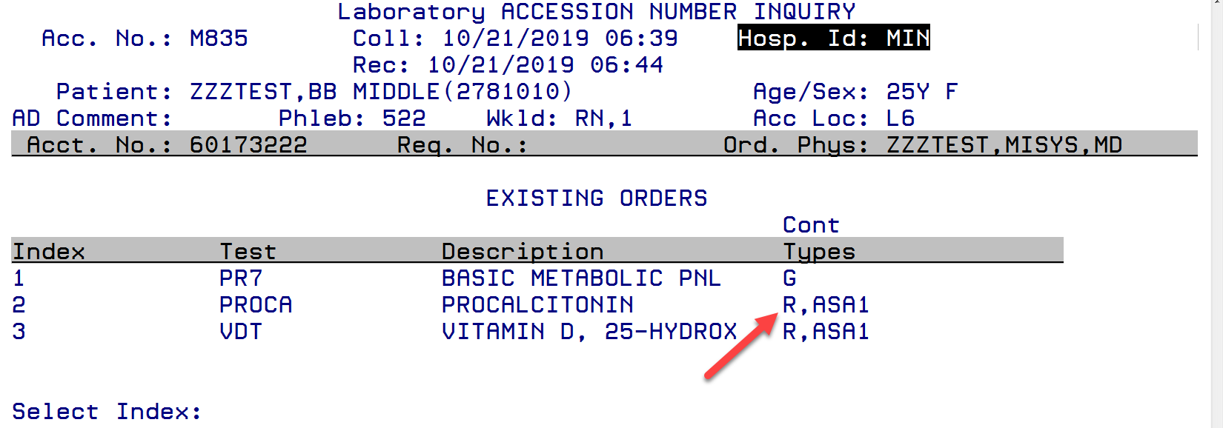  2) Go to SMART --> Tracking --> Specimen --> Location  Search by accession number  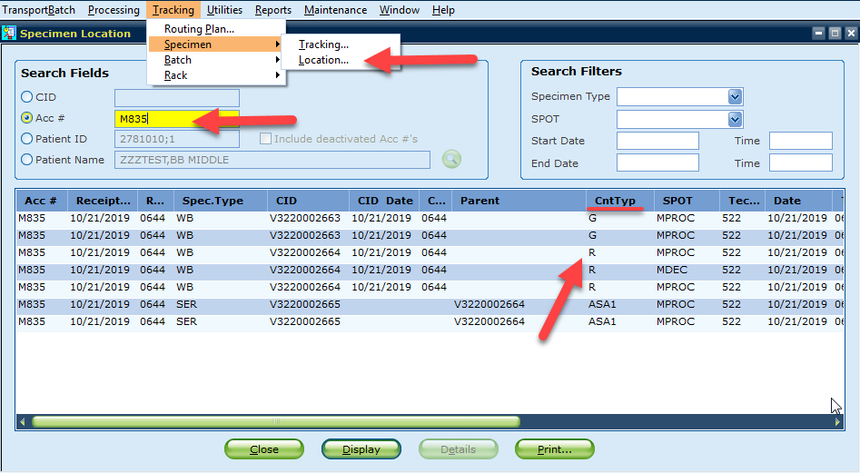
 | 3 | If sample is available:  - Cancel the test with the ADDTO priority using the code RAC (reassigned to a different accession number).  - Order the test(s) requested on the original accession number of the sample.
 | 4 | If sample is not available:  - Call the unit to notify them that the testing will be canceled.  - Cancel the test with the appropriate cancellation code. Document the notification to the unit.
 | 5 | Spot Code Examples after adding tests:  - Adding tests that need decant to already decanted samples  (PROCA-->VDT). * asterix will appear as spot code.  Need to go through the decant step one more time in SMART.  - Adding tests that don't need decant to already decanted samples (PR7-->VDT). MCHEM/SCHEM will appear as spot code and no extra process needed.  - Adding tests that need decant to samples that are not decanted (VDT-->PR7). MDEC/SDEC will appear as spot code and need to go through the decant step in SMART.  Please note: SMART will always automatically add tests to CID that has the same preferred tube type. For example, SMART will add PROCA to VDT CID when adding to an accession number that includes both VDT and PR7.
References | Sunquest Version Manual
Training and Competency | iMentor Self Paced Courses  LIS Checklist
Historical record | Version Written/Revised by: Effective Date: Summary of revisions:  1 P. Mattson 03/1990 Initial Version  2 R. Gulke 06/21/2005 New template  3 R. Gulke 06/11/2010 ADDTO priority replaces Add/Cancel Order  4 R. Gulke 03/14/2013 Online format  5 S. Kang 10/22/2019 How to check original container with SMART. Different spot code senario with add to orders.

