Racking Specimens

Purpose | This procedure provides instructions for racking specimens.
Policy Statements | - This procedure applies to all laboratory staff who process samples
 | Follow the activities in the table below to process samples through Decant.
Procedure | Step | Action |  |  |  | Related Document
A. The Main SQ GUI Menu Selection Screen will open, select SMART


B.
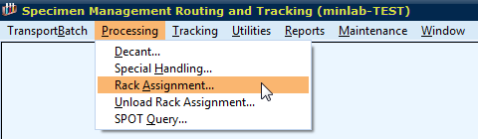
C. If creating a new rack:
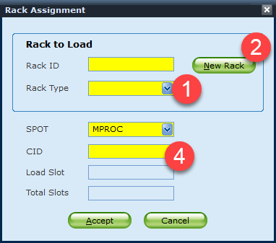

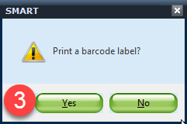

First select the rack type then press new rack button. Rack ID number will be automatically assigned. Then click Yes to print a Rack ID barcode label. Finally, scan CID numbers that need to be racked.

Rack IDs: MCHEMF- MIN Chemistry Freeze (Vista/Alinity 7 Days)
MI2502F- MIN Celiac/Allergen Freeze (1 Month)
MC14F- MIN Architect/ISYS Freeze (14 Days)
SCHEMF- STP Chemistry Freeze (Anything but XL 7 Days)
SXLF- STP Liaison Freeze (14 Days)

If adding samples to an existing rack:
First, scan the rack ID barcode. Rack type will be automatically filled in.
Then scan CID numbers that need to be racked.

NOTE: Multiple days of MIN Celiac/Allergen samples can be combined under one rack since they are kept for 1 month.
D. Order of racking specimens:
First, place a rack so that the side with rack ID holder stays on left side.
Then rack specimens from left to right and back to front.
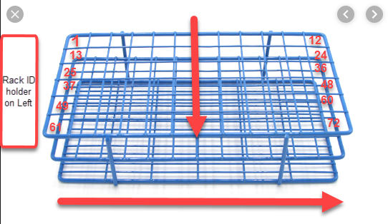

References | Sunquest 7.2 Manual
Training Plan/  Competency  Assessment | iMentor self-paced classes  New employee training  Upgrade Training  LIS Competencies
Historical Record | Version |  | Written/Revised by: | Effective Date: | Summary of Revisions
 | 1 |  | S. Kang | 10/22/2019 | Initial Version

