Transport Batches

Purpose | This procedure provides instructions for creating Transport Batches  This procedure provides instructions for transporting specimens in the Laboratory Information system. Transport batches will allow us to document where the samples are and allow for prompt testing once samples have arrived at the final destination. This procedure describes how to use Sunquest transport batches to track specimens sent from the originating site to its final destination.
Policies | - This procedure applies to all laboratory staff responsible for sending or receiving specimens between campuses within their departments.  - Lab staff within the respective departments will clearly identify which samples are being sent to the other campus for testing.  - All specimens transported between campuses must be tracked via a transport batch.  - Non-interfaced send out tests should have a transport batch created showing which samples have been sent to the Reference lab.
Procedure | Follow the activities in the table below for TRANSPORTING BATCHES.
 | Step | Action
 | 1 | Create a Transport Batch BETWEEN HIDs  - Open SMART  
- Select Transport Batch and Batch Formation and Edit
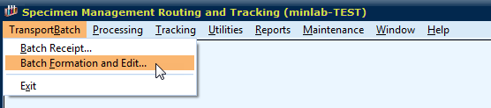

- How to create a transport batch list.
In batch formation scan the CID under Adding to List and select Add
The CIDS will appear in the list. A Batch ID is assigned when you select Save.
Print the batch to send.
In this example a batch has been created to transport from STP to MIN by scanning each CID
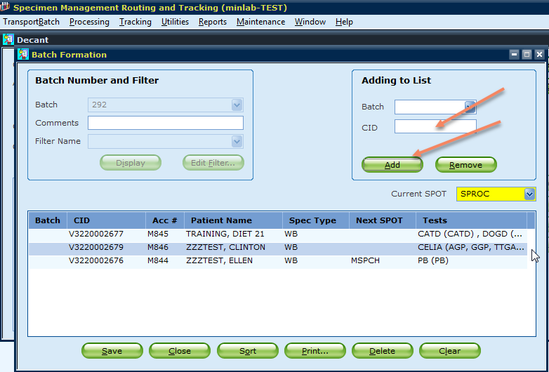

In this example, PKUs are being sent to MDH by scanning each CID
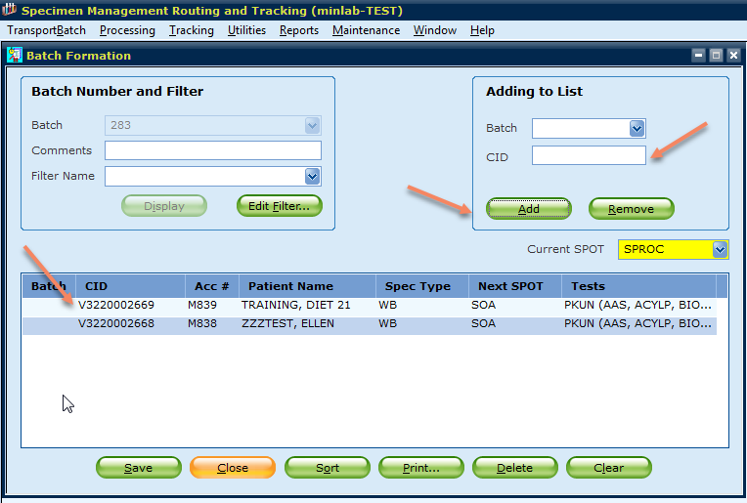
Print the batch list which can be the packing list you send to the reference lab.

- Filters are used to make sure you did not miss a sample.. Select a filter and confirm your default spot
MIN to STP
STP to MIN
STP to Min Micro
MIN SO
STP SO
In the STP to MIN batch above, there are 3 accession numbers. I can check I have every sample by selecting the STP to MIN filter. By using the filter, I found one more lead to add to my batch
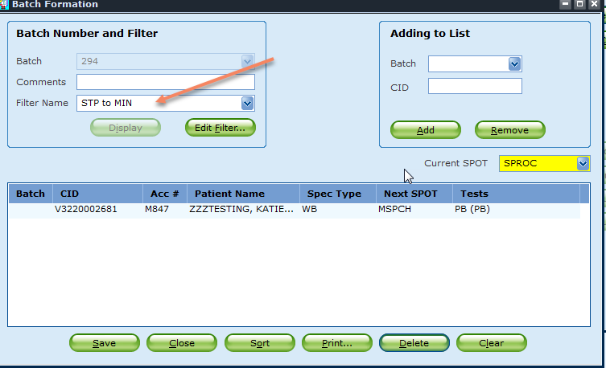
Locate the sample and close the batch created by the filter without saving.

- Modify a batch
Enter the ORIGINAL batch number under Batch Number and filter
In the example above the batch was 292
Scan the CID under adding to list. Select Save and print a new list
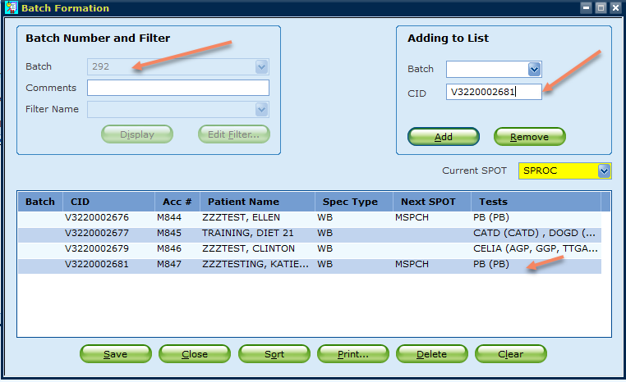

To remove a CID open the batch and select the CID and delete.
 | 2 | Receive a Batch
- Open SMART
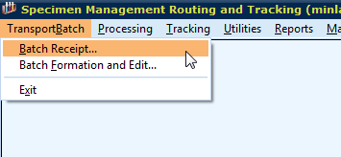
- Scan the batch ID and scan each container and accept container
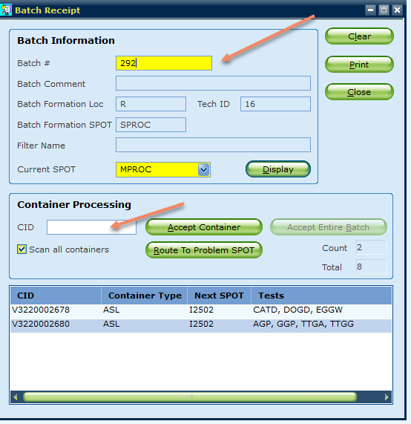

Procedure Notes | Any tests defined to download to an analyzer will not have a load list created until the CID is received in the final SPOT
References | Sunquest Version Manual
Training/  Competency  Assessment | SMART training
 | Version |  | Written/Revised by: | Effective Date: | Summary of Revisions
Historical Record | 1 |  | Chris Vevea | 03/15/2014 | Initial Version
 | 2 |  | Roxann Gulke | 03/28/2014 | Approved
 | 3 |  | Marisa Gremillion | 08/08/2017 | Changed notes for manual add to batch to be the last step
 | 4 |  | Roxann Gulke | 08/08/2017 | Approved
 | 5 |  | Roxann Gulke | 10/22/0209 | SMART

