# Respiratory Viral Panel (RVP) Appendix A1: Report Examples

1. **Sunquest RVP Keyboard used for resulting**

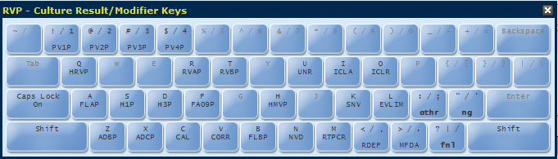

1. **Positive RVP results**
2. Enter positive results
3. Method (RTPCR)
4. Definition of testing (RDEF)
5. Modified FDA Test (MFDA)
6. Reference Range: Negative (;RRN)

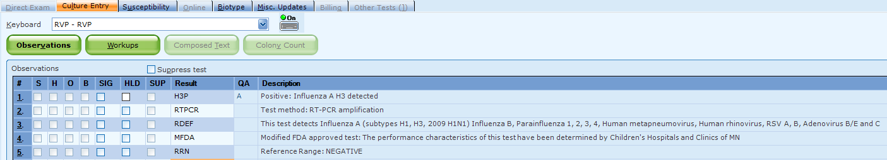

 Click the summary button to review report before filing

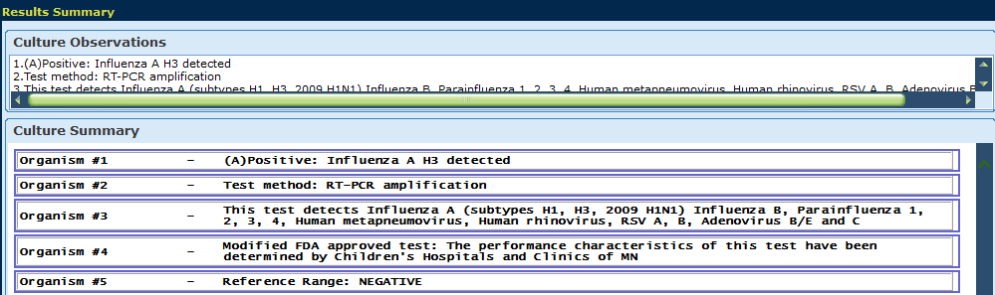

1. **Negative RVP results** for all viral agents
2. Enter NVD
3. Method (RTPCR)
4. Definition of testing (RDEF)
5. Modified FDA Test (MFDA)
6. Reference Range: Negative (;RRN)

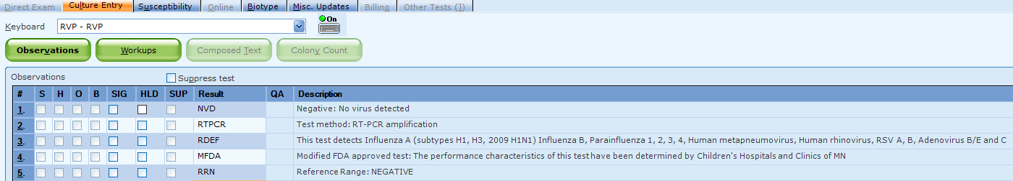

1. **\*\*Limitation: Enterovirus D68** and poliovirus may cross-react with human rhinovirus
2. If human rhinovirus is detected, EVLIM must be entered into the report
3. Method (RTPCR)
4. Definition of testing (RDEF)
5. Modified FDA Test (MFDA)
6. Reference Range: Negative (;RRN)

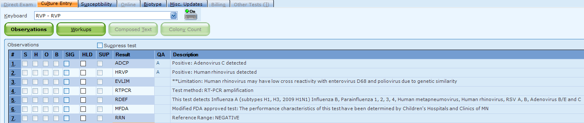

 Click the summary button to review report before filing

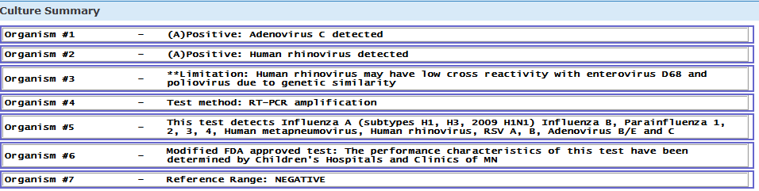

1. **Inconclusive results, repeat testing:** Perform a summary review for accuracy when using free text

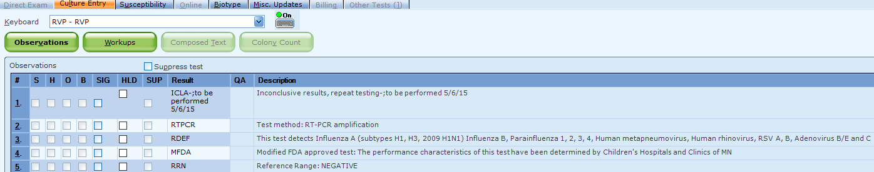



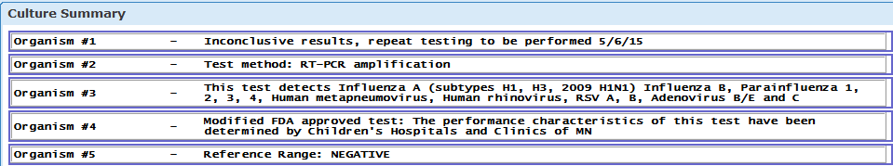

1. **Unresolved results:** Perform a summary review for accuracy when using free text

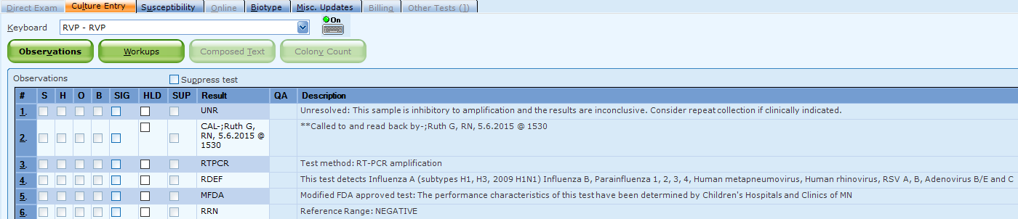



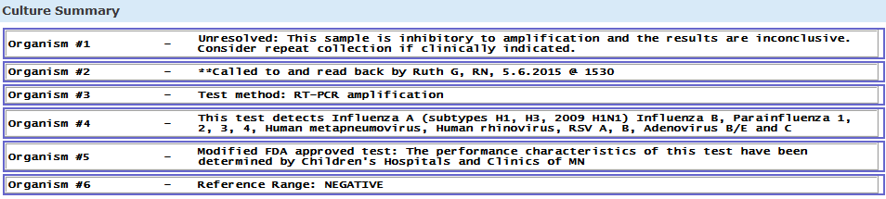

1. **Corrected report:** Perform a summary review for accuracy when using free text

