Water Cultures

Purpose | This procedure provides instructions for WATER CULTURES for the Microbiology Laboratory.
Policy Statements | This procedure applies to Microbiologists who perform culture set-up and plate reading.
Principle and Clinical Significance | Millipore Samplers provide a means for microbiological analyses of laboratory grade water. The sampler allows 1 ml of water to affix microorganisms to the membrane filter that is in contact with a nutrient pad. The filter is grid-marked to aid in counting the microbial colonies on the surface.
 | Supplies |  |  | Equipment
Materials | Millipore Heterotrophic Plate Count Sampler (HPC): color code – Red, catalog no. MHPC10025  Millipore Yeast and Mold Sampler: color code –Yellow, catalog no. MY0010025 |  |  | • Ambient air incubator
Sample | Evoqua Deionized water: This water is the result of deionization treatment beds and is available on tap in the dishwashing room, Chemistry, Special Chemistry and Microbiology.
Special Safety Precautions | Microbiologists are subject to occupational risks associated with specimen handling. Refer to the safety policies:  - Biohazard Containment  - Safety in the Microbiology Laboratory  - Biohazardous Spills
Procedure | Inoculation  Weekly, label 3 red samplers with the date and location, one for DI spigot in Special Chemistry, one for DI spigot in the dishwashing room and alternating each week, one for DI spigot in Microbiology or Chemistry.  Weekly, label 3 yellow samplers with the date and location, one from DI spigot in Special Chemistry, one for DI spigot in the dishwashing room and alternating each week, one from DI spigot in Microbiology or Chemistry.  Using a ChloroPrep pad, swab the end of the DI spigots. Flush for 30 seconds.  Fill water into the Sampler case, to the upper graduation line (18 ml).  - Insert the Sampler firmly into the case containing the water sample.  - Lay the Sampler face down for 30 seconds to allow water to be drawn through the filter. The filter will draw up 1 ml.  - Remove the paddle and with a firm snap, remove water from the case.  - Empty case and reinsert the paddle, securing firmly to prevent drying.  - Repeat steps 3-8 for each DI water culture.  - Incubation  - Incubate the Samplers gridded side down for 72 h in an ambient air incubator 35ºC.  - Culture examination  - After incubation, remove paddle from case and examine the surface using an illuminated magnifier.  - Bacterial colonies will appear glistening and translucent or transparent. Colors may vary from colorless to white, cream, yellow or red.  - Yeast usually have a satiny, opaque, green-yellow color.  - Molds will vary depending on the length of incubation time.  - Count the number of colonies and record as colony count/ml.  - If there are more than 1000 colonies, report as >1000 col/ml.  - Record results on the chemistry department water quality log sheet.
Limitations | - Store Millipore samplers at room temperature until expiry date.  - Avoid touching gridded surface.  - Unit should not be agitated after sample liquid is added. Make sure membrane is uniformly wetted. Ensure no more bubbles come out of vent prior to removing paddle.  - Number of colonies observed on the filter will be the number recorded.
Method Performance Specifications | - CAP Specifications:  - Type I : 10 col/ml  - Type II: 1000 col/ml  - Do not immerse the paddle longer than recommended, otherwise a loss of medium through the membrane and into the sample may occur.  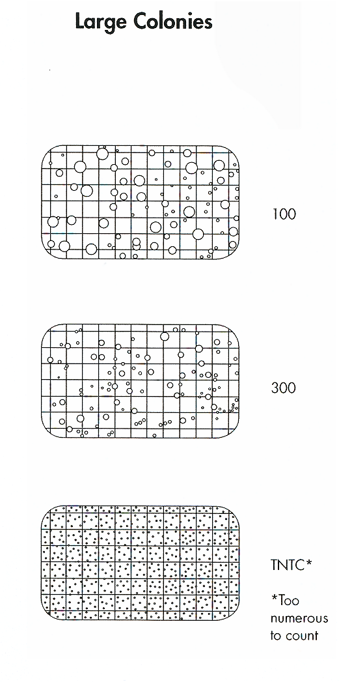
References | - CLSI. Preparation and Testing of Reagent Water in the Clinical Laboratory; Approved Guideline—Fourth Edition. CLSI document C3-A4. Clinical and Laboratory Standards Institute, 940 West Valley Road, Suite 1400, Wayne, PA 19087 USA, 2006.  - Reagent Water Specifications. College of American Pathologists, Commission on Laboratory Inspection and Accreditation. CAP Checklist 4/21/2014. GEN.41500  - Millipore product insert, P15325, Rev. G, 01/2012.
Training Plan/ Competency Assessment | Training Plan |  |  | Initial Competency Assessment
 | - Employee must read the procedure  - Employee will observe trainer performing the procedure.  - Employee will demonstrate the ability to perform procedure and record results after instruction by the trainer. |  |  | - Direct observation
Historical Record | Version | Written/Revised by: | Effective Date: |  | Summary of Revisions
 | 1 | Pat Ackerman | 08/26/1997 |  | Initial Version
 | 1.2 | Pat Ackerman | 09/02/2005 |  | Added interpretation cartoons
 | 1.3 | Becky Carlson | 07/01/2008 |  | Revised sampling time to 60 seconds per Millipore customer info.
 | 1.4 | Becky Carlson | 04/04/2015 |  | Re-numbered from MC 814
 | 2 | Jessica Craig | 04/09/2015 |  | Transferred to new format.
 | 3 | Susan DeMeyere | 3/2/2018 |  | Update logo, revise sampling time to 30 seconds per Millipore User Guide. Update Millipore reference. Added to Limitations section.
 | 4 | Susan DeMeyere | 2/10/2020 |  | Added yellow yeast and mold sampler. Add sampling dishwashing room DI spigot. Removed Millipore tubing sampling. Change to read at 72 hours.
 | Archived by: |  | Archived Date:

