Blood Bank Liquid Nitrogen Freezer Alarm Check

Purpose | This procedure provides instructions for verify the functionality of the audible alarm system on the liquid nitrogen freezer used to store cardiac tissue.
Policy Statements | - Alarm testing shall be performed initially with installation, after major repairs and a minimum of a quarterly basis  - The alarm should sound at a temperature that allows appropriate action to be taken before store components reach undesirable temperatures.  - Temperature changes should be allowed to occur slowly.  - Acceptable results  - High temperature of activation <-150°C
Related  Documents | TSf 17.14.2 Liquid Nitrogen Freezer Alarm Check Form
Materials | MVE Cryo Freezer Model MVE 510 AF-GB  - Serial Number: CAB2115040004
Procedure
 | Step | Action
 | 1 | Call Security at X55416 to alert them that you are testing alarms.
 | 2 | Press “SETUP”  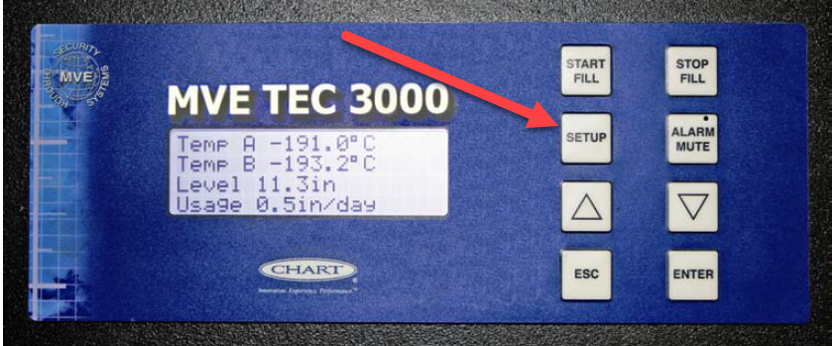
 | 3 | Enter the Password using the “▲/▼” keys to scroll to the appropriate number.  PASSWORD 3456
 | 4 | Press “Enter”  The display will read “Temperature Menus”
 | 5 | Press “Enter”  The display will read “Temp A Menu”
 | 6 | Press “Enter”  The display will “Temp A Enabled”
 | 6 | Press “Setup”  The display will read “Initiate High Temp A Alarm Test”. Use the “▲/▼” keys to change NO to YES and press “Enter” to initiate the alarm test.  Note: If High Temp Alarm Test is initiated, the display will read “Testing” and show the temp change throughout the test.
 | 7 | Record the digital temperature reading at which the alarm sounds, the date of the test, and techs initials on TSf 17.14.3.
 | 8 | Press the Alarm Silence button to silence the alarm.
 | 9 | Change Alarm test from Yes to NO using the “▲/▼” and press enter.
 | 10 | Hit the ESC button twice to get back to main screen
 | 11 | Confirm temperature returns to acceptable range.
 | 12 | Call security at X55416 to verify alarm sounds. Record on TSf 17.14.3
Interpretation | Acceptable results: Alarm activation at a temperature <-150°C  Take appropriate corrective action if temperatures of activation are too high, or if the alarm system fails to function as expected (does not activate or fails to deactivate). Record the nature of the corrections on the appropriate QC she and necessary repairs on the Equipment Service notebook.  Corrective actions may include:  - Retesting the alarm activation.  - Verifying the alarm is on.  - Verifying alarm set points (refer to instrument manual)  - Checking the battery/power source  - Contacting engineering or the manufacturer for service.  - Notify the section supervisor if the problem is not resolved.
References | AABB Standards, current edition  User guide for TEC 3000 Technical Manual
Approval  Workflow | Transfusion Service/Technical Specialist
Historical Record | Version |  | Written/Revised by: | Effective Date: | Summary of Revisions
 | 1 |  | S. Cassidy | 02/14/2020 | Initial Version

