GeneXpert Factor II and Factor V Assay

Purpose | This procedure provides instructions for performing the Xpert Factor II and Factor V Assay on the Cepheid GeneXpert system.
Policy Statements | This procedure applies to all molecular technical staff performing testing on the GeneXpert.
Principle and Clinical Significance | The Xpert® Factor II & Factor V (FII and FV, respectively) Assay is a qualitative in vitro diagnostic genotyping test for the detection of Factor II and Factor V alleles from sodium citrate or EDTA anticoagulated whole blood. The test is performed on the Cepheid GeneXpert® Dx System software version 4.0 or higher. This test is intended to provide results for Factor II (G20210A, rs1799963)) and Factor V Leiden (G1691A, rs6025) mutations as an aid in the diagnosis in individuals with suspected thrombophilia.^{[1]} The assay can accurately characterize the presence of FV G1691A and FII G20210A polymorphisms. Of additional note, the assay improves standardization across varying healthcare environment, contributes to a reduction in the potential for human errors and allows for cost savings with the simultaneous detection of both variant alleles.^{[2, 3]}  Summary and Explanation  There is an association of Factor II (G20210A) and Factor V Leiden (G1691A) mutations with an increased risk for venous thrombosis.^{[1]} Point mutations in these genes are the most common causes of inherited thrombophilia.^{[4]} The Factor II or Prothrombin (G20210A) mutation refers to the G to A transition at nucleotide 20210 in the 3' untranslated region of the gene and is associated with increased plasma levels of prothrombin. Factor V Leiden (G1691A) refers to the G to A transition at nucleotide position 1691 of the Factor V gene, resulting in the substitution of the amino acid arginine by glutamine in the Factor V protein, causing resistance to cleavage by Activated Protein C (APC). Factor II (G20210A) and Factor V Leiden (G1691A) mutations are present in 2% and 5% of the general population, respectively.^{[1]}  Principles of the Procedure  The GeneXpert Dx System automates and integrates sample purification, nucleic acid amplification, and detection of the target sequence in whole blood using real-time Polymerase Chain Reaction (PCR) assays. The system consists of an instrument, personal computer, handheld barcode scanner, and preloaded software for running tests and viewing the results. The system requires the use of single-use disposable cartridges that hold the PCR reagents and host the PCR process. The Xpert Factor II & Factor V Assay includes reagents for the detection of Factor II and Factor V normal and mutant alleles from sodium citrate or EDTA anticoagulated whole blood. Each assay cartridge also contains a Probe Check Control (PCC) that verifies reagent rehydration, PCR tube filling in the cartridge, probe integrity, and dye stability.  The primers and probes in the Xpert Factor II & Factor V Assay determine the genotype of the Factor II gene (at position 20210) and/or the Factor V gene (at position 1691).^{[1]}
Test Code | P2M – Factor II mutation (Prothrombin mutation)  F5LM – Factor V Leiden mutation  F25M – Combo: Factor II and Factor V
Turnaround time | 2 days
Sample | - Acceptable specimens:  - Whole blood – Lavender top, EDTA – preferred  - Whole blood – Blue top, Sodium Citrate  - SDES codes/Specimen type:  - Blood: BLD  - Specimen Collection and Transport:  - Refer to Lab Test Directory on StarNet  - Specimen assessment:  - Refer to the policies MB 1.01 Specimen Management in Molecular Biology and MB 1.02 Specimen Rejection Criteria for Molecular Biology  - Specimen Storage  - Stable at room temperature (20-30 °C) for up to 24 hours  - Stable at 2-8 °C for up to 15 days  - Stable at -20 °C for up to 90 days
Special Safety Precautions | Molecular personnel are subject to occupational risks associated with specimen handling. Refer to the safety policies located in the safety section of the Microbiology, Virology, and Molecular Procedure Manual:  - Safety in the Microbiology/Virology Laboratory  - Safe Work Practices in Molecular  - Biohazardous Spills  - Biohazardous Spill in Molecular  - Biohazard Containment
Materials | Reagents Supplies Equipment  - 10% bleach - 70% ethanol - Xpert Factor II & Factor V Assay cartridges - Transfer pipettes - 1.5 mL Cryovials - 200 uL extended pipette tips - Sample racks - Cartridge transfer tray - Extended pipette tips - Gloves Store kits at 2-28°C. Kits are stable until the expiration date printed on the outer box. - Biosafety Hood - Cepheid GeneXpert Instrument and computer - Printer - 200uL pipette
Calibration | Annual “Xpert Check Kit” calibration performed by Cepheid.
Quality Control | Daily Quality Control:  Once an Xpert cartridge has been loaded and before the sample processing steps begin, the software checks the optics, the readiness of the module’s mechanical components, and the ambient temperature of the module to assure proper performance of PCR, and the physical integrity of the cartridge.  Each test includes a Probe Check Control (PCC).  PCC: Performs a check on the amplification portion of the assay. Before the PCR reaction starts, the GeneXpert instrument measures the fluorescence signal from the probes to monitor bead rehydration, reaction-tube filling, probe integrity, and dye stability. Therefore, it controls for missing or incompletely hydrated beads of enzyme and target specific reagent. It also controls for the generated fluorescence which must meet internal acceptance criteria.  NOTE: The sample functions as its own internal control since both normal and mutant gene sequences are detected, and each person tested is expected to have one of these sequence signatures.^{[5]}  External Quality Control:  - Perform QC using rotating external positive and negative controls every 30 days. Record results in the GeneXpert assay binder on the Log.  - See IQCP document.  - See Quality Control Procedure MC 9.61 GeneXpert Factor II and Factor V Assay Quality Control  New Lot/Shipment Quality control:  - Perform QC using external positive and negative controls with each new lot or shipment before putting into service. Record results in the GeneXpert assay binder on the Log.  - See Quality Control Procedure MC 9.61 GeneXpert Factor II and Factor V Assay Quality Control  NOTE: External quality control may be performed on an as needed basis if certain circumstances arise. Examples include:  - Drift in results (e.g., increasing/decreasing positivity rates)  - Potential contamination (negative control)  - After drastic system maintenance
Procedure | Sample preparation:  - Print test Worksheet, F25.  - Verify appropriate labeling and test order.  - Match samples and labels to worksheet.  NOTE: if testing a frozen sample allow blood to thaw completely at room temperature.  Cartridge preparation:  - Obtain an assay cartridge, 200uL pipette and extended pipette tips.  - Inspect cartridge for issues: broken components, crystalized reagent, etc.  - Document any issues in the problem log.  - Label the side of the cartridge with a barcoded foot label.  - Invert the sample 5-10 times.  - Open the cartridge lid and samples; transfer 50uL to the bottom wall of the sample opening.  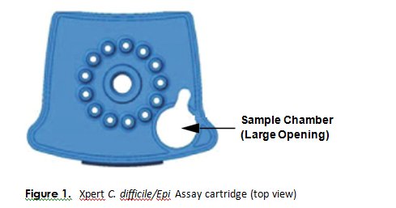  - Close the cartridge lid, and set onto the transfer tray or off to the side in the hood.  - Change gloves and proceed to prepare additional samples or start the test.  NOTES:  -Hood surfaces must be cleaned between samples with 10% bleach followed with 70% ethanol if there were any splashes, spills, or uncertainty of cleanliness.  **Start the test within 15 minutes of adding the sample to the cartridge  Starting the test:  - Ensure clean gloves are on before stepping to the computer work space.  - If instrument and computer are turned off: start up the instrument by flipping the power switch located in the back of the instrument. Turn on the computer next.  - Log onto Windows  - The GeneXpert software will launch automatically. If it doesn’t double-click the GeneXpert Dx software shortcut icon on the desktop.  - Log onto the software.  - User: First 6 letters of your first and last name (combined)  - Password: First 6 letters of your first and last name (combined)  - In the GeneXpert System window, click Create Test.  - Navigate to the Sample ID box. Scan or type in the sample ID.  - Scan the barcode on the cartridge.  NOTE: if the barcode on the cartridge does not scan, then repeat the test with a new cartridge.  - Select the appropriate test (FII, FV or FII & FV) and type for samples or controls.  - Enter additional information in the “notes” field (day of QC, collect date, etc.) if needed.  - Click Start Test.  - Enter your username and password, if requested.  - Open the instrument module door with the blinking green light.  NOTE: when setting up for testing you may opt to use any available module.  - With the barcode facing towards you, set the cartridge into the module and close the door.  - Wait for the test to start and the light to stop blinking. The test will run for approximately 40 minutes.  - Turn printer on.  - Verify the validity of results BEFORE removal of the cartridge. If valid results were NOT obtained the original sample should be retested.  - Remove the cartridge when testing is finished (the light will be off and the system will release the door lock).  - Dispose of used cartridges into bio-bags and place into biohazard sharps bins.  - Clean any equipment used (pipettes, racks, transfer tray, etc.), hood, and counters (including keyboard, scanner, and mouse) at the end of the day.  NOTE: Sample processing, testing, and cleaning should follow a unidirectional work-flow to avoid contamination.
Interpretation/ Results | - Click on View Results on the top drop-down menu bar and select View Test.  - Select the result you would like to review: Click OK.  - Review result interpretations and amplification curves for exponential growth (if applicable).  - Click on the Errors tab to ensure no errors occurred during testing. (Section 9.18.2 in Operator Manual provides error code descriptions)  See result examples below:  Normal (Wild type):  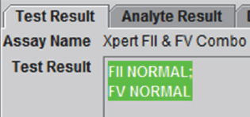  FII and FV heterozygous:  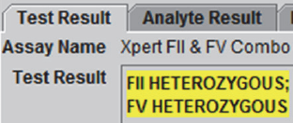  FII and FV homozygous:  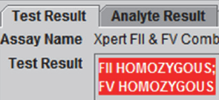  Reasons to retest/troubleshooting:  - An INVALID result:  - The sample was not properly processed.  - PCR was inhibited.  - An ERROR result – the Probe Check control failed. This may indicate:  - The reaction tube was filled improperly.  - A reagent probe integrity problem was detected.  - The maximum pressure limit was exceeded.  - A valve positioning error was detected.  - IF the probe check passed, the error was caused by a system component failure  - NO RESULT:  - This result indicated that insufficient data were collected (e.g. test stopped while in progress or power failure occurred).  NOTE: Record any failures or errors on the “GeneXpert Service and Error Log” log.  NOTE: See MC 9.01 for Instrument Maintenance tasks
Retesting Procedure | - Repeat testing from the original sample according to the SOP above.
Result Reporting | - Ensure that the printer is turned on.  - Reports will print automatically.  - Results will automatically transmit to the LIS.  - Log into Sunquest to release results.  - Select Result Entry from Menu options   - In the Configuration field select the appropriate test in the dropdown box.  - Select the test code order to result.  - Click on the button located in the lower right corner to populate the transmitted results.  - Review messages located on the top and results. Compare results to the GeneXpert report to ensure they match.  NOTE: Interpretation comments will automatically append to results. Reference the result comments below.  - Check the release box. 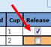  - Click button located on the lower left corner. Click when the “Verify Release Destination” window opens.  - Call a completed worksheet, check results, and staple to GeneXpert Report. Place in the GeneXpert result binder.  NOTE: No results are considered critical  NOTE: All positive results are to be communicated to the Technical Director
Result interpretation and comments | GeneXpert Result Sunquest Result Code & Interpretation Sunquest Comment Code & Interpretation  Any valid result N/A (see all result codes and interpretations below) F25C - code is automatically appended to all valid results: The individual may have other genetic and environmental risk factors for thrombosis. Consider genetic consultation and counseling of potentially affected family members regarding laboratory testing.  P2M: Factor II mutation (Prothrombin mutation)  FII Normal FIIN: Prothrombin (Factor II) G20210A mutation NEGATIVE F2NC: This individual DOES NOT have the prothrombin (Factor II) G20210A mutation.  FII Heterozygous FIIHE: Prothrombin (Factor II) G20210A mutation PRESENT (HETEROZYGOUS) F2EC: This individual DOES have the Prothrombin (Factor II) G20210A mutation on ONE allele (heterozygous mutant). The Prothrombin (Factor II) G20210A mutation is a risk factor for venous thromboembolism.  FII Homozygous FIIHO: Prothrombin (Factor II) G20210A mutation PRESENT (HOMOZYGOUS) F2OC: This individual DOES have the Prothrombin (Factor II) G20210A mutation on BOTH alleles (homozygous mutant). The Prothrombin (Factor II) G20210A mutation is a risk factor for venous thromboembolism.  F5LM: Factor V Leiden Mutation  FV Normal FVN: Factor V Leiden (G1691A) mutation NEGATIVE F5NC: This individual DOES NOT have the Factor V Leiden (G1691A) mutation.  FV Heterozygous FVHE: Factor V Leiden (G1691A) mutation PRESENT (HETEROZYGOUS) F5EC: This individual DOES have the Factor V Leiden (G1691A) mutation on ONE allele (heterozygous mutant). The Factor V Leiden (G1691A) mutation is a risk factor for venous thromboembolism.  FV Homozygous FVHO: Factor V Leiden (G1691A) mutation PRESENT (HOMOZYGOUS) F5OC: This individual DOES have the Factor V Leiden (G1691A) mutation on BOTH alleles (homozygous mutant). The Factor V Leiden (G1691A) mutation is a risk factor for venous thromboembolism.  F25M: Combo: Factor II and Factor V  FII Normal & FV Normal FIIN: Prothrombin (Factor II) G20210A mutation NEGATIVE FVN: Factor V Leiden (G1691A) mutation NEGATIVE F25NC: This individual DOES NOT have the prothrombin (Factor II) G20210A mutation. This individual DOES NOT have the Factor V Leiden (G1691A) mutation.  FII Heterozygous & FV Normal FIIHE: Prothrombin (Factor II) G20210A mutation PRESENT (HETEROZYGOUS) FVN: Factor V Leiden (G1691A) mutation NEGATIVE F2E5N: This individual DOES have the Prothrombin (Factor II) G20210A mutation on ONE allele (heterozygous mutant). The Prothrombin (Factor II) G20210A mutation is a risk factor for venous thromboembolism. This individual DOES NOT have the Factor V Leiden (G1691A) mutation.  FII Homozygous & FV Normal FIIHO: Prothrombin (Factor II) G20210A mutation PRESENT (HOMOZYGOUS) FVN: Factor V Leiden (G1691A) mutation NEGATIVE F2O5N: This individual DOES have the Prothrombin (Factor II) G20210A mutation on BOTH alleles (homozygous mutant). The Prothrombin (Factor II) G20210A mutation is a risk factor for venous thromboembolism. This individual DOES NOT have the Factor V Leiden (G1691A) mutation.  FII Normal & FV Heterozygous FIIN: Prothrombin (Factor II) G20210A mutation NEGATIVE FVHE: Factor V Leiden (G1691A) mutation PRESENT (HETEROZYGOUS) F2N5E: This individual DOES have the Factor V Leiden (G1691A) mutation on ONE allele (heterozygous mutant). The Factor V Leiden (G1691A) mutation is a risk factor for venous thromboembolism. This individual DOES NOT have the prothrombin (Factor II) G20210A mutation.  FII Normal & FV Homozygous FIIN: Prothrombin (Factor II) G20210A mutation NEGATIVE FVHO: Factor V Leiden (G1691A) mutation PRESENT (HOMOZYGOUS) F2N5O: This individual DOES have the Factor V Leiden (G1691A) mutation on BOTH alleles (homozygous mutant). The Factor V Leiden (G1691A) mutation is a risk factor for venous thromboembolism. This individual DOES NOT have the prothrombin (Factor II) G20210A mutation.  FII Heterozygous & FV Heterozygous FIIHE: Prothrombin (Factor II) G20210A mutation PRESENT (HETEROZYGOUS) FVHE: Factor V Leiden (G1691A) mutation PRESENT (HETEROZYGOUS) F25E: This individual DOES have the Prothrombin (Factor II) G20210A mutation on ONE allele (heterozygous mutant). This individual DOES have the Factor V Leiden (G1691A) mutation on ONE allele (heterozygous mutant). The Prothrombin (Factor II) G20210A mutation and the Factor V Leiden (G1691A) mutate on are both independent risk factors for venous thromboembolism.  FII Homozygous & FV Heterozygous FIIHO: Prothrombin (Factor II) G20210A mutation PRESENT (HOMOZYGOUS) FVHE: Factor V Leiden (G1691A) mutation PRESENT (HETEROZYGOUS) F2O5E: This individual DOES have the Prothrombin (Factor II) G20210A mutation on BOTH alleles (homozygous mutant). This individual DOES have the Factor V Leiden (G1691A) mutation on ONE allele (heterozygous mutant). The Prothrombin (Factor II) G20210A mutation and the Factor V Leiden (G1691A) mutation are both independent risk factors for venous thromboembolism.  FII Heterozygous & FV Homozygous FIIHE: Prothrombin (Factor II) G20210A mutation PRESENT (HETEROZYGOUS) FVHO: Factor V Leiden (G1691A) mutation PRESENT (HOMOZYGOUS) F2E5O: This individual DOES have the Prothrombin (Factor II) G20210A mutation on ONE allele (heterozygous mutant). This individual DOES have the Factor V Leiden (G1691A) mutation on BOTH alleles (homozygous mutant). The Prothrombin (Factor II) G20210A mutation and the Factor V Leiden (G1691A) mutation are both independent risk factors for venous thromboembolism.  FII Homozygous & FV Homozygous FIIHO: Prothrombin (Factor II) G20210A mutation PRESENT (HOMOZYGOUS) FVHO: Factor V Leiden (G1691A) mutation PRESENT (HOMOZYGOUS) F25O: This individual DOES have the Prothrombin (Factor II) G20210A mutation on BOTH alleles (homozygous mutant). This individual DOES have the Factor V Leiden (G1691A) mutation on BOTH alleles (homozygous mutant). The Prothrombin (Factor II) G20210A mutation and the Factor V Leiden (G1691A) mutation are both independent risk factors for venous thromboembolism.  Invalid, Errors, and No Results  Invalid or Error FAIL: FAILED TESTING FAILC: Patients on heparin therapy, blood transfusion patients and patients with very low white blood cells counts may have blood specimens that cannot be adequately interpreted by the test. Recommend repeat testing when therapy/transfusion is complete and/or white blood cell count returns to normal. RP: Enter called-to information  No Result N/A (no results reported in Sunquest) N/A (no results reported in Sunquest)
Sample Storage | - If there is enough volume after testing: freeze an aliquot of blood:  - Label a 1.5 mL cryovial:  - Invert sample 5 – 10 times  - Transfer up to 0.5 – 1 mL EDTA blood with a sterile transfer pipette  - Mark sample and aliquot tubes with results.  - Store original sample tubes in molecular, room 2 fridge. Discard after 15 days.  - Store aliquot tubes in molecular room 2, -70°C freezer. Discard after 90 days.
Invalid Results | - IF an invalid result is repeated AND a valid result is obtained, select and only release the valid result interpretation in the LIS.  - IF an invalid result is repeated AND an invalid result is obtained, select only one of the invalid results to verify. The provider must be notified of these results.  The result will be reported as Failed Testing and the following comment will automatically append: “Patients on heparin therapy, blood transfusion patients and patients with very low white blood cells counts may have blood specimens that cannot be adequately interpreted by the test. Recommend repeat testing when therapy/transfusion is complete and/or white blood cell count returns to normal range.”  Add the code PB, press tab, and enter semi-colon record who the result was relayed to and the date/time.
Manual Entry of Results | - Open Result Entry, select the Manual resulting mode (top left corner), from the configuration drop down select the appropriate test code. Click in the lower right corner.  - Enter the Specimen ID or scroll to the correct patient if necessary (lower left corner).  - Type in results and applicable comments.  - Check results against instrument print out and click .
Correcting Results | - Open Result Entry, select the Manual resulting mode (top left corner) from the configuration drop down select the appropriate test code. Click in the lower right corner.  - Enter the Specimen ID, enter Tab and click Yes to modify the result.  - Change the incorrect result. The corrected result comment will automatically append. Add the PB code, press tab, enter a semi-colon and record who was called and the time/date.  - Click . Click when the “Verify Release Destination” window opens.
Limitations | - The performance of the Xpert Factor II & Factor V Assay was validated using the procedures provided in the package insert only. Modifications to these procedures may alter the performance of the test. Results from the Xpert Factor II & Factor V Assay should be interpreted in conjunction with other laboratory and clinical data available to the clinician.  - Rare Factor V mutations (A1696G, G1689A, and A1692C) and any additional SNPs in the probe binding region may interfere with the target detection and yield an INVALID result.  - The performance of the Xpert Factor II & Factor V Assay was not evaluated with samples from pediatric patients during the FDA-approval/clearance application. However, in-house verification of the manufacturer’s claims did include pediatric samples and no errors were encountered.  - Patients on heparin therapy and blood transfusion patients may have blood specimens that potentially interfere with the PCR results and lead to invalid or erroneous results.
Method Performance Specifications | According to the manufacturer, per the package insert:  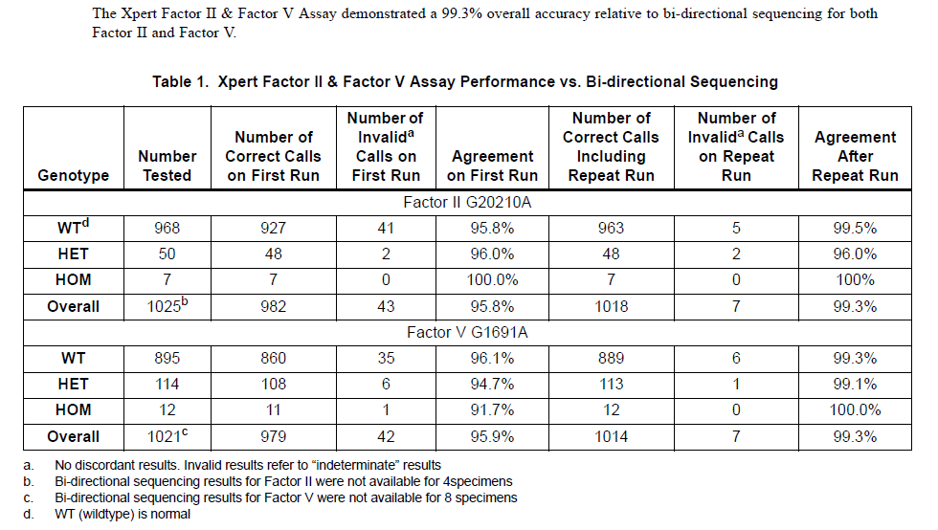
References | 1. Xpert Factor II and Factor V Package Insert, 301-0590, Rev B. In. Sunnyvale, CA: Cepheid; 2017.  2. Gessoni G, Valverde S, Manoni F. Evaluation of the GeneXpert assay in the detection of Factor V Leiden and Prothrombin 20210 in stored, previously classified samples. Clinica Chimica Acta 2012; 413(7-8):814-816.  3. Gessoni G, Sara SV, Canistro R, Manoni F. GeneXpert in the diagnosis of risk factors for thrombophilia: evaluation of its use in a small laboratory. Blood Transfusion 2012; 10(2):228.  4. De Stefano V, Martinelli I, Mannucci PM, Paciaroni K, Chiusolo P, Casorelli I, et al. The risk of recurrent deep venous thrombosis among heterozygous carriers of both factor V Leiden and the G20210A prothrombin mutation. New England Journal of Medicine 1999; 341(11):801-806.  5. 510(k) Summary - Cepheid Xpert HemosIL FII and FV. In. Sunnyvale, CA: Cepheid; 2009.
Alternate Methods | 1. Send specimens to Mayo Medical Laboratory  2. Mayo Order code: PTMU and F5L  3. Logistics:  - EDTA or Sodium citrate tube, minimum volume 1 ml  - Store and ship samples at ambient temperatures
Proficiency Testing | CAP materials: 2 shipments a year with 3 samples (TPM).
Training Plan/ Competency Assessment | Training Plan |  |  | Initial Competency Assessment
 | - Employee must read the procedure.  - Employee will demonstrate the ability to perform procedure, record results, and document corrective action after instruction by the trainer. |  |  | - Direct observation
Historical Record
 | Version | Written/Revised by: | Effective Date: |  | Summary of Revisions
 | 1 | Julie Laramie | 01/21/2020 |  | Initial Version
 | 2 | Julie Laramie/Tina Gronquist | 02/09/2020 |  | Added result/interpretation table
 | Archived by: |  | Archived Date:

