Decanting Specimens

Purpose | This procedure provides instructions for processing specimens the DECANT SPOT.
Policy Statements | - This procedure applies to all laboratory staff who process samples
 | Follow the activities in the table below to process samples through Decant.
Procedure | Step | Action |  |  |  | Related Document
A. The Main SQ GUI Menu Selection Screen will open, select SMART


 |  | B. 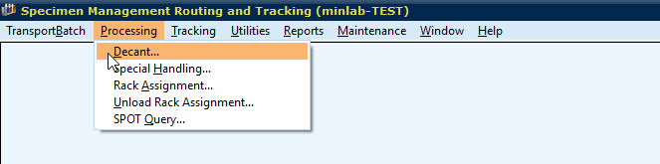
C. Scan the CID and select the decant spot MDEC (MIN) or SDEC (STP) and enter. Any instructions for decanting the container will display.
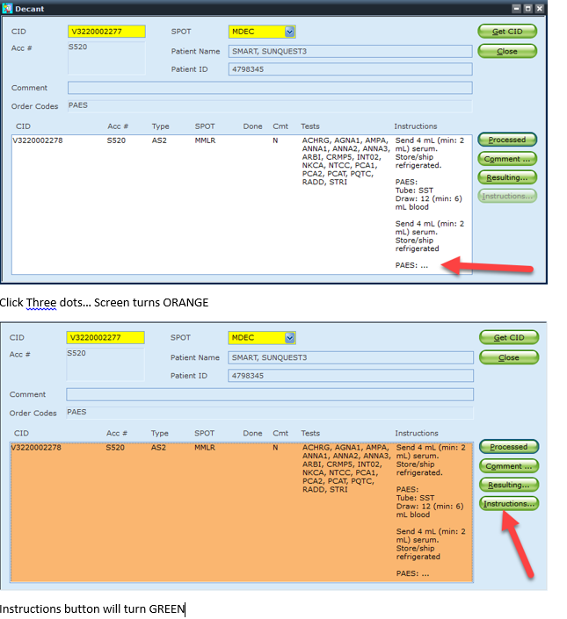

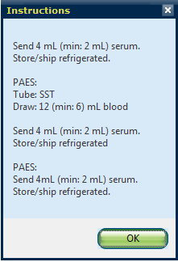
Additional instructions appear in a pop-up box

D. Once decanting is complete, select the green Processed button and your aliquot label(s) will print. If you only want one of the test aliquot labels to print at a time, you can select the specific item being decanted (and it will turn orange) to print just that item. If no line item is selected, all aliquot labels for that container ID (CID) will print to your designated label printer. Please note, a new CID will be assigned to the aliquot that is one number larger than the parent CID.
E. The Rack assignment window will pop-up if the parent container is not moving to a spot. Select cancel as we will not be racking parent containers.

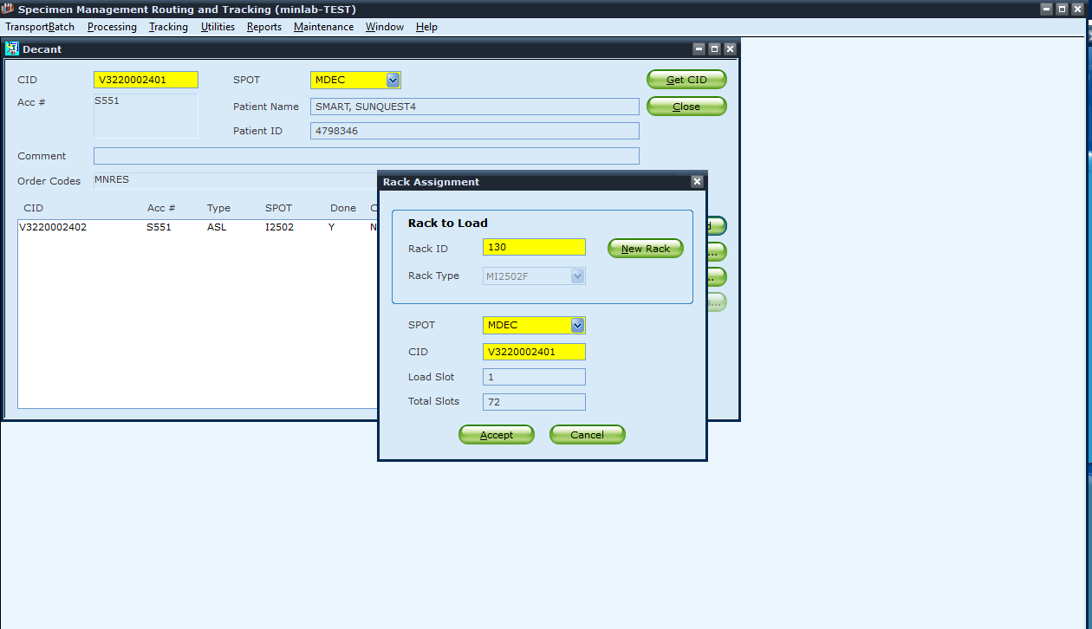
References | Sunquest 7.2 Manual
Training Plan/  Competency  Assessment | iMentor self-paced classes  New employee training  Upgrade Training  LIS Competencies
Historical Record | Version |  | Written/Revised by: | Effective Date: | Summary of Revisions
 | 1 |  | R. Gulke | 10/22/2019 | Initial Version

