Racking,Unracking and Tracking Specimens

Purpose | This procedure provides instructions for racking specimens.
Policy Statements | - This procedure applies to all laboratory staff who process samples
 | Follow the activities in the table below to process samples through Decant.
Procedure | Step | Action |  |  |  | Related Document
 | 1 | A. The Main SQ GUI Menu Selection Screen will open, select SMART  
 | 2 | B.  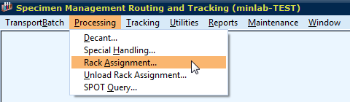
C. If creating a new rack:
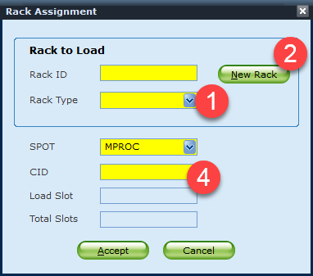

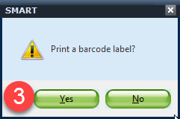

First select the rack type then press new rack button. Rack ID number will be automatically assigned. Then click Yes to print a Rack ID barcode label. Finally, scan CID numbers that need to be racked.

Rack IDs: MCHEMF- MIN Chemistry Freeze (Vista/Alinity 7 Days)
MI2502F- MIN Celiac/Allergen Freeze (1 Month)
MC14F- MIN Architect/ISYS Freeze (14 Days)
SCHEMF- STP Chemistry Freeze (Anything but XL 7 Days)
SXLF- STP Liaison Freeze (14 Days)

If adding samples to an existing rack:
First, scan the rack ID barcode. Rack type will be automatically filled in.
Then scan CID numbers that need to be racked.

NOTE: Multiple days of MIN Celiac/Allergen samples can be combined under one rack since they are kept for 1 month.

NOTE: Please DO NOT rack specimens that are still pending. Racking uncompleted specimens may result in running duplicate tests.
D. Order of racking specimens:
First, place a rack so that the side with rack ID holder stays on left side.
Then rack specimens from left to right and back to front.
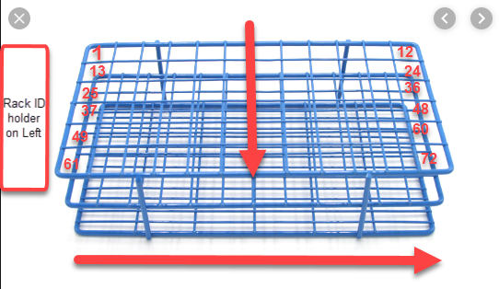

 | 3 | Unracking/Removing specimens from a rack:  A. Go to TrackingRackStatus  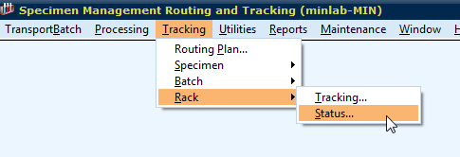  Select the Rack IDSelect the CID numberClick Remove  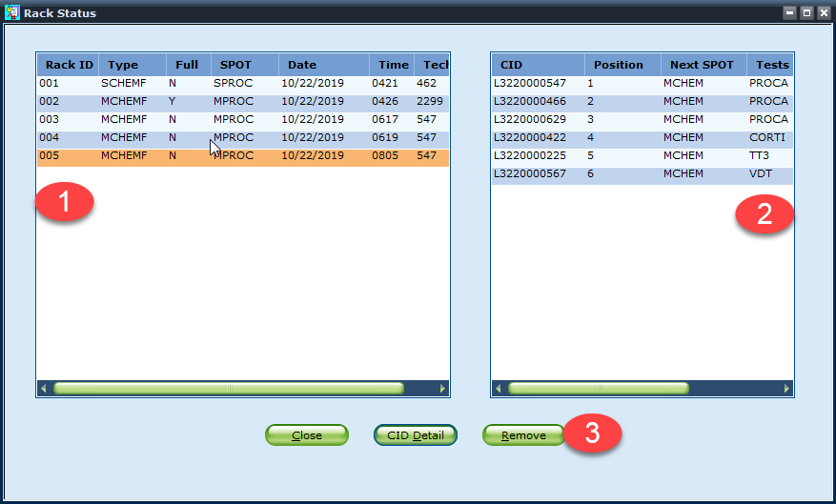  NOTE: Please immediately remove a specimen from SMART rack status once unracked.
 | 4 | Unracking/Removing a whole rack:  A. Go to TrackingRackStatus  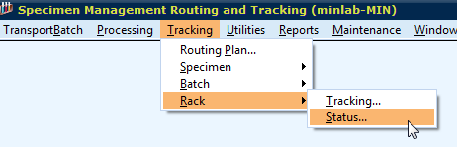  Select Rack IDClick Remove  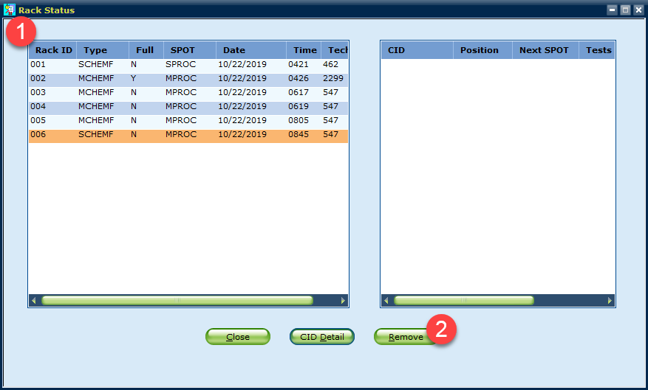  NOTE: A whole rack is removed only when designated storage time is expired and specimens are thrown away.
 | 5 | Tracking a specimen:  - Go to TrackingSpecimenLocation  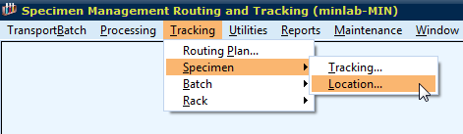  B. Enter preferred search information (Usually CID# or ACC#).  A specific specimen type can be entered to narrow down the search.  Click Display.  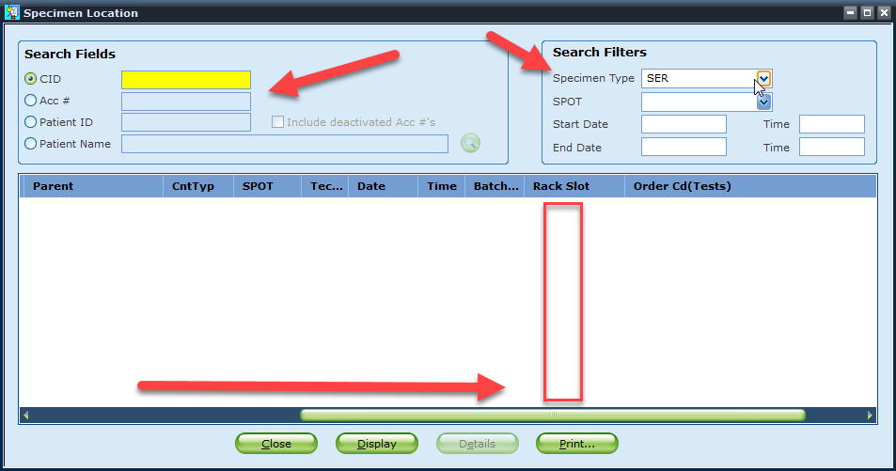  Scroll all the way to the right to find Rack Slot information. (xxx-xx format)  First three digit number represents the Rack ID number and next two digit number represents the spot number.  C. Go to Tracking-->Rack-->Status  D. Rack type and rack creation date information can be found here.  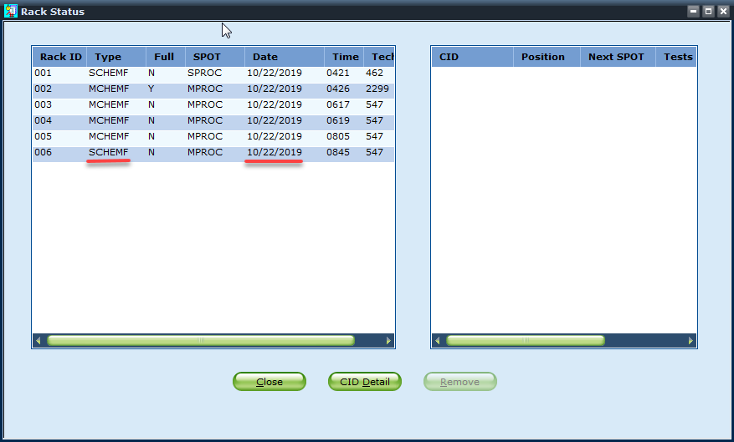
References | Sunquest Manual
Training Plan/  Competency  Assessment | iMentor self-paced classes  New employee training  Upgrade Training  LIS Competencies
Historical Record | Version |  | Written/Revised by: | Effective Date: | Summary of Revisions
 | 1 |  | S. Kang | 10/22/2019 | Initial Version
 | 2 |  | S.Kang | 02/11/2020 | Added unracking / tracking

