Entering Tissue into Inventory

Purpose | This procedure provides instructions for the entry of all tissue products into the Sunquest system for record keeping purposes.  Non-Manufactured Tissue, Manufactured Tissue, Cardiac Tissue, Autologous Tissue
Policy Statements | All tissue products must be entered into the LIS system to become part of the accessible inventory.
Definitions | Cardiac Tissue: Cardiac allograft tissue  Manufactured Tissue: Human derived tissue products such as gel, putty, paste identified by lot number.  Non-manufactured tissue: Human derived products such as bone, tendon identified by product type and unique identification number.  Autologous Tissue: Tissue harvested from a Children’s patient/donor for re-implantation into the same patient/donor at a later date at Children’s.
Related  Documents | TS 20.4 Inspection of Tissue Products
Procedure
 | Step |  | Action
Entering Non-Manufactured Tissue Products into Inventory | 1 |  | Confirm packing Sheet to type and quantity of product received.
 | 2 |  | Inspect products.  - Notify the supplier and Children’s Purchasing department (x55827) of any discrepancies or unacceptable product.
 | 3 |  | Log into the Gateway choosing location: R for Mpls, or L for STP
 | 4 |  | Enter or scan the appropriate information in all yellow entry field prompts, tabbing to move to the next entry field. Note: The Supplier Unit # entered must match the labels and/or forms that will be used supplier feedback report form.  - Use the Sunquest search functions for selection of Supplier and Component.  - Notify the Technical Specialist immediately if the exact Supplier is not identified using the search option.  - Select Component SORT if the exact component is not identified using the search option.  - Tab past the Division # entry field.  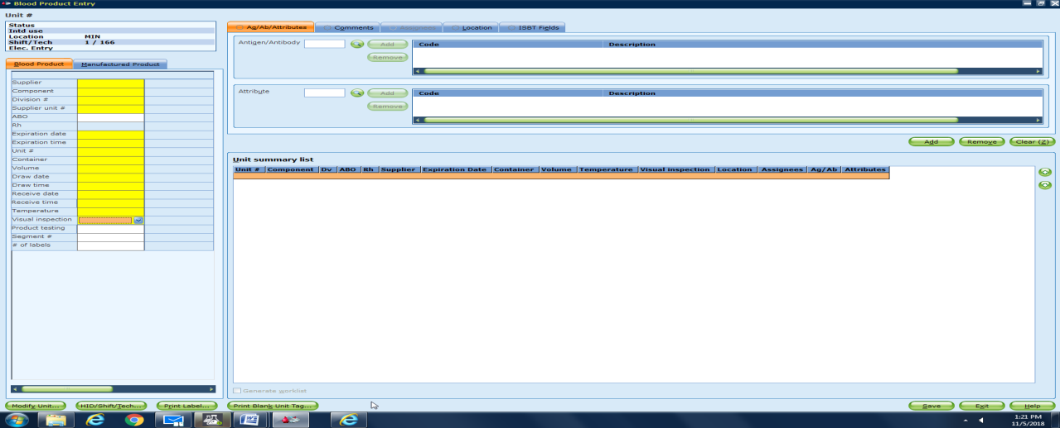
 | 6 |  | Enter temperature of tissue products  - Ambient tissue- (Verified package integrity and that product was received at ambient temperature. Product to be stored at ambient temperature.) enter room temperture.  - Frozen Tissue at –70 (Verified package integrity and that the supplier shipping container was received undamaged and with the stated timeframe. Product to be stored at –70) enter Frozen
 | 7 |  | Visual Inspection choose Pass or Fail  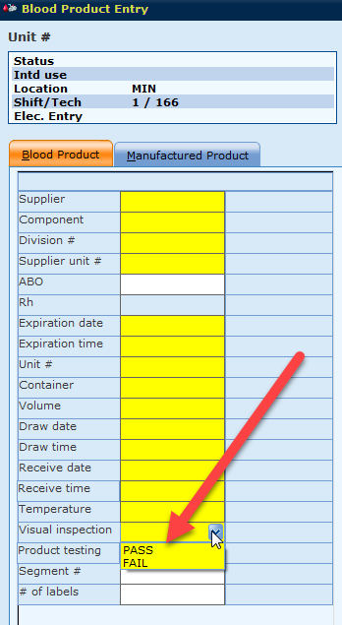
 | 8 |  | Click on the on the Comments tab.  - In the Free text box, type in additional comments E.g. Enter the specific name of the special order tissue. (SORT)  - Click Add. The code and description, or the free text comment displays in the comment list.  - Repeat for each additional comment  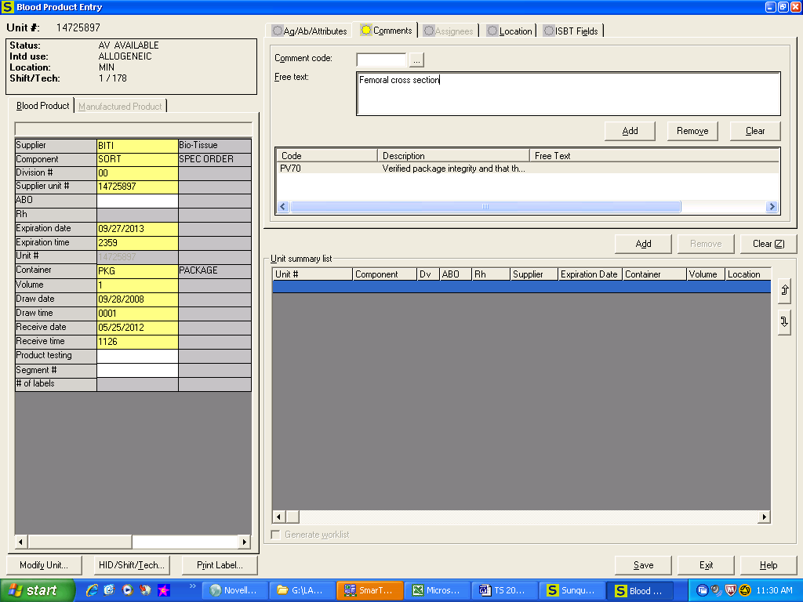
 | 9 |  | Verify the accuracy of all entry fields.
 | 10 |  | Click Add to put product onto the Unit summary list. Repeat steps 4-9 to add additional products.
 | 11 |  | Click Save when all entries are completed.
 | 12 |  | Adhere the corresponding printed Sunquest barcode label to the outside package container without obstructing any other information.
 | 13 |  | Make copy of the tissue package insert if accessible without compromising the tissue packaging.  - Leave copy of the package insert for the Technical Specialist to review and maintain.
 | Step |  | Action
Entering Manufactured Tissue Products into Inventory | 1 |  | Confirm packing sheet to type and quantity of product received.
 | 2 |  | Inspect products.  - Notify supplier and Children’s Purchasing department (55827) of any discrepancies or unacceptable product.
 | 3 |  | Log into the Gateway choosing location: R for Mpls, or L for STP
 | 4 |  | Click on the Manufactured Product tab.  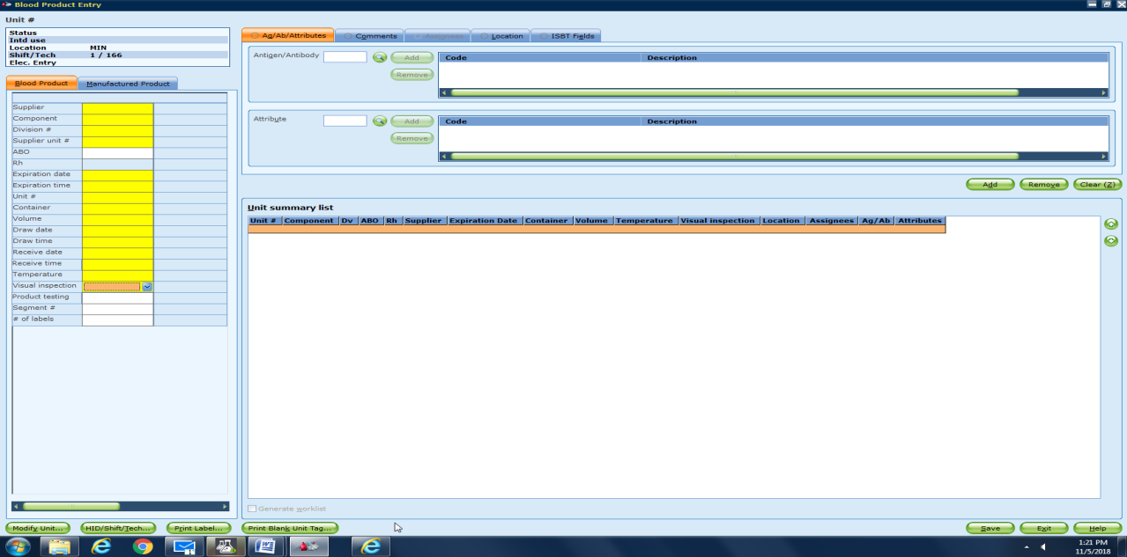
 | 5 |  | Enter or scan the appropriate information in all yell enter field prompts, tabbing to move to the next entry field.  - Use the Sunquest search functions for selection of Supplier and Component.  - Notify the Technical Specialist or Lead immediately if the exact Supplier is not identified using the search option.  - Select Component SORM if the exact component is not identified using the search option.  If Then  New lot number Proceed to step 6-10 New Lot  Duplicate Lot number a QA failure will show Proceed to step 11-16 Duplicate Lot
 | 6 |  | Enter temperature of tissue products  - Ambient tissue- (Verified package integrity and that product was received at ambient temperature. Product to be stored at ambient temperature.) enter room temperture.
 | 7 |  | Visual Inspection choose Pass or Fail
-New lot | 8 |  | Click on the on the Comments tab.  - In the Free text box, type in additional comments E.g. Enter the specific name of the special order tissue. (SORM)  - Click Add. The code and description, or the free text comment displays in the comment list.  - Repeat for each additional comment  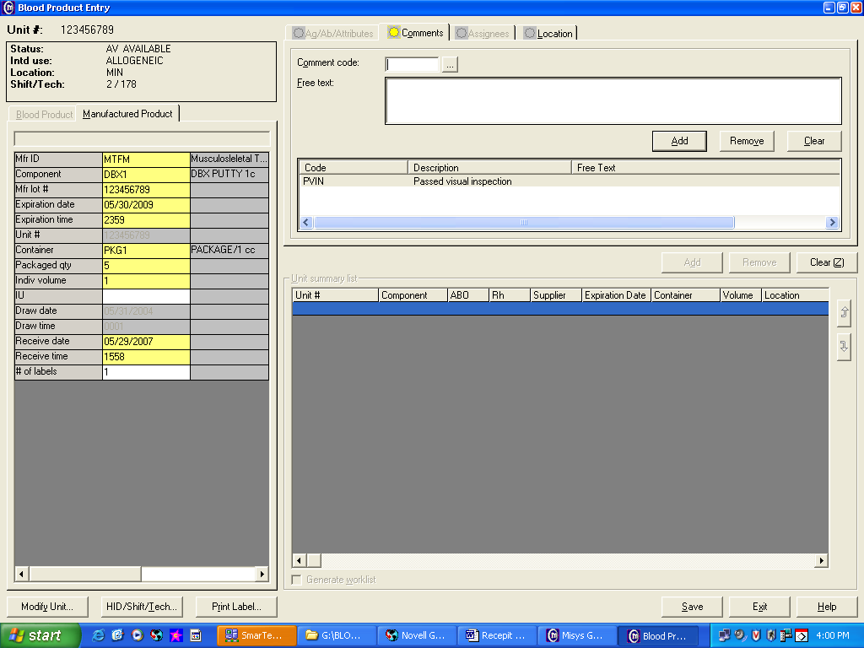
 | 9 |  | Verify the accuracy of all entry fields.  - Click Save if accurate  - Re-enter incorrect information
 | 10 |  | [The system will assign a slash number to each individual package within the lot.]  Click OK.  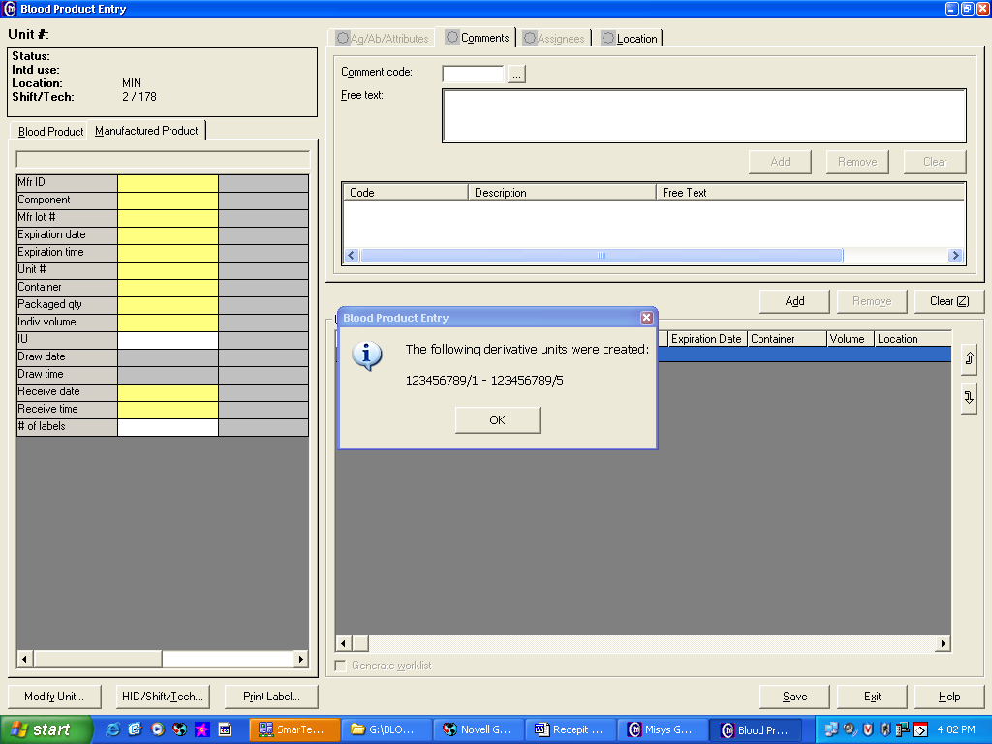
 | 11 |  | Adhere a printed Sunquest barcode label to the outside of the package container without obstructing any other information. Manually indicate the slash number to the printed Sunquest barcode label.
 | 12 |  | Make copy of the tissue package insert if accessible without compromising the tissue packaging.  Leave copy of the package insert for the Technical Specialist to review and maintain.
-Duplicate Lot | 13 |  | The following screen will display if entering additional packages from a lot number previously received:  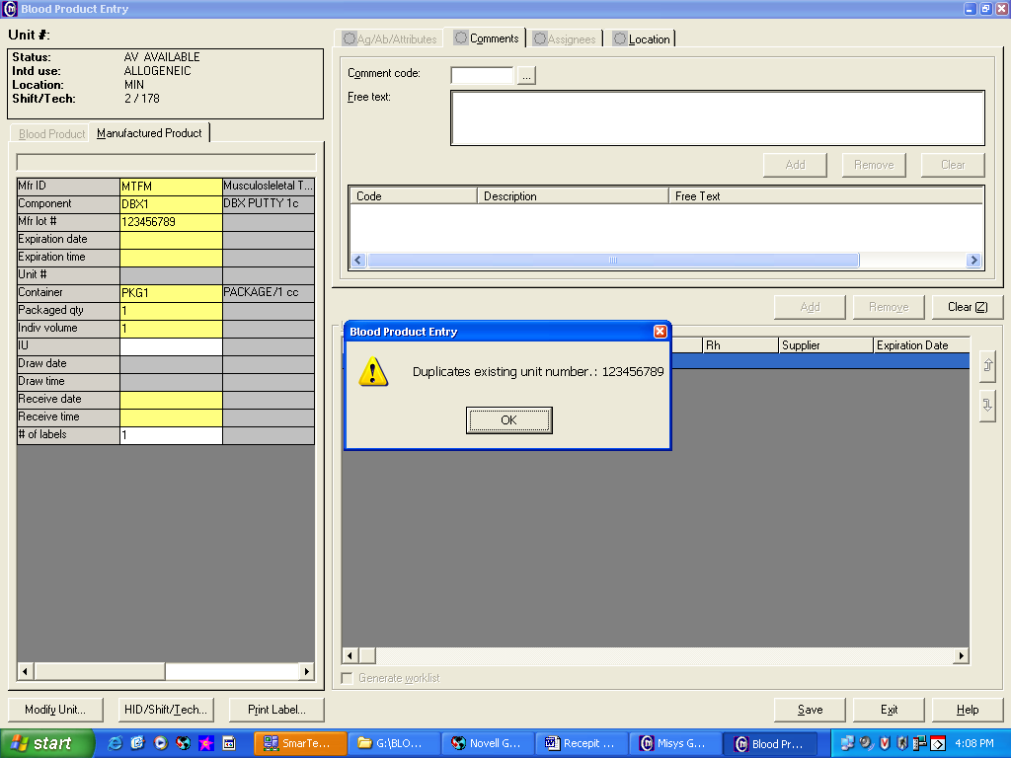  - Click on OK  - Click on Modify Unit at the bottom left of the screen
 | 14 |  | 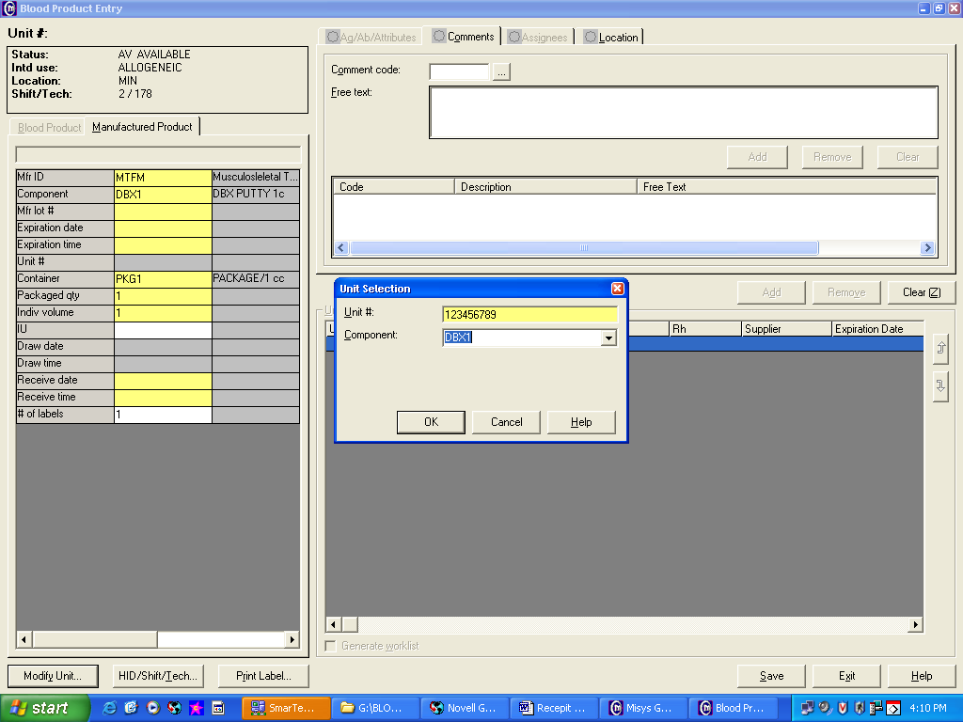  - Enter the Lot number and verify component type  - Click on OK
 | 15 |  | 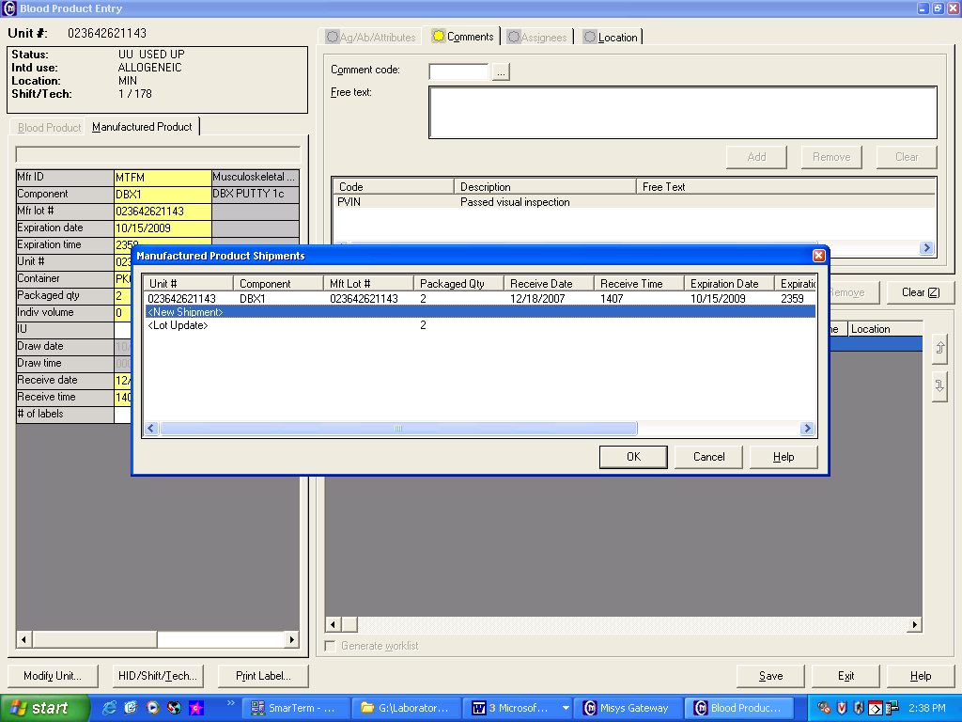  - Click on New Shipment at the prompt (Select Lot Update if correcting inventory).  - Click OK  - The entry fields will populate for the specific lot number.
 | 16 |  | - Enter Expiration Date  - Enter Package Qty for the new shipment  - Document temperature and visual inspection that product was received at ambient temperature.  - Click Add  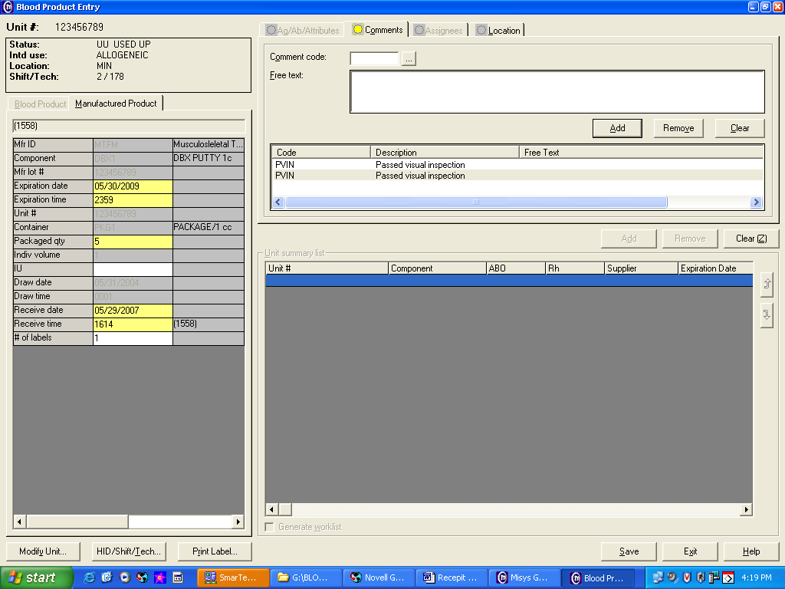
 | 17 |  | - Click Save. [The system will sequentially assign slash numbers to the new shipment.]  - Click OK  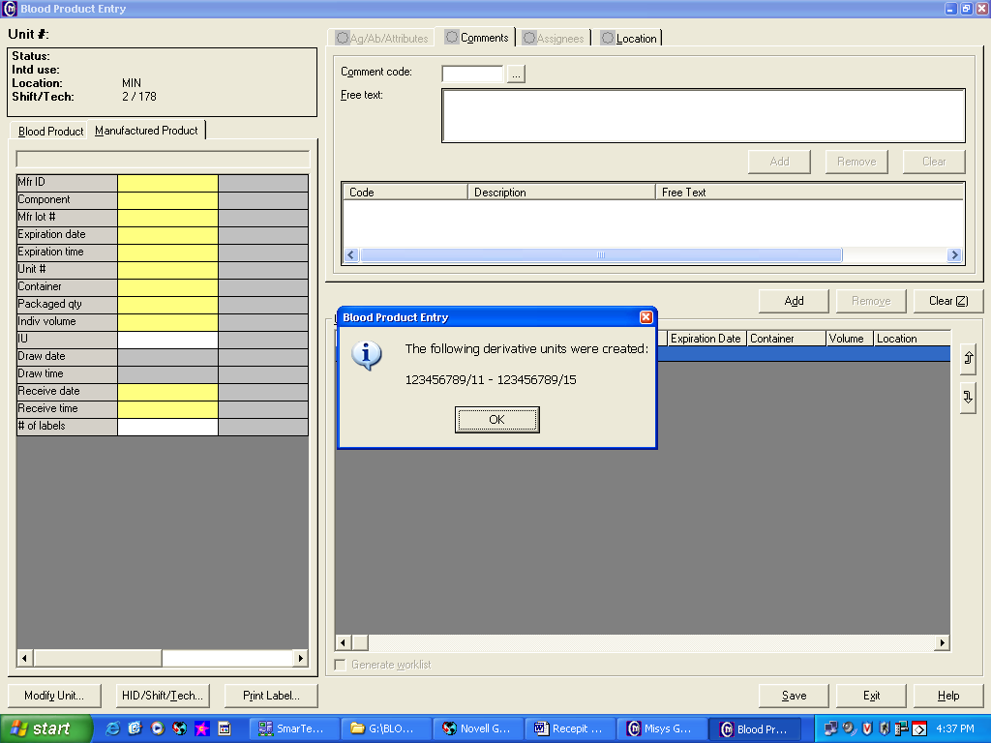
 | 18 |  | Adhere a printed Sunquest barcode label to the outside of the package container without obstructing any other information. Manually indicate a slash number to the printed Sunquest barcode label.
Entering Autologous Bone into Inventory | Step | Action
 | 1 | Log into the Gateway choosing location: R for Mpls, or L for STP
 | 2 | Double click on the Blood Product Entry folder under the All tab or the Blood Bank tab. The Blood Product Entry window opens.
 | 3 | Enter the appropriate information at the specific prompt, tabbing to move to the next prompt.  - Supplier: CHMP-Minneapolis, or CHSP-St. Paul  - Component: AUTOB  - Division #: Enter A0 for the first container and any subsequent container as B0, etc. Always enter a Division #.  - Supplier unit #: Patient MRN from Autologous Tissue Donor label.  - Expiration Date: 6 months from collection date for bone stored at –20 to –40°C or 5 years from collection date for bone stored at less than –40°C.  - Collection Date: Enter autograft collection date from label.
 | 4 | Enter the patient’s MRN in the Patient ID window under the Assignees tab.
 | 5 | Click on ADD to file the assignee information.  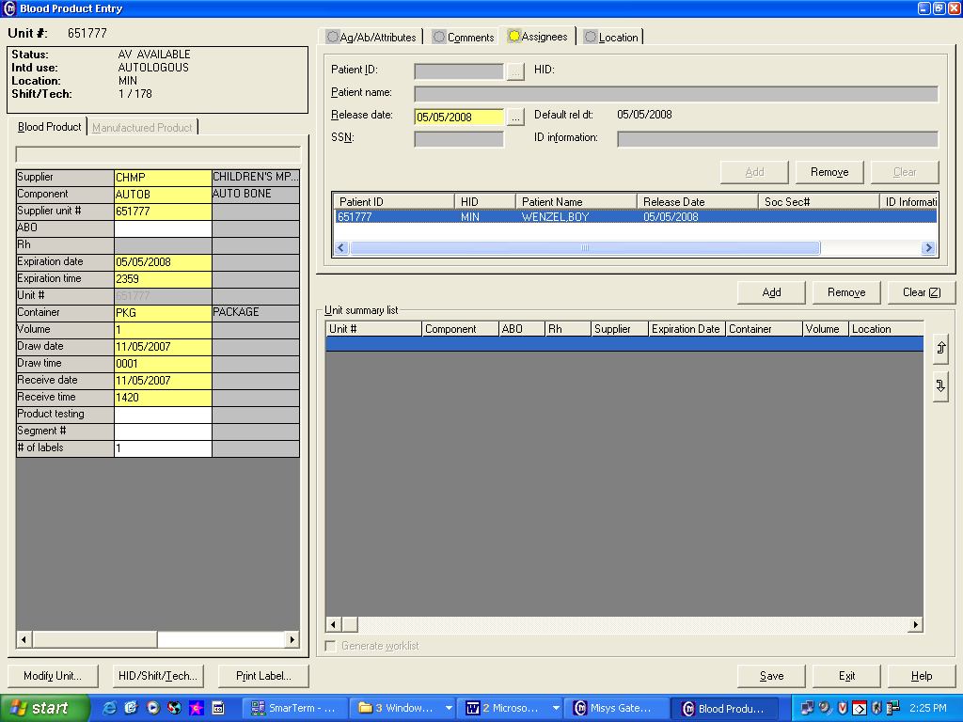
 | 6 | Click on the Comments tab.  - Enter the tissue description and surgeon information found on the product label as “free  text” information under the Comments tab and click on Add.  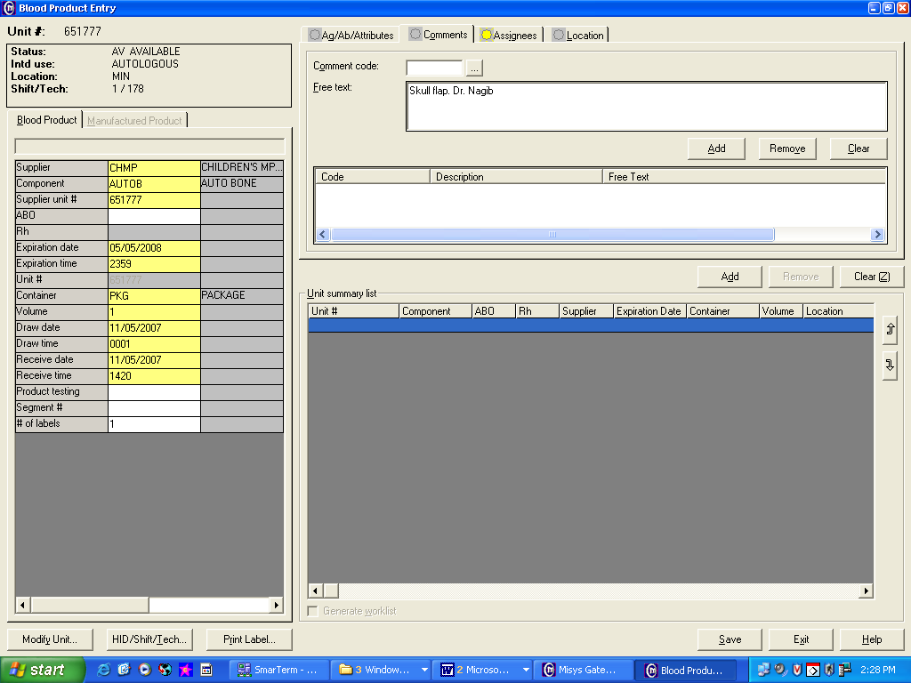  b. Document visual inspection in the Comment code box by entering a comment code.  - PVAB (Autologous bone passed packaging and labeling requirements. Product to be  stored at –70) or FVIN (Failed Visual Inspection).
 | 7 | Enter Room temperature and visual inspection
 | 8 | Click on Save to file the Blood Product Entry.
 | 9 | - Document appropriate expiration date (5 year or 6 months) on the autologous label.  - Adhere autologous label to bag with cyrotape  - Adhere the printed Sunquest barcode label to bag with cyrotape
 | 10 | Send Sunquest mailbox to BB staff regarding receipt of autologous tissue and storage location.
References | Sunquest Users Manual, current edition
Approval  Workflow | Transfusion Service/Medical Director
Historical Record | Version |  |  | Written/Revised by: | Effective Date: | Summary of Revisions
 | 1 |  |  | J. Wenzel | 10/01/2008 | Initial Version
 | 2 |  |  | J Wenzel | 11/20/2008 | Online Version
 | 3 |  |  | Nancy Poupard | 11/16/2009 | Modified supplier unit # for multiple autologous bones
 | 4 |  |  | S. Cassidy/J Wenzel | 5/30/2012 | Renumbered with merger of TS 20.5v2, TS20.5.1v2, TS20.6v2, TS20.7v3.  Revised product receipt inspection comment codes. Added step to maintain copy of tissue package insert.  Eliminated appendixes of suppliers and component codes for manuafactured and non-manufactured tissue and added instruction to use SQ search functions. Added use of division # for multiple AUTOB and mailbox notification.
 | 5 |  |  | S. Cassidy | 03/13/18 | Removed Cardiac tissue entry
 | 6 |  |  | S. Cassidy | 11/27/18 | added Sunquest 8.2 upgrade

