GeneXpert Xpert Enterovirus (EV) Assay

Purpose | This procedure provides instructions for performing the Xpert EV Assay on the Cepheid GeneXpert system.
Policy Statements | This procedure applies to all technical staff performing testing on the GeneXpert.
Principle and Clinical Significance | The Xpert Enterovirus (EV) Assay is intended to aid in the diagnosis of Enterovirus RNA in cerebrospinal fluid (CSF) specimens from individuals with signs and symptoms of meningitis. The assay is not intended to monitor treatment for Enterovirus infections.¹  Enterovirus is taxonomically classified as those viruses consisting of poliovirus, coxsackieviruses, echoviruses, and enteroviruses. Enteroviruses cause a wide range of infections and are spread most often through direct contact with respiratory secretions of an infected person. The common symptoms are fever, severe headache, stiff neck, light sensitivity, drowsiness or confusion, and nausea and vomiting.  While most infections are either asymptomatic or result in minor febrile illness, they often result in hospitalization, especially of infants and children.¹ The most common presenting features associated with neonatal enterovirus infection are fever, irritability, poor feeding, and lethargy.^{2,3} About 90% of viral meningitis are caused by enterovirus; and enteroviruses are the most common cause of meningitis in the United States, with an estimated 30,000-50,000 hospitalizations each year.¹ In neonates there is evidence suggesting that enterovirus infections can be acquired antenatally, intrapartum and postnatally.²  An enterovirus test, together with clinical observation and other clinical information, can help physicians identify patients with enteroviral meningitis to aid in patient management.  The GeneXpert automates and integrates sample purification, nucleic acid amplification, and detection of the target sequences in clinical specimens by using real-time PCR. The Xpert EV assay is designed to detect enterovirus (EV) RNA in CSF samples. The assay includes reagents, primers, and probes for the simultaneous detection of nucleic acid from the target EV and the sample-processing control/internal (SPC/IC). The assay includes SPC/IC to verify adequate processing of the target virus and monitors the presence of inhibitors in the RT-PCR assay to avoid a false negative result.^{1,2}
Test Code | EVPCR
Sample | - Acceptable specimens:  - Cerebral Spinal Fluid (CSF) in a sterile container  NOTE: do not use specimens that have been centrifuged  - SDES codes/Specimen type:  - CSF - Cerebral Spinal Fluid  - LCSF - Lumbar puncture CSF  - Specimen Collection and Transport:  - Refer to Lab Test Directory on StarNet  - Specimen assessment:  - Refer to the policy MCVI 2.1 Specimen Rejection Criteria.  - Specimen Storage  - Refrigerated (2 - 8 °C): 3 days  - Freeze specimens if test is not performed within 72 hours of collection.  NOTE: do not freeze and thaw specimens more than two times
Special Safety Precautions | Microbiologists/virologists are subject to occupational risks associated with specimen handling. Refer to the safety policies located in the safety section of the Microbiology and Virology Policy Manual:  - Biohazard Containment  - Safety in the Microbiology/Virology Laboratory  - Biohazardous Spills
Materials | Reagents Supplies Equipment  - 10% bleach - 70% ethanol - Xpert EV cartridges - Transfer pipettes - Sample racks - Cartridge transfer tray - 200 uL extended pipette tips Store kits at 2-28°C. Kits are stable until the expiration date printed on the outer box. - Biosafety Hood - Cepheid GeneXpert Instrument and computer - Printer - 200 uL pipette
Calibration | Annual “Xpert Check Kit” calibration performed by Cepheid.
Quality Control | Daily Quality Control:  Once an Xpert cartridge has been loaded and before the sample processing steps begin, the software checks the optics, the readiness of the module’s mechanical components, and the ambient temperature of the module to assure proper performance of PCR, and the physical integrity of the cartridge.  Quality Control  Each cartridge includes a Sample Processing Control (SPC/IC) and Probe Check Control .  - Sample Processing Control (SPC/IC [CIC]): Ensures the sample was processed correctly. The SPC verifies that sample processing is adequate. Additionally, this control detects sample-associated inhibition of the real-time PCR assay, ensures the PCR reaction conditions (temperature and time) are appropriate for the amplification reaction, and that the PCR reagents are functional. The SPC should be positive in a negative sample and can be negative or positive in a positive sample. The SPC passes if it meets the assigned acceptance criteria.  - Probe Check: Before the start of the PCR reaction, the GeneXpert System measures the fluorescence signal from the probes to monitor bead rehydration, reaction tube filling, probe integrity, and dye stability. The Probe Check passes if it meets the assigned acceptance criteria.  NOTE: When Enterovirus levels are high enough to generate very early Cts, the SPC/IC amplification curves may not be seen, and the results will not be reported.  External Quality Control:  - Perform QC using external positive and negative controls every 30 days  - Record results in the GeneXpert assay QC binder  - See IQCP document  - See Quality Control Procedure  New Lot/Shipment Quality control:  - Perform QC using external positive and negative controls with each new lot or shipment before putting into service  - Record results in the GeneXpert assay QC binder  - See Quality Control Procedure  Wipe testing control:  - Perform wipe testing every 30 days to monitor for contamination  - Record results in the GeneXpert assay QC binder  - See Quality Control Procedure  NOTE: External quality control may be performed on an as needed basis if certain circumstances arise. Examples include:  - Drift in results (e.g., increasing/decreasing positivity rates)  - Potential contamination (negative control)  - After drastic system maintenance
Procedure | Cartridge preparation:  - Clean hood with10% bleach (made daily) followed by 70% ethanol.  - Change gloves.  - Obtain an assay cartridge and one set of reagents 1- 4 from the EV package.  - Label the side of the cartridge with a bar-coded foot-label.  - Open the cartridge lid.  - Open the Binding Reagent (1) ampule by twisting and breaking off the cap.  - Insert tip of the Binding Reagent (1) ampule into cartridge chamber 1 and squeeze the ampule until the entire content is emptied.  - Open the Wash Reagent (2) ampule by twisting and breaking off the cap.  - Insert the tip of the Wash Reagent (2) ampule into cartridge chamber 2 and squeeze the ampule until the entire content is emptied.  - Open the Elution Reagent (3) ampule by twisting and breaking off the cap.  - Insert the tip of the Elution Reagent (3) ampule into cartridge chamber 3 and squeeze the ampule until the entire content is emptied.  - Using the 200uL pipette, add 140uL of the Lysis reagent (4) to cartridge chamber 4S. Discard the Lysis Reagent (4) vial.  - Vortex the sample for 5 – 10 seconds and using the 200uL pipette, add 140uL of the sample to cartridge chamber 4S.  NOTE: To prevent large air bubbles from forming, be sure to hold the pipette tip at the top of the chamber and dispense the sample slowly.  - Close the cartridge lid.  NOTES:  -See Figure 1 and Figure 2 for a visual of the top of the cartridge and sample set up  -Hood surfaces must be cleaned before processing and between samples with 10% bleach followed with 70% ethanol  -Change gloves between set up of multiple samples  -If setting up multiple samples, open one set of reagents at a time in a clean work space  -A surgical mask must be worn if any signs of a respiratory illness are present in the user  -**Start the test within 30 minutes of adding the reagents to the cartridge  Figure 1: Expert EV Cartridge Top View)  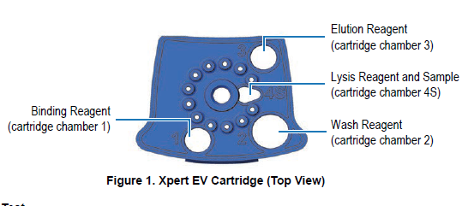  Figure 2: Expert EV Cartridge Preparation  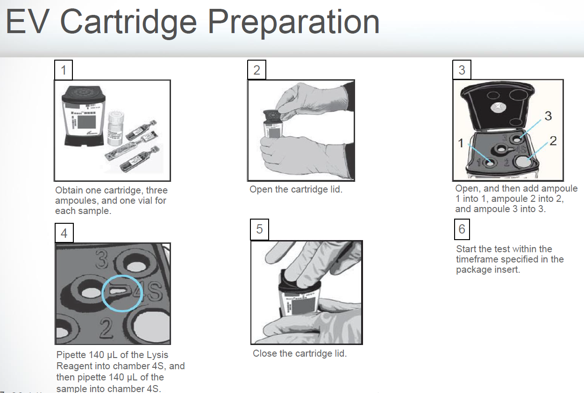  Starting the test:  - Ensure clean gloves are on before stepping to the computer work space.  - If instrument and computer are turned off: start up the instrument by flipping the power switch located in the back of the instrument. Turn on the computer next.  - Log onto the appropriate Windows account:  - User: Cepheid-Admin  - Password: cphd  - The GeneXpert software will launch automatically. If it doesn’t double-click the GeneXpert Dx software shortcut icon on the desktop.  - Log onto the software.  - In the GeneXpert System window, click Create Test.  - Navigate to the Sample ID box. Scan or type in the container ID.  - Scan the barcode on the cartridge.  NOTE: if the barcode on the cartridge does not scan, then repeat the test with a new cartridge  - If prompted, select Xpert EV Assay from the Select Assay MENU.  - Enter additional information in the “notes” field (day of QC, collect date, etc.) if needed.  - Click Start Test.  - Enter your username and password, if requested.  - Open the instrument module door with the blinking green light.  NOTE: when setting up for testing you may opt to use any available module.  - With the barcode facing towards you, set the cartridge into the module and close the door.  - Wait for the test to start and the light to stop blinking. The test will run for 150 minutes (~2.5 hours).  - Turn printer on.  - Remove the cartridge when testing is finished (the light will be off and the system will release the door lock).  - Dispose of used cartridges into bio-bags and place into biohazard sharps bins.  - Clean any equipment used (pipettes, racks, transfer tray, etc.), hood, and counters (including keyboard, scanner, and mouse) at the end of the day.  NOTE: Sample processing, testing, and cleaning should follow a unidirectional work-flow to avoid contamination.
Interpretation/ Results | - Refer to Table 1 for result interpretation.  Table 1: Enterovirus Instrument Results and Interpretations  Result Interpretation  Enterovirus NEGATIVE (Note SPC/IC is displayed as CIC) EV target RNA is not detected. - EV- NEG - CIC (SPC/IC) – PASS - Probe Check– PASS ; all probe check results pass - Negative Xpert EV results do not rule out enterovirus as cause of meningitis but that enterovirus was not detected  Enterovirus POSITIVE (Note SPC/IC is displayed as CIC) EV target RNA is detected. - EV-POS - CIC – N/A; When EV Titer is high, the RT-PCR for the SPC might be suppressed - Probe Check– PASS; all probe check results pass - Positive Xpert EV results do not rule out other causes of meningitis, including bacteria, mcyobacteria, other viruses (e.g. herpes family, arboviruses, mumps, ect) and fungi.  INVALID Presence or absence of the target RNA cannot be determined. SPC/IC does not meet acceptance criteria, or PCR is Inhibited. Repeat testing. - EV: INVALID - CIC (SPC/IC): FAIL - PCC – PASS; all probe check results pass  ERROR Presence or absence of the target RNA cannot be determined. Probe check control failed, reaction tube improperly filled. Repeat testing. - EV: NO RESULT - CIC (SPC/IC): NO RESULT - Probe Check: FAIL*; all or one of the probe check results failed *If the probe check passes or shows NA, the error was caused by the maximum pressure limit exceeding the acceptable range or by a system component failure.  NO RESULT Presence or absence of EV target RNA cannot be determined. A NO RESULT indicates that insufficient data were collected. For example, a cartridge integrity test failed, the operator stopped a test that was in progress or a power failure occurred. Repeat testing. - EV: NO RESULT - CIC (SPC/IC): NO RESULT - Probe Check: N/A* *If the probe check shows NA, the error caused by the maximum pressure limit exceeding the acceptable range terminates the run prior to probe check.  Reasons to retest the original sample:  - An INVALID result (SPC/IC failure). This may indicate:  - The sample was not properly processed.  - PCR was inhibited.  - An ERROR result. This may indicate:  - The reaction tube was filled improperly.  - A reagent probe integrity problem was detected.  - The maximum pressure limit was exceeded.  - A valve positioning error was detected.  - NO RESULT:  - This result indicated that insufficient data were collected (e.g. test stopped while in progress or power failure occurred).  NOTE: Record any failures, errors and repeat testing in the “GeneXpert Maintenance and Problem Log”  Retesting procedure:  - Obtain the original sample and a new cartridge.  - Retest the sample according to the instructions in this SOP.  - Report results according to Table 2 below.  Table 2: Retesting Results and Interpretation  Initial result Repeat Result Report  INVALID INVALID Unresolved  VALID Valid results  ERROR ERROR or INVALID Unresolved  VALID Valid results  NO RESULT NO RESULT, ERROR or INVALID N/A – repeat testing  - See the instructions below for reporting unresolved results.
Result Reporting | - Ensure that the printer is turned on.  - Reports will print automatically.  - Put large patient label on report.  - Valid Negative results will automatically transmit to the LIS and be auto-verified.  NOTE: you must check your results upon completion of testing to ensure validity of results  - Valid Positive results will be held for review and the addition of a call comment.  - At the end of the shift call a completed worksheet for EVPCR, check results, and staple to GeneXpert Report. Place in the GeneXpert EV result binder.  - Store samples in rack freezer:  - Mark positive samples on top of caps.  - Discard old samples after a minimum of 3 months.
Alert Values | - All results Positive EV results need to be called to the patient’s Care Giver.  - The code SURE (Semi-urgent result) will automatically append. Add the code CAL, press tab, enter semi-colon, and record who the result was called to and the time/date.
Reporting Invalid (unresolved) Results | - Notify the care provider of the unresolved result.  - Log into Sunquest to release results.  - Select Result Entry from Menu options   - In the Configuration field select CGX from the dropdown box.  - Click on the button located in the lower right corner to populate the transmitted results.  - Review messages located on the top and results. Compare results to the GeneXpert report.  - The result will be reported as unresolved (UNRE) and the following code SIA will automatically append: “This sample is inhibitory to amplification and the results are inconclusive. Consider repeat collection if clinically indicated.”  - Add the code CAL to one of the results, press tab, enter semi-colon record who the result was relayed to and the date/time.  - Check the release box. 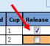  - Click button located on the lower left corner. Click when the “Verify Release Destination” window opens.
Correcting Results | - Open Result Entry, select the Manual resulting mode (top left corner), from the configuration drop down select the appropriate test. Click in the lower right corner.  - Enter the Specimen ID, enter Tab and click Yes to modify the result.  - Change the incorrect result. The corrected result comment will automatically append. Add the CAL comment, press tab, enter a semi-colon and record who was called and the time/date.  - Click . Click when the “Verify Release Destination” window opens.
Limitations | - Results from the Xpert EV assay should be interpreted in conjunction with lab results and clinical data.  - The Xpert EV assay is for the detection of enterovirus only.  - An EV Positive result does not rule out the presence of another pathogen like bacteria in CSF.  - An EV Negative result does not rule out the presence of enterovirus.  - The EV Assay does not rule out Herpes-induced or fungal meningitis; additional testing is required to rule out these infections.  - A negative test result does not exclude the possibility of infection because the test result may be affected by improper specimen collection, technical error, sample mix-up, or because the number of organisms in the sample is below the limit of detection of the test.  - Because the detection of Enterovirus is dependent on the organism’s RNA present in the sample, reliable results are dependent on proper sample collection, handling, and storage.  - The Xpert EV test provides qualitative results and does not provide the quantitative value of the organism detected in the specimen.  - The performance of the Xpert EV test was evaluated using the procedures provided in the package insert only.
Method Performance Specifications | According to the manufacturer (per the package insert) – Overall specifications are shown in Table 3:  Table 3: Overall Specifications – Clinical Performance  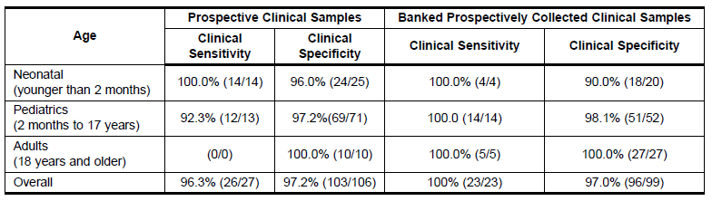
References | 1. Xpert EV Package Insert, GEXEV-100N-100, 300-5052, Rev K. In. Sunnyvale, CA: Cepheid.  2. Tebruegge M, Curtis N. Enterovirus infections in neonates. Paper presented at: Seminars in Fetal and Neonatal Medicine2009.  3. Abzug MJJPd. Presentation, diagnosis, and management of enterovirus infections in neonates. 2004;6(1):1-10.
Alternate Methods | - Enterovirus RNA Detection PCR at Mayo Clinic Laboratories (ENTP)
Proficiency Testing | An alternative proficiency assessment will be performed twice per year with 5 samples.
Training Plan/ Competency Assessment | Training Plan |  |  | Initial Competency Assessment
 | - Employee must read the procedure.  - Employee will demonstrate the ability to perform procedure, record results, and document corrective action after instruction by the trainer. |  |  | - Direct observation
Historical Record
 | Version | Written/Revised by: | Effective Date: |  | Summary of Revisions
 | 1 | Julie Laramie / Matthew Meyer | 5/25/2020 |  | Initial Version
 | Archived by: |  | Archived Date:

