FACSDiva Database Backup

Purpose | In the event of hard drive failure of the FACSCanto II computer, the FACSDiva database may be lost. A backup copy of the database must be stored on the Children’s network drive to facilitate recovery of experiment templates and instrument configurations. This procedure does not replace the daily export of patient experiments to their appropriate network folders.
Policy Statements | This procedure applies to all laboratory technologists performing Flow Cytometry testing, the section  supervisor, and section pathologist.
Procedure
 | Step | Action |  |  |  | Related Document
 | 1 | Close the FACSDiva program if open.
 | 2 | Under G:\FlowLab\DIVA BACKUP, create a new folder named with today’s date.
 | 3 | Click the icon on the desktop to open BD FACSDiva Data Manager. |  |  |  | 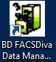
 | 4 | Under the “Backup” tab, use the “Browse” button to navigate to the network folder in which the backup copy will be stored.  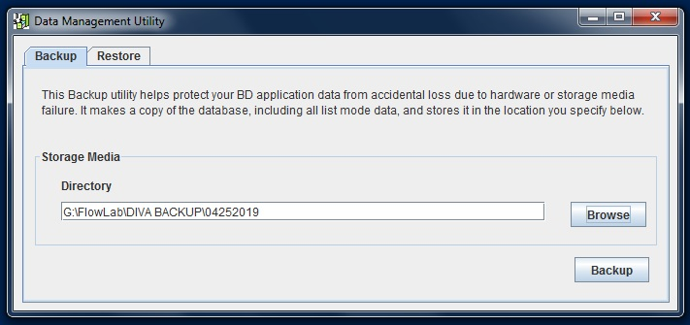
 | 5 | Click “Backup.” A progress box will appear and will indicate when the backup is complete.
 | To Restore Database:
 | 1 | Ensure you are logged in to the FACSCanto II computer as Admin.
 | 2 | Open the Data Manager and click on the “Restore” tab.
 | 3 | Use the “Browse” button to navigate to the folder containing the backup copy you wish to use.
 | 4 | Click “Restore.” Any experiments that have been recorded since the backup was performed and have NOT been exported to the network drive will be lost. Click “OK” to continue.
 | 5 | A progress box will appear and will indicate when the restore process is complete.
References | BD FACSDiva Version 8.0 Software Reference Manual 23-14523-00
Historical Record
 | Version |  | Written/Revised by: | Effective Date: | Summary of Revisions
 | 1 |  | Amanda McCaustland | 08/28/20 | Initial Version

