KingFisher Flex Maintenance and Troubleshooting

Purpose | This procedure provides instructions for maintenance tasks performed on the KingFisher Flex 96 well extraction platform.
Policy Statements | This procedure applies to technical staff performing testing on the KingFisher Flex.
Special Safety Precautions | Microbiologists/virologists are subject to occupational risks associated with specimen handling. Refer to the safety policies located in the safety section of the Microbiology and Virology Policy Manual and the Molecular Biology Manual:  - Biohazard Containment  - Safety in the Microbiology/Virology Laboratory  - Biohazardous Spills  - Safe Work Practices in Molecular
Materials | Reagents Supplies Equipment  - 5% Extran - 70% ethanol - Distilled water - 100% ethanol - Absorbant Cloths - Paper towels - 1000 μl tip rack - 2 ml safe-lock microcentrifuge tube - Buffer Bottle - Alcohol based disinfection wipes - Pressurized air
Procedure | Daily  Shutdown and restart the instrument:  - Flip the switch on the left side of the instrument to turn it off and on.  Clean the instrument:  - Wipe down the instrument surface, turntable, shield plate, and display areas daily with 5% extran followed by 79% ethanol.  NOTE: The keypad has a wipe-clean surface.  NOTE: The shield plate is autoclavable (at 1 bar pressure and 121°C for 20 minutes).  - Plastic covers and surfaces can be cleaned with extran followed by 79% ethanol.  NOTE: If any surfaces are contaminated with biohazardous material, saline solutions, solvents, acids, alkaline solutions, or dust, immediately clean with extran followed by 79% ethanol.  NOTE: Low pressure compressed air can also be used to clean the outside of the instrument and the turntable.  Weekly  Cleaning the turntable  - Keep the turntable surface clean to avoid dust and dirt entering the instrument.  - Clean the turntable surface and black spill shield at least once a week using a soft cloth soaked in 5% extran followed by 79% ethanol.  - Detach the turntable for cleaning (Figure 5–49 through Figure 5–51). Unscrew the two finger screws (Figure 5–49).  NOTE: the screws still remain attached to the turntable when the screws are unfastened. If you have spilt infectious agents on the turntable, clean it with a cloth dampened with 5% extran followed by 79% ethanol.  - Clean the black spill shield (Figure 5–51) and the turntable using a soft cloth or tissue paper soaked in 5% extran followed by 79% ethanol.  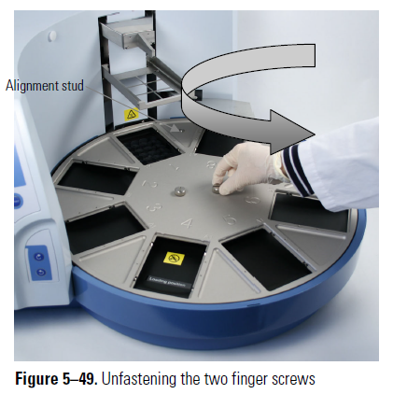  Lift the turntable off (Figure 5–50).  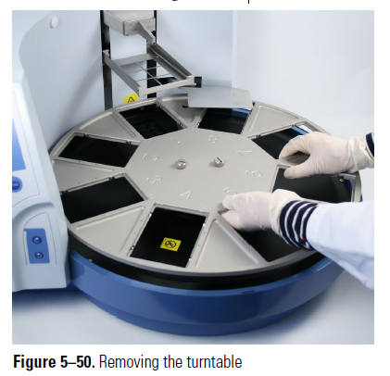  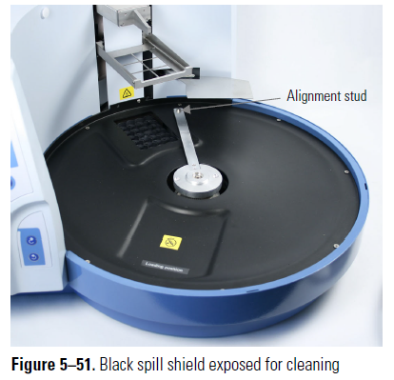  - When you replace the turntable, insert the turntable so that you place it first onto the aligning stud. Then fasten the two finger screws.  NOTE: You can gently rotate the turntable while the instrument is switched off.  Cleaning the heat block  - Wipe with 5% extran follow by 70% ethanol (see removal procedure below).  As Needed:  Cleaning the magnetic rods  - If required (spills or visibly dirty), wipe the magnetic rods using a soft cloth or tissue paper soaked in 5% extran followed by 70% ethanol.  Caution The KingFisher Flex should not be kept in close proximity to magnetic tapes, computer discs or other magnetic storage systems, such as credit cards, as these can be damaged by the strong magnetic field of the KingFisher Flex heads.  NOTE: Do not hold the KingFisher Flex heads close to a PC display, since this may cause damage to the display. Do not use metal tools when handling KingFisher Flex heads. Be careful not to break the magnets while cleaning.  Warning This product contains very strong permanent magnets. People wearing a pacemaker or metallic prostheses should not use this product. A pacemaker or prostheses may be affected or damaged if it comes in close contact with a strong magnetic field.  Installing the tip shield  - Remove the plastic cover.  - Place absorbent or kim wipes on turn table openings to prevent loss of screws.  - Insert first screw in one hole, then place tip shield under and partially tighten.  - Add second screw and tighten both completely.  Changing the heat block  - Using the arrow keypad, move right to the red tab.  - Select maintenance protocol (wrench) then press “Ok”.  - Choose “Change_heatblock” protocol and press “Start”.  - Wait until the heat block platform rises out of the opening.  - Center the heat block on silver platform and press down to click into place.  NOTE: the heat block and be inserted in either direction, with pegs facing down.  - Press “Start” to complete the installation.  Installing the magnet head and checking the tip comb  - When taking out the magnet head (from the box or instrument), do not handle from magnetic pins.  - Using the arrow keypad, move right to the red tab and select maintenance protocol, then “Ok”.  - Choose “Change_magnet” protocol and press “Start”.  - Once pins are aligned, slide the block horizontally into holes towards the back of the arm assembly until you hear a click. (side with 2 pins slides in first).  - Press “Start” to complete the magnet install.  NOTE: Two pieces of the magnet arm assembly should close together upon completion.  - Using the arrow keypad, move right to the red tab and select maintenance protocol, then “Ok.  - Using arrow, select “Change_96w_tip”, then press start.  - Select the appropriate tip comb to match the magnet head and place into plate.  NOTE: Check for tip comb curvature, flex tip comb to straighten if necessary. There is no specific orientation needed for the plate.  - Place tip comb in plate and onto loading position on turn table.  NOTE: No specific orientation needed for plate.  - Allow the instrument to proceed through to check tip comb alignment.  - Press “Start” to begin tip comb test run.  NOTE: A successful test will return tip comb to plate and move it to the loading position for retrieval.  Decontamination procedure  - Decontamination should be performed in accordance with normal laboratory procedures. Any decontamination instructions provided with the reagents used should be followed. Decontamination is only recommendable when infectious substances have been in direct contact with any part of the instrument. If there is a risk of contamination with biohazardous material, the decontamination procedure must be performed.  - Decontaminate completely before relocating the instrument to another location or before sending for service. Decontamination is not required for the proper functioning of the instrument.  - Empty the turntable.  - Switch OFF the power and disconnect the mains supply cable (Figure 3–14).  - Disinfect the outside of the instrument using a cloth dampened with 5% extran followed by 70% ethanol.  - Place the instrument in a large plastic bag. Ensure that the see through lid has been removed.  - Place a cloth soaked in the prepared solution into the bag. Ensure that the cloth does not make contact with the instrument.  - Close the bag firmly and leave the instrument in the bag for at least 24 hours.  - Remove the instrument from the bag.  - Clean the instrument using a mild detergent.  - Remove any stains using 70% ethanol.  - If shipping the instrument, after performing this decontamination procedure, enclose a signed and dated Certificate of Decontamination both inside the transport package and attached to the outside of the package (see Appendix A: “Certificate of Decontamination”).  NOTE: “How to” videos for several maintenance activities are available online here: https://www.thermofisher.com/us/en/home/life-science/dna-rna-purification-analysis/automated-purification-extraction/kingfisher-flex.html  Error messages and warnings  When an error is detected, the current operation is terminated. After an error, it is best to abort the current run and restart from the beginning after the problem is fixed. The KingFisher Flex internal software has the following error messages and warnings (Table 8–8).  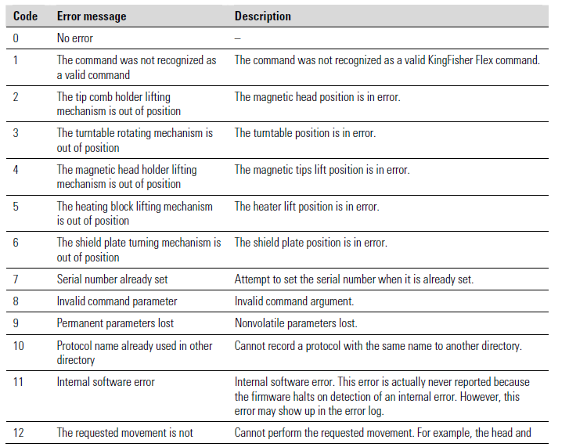  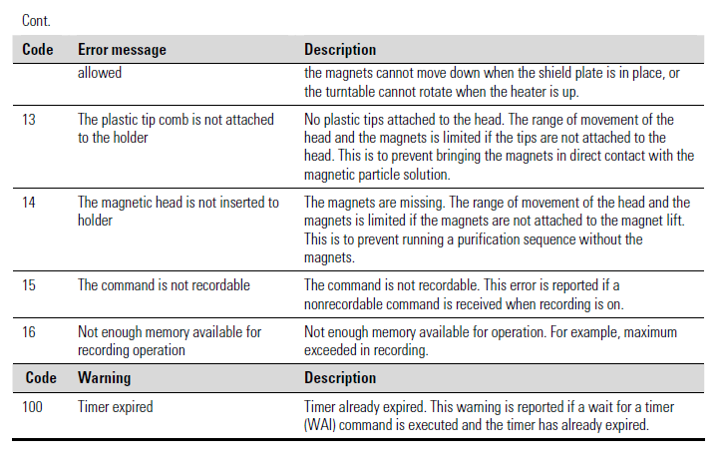  A troubleshooting guide for the KingFisher Flex instrument is presented in Table 8–9.  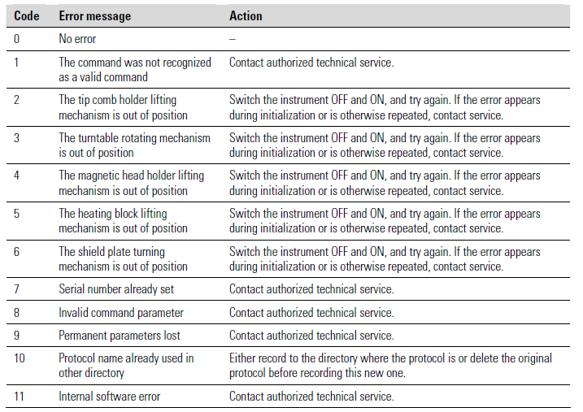  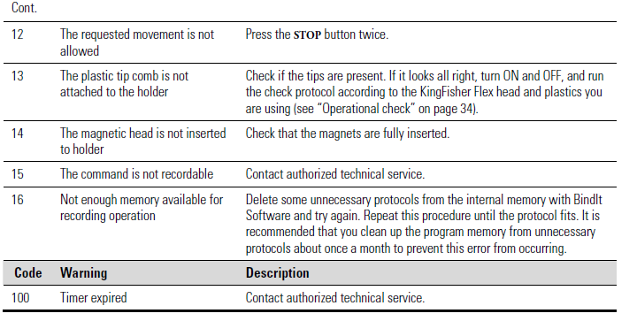
Result Reporting | Record completion of maintenance tasks on the Maintenance Log.
References | - Thermo Scientific KingFisher Flex User Manual, Rev. 1.2, 2010, Thermo Fisher Scientific Corporation, Waltham, MA.
Historical Record
 | Version | Written/Revised by: | Effective Date: | Summary of Revisions
 | 1 | Julie Laramie / Michelle Merryman | 11/09/2020 | Initial Version
 | Archived by: |  | Archived Date:

