Vitek 2 Quality Control for ID and AST

Purpose | This procedure provides instruction for how to perform: VITEK 2XL QUALITY CONTROL for ID and AST cards.
Policy Statements | Vitek QC is performed on each new lot and/or shipment of ID and AST cards before put into use.  AST QC is performed weekly thereafter except for the AST-GP74.  AST-GP74 QC is performed with each day of use.  Vitek QC (all types AST cards and GN ID card) is performed after biennial Preventative Maintenance (PM), and/or repairs or replacement of critical components, major maintenance or service, to ensure the cards perform according to expectations.  If there is a QC failure, document observation, notify supervisor and call bioMérieux technical service at  1-800-682-2666.
Materials
 | Reagents |  | Supplies |  | Equipment |  |  | Media
 | - AST -GP67 bioMérieux product number 22226  - AST-ST02  bioMérieux product number 420915  - AST-GP74 bioMérieux product number 414971  - AST-GN95 bioMerieux product number 421982  - AST-XN08  bioMerieux product number 421983  - GN ID cards, bioMérieux product number 21341  - GP ID cards, bioMérieux product number 21342  - YST ID cards, bioMérieux product number 21343  - NH ID cards, bioMérieux product number 21346  - ANC ID cards, bioMérieux product number 21347 |  | - 0.45% Saline, Cardinal Healthcare product number 3D0775  - 0.45% IV saline, Cardinal Healthcare product number 2B16314X  - 10 mm x 75 mm polystyrene tubes, bioMérieux product number 69285  - Sterile, cotton-tipped applicator swabs, warehouse product |  | - Vitek 2 instrument, bioMérieux product number 530052-1  - DensiChek, bioMerieux product number 27207  - Adjustable volume dispenser, bioMérieux product number V1200  - Smart Carrier Cassette with button memory, bioMérieux product number 27700  - Vortex Mixer, Barnstead International, model # M37615 |  |  | - CHOC  - SB  - SAB  - MAC
Storage | - Cards should be stored in factory sealed pouches at 2-8 °C.  - All other supplies are stored at room temperature.
Special Safety Precautions | Microbiologists are subject to occupational risks associated with specimen handling.  - Biohazard Containment  - Biohazardous Spills  - Safety in the Microbiology Laboratory
QC Organisms | AST-GP67:  - Enterococcus faecalis, ATCC 29212  - Enterococcus faecalis, ATCC 51299  - Staphylococcus aureus, ATCC 29213  - Staphylococcus aureus, ATCC BAA-976  - Staphylococcus aureus, ATCC BAA-977  - Staphylococcus aureus, ATCC BAA-1026  AST-ST02:  - Streptococcus pneumoniae, ATCC 49619  - Staphylococcus aureus, ATCC 29213  - Staphylococcus aureus, ATCC BAA-977  AST-GP74:  - Streptococcus pneumoniae, ATCC 49619  AST-GN95:  - Escherichia coli, ATCC 25922  - Escherichia coli, ATCC 35218  - Pseudomonas aeruginosa, ATCC 27853  - Klebsiella pneumoniae, ATCC 700603  AST-XN08:  - Escherichia coli, ATCC 25922  - Escherichia coli, ATCC 35218  - Pseudomonas aeruginosa, ATCC 27853  - Klebsiella pneumoniae, ATCC 700603  GN ID cards:  - Escherichia coli, ATCC 25922  - Escherichia coli, ATCC 35218  - Pseudomonas aeruginosa, ATCC 27853  - Klebsiella pneumoniae, ATCC 700603  GP ID cards:  - Enterococcus casseliflavus, ATCC 700327  - Streptococcus thermophilus, ATCC 19258  YST ID cards  - Candida albicans, ATCC 14053  NH ID cards  - Eikenella corrodens, ATCC BAA-1152  ANC ID cards:  - Clostridium septicum, ATCC 12464  - Bacteroides ovatus, ATCC BAA-1296
Procedure-Add cards to Inventory | - Vitek 2 directory → QC icon (has line graph symbol).  - Click the truck icon.  - When the “enter new shipment window” appears, enter the lot number and fill in the fields on the window.  - Enter the number of boxes in the lot received. Press <enter>.  - Click “add” to make another entry.
Procedure-Sample Preparation | - Refer to the Vitek 2 Systems Product Information document for organism media and incubation requirements.  - Organisms subcultured from frozen stock should be sub-cultured twice prior to testing.  - Allow test cards and saline to reach room temperature.  - Obtain Smart Carrier Cassette and place on bench top.  - Enter Vitek 2 Web Viewer. Log in at user name with labadmin and password with labadmin.  - Click on Vitek 2 FLEXprep icon  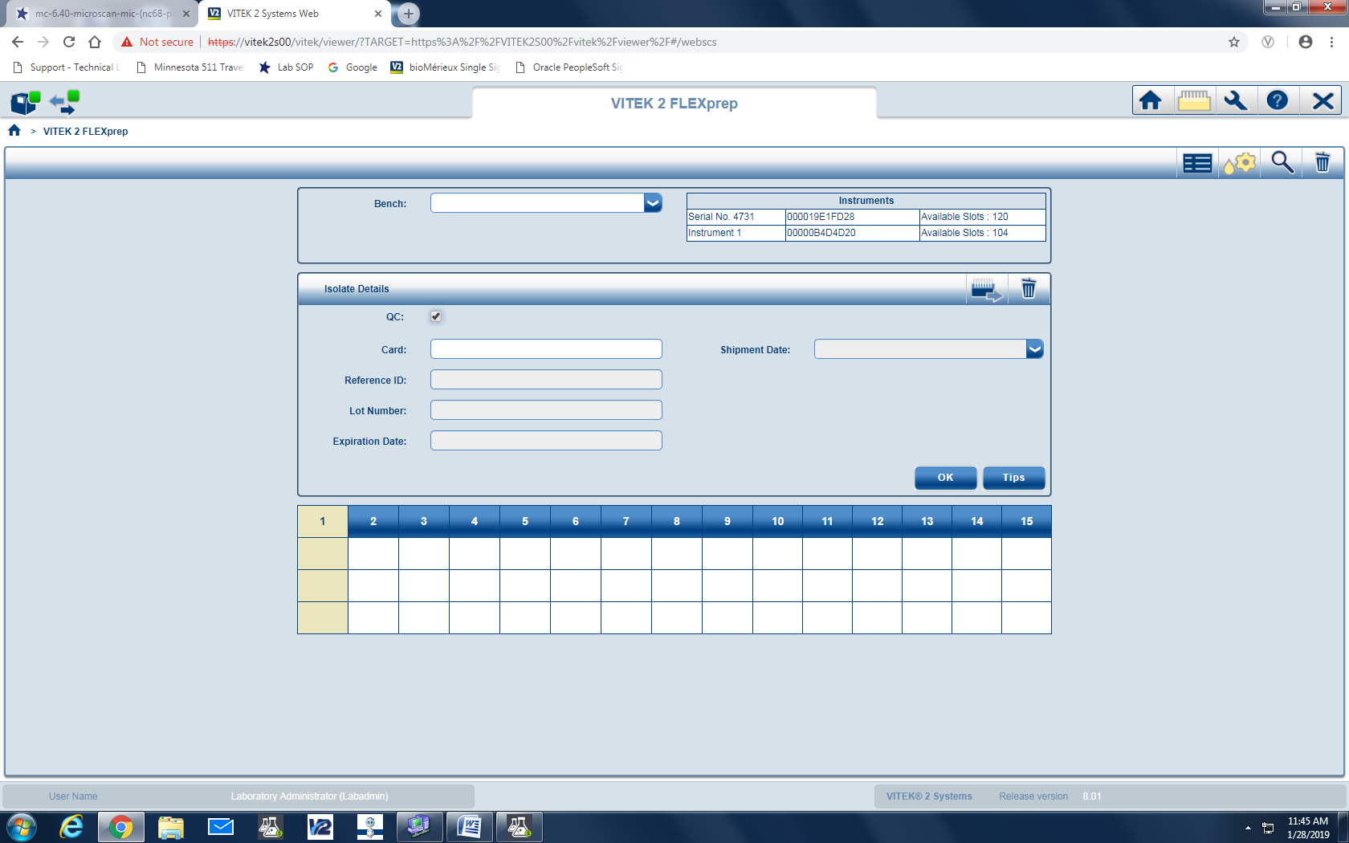  - Click on the QC box  - Scan the barcode of the QC card being tested.  - Select in the drop down box in the Reference ID box.  - Lot number and Expiration date will appear.  - Refer to Vitek 2 procedure MC 7.00 for further information on suspension preparation.  - Once all setup is complete, click on the icon to send the cassette to Vitek 2 System  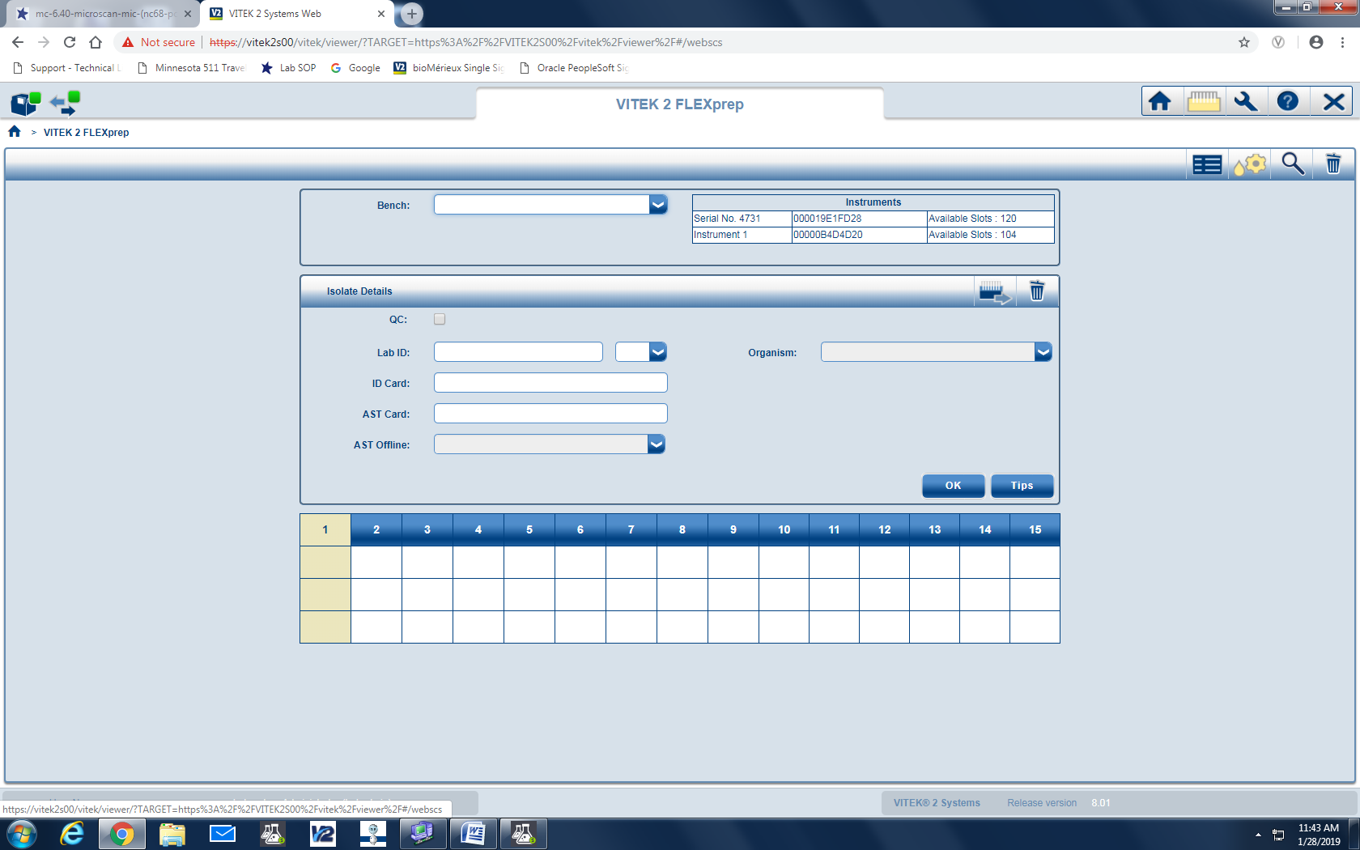  - Record card setup with panel type and date and initials on Vitek Weekly and New Lot QC Review Log  - Refer to MC 7.00 Vitek 2XL Procedure for placement of cassette in the Vitek 2XL.
Verifying and Printing QC Results | - Vitek 2 directory → QC icon. (has line graph symbol).  - Click on the drop down ‘Filter by:’ → ‘deviation’  - If any deviations are noted, click on the ‘comment’ field and explain occurrence and next steps.  - Record “Pass/Fail” Read tech, date, and description of problem (if “Fail”) and Problem resolution.  - It must be noted if the failure affected patient test results. Notify micro staff and Micro Supervisor.  - Vitek 2 directory → QC icon  - Click on the drop down ‘Filter by:’ → ‘custom’.  - Fill in date range for desired results.  - Click the printer icon near the upper right corner of the screen.  - Click ‘Print’ to generate report.  - Initial and date each organism column, double-checking for deviations. Acceptable ranges are listed alongside actual result.  - Monthly Review: Each month QC data will be reviewed and assessed by the Micro Supervisor or designee.  - Person assessing initials the log for monthly review and notifies Lab Director of any ongoing or critical issues.
Out of Control Results due to obvious error | - Document the reason and retest the strain on the day.  - If the repeated result is within range, no further corrective action is necessary.  - Examples of obvious error include: Use of wrong card, Use of wrong control strain, Contamination, Wrong incubation temperature or conditions.
Out of Control Results not due to obvious error | - Investigate possible procedural problems: Standardization of the inoculum, Storage and expiration dates of the cards, incubation conditions, control strain was not contaminated, and control organism was more than 24 h old.  - Retest the strain on the same day.  - If the repeated result is within range, no further corrective action is necessary.  - If QC fails second day, test the antimicrobial agent for 5 consecutive days. Record all results.  - If all 5 results are within range, no additional corrective action is necessary.  - If the problem is not resolved (1 or more parameters out of range), daily QC testing must be done until the problem is resolved.  - It may be necessary to obtain a new QC organism either from the frozen stock or from BD.  - Call BD technical service at 1-800-638-8663 if it may be a manufacturer problem.  - Perform alternate test method until the problem is resolved.  - Suppress the results for the individual antimicrobial agent.
References | - Vitek 2 Instrument User Manual, bioMérieux, 2008.  - Vitek 2 Product Information Manual, 2009.  - Vitek 2 Customer Training Course manual, bioMérieux, 2014.
Training Plan/ Competency Assessment | Training Plan |  |  |  |  | Initial Competency Assessment
 | - Employee must read the procedure.  - Employee will observe trainer performing the procedure.  - Employee will demonstrate the ability to perform procedure, record results and document corrective action after instruction by the trainer. |  |  |  |  | - Direct observation.
Historical Record
 | Version | Written/Revised by: |  | Effective Date: |  |  | Summary of Revisions
 | 1 | Kristin Renner |  | 10/1/2005 |  |  | Initial Version
 | 1.1 | Kristin Renner |  | 7/17/2006 |  |  | Added hyperlinks
 | 1.2 | Becky Carlson |  | 10/6/2009 |  |  | Updated product information and organism information
 | 1.3 | Brian Howell |  | 6/18/2011 |  |  | Reworded sections to reflect new software.
 | 1.4 | Becky Carlson |  | 5/15/2003 |  |  | Updated product information
 | 2 | Becky Carlson |  | 4/7/2015 |  |  | Updated product information; Re-formatted to CMS; Re-numbered from MC 1002
 | 3 | Becky Carlson |  | 9/28/2015 |  |  | Added Vitek Weekly and New Lot QC Review Log for recording of QC results
 | 3 | Becky Carlson |  | 3/23/2017 |  |  | Added biennial PM required QC statement to Policy Statement section.
 | 3 | Susan DeMeyere |  | 5/23/2017 |  |  | Removed XN06 cards, discontinued
 | 3 | Susan DeMeyere |  | 5/31/2017 |  |  | Removed 30 day QC for Vitek ID cards per Cap requirement COM.50500-Does not apply to ID systems.
 | 4 | Susan DeMeyere |  | 3/2/2018 |  |  | Biennial Review
 | 5 | Susan DeMeyere |  | 2/15/2019 |  |  | Add AST-GN95, remove AST 69 and 79 and update Vitek Web Viewer.
 | 6 | Susan DeMeyere |  | 12/14/2020 |  |  | Add AST-ST02, change AST-GP74 QC to day of use.

