Thermo Scientific ALPS 50V Microplate Heat Sealer Function and Maintenance

Purpose | This procedure provides instructions for loading and thermally sealing biological plates and for maintenance tasks performed on the Thermo Scientific ALPS 50V Microplate Heat Sealer.
Policy Statements | This procedure applies to technical staff using the Thermo Scientific ALPS 50V Microplate Heat Sealer.
Special Safety Precautions | Microbiologists/virologists are subject to occupational risks associated with specimen handling. Refer to the safety policies located in the safety section of the Microbiology and Virology Policy Manual:  - Biohazard Containment  - Safety in the Microbiology/Virology Laboratory  - Biohazardous Spills
Materials | Reagents Supplies Equipment  - 5% Extran - 70% isopropyl alcohol - Absorbent Cloths - Thermo Scientific Easy Peel Sealing Film product AB-0745 - Plate carriers - Thermo Scientific ALPS 50V Heat Sealer
Function Procedure - Heat Sealing | The ALPS 50V sealer is designed to be used with deep well plates without a carrier and PCR plates and microplates with carriers.  - Switch instrument on. If necessary, set required sealing time and heater set-point temperature via the keypad and LED display.  NOTE: The LED display shows the current settings for the sealing temperature or time and the heater on/off status retained from the last seal.  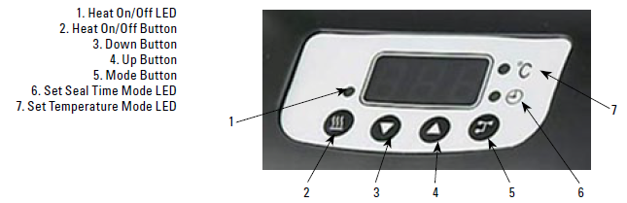  Seal time: 2 seconds  Temperature: 170°C  - Press the mode switch to toggle the display between seal time and temperature setting. Set the sealing time and temperature by pressing the up and down arrow keys.  NOTE: The “°C” mode LED lights indicate that the adjustable field is temperature.  - After desired settings have been entered, enable the heater by pressing the Heat on/off button.  - Allow the instrument to reach the desired temperature (~10 minutes). The Heat on/off LED will flash while the sealer is coming up to temperature and will remain on permanently when the set point (+/- 2°C) is reached.  - Load a plate and add the sealing film (white side up). Do not touch the heating surface.  NOTE: no carrier plate (black) is required to seal deep well plates. Use carrier if sealing 96 well PCR plates.  - Grasp the handle with one or two hands, as appropriate.  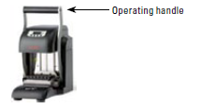  - Lower the handle to thermally compress sealing film onto sample plate.  NOTE: When correct clamping pressure is achieved, an audible warning will sound and the timer will count down to zero. Do not apply more pressure to the handle than is necessary to operate the micro switch.  - At zero seconds, the display will flash and an audible warning will sound. Release the heater plate from the sealed sample plate by raising the handle to its upper position and review the seal. NOTE: Failure to raise the handle could ruin the sample plate.  - Carefully remove the sealed plate and check the seal is properly adhered.  Caution: Foil sealed plates remain hot for a number of seconds after sealing and should be handled with care.  Caution: The unit will remain hot for a considerable amount of time after it has been turned off and must be allowed to cool down to an acceptable level before cleaning.
Maintenance | Daily/With Use  - Clean the instrument with 5% extran followed by 70% ethanol.  - Record completion of maintenance tasks on the Maintenance Log.
Troubleshooting | Contact Thermo Fisher Scientific Customer Support at 1-800-345-0206.
References | - Thermo Scientific ALPS 50V Microplate Heat Sealer User Manual. Issue 2.00. 2007.  - ThermoFisher Easy Peel Heat Sealing Tape Package Insert
Historical Record
 | Version | Written/Revised by: | Effective Date: | Summary of Revisions
 | 1 | Michelle Merryman / Julie Laramie | 01/25/2021 | Initial Version
 | Archived by: |  | Archived Date:

