RS 3400 Syringe Holder

Purpose | This procedure provides instructions on how to properly use the syringe holder in the RS 3400 Canister holders.
Policy Statements | - The syringe holder is designed to hold standard 35 mL or 60 mL syringes and using a cap/lock at the syringe end which comfortable fits within the dimensions of the syringe holder  - The holder is made of foam and is subject to normal deterioration (similar to plastic).  - It should be replace periodically based on its observed wear and failure to properly hold syringes and/or be retained properly by the canister holder in the RS 3400
Materials | Supplies
- 35 mL or 60 mL luer lock syringe
- RS 3400 Syringe Holder
Procedure | 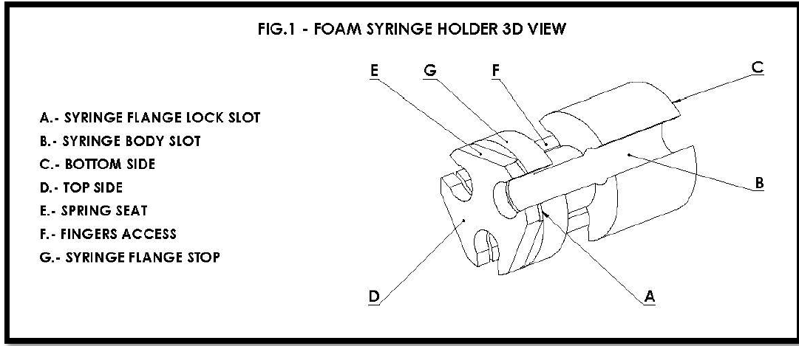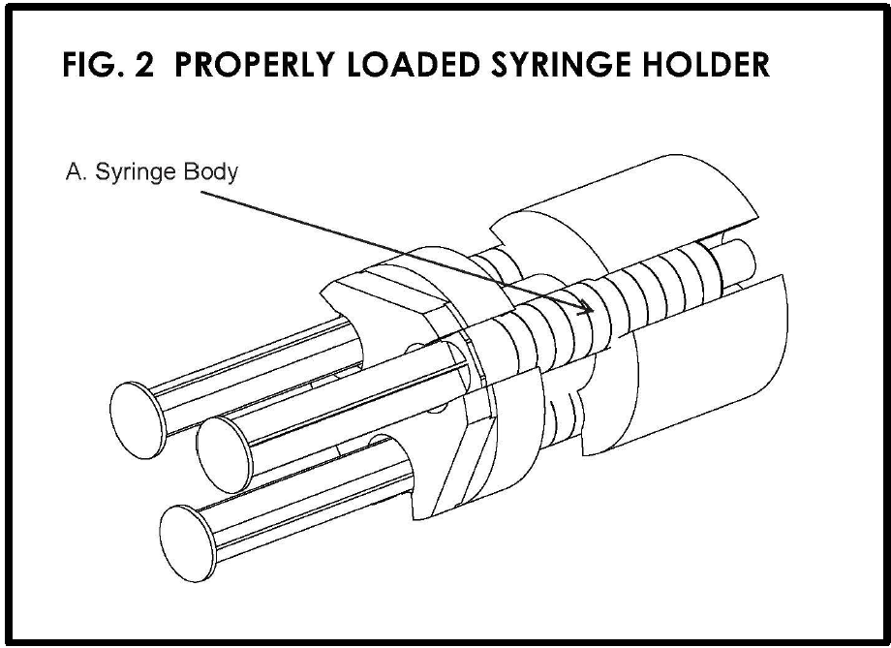  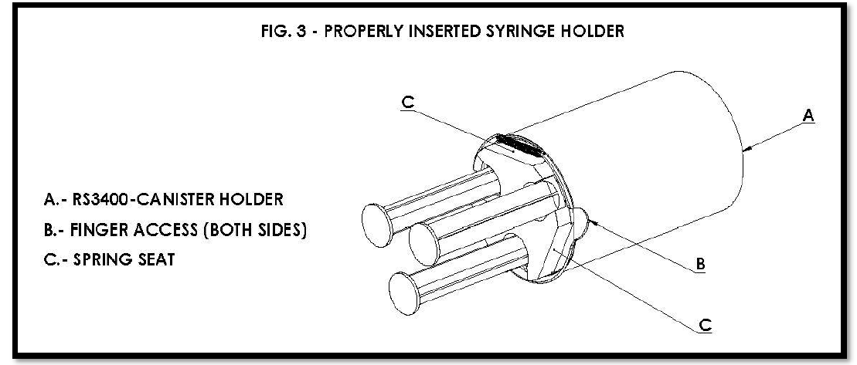
 | Step | Action
 | 1 | The syringe body is gently pushed into the syringe body slot (see B in Fig 1 and A in Fig 2) so that the syringe flange fits within the syringe flange lock slot (see A in Fig. 1 and Fig 2). The syringe flange should sit in contact with the syringe flange stop (see G. in Fig. 1). The syringe body should be completely with the syringe body slot so it will not impede the insertion of the loaded syringe holder into the RS 3400 canister holder (see Fig. 1 and Fig. 2).  The tip of the syringe should not extend beyond the bottom of the syringe holder (see C. inn Fig. 1 and Fig. 2)  Note:  - Place a rubber band around the syringe body in the syringe holder when 35 mL syringes are used to help secure the syringes.  - Avoid handling the syringe plungers when inserting the syringes into the holder.
 | 2 | The syringe holder will accommodate up to 3 syringes at once but can be used for 1, 2, or 3. Once the syringe(s) is/are within the syringe holder, the syringe holder can then be placed into the RS 3400 canister holders by handling the syringe holder at the syringe flange stop, or main body of the syringe holder. The syringe holder must be oriented in the canister holder so that the spring retains the syringe holder at the spring seat portion of the syringe holder (See E. in Fig.1 and Fig. 3)  Note:  In the case where only 1 syringe is contained in the syringe holder, the syringe holder should be oriented so that the syringe is toward the bottom of the canister holder.
 | 3 | The syringe holder can be gently removed from the canister holders by using two hands to draw out the syringe holder by using the finger access slots on the each side of the canister holder (See B. in Fig. 3). This allows the operator to avoid handling the syringe plungers.
 | 4 | Once the syringe holder is out, the syringes can be removed by holding the syringe holder by the syringe flange stop (or main body of the syringe holder) and gently pulling the syringe out by the syringe body, not disturbing the syringe plunge.
References | - RS 3400 Syringe Holder Operators Manual, Rad Source Technologies, Inc., Version 3
Approval  Workflow | Transfusion Service/Lab Director
Historical Record | Version |  | Written/Revised by: | Effective Date: | Summary of Revisions
 | 1 |  | S. Cassidy | 3/1/2021 | Initial Version

