SUNQUEST COLLECT FOR LAB - ANDROID DEVICE

Purpose | This procedure provides instructions for Sunquest Collect to be used by trained health care professionals. Collect helps users manage the following activities:  • Positive patient identification by scanning barcoded patient armband  • Recording specimen collection  • Monitoring specimen collection  • Rescheduling an order  • Adding a test to an order  • Crediting an order  • Printing labels
Materials | Supplies |  |  |  |  | Equipment
 | - Label stock for blue tooth printers |  |  |  |  | - Android handheld device  - Bluetooth printer
Special Safety Precautions | All users must read and obey the warning notices with regard to the usage of wireless devices included in your device manufacturer’s documentation. Pacemaker manufacturers recommend that a minimum of 15 cm (6 in) be maintained between a wireless device and a pacemaker to avoid potential interference with the pacemaker. These recommendations are consistent with independent research and recommendations by Wireless Technology Research. Persons with pacemakers should always keep the device more than 15 cm (6 in) from their pacemaker when turned on. If you have any reason to suspect that interference is taking place, turn off the wireless device
Procedure

 | Step
 | 1 | Log into Sunquest Collect. Tap on the Sunquest Collect icon from the Android Screen.  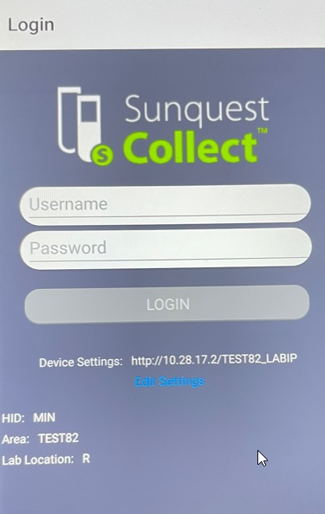  Note: If you create bar codes for your credentials to be scanned for login and use small characters/mixed case within your password, you will need to create your bar code using Code 128. The standard Code 39 will not accept small characters. If using barcode for credentials, the username and password cannot be saved in the same place  Enter appropriate Username and Password. Credentials can either be entered manually from the device keyboard or scanned by bar code. Tap LOGIN.
 | 2 | Selecting a printer: If no printer is paired with your device, you will be prompted to pair. If a device is paired, you will continue on the Worklist Screen.  A printer will be paired with each Android handheld when put into service, however the printer can be easily changed in the event of malfunction.  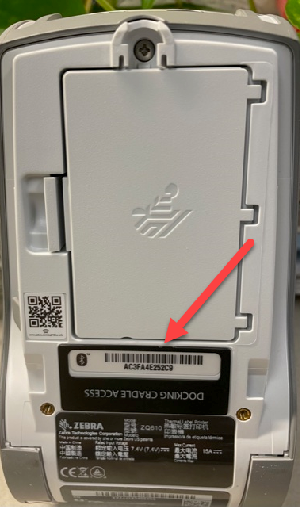  Note: If no printer is paired, you will be prompted to select a printer at login.  This is accomplished by scanning the MAC address bar code on the back of the printer device indicated by the red arrow.  You will get the following communications during the pairing process between the Android device and the printer once the bar code is scanned.  On the printer display you will get a BT PAIRING EVENT showing on the screen.  Accept the Pairing Event on the printe by hitting the black button below ACCEPT on the printer.  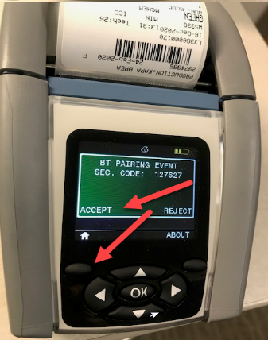  Back on the Android device tap PAIR.  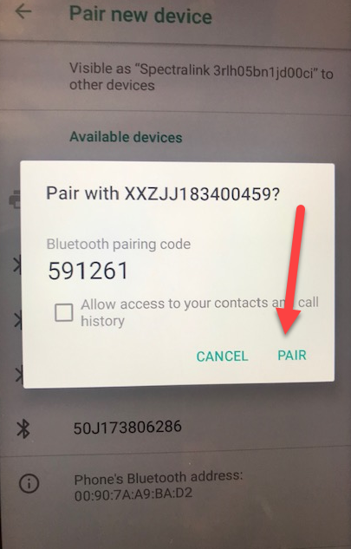  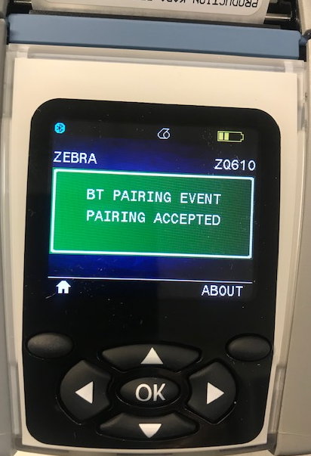  If pairing with the printer is successful, you will see the above message on your printer.
 | 3 | The Collect Screen:  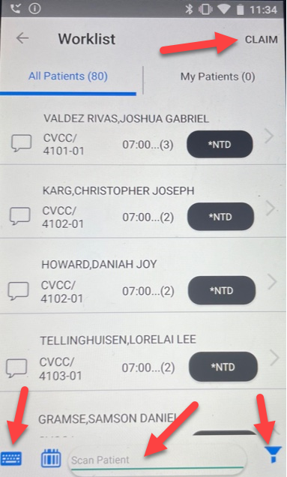  Claim: Located in the upper right hand corner.  Filter: Located in the lower right hand corner.  Scan Patient: Located in the middle lower edge of the screen.  Keyboard: Located in the lower left corner of the screen.  The worklist above is sorting by patient location and time. On the main worklist screen, you can see the patient name, location/room-bed, requested collect time and draw priority. Both Nurse to Draw (NTD) and Lab to Draw orders will display.  FILTER: You can scroll through the whole list that qualifies for draws within your collection window OR you can Filter down to a specific location, priority or time frame. The filter can be accessed in the lower right corner of the device screen. Filters selected will remain on the device until rebooted or deleted by the logged in User.  CLAIM: You can now go through your list and Claim certain patients you intend to draw so they cannot be selected by other phlebotomy staff.  SCAN/KEYBOARD: Scanning the patient armband is the recommended way to access and confirm your patient and orders. However, in emergent situations, the MRN could be typed in using the keyboard in the lower left corner of the screen. If you manually enter the MRN, you will need to choose a reason for the entry. Either “Emergent” or “ID Band did not scan”.
 | 4 | Selecting Patients and Tests and performing specimen collection:  You can preview the draw for a patient by selection the right arrow next to their patient information on screen.  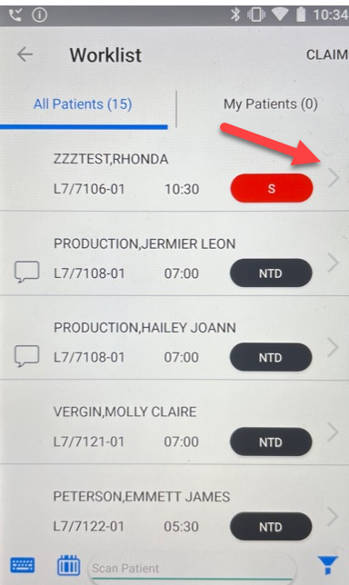  Note: Scanning can be accomplished by using either the left or right hand upper buttons on either side of the device.  Note: You can choose just to scan your patient from this screen and it will bring up any pending orders for the patient that qualify within the time window.  Once you tap the arrow on the right side of the screen, the current orders are viewable for the patient so the draw can be previewed. For isolation and all NICU patients, place the android device inside a clear plastic zippered bag. (Between patients follow all isolation procedures).  To continue processing the draw for the patient, you must scan the armband for positive patient Identification. If the ID matches you will be permitted to select tests, If the ID does not match, you will get a Patient ID Mismatch message and will not be allowed to continue. You will need to resolve before continuing.  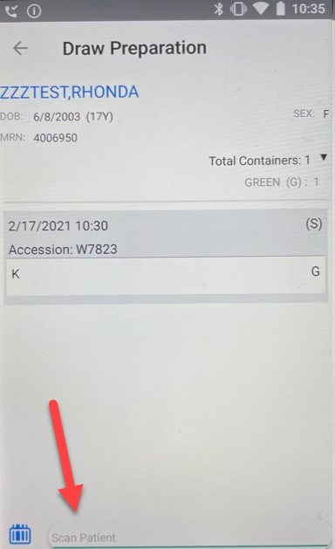  Note: Carefully verify the demographic  data and follow phlebotomy guidelines for patient identification protocols.  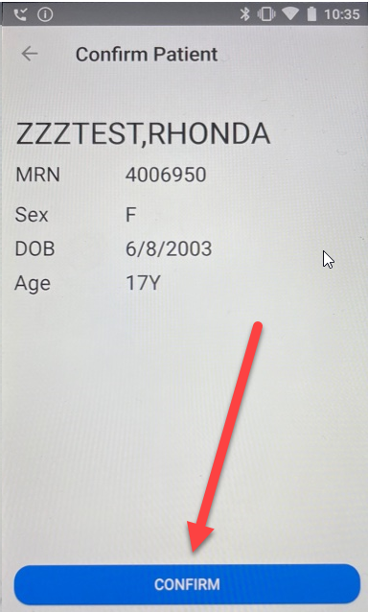  Note: Once you confirm the patient is correct, the screen will do a 5 second count down to collate orders for the patient before moving to this screen.  If the Medical Record Number scan matches the order, verify visually per procedure this is the patient you are processing. Once you have done that, tap the CONFIRM blue box.  You will then be taken to the patient’s pending orders. Review the collect time for each order to ensure you will be collecting the correct orders for the current timeframe. Future orders may show in this window if they are within the Search window (8 hrs back, 4 hrs future).  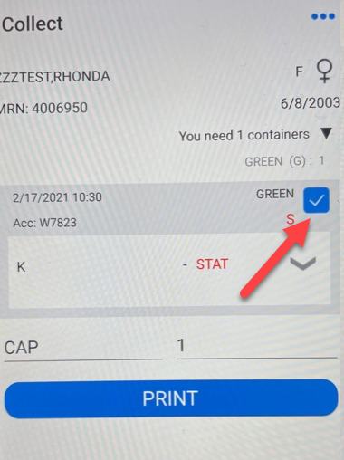  From the “Collect” page, make any necessary order changes such as reschedule, add tests, credit tests, or add comments to the appropriate accessions or tests. (See Step 8: Additional Options from the Collect Screen).  Tap the boxes next to the tests you intend to collect and review the summary section for the number of and type of tubes needed for the order. Draw the required specimen volume and fill appropriate tube(s) for all accessions.  Note: This screen displays the tube type(s) and number of containers to collect displayed just below the patient demographics.  Draw the patient. Once the draw is complete, tap the PRINT blue box to print the labels specific to your draw. Labels will print to your paired device. Match each label by the tube description and label your tubes appropriates. Labels should not be printed prior to the specimen collection. Reprint labels as needed. Default workload is CAP and 1, but can be updated by tapping on the appropriate field to adjust as needed. (ie, VP, 1 or VP, 2)  Once labels are affixed to the tubes, continue to complete the order in Collect and tube or bring specimens to the lab. Return any unused labels to the lab with the specimen(s).
 | 5 | Order completion:  Complete the collection process, you must tap YES–DONE to submit the draw data to the lab system.  Note: If YES – DONE is not tapped, the draw will not be recorded and the collect time and any changes made will not be transmitted to the lab  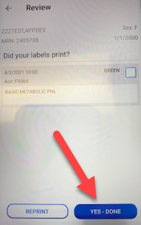  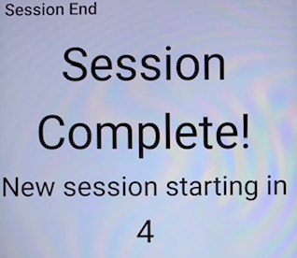  The screen will exit and refresh in 5 seconds.
 | 6 | Manual Medical Record Number (MRN) Entry  An armband scan is the recommended method for positive patient ID and locating orders in Clinical Collect. However, there may be special instances where you are forced to enter the patient manually into the system. This would either be an Emergent situation where no orders are yet in the system and Temporary Labels are required OR the Armband will not scan and you can’t leave the bedside to obtain a new armband. In these instances you would select the Keyboard Icon from the lower left corner of the Worklist Screen and type in the patient Medical Record Number (MRN).  Clinical Collect knows if the keyboard is accessed and the MRN is entered manually.  The user will then be forced to select one of the check boxes to explain the reason for the  Manual entry before they will be allowed to continue. Manual entries will be monitored for Quality Assurance purposes and reports will be shared with the Lab Management team for review.  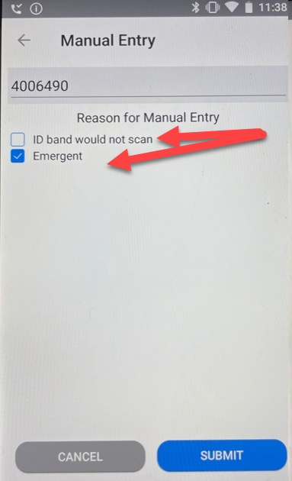  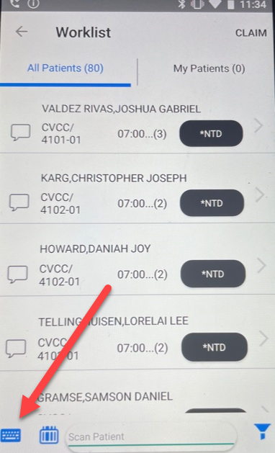
 | 7 | Temporary Labels  If the patient is validated by the system, but no orders are available or qualify, you will have option of printing Temporary Labels for your collection tubes.  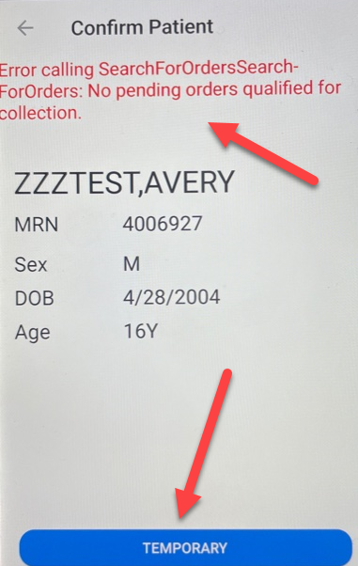  Tap the blue TEMPORARY selection and do reprints until you get the number of labels required for you tubes.
 | 8 | Result at Request (RAR) Tests:  There are several tests that may require information on collection as indicated by the RED EXCLAMATION ! You must tap on the Red Down Arrow to continue.  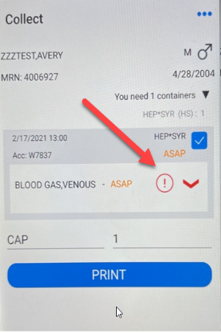  RAR: The most common is blood gas testing with FiO2 (O2 Administered)  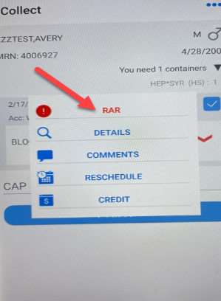  Tap RAR to continue. You must enter a value to continue.  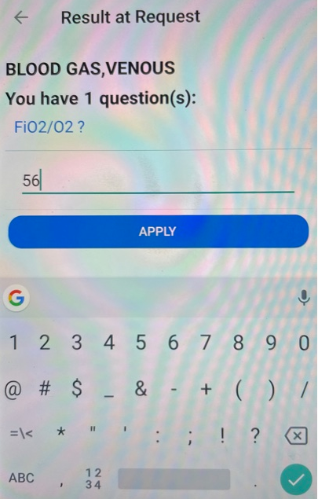  Enter your numeric value from the keyboard or RA (Room Air) if the patient is not on O2 and tap APPLY.  Once you have completed the RAR, the exclamation mark will no longer be red and you will  be able to print labels and finish the collection.
 | 9 | Additional Options from the Collect Screen:  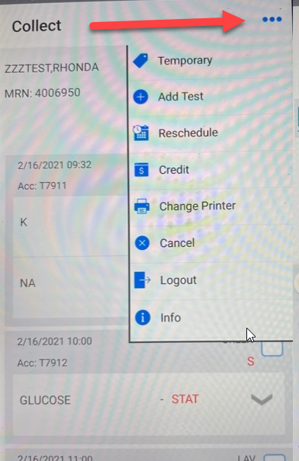  Selecting/tapping on the 3 dots from the Collect screen will allow additional options:  Temporary: Print temporary labels  Add Test: Allows a limited selection of tests that can be added at the point of collection.  Reschedule: Allows you to reschedule the draw to a future time if it cannot be collected.  Credit: Allows you to credit testing  Change Printer: Allows pairing another printer  Cancel: Will cancel you back to the worklist and the current draw will not proceed  Logout: Will exit you out of Clinical Collect to the login screen  Info: Provides info on current user and device information
 | 10 | Add Test:  There are times when phlebotomy may want to add an extra tube or ADDT for additional orders they may be placing from Cerner. The Add Test option allows the phlebotomist to select a test by tapping the blue square next to the description, and add a comment. It will also print a label for the Add.  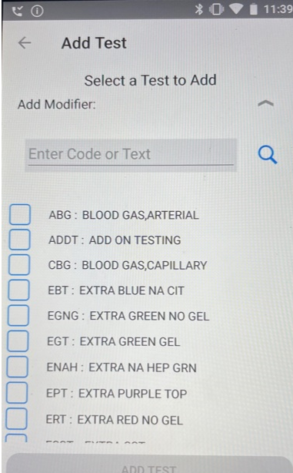  Current Add Test Options:  ABG - Arterial Blood Gas  ADDT - Add on Testing  CBG - Capillary Blood Gas  EBT - Extra Blue NaCit  EGNG - Extra Green NO GEL  EGT - Extra Green Gel  ENAH - Extra NaHep  EPT - Extra Purple  ERT - Extra Red NO GEL  ESST - Extra SST  VBG - Venous Blood Gas  Comments can be entered as Free Text or a code. To search for a code, select the spy glass. Comments cannot contain these characters: # \ ! - ; |  When complete, tap Add Test at the bottom of the screen.
 | 11 | Reschedule:  When you reschedule an order, Sunquest cancels the original order and will  create a new order. When you partially reschedule an order, Sunquest automatically credits the rescheduled test(s) on the original order and creates a new order.  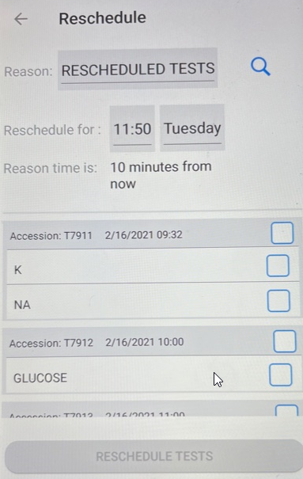  In the reschedule window:  Reason: Will automatically populate as RESCHEDULED TESTS  Rechedule for: Will automatically fall in as 10 minutes into the future. You can tap on the time field to pick a different time. (See next page). If you tap on the day field, you can pick another day. Most often the day should remain unchanged.  Tests to be rescheduled: Check the box(es) next to the test(s) to be rescheduled. (See next page)  Reason time: Will update as the reschedule time is changed by any new selection for the time field.  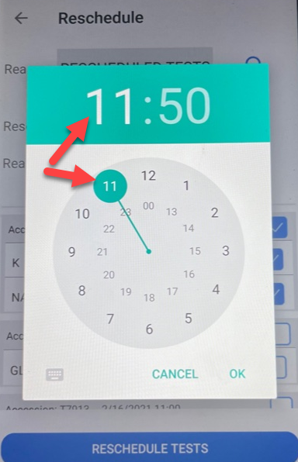  Tap to check the test(s) you want to reschedule. Note: If a test is part of a package, all tests within the package will be automatically selected.  Reschedule Future Time Selection box:  When you tap on the time field from the reschedule window you will see the image to the left. Tap on the hour field in the green banner to select the future hour. The outer rim of the circle designates AM and the inner circle designates PM in military time. Tap the number for the hour to select your future time for the rescheduled collection.  Then tap the minute field from the green banner and another round indicator will be present for the minute field selection.  Once the desired reschedule time appears in the green banner, tap OK or CANCEL if the reschedule is no longer needed.  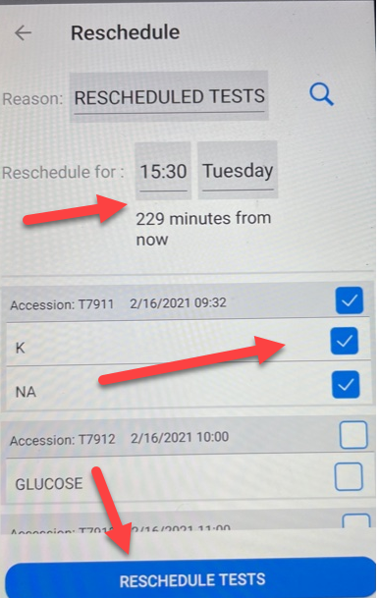  Once selections have been made for rescheduling review to ensure your selections are correct. If it is correct, proceed. If not, touch the time field and reselect.  Once correct, tap the RESCHEDULE TESTS blue bar at the bottom of the screen to complete the reschedule.  The reschedule orders will create a new accession for the new time and will appear back on the worklist for the future time.  In this window, the K and NA will be moved to 15:30 on Tuesday, 229 minutes from the current time.
 | 12 | Claim: You can claim patients from the worklist to let other staff know you will be collecting particular draws so no other staff person responds to the collection request. To do so, tap on CLAIM in the upper right hand corner of the screen.  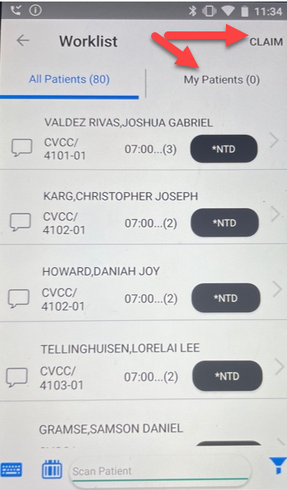  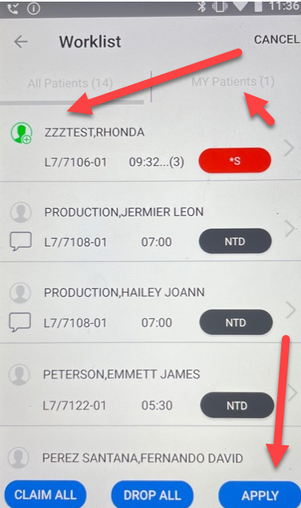  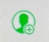 By tapping on the person icon, you can turn it green and will mark this patient as CLAIMED by you. Once you tap APPLY the patient is “claimed” and cannot be collected by any one else. You can also choose to DROP ALL all of your Claims or also CLAIM ALL of the items on your worklist. In the example above, you will see the “My Patients” displays as 1 as only one patient has been claimed above. You may use the CLAIM feature after you have filtered for a specific location you are responsible for. See Filtering below.
Claim (continued):
In the images above, the claim icons in GREEN are claimed by you.
The images in BLUE are claimed by other staff. Please note the Tech code of the phlebotomist holding the claim will display above the blue person icon.
You can review all items you have claimed under My Patients. If you cannot complete the draw, you must release the claim so others can
collect the patient.
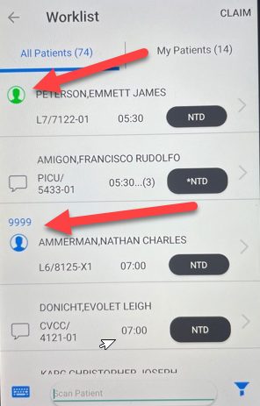
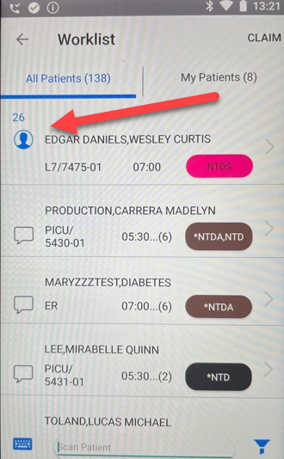
 | 13 | Filtering:  You can filter the patients you see on the worklist by their location, order priority, and scheduled collection time. Filters are accessed through the icon on the lower right hand of the screen.  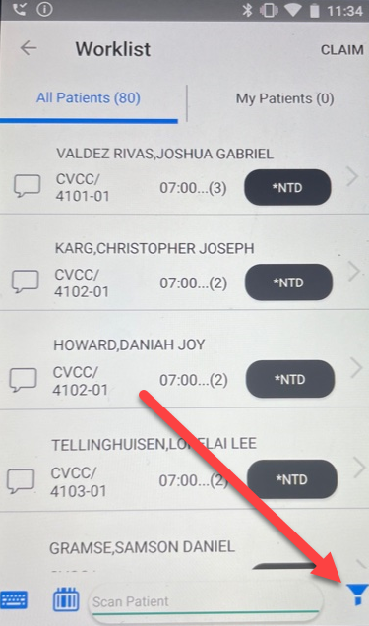  The filter box to the left allows you to pick a sort to narrow down your worklist. Most often the sort by location would be used if you were only drawing on a certain floor. To open the filter, select the down arrow next to the item you want to filter.  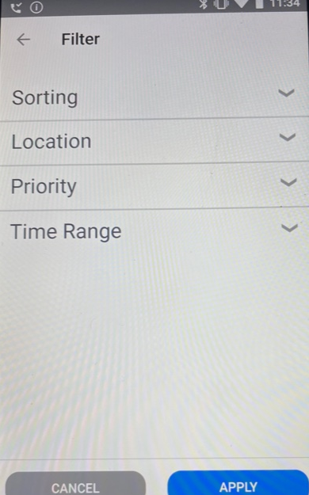
Location Filter:
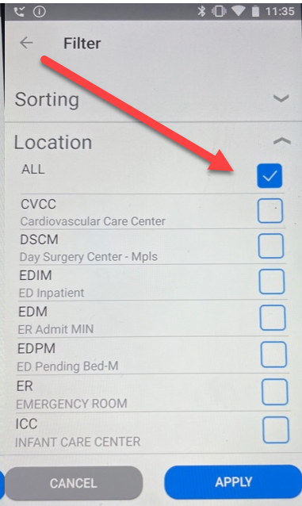
Location ALL is checked and will show all inpatient locations on the worklist. To see a worklist for one or more specific locations, you must uncheck ALL and then check the specific location(s) you want and tap APPLY. When you go back to the worklist, you should only see those selected locations on the worklist.

NOTE: The Filtered location selection will continue to be applied until it is changed by the user or the device is rebooted.

 | 14  Priority Filter: A filter by priority will not be enabled at this time. For feedback regarding this option, see LIS | Priority Filter: Time Range Filter:  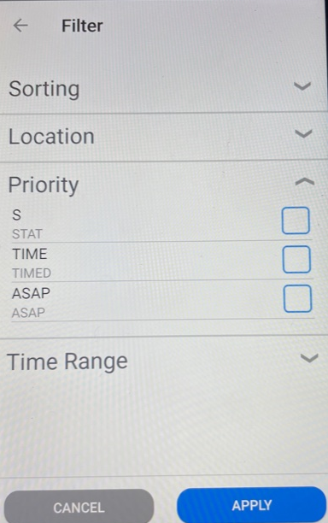  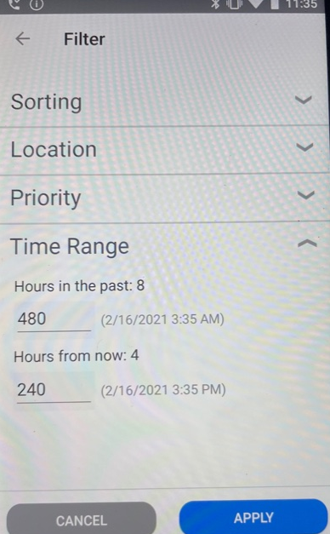  Time Range Filter: The default search range is 8 hrs (480 min) back and 4 hrs (240 min) forward in time. And reflect the orders that will display on the worklist. The times can be expanded or made shorter in this filter. Tap APPLY to change
Resetting Filters:
Filters that are changed will remain on the device until it is rebooted or the session is closed. To close the session you must hit the square button on the bottom of the device and then quickly swipe left if a Collect Sessionn appears. It displays very quickly.
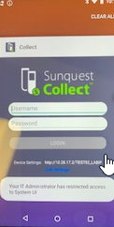
Swipe this screen to the left to close and end the Collect session and return to default filters.
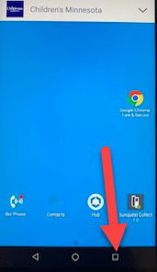
References | Sunquest Collect User’s Guide
Training Plan/  Competency  Assessment | LIS Competency  Employee Training
Historical Record | Version |  | Written/Revised by: |  | Effective Date: |  | Summary of Revisions
 | 1 |  | Paula Mattson |  | 4/15/2021 |  | Initial Version
 |  |  | Roxann Gulke |  | 4/18/2021 |  | Approved

