BloodHub- Credits

Purpose | This procedure provides instructions for entering in credits for blood products that either are short-dated, recalled or broken through BloodHub.
Procedure
 | Step | Action
 | 1 | Sign into BloodHub  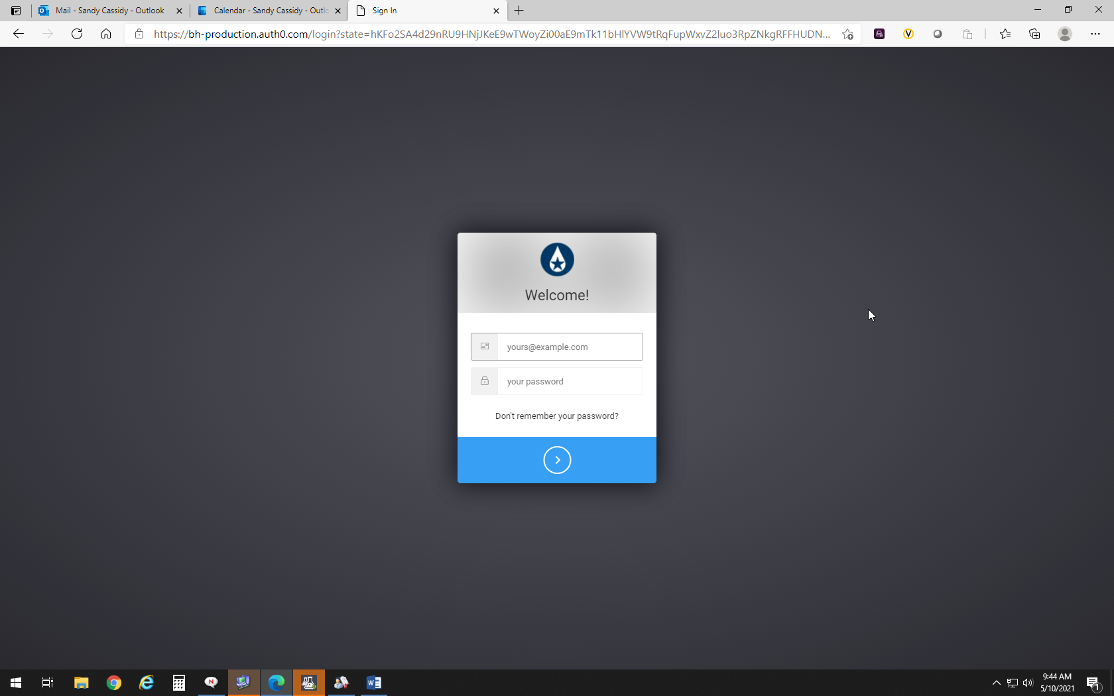
 | 2 | Click on Manage Inventory  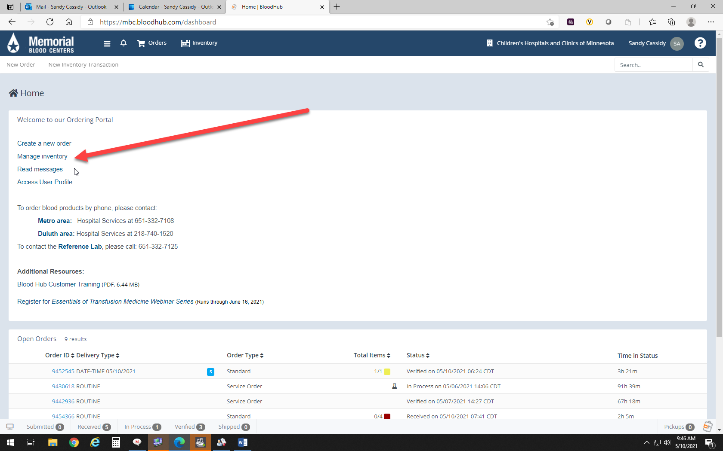
 | 3 | Click on “Discard Units”  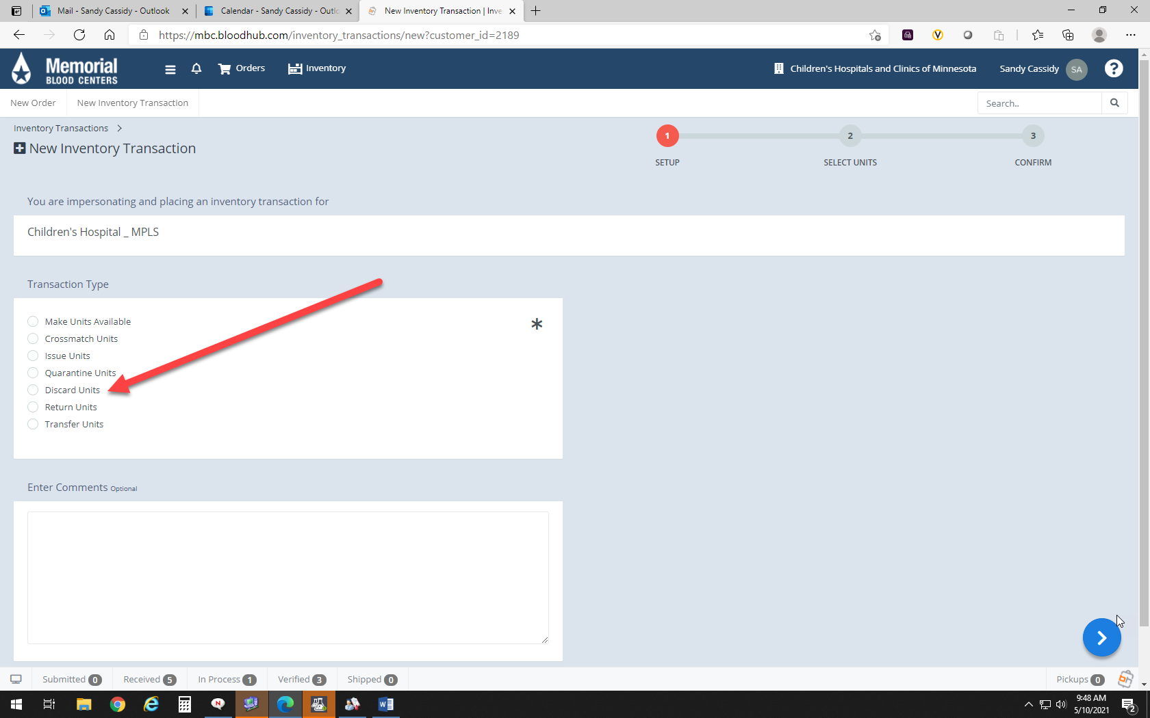
 | 4 | Select Discard Reason:  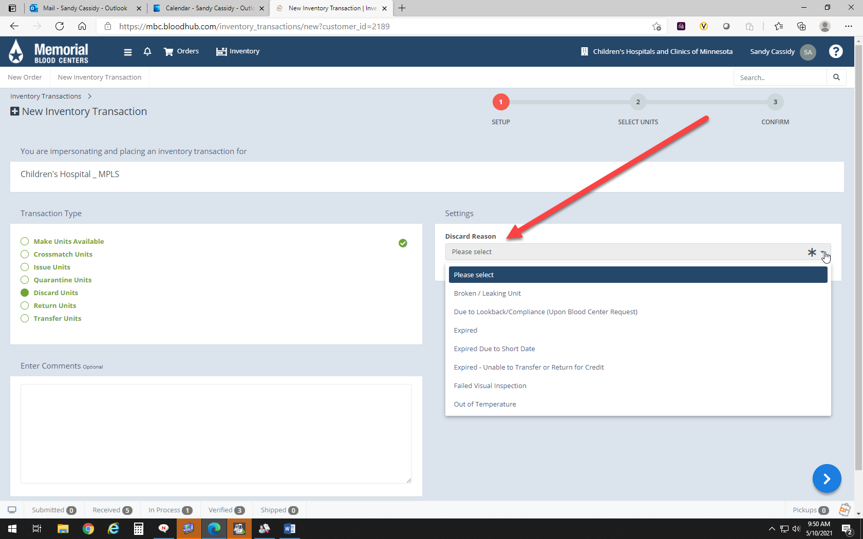
 | 5 | Click “Blue Arrow” to continue  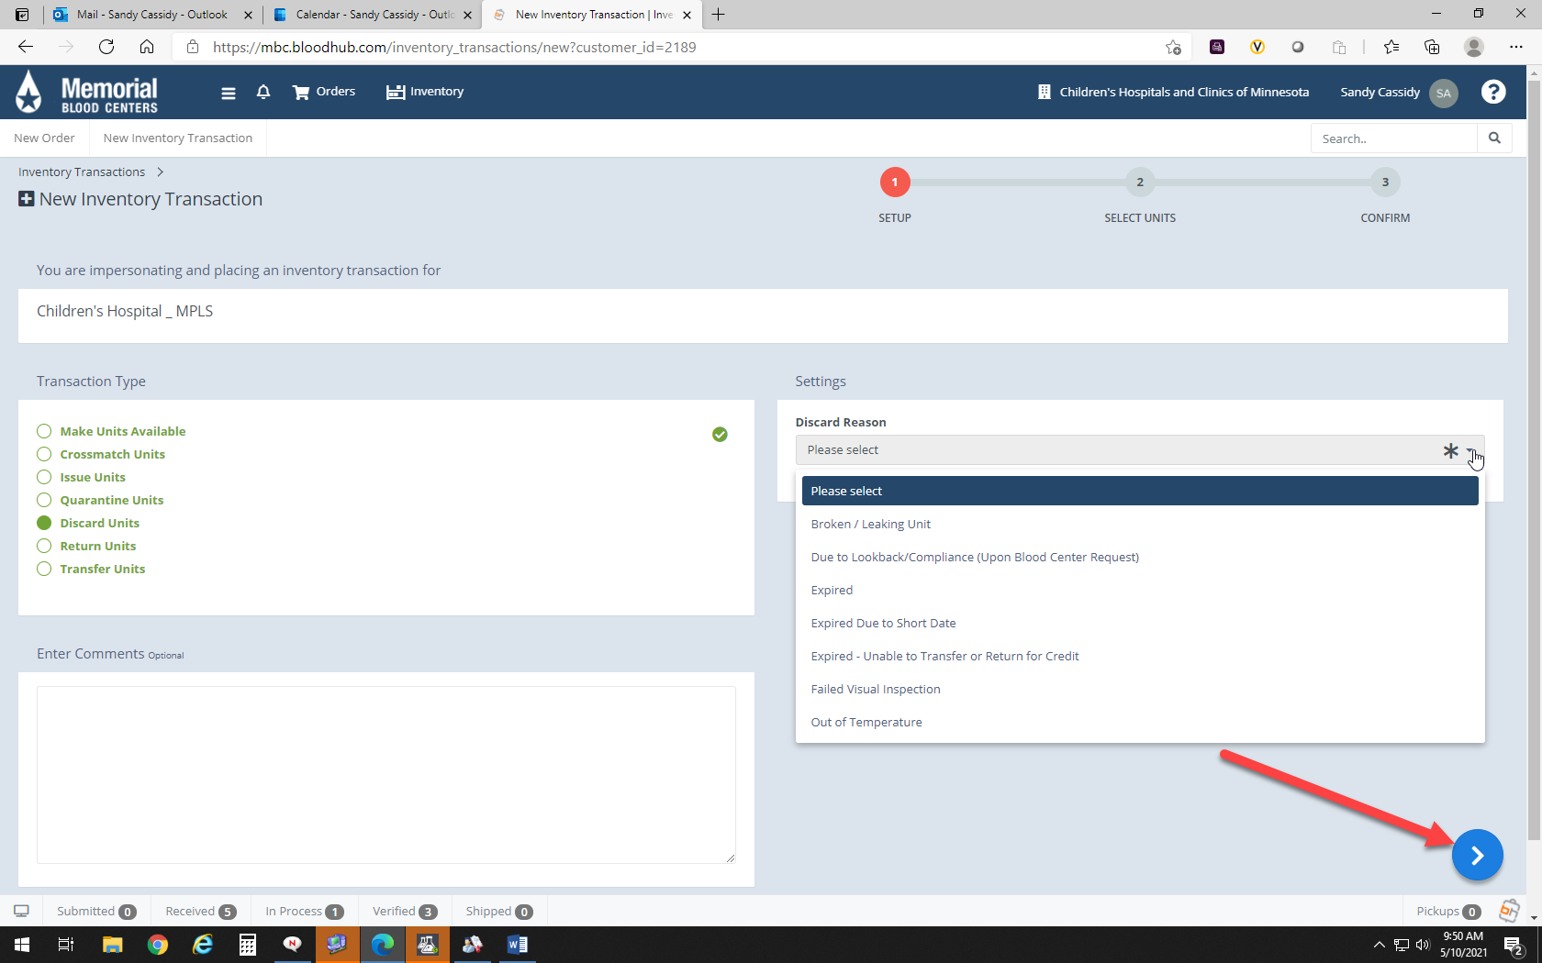
 | 6 | Enter the unit number and the product code (EXXXXV00)  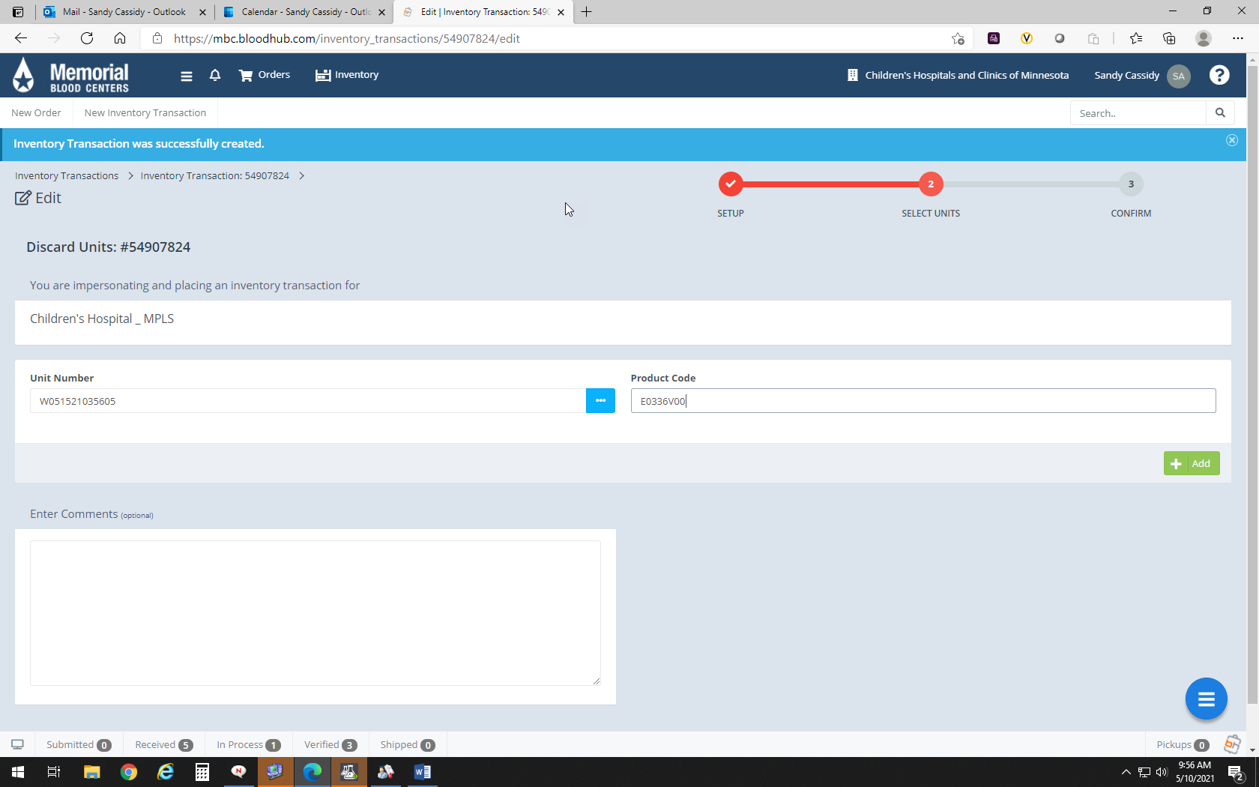
 | 7 | Click the “ADD” button  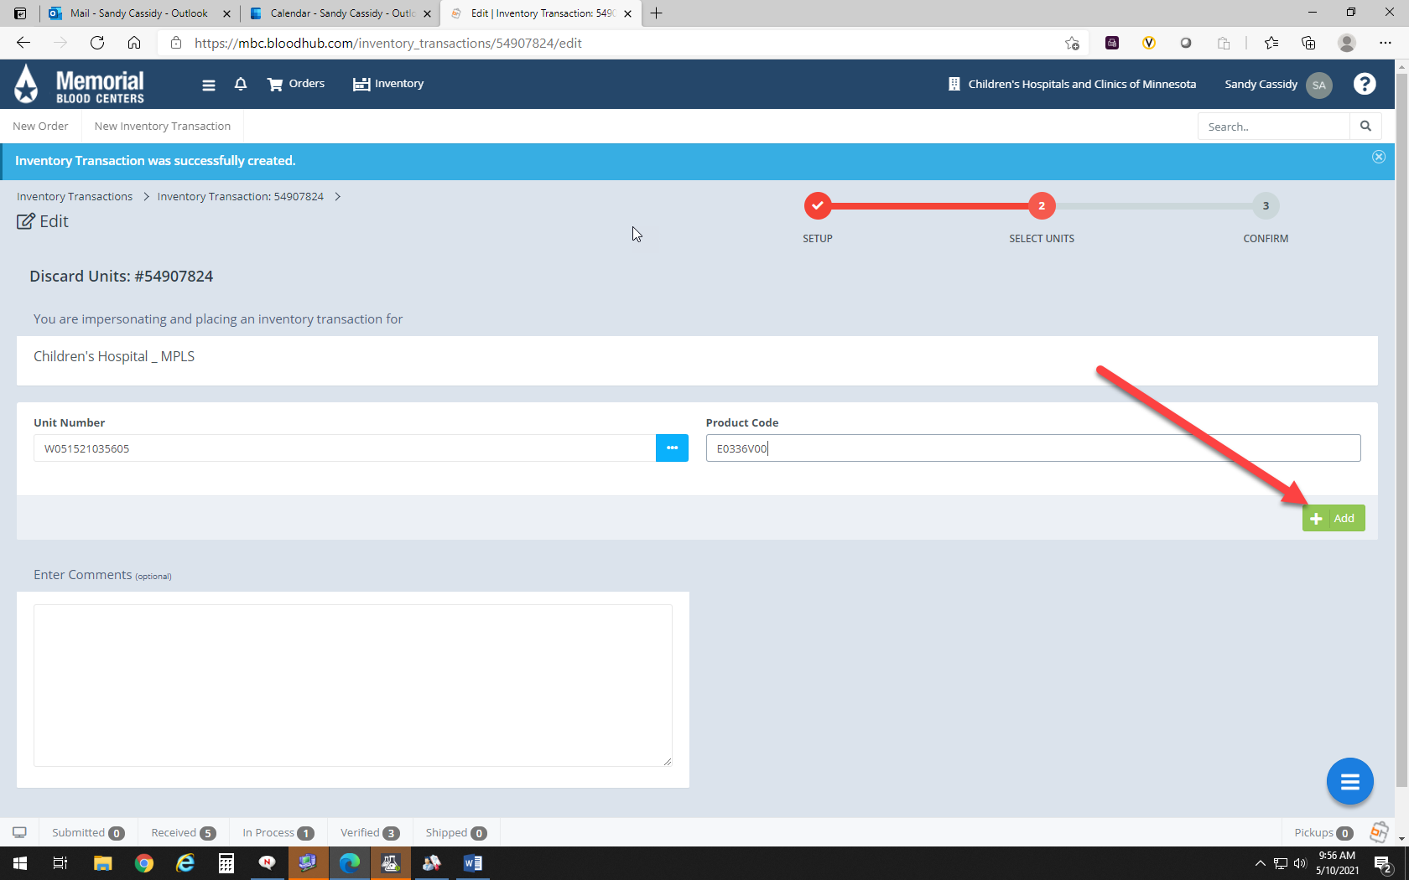
 | 8 | The Blood type and Expiration date should auto-populate  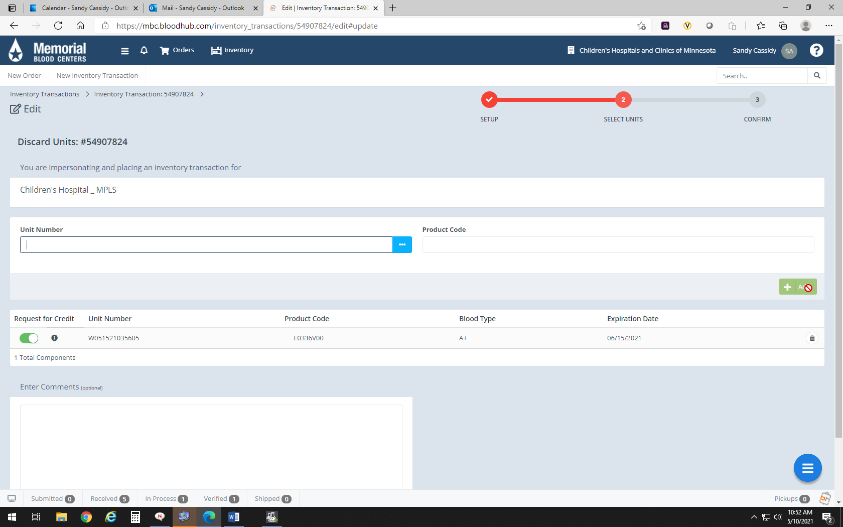
 | 9 | Verify the button under “Request for Credit is selected if credit is requested.  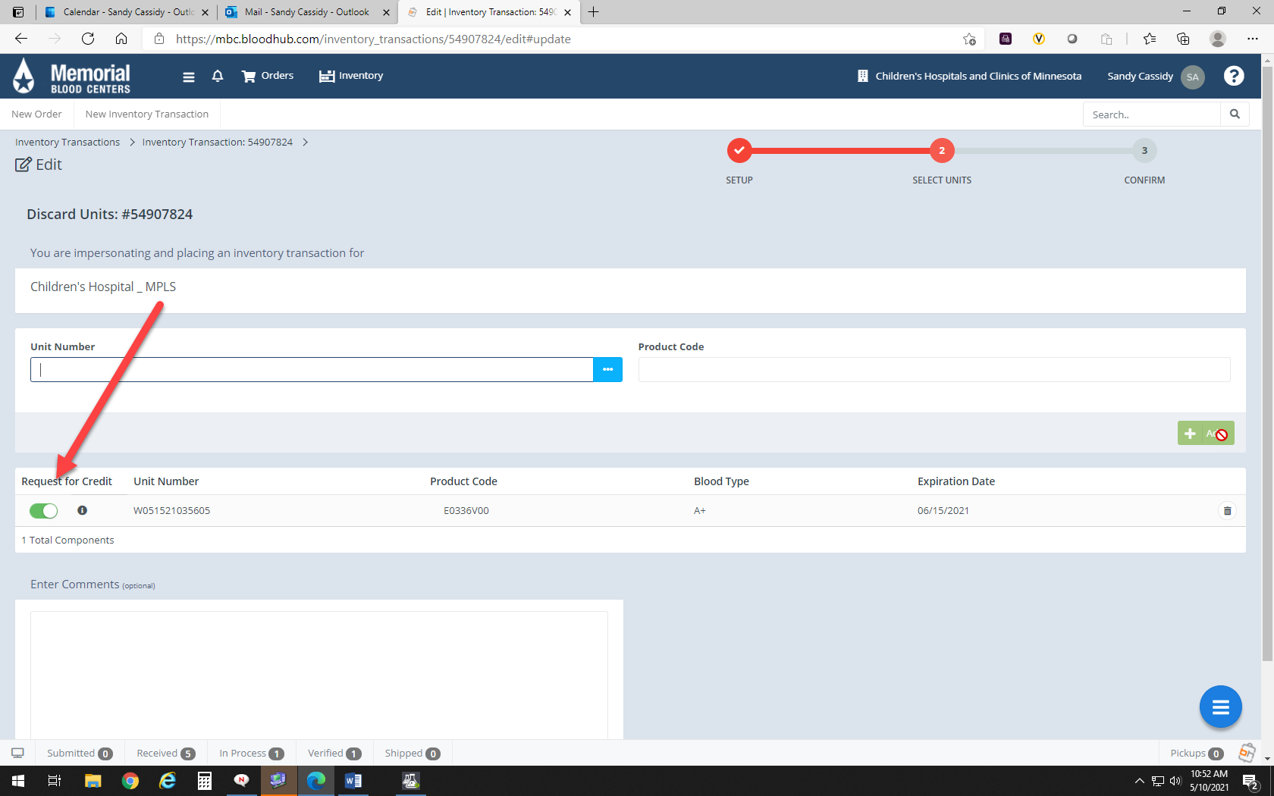
 | 10 | Click “Next”  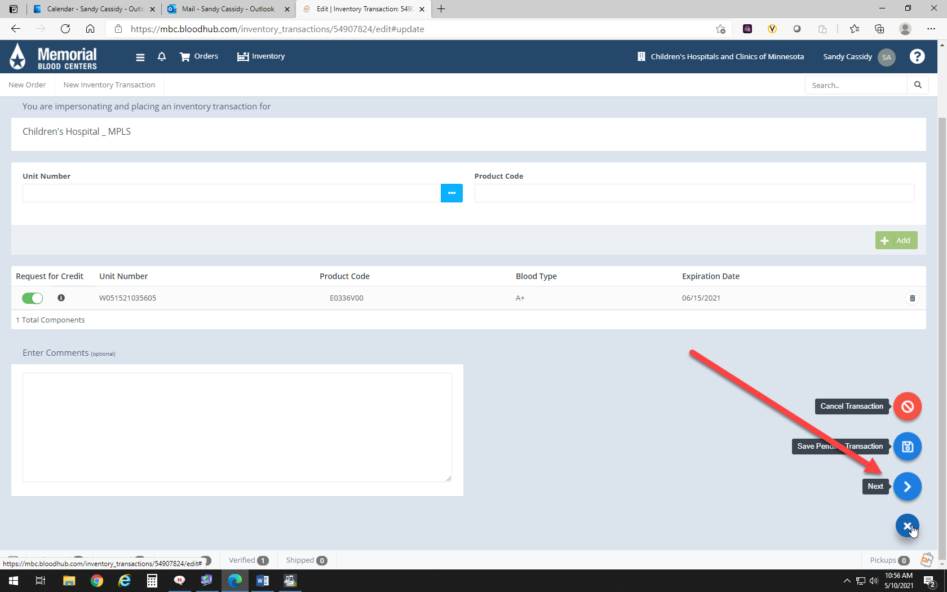
 | 11 | 1.Verify information has been entered correctly  2. Make corrections with the “Edit Transaction link under 3 line menu  3. Click “Confirm” located under 3 line menu at bottom right  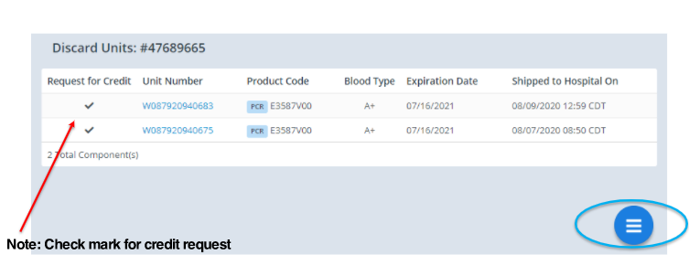
 | 12 | Unit has been discarded in BloodHub and the credit request has been sent to IBR HS  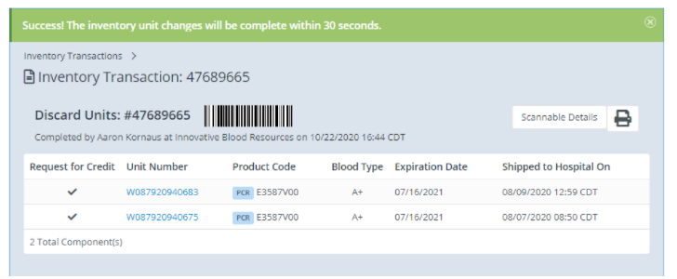
 | 13 | Print credit report and file with invoices  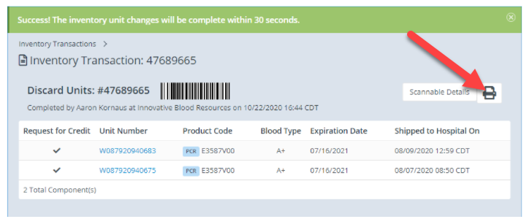
Approval  Workflow | Transfusion Service/Transfusion Medical Director
Historical Record | Version |  | Written/Revised by: | Effective Date: | Summary of Revisions
 | 1 |  | S. Cassidy | 5/20/2021 | Initial Version

