BloodHub- Reference Lab Ordering and Reports

Purpose | This procedure provides instructions for entering reference lab orders and extract reference lab patient reports through BloodHub.
Procedure
 | Step | Action
Entering Reference Lab Orders | 1 | Sign into BloodHub  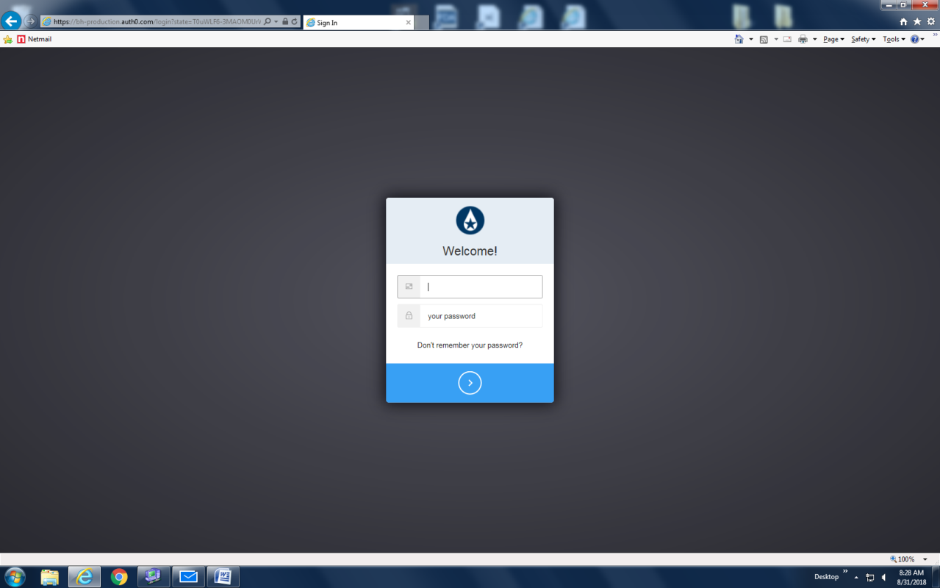
 | 2 | Click on “New Order” or “Create a new order”.  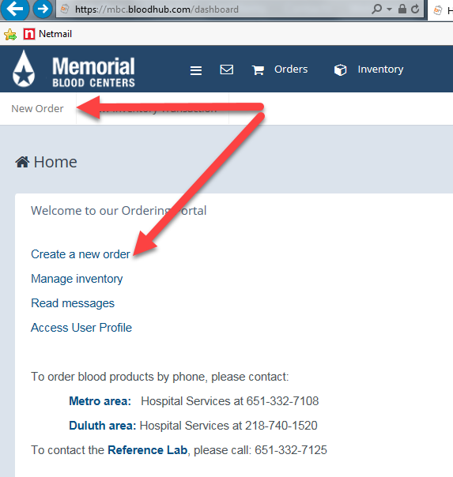
 | 3 | Select delivery type and order type.  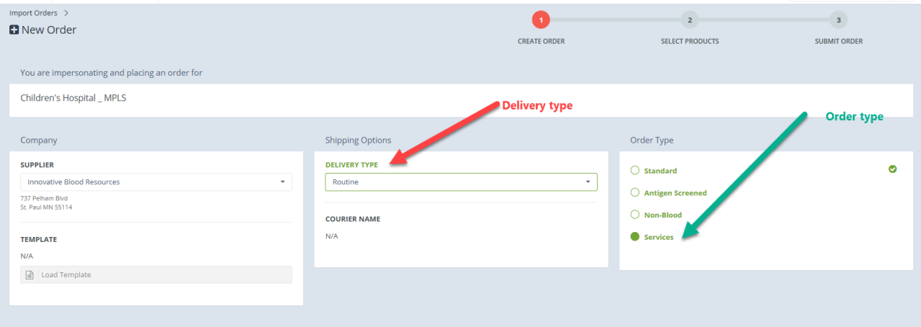
 | 4 | Select type of service required.  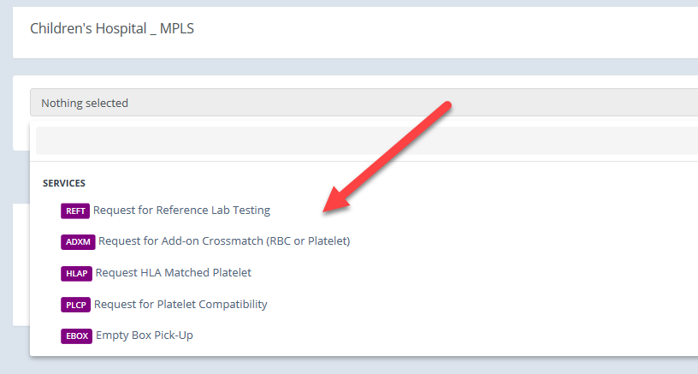
 | 5 | Select test required  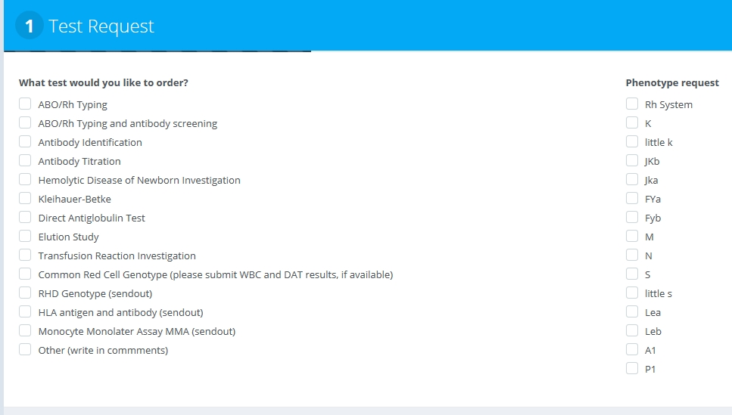
 | 6 | Fill in Patient Information. (any field with an asterisk needs to populated)  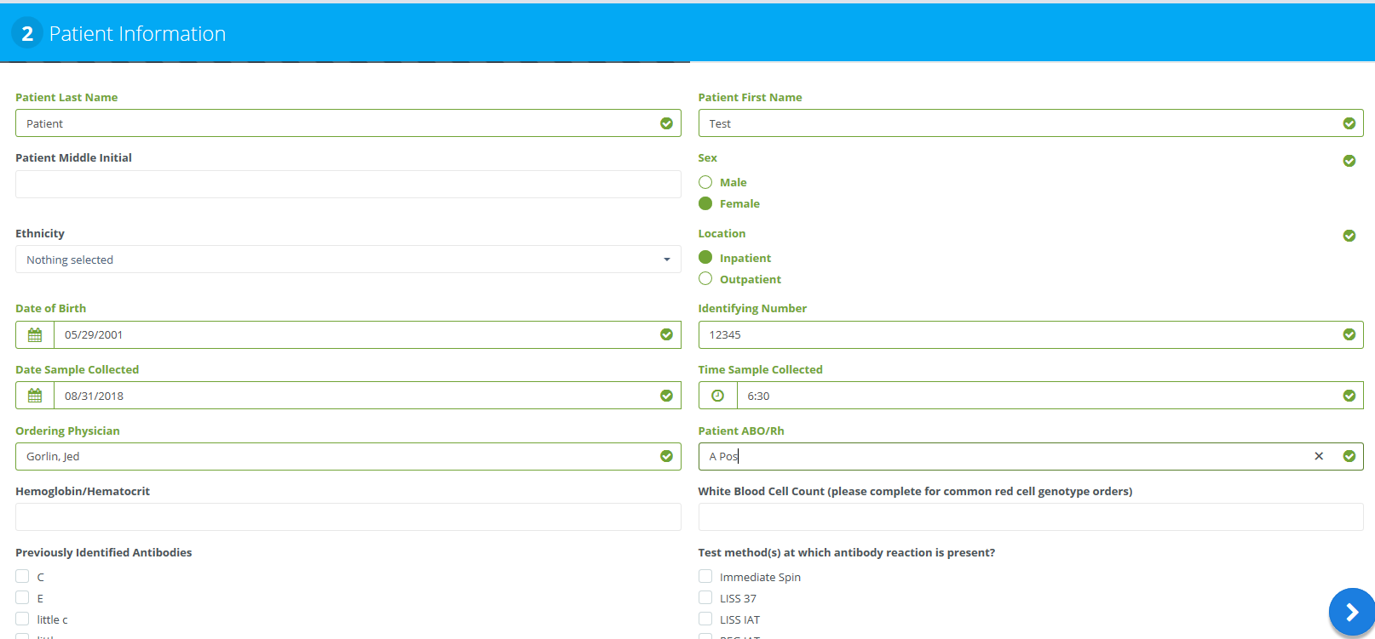
 | 7 | Fill in Clinical History. (any field with an asterisk needs to populated)  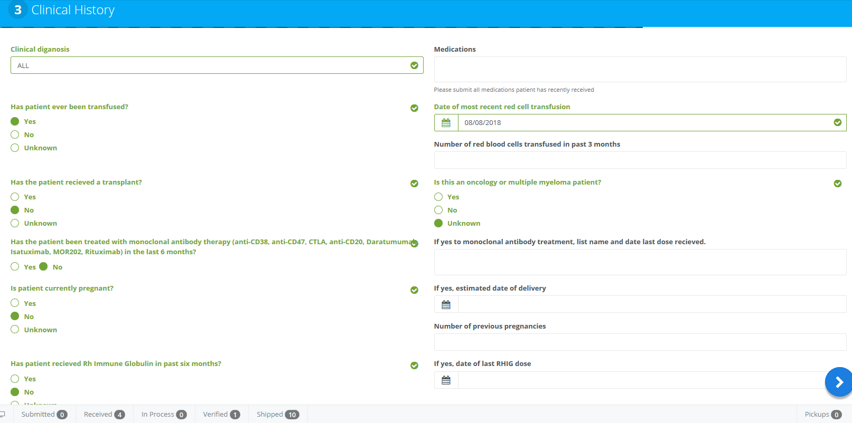
 | 8 | Fill in Unit Request. (any field with an asterisk needs to populated)  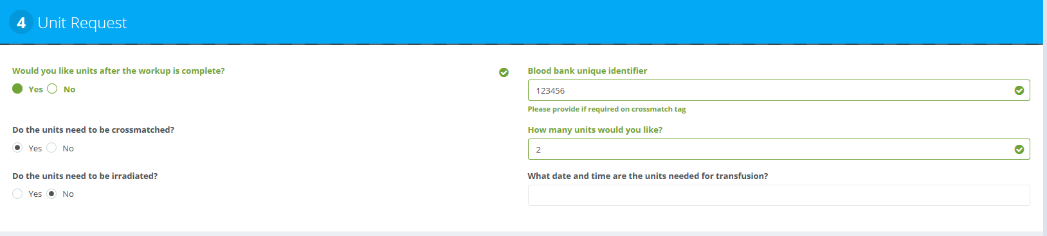
 | 9 | Click Blue Arrow.  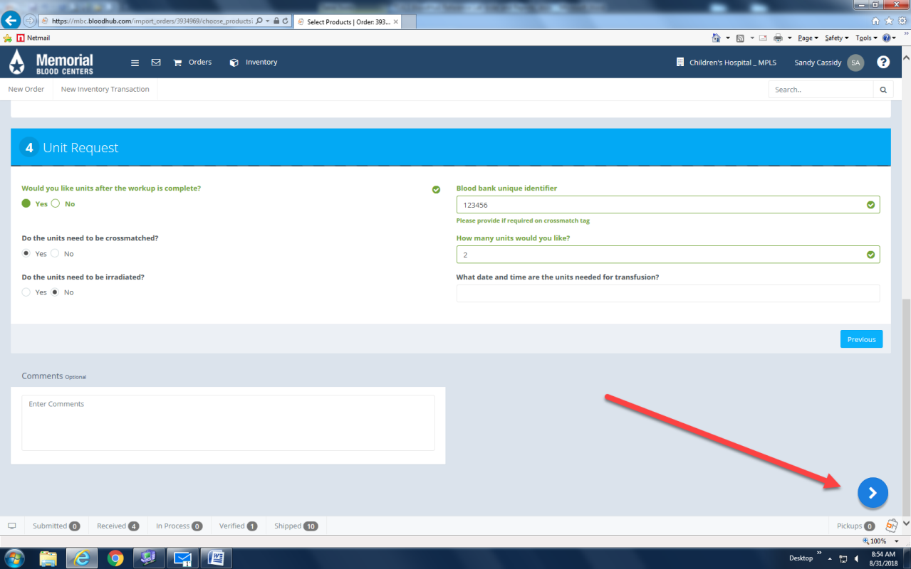
 | 10 | Review Order  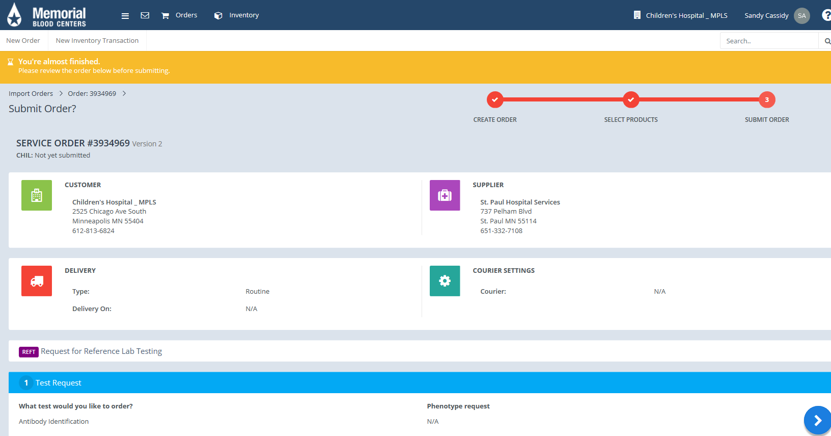
 | 11 | Click Blue Arrow  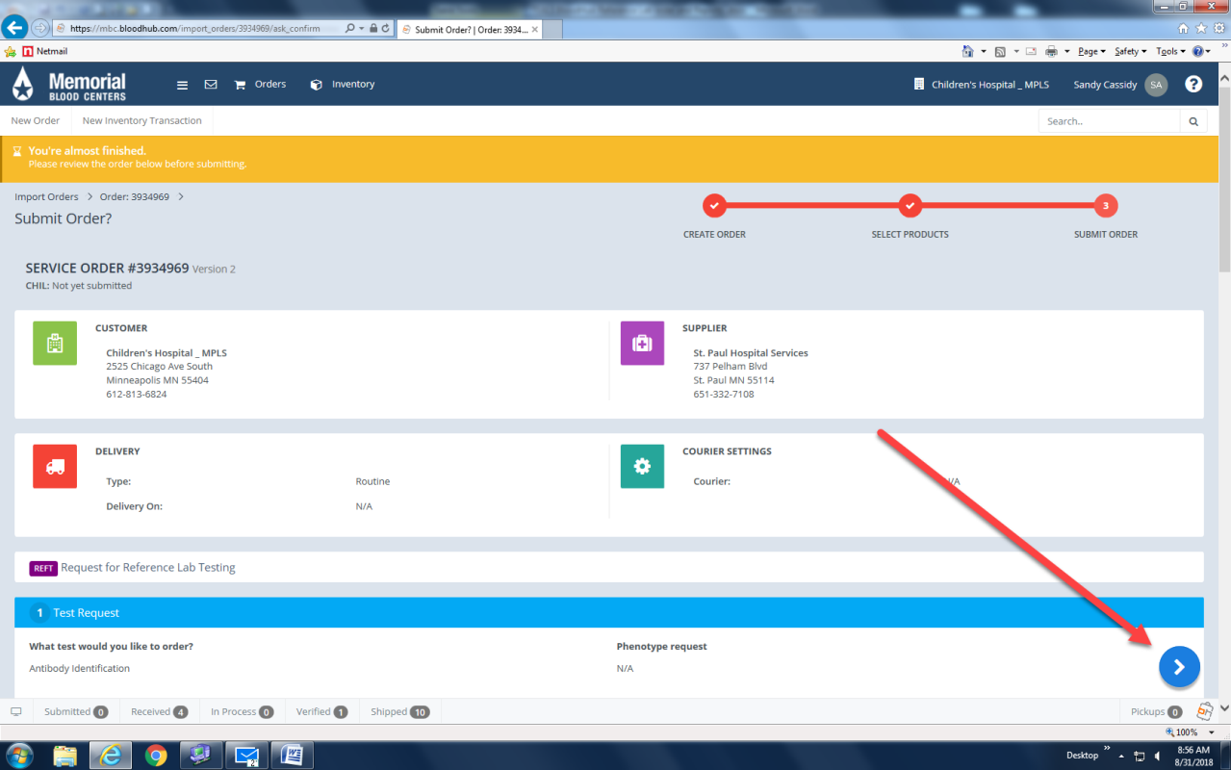
 | 12 | Click Submit  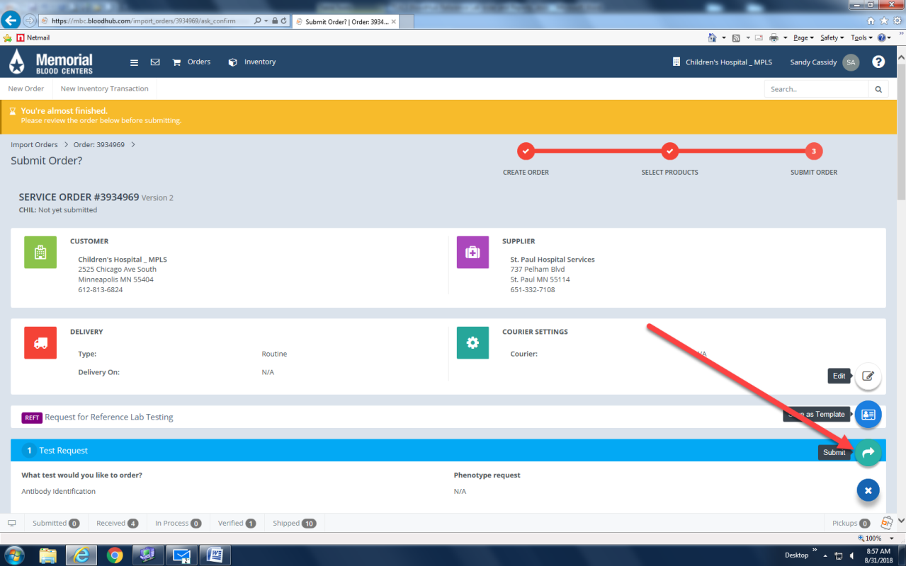
 | 13 | Write Order # number on blue requisition and print two copies of the reference lab order. One copy to send with sample and attached the other copy to blue requisition sheet.  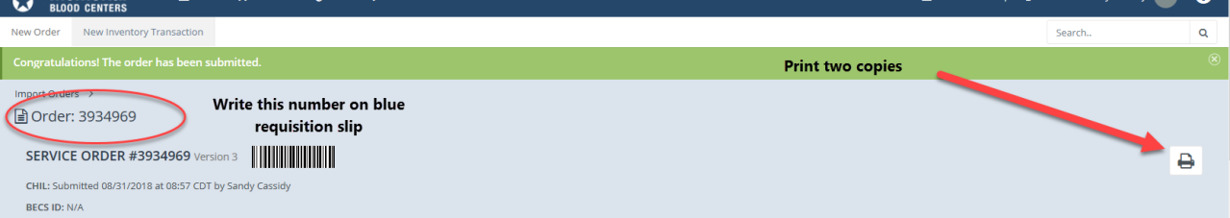
 | Step | Action
Printing off Reference lab patient reports | 1 | GroupWise notification that a reference lab report is available. (Note: preliminary reports will still called)
 | 2 | Open email and click on “BloodHub Order XXXXX”  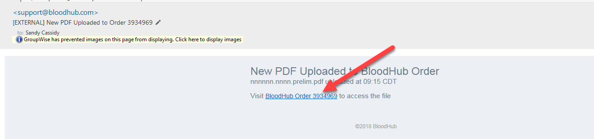
 | 3 | Sign-in to BloodHub  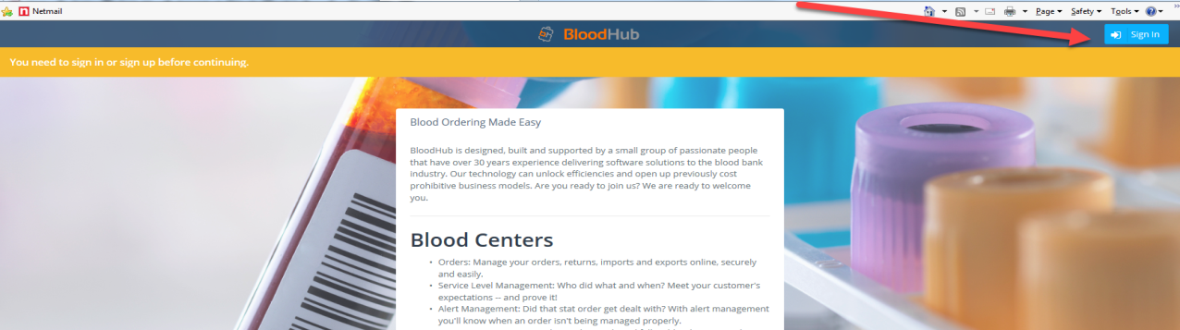
 | 4 | Scroll down to the bottom of the page to “Attachments” and download and print both patient’s report  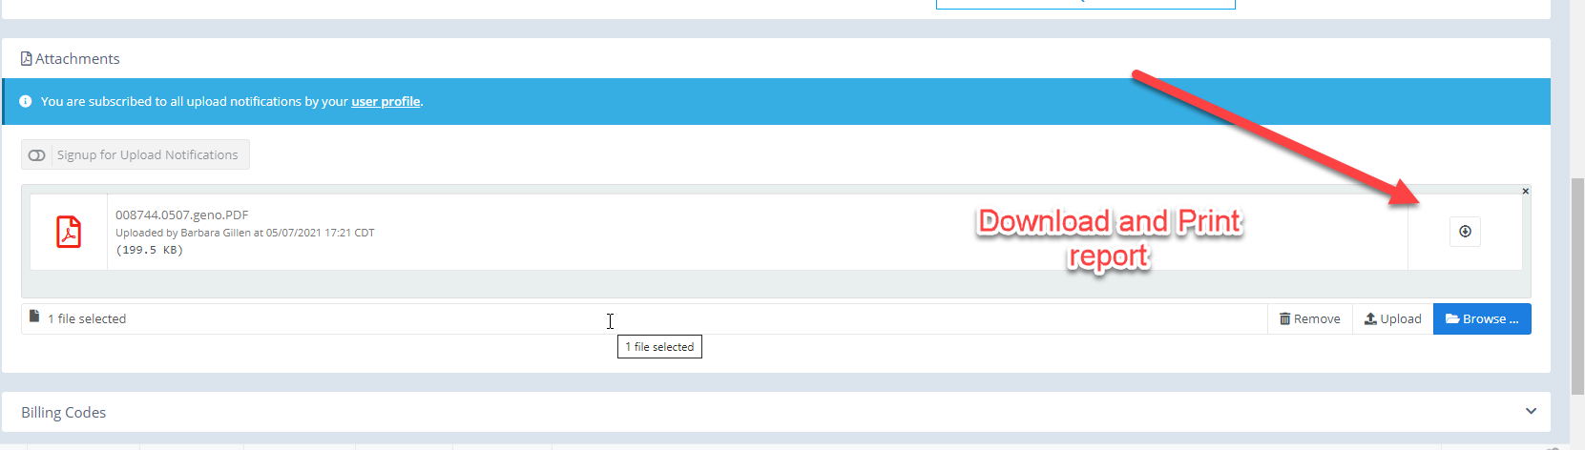
 | 5 | View billing Slips for Testing Service Orders (billing slips with a summary of charges will be available in BloodHub once the order is in the Billing Complete Status.) Click on Billing Slip and print out charges. Follow the same process for antigen negative unit orders.  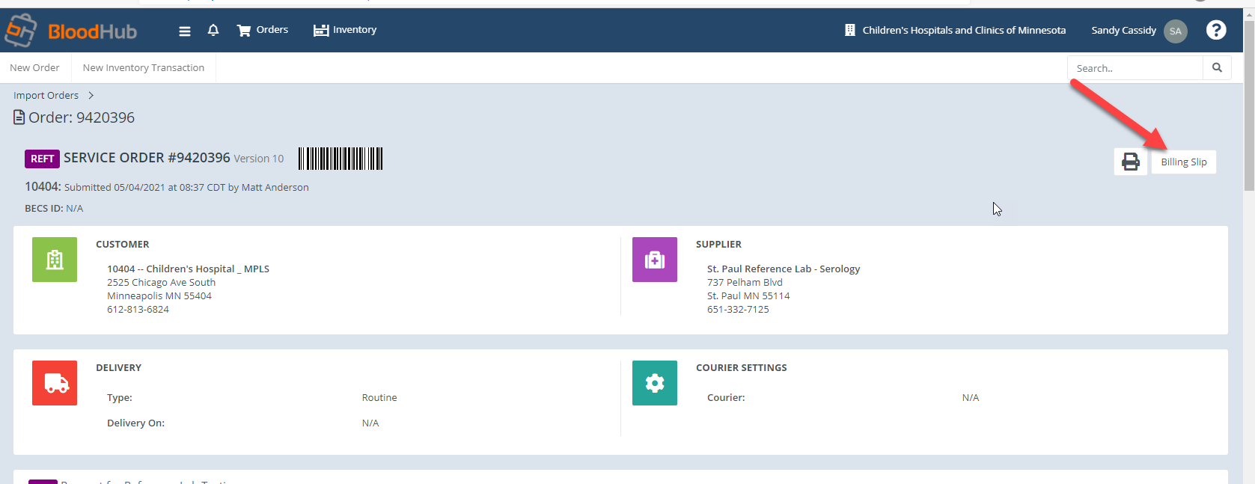
Approval  Workflow | Transfusion Service/Transfusion Medical director
Historical Record | Version |  | Written/Revised by: | Effective Date: | Summary of Revisions
 | 1 |  | S. Cassidy | 09/12/18 | Initial Version
 | 2 |  | S. Cassidy | 5/20/2021 | Updated to printout billing

IBR Reference Lab Tests
Billing Code | Description
ABID | Antibody Identification
ABID + DAT | Antibody Identification Plus DAT
ABS | Antibody Screen Only
ABSBT | Antibody Screening and Blood Type
Adsorption | Adsorption
AFHRS | On-Call Charge
AGN-S | Unit Antigen Screening
AGN-T | Unit Antigen Typing
CSEP | Cell Separation
DATB | DAT Battery-Polyspecific IgG C3 AHG
DTTP/S | DTT Plasma/Serum Treatment
ELU | Elution
GENOCP | Genotyping Common Panel
HGB S | Sickle Cell test
HLA/HPA | HLA/HPA Platelet
HLAID1 | HLA Antibody ID Class High Resolution
HLAPHE | HLA-AB Low Resolution
INH | Inhibition/Neutralization
PLCT | Platelet Compatibility Panel
PLTXM | Platelet Crossmatch
RARE5 | Rare Unit (Frequency 5%)
RBCPANL | Red Cell Panel
RBCPHEN | Red Cell Phenotyping
RBCXM | Red Cell crossmatch
RHGENO | RHD or RHCE Genotype
RHPHEN | Rh Phenotyping
SCRPS | Unit Screening with Patient Serum
SFEE | Search Fee
STROMAADSS | Stroma Adsorption (Single)
STROMAADST | Stroma Adsorption (Triple)
THAWRRC | Thawing of Rare Reagent Cells
TITR | Titration
TRT-Chem | Treated Cells-Chemical
TRT-ENZ | Treated Cells-Enzyme
TYPE | Blood Type Only- ABO& D

