Agena MassArray Instrument Maintenance and Troubleshooting

Purpose | This procedure provides instructions related to function and maintenance of the Agena Bioscience MassArray.
Policy Statements | This procedure applies to technical staff performing testing on the Agena MassArray.
Special Safety Precautions | Microbiologists/virologists are subject to occupational risks associated with specimen handling. Refer to the safety policies located in the safety section of the Microbiology and Virology Policy Manual:  - MB 2.02 Biohazard Containment  - Safety in the Microbiology/Virology Laboratory  - Biohazardous Spills
Materials | Reagents Supplies Equipment  - Deionized (DI) water - House hold bleach - Clean Resin - Calibrant - Lint-free laboratory wipes - Lint-free cloth (microfiber) - Laboratory Gloves - Waste collection tubing and container - 5 mL repeater pipette tips - 96 well PCR plate - Spectral chip - Pipette tips - 5 mL repeater pipette - 100-200 uL pipette
Procedure | NOTE: Analyzer Control, Chip Prep Control and SpectroACQUIRE programs must always remain open for proper function.  Computer Password: biomass  Daily / With Use Maintenance/As Needed:  Check Clean Resin:  1. In the SpectroACQUIRE run set up tab: Click “Refill Maintain Resin” and select “yes” to access it now.  2. When the light turns solid green, remove the top access cover.  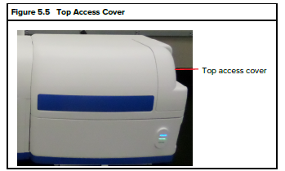  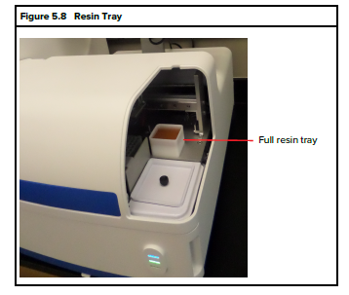  3. Check the resin level and ensure it is still liquid: refill if necessary.  4. Select “Resin Not Refilled” if not replacing.  Refilling the Resin tray  Refill the resin tray when the Resin tray when the Resin Low or Empty indicator is on in the setup tab of spectroACQUIRE OR at least every 30 days.  1. Prepare the resin for use by adding 16 mL of DI water to a Clean Resin container  NOTE: record resin in use date on inventory log  2. Click “Refill Maintain Resin” and select “yes” to access it now.  3. When the light turns solid green, remove the top access cover.  4. Discard old Resin by pouring down the drain, clean tray with water and dry.  5. Replace tray on instrument and dump fresh Resin in.  5. Select “Resin Refilled” when done.  Check water (System Fluid) level  The level should be checked daily. Add fluid if level is low and/or when the System Fluid Empty indicator light comes on in the Run Setup tab.  1. When checking the Resin daily, also check the water level (System Fluid) by removing the supply tank lid and grid.  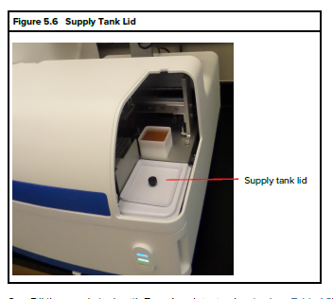  2. Ensure that the water level is over the tubing.  3. If necessary fill the supply tank with DI water until the liquid is cover the tubing.  Weekly Maintenance  Draining the Waste Tank  Drain the waste tank when the Waste Tank Full indicator light comes on in the run Setup tab of SpectroACQUIRE  1. Fill a waste collection container with 500 mL household bleach and set on floor below the instrument.  2. Open the front access door.  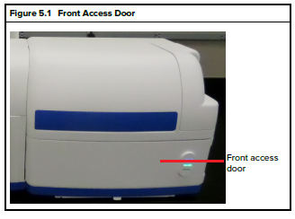  3. Insert the open end of the waste tubing (the end without the quick-disconnect fitting (see figure below) into a sink or container that is lower than the level of the waste tank drain port (the waste water drains by gravity.  NOTE: the container should be large enough to hold 6 liters of liquid.  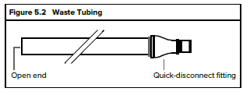  NOTE: Waste water will flow immediately when the waste tubing is connected to the waste tank drain.  4. Insert the waste tubing quick-disconnect fitting into the waste tank drain port. Push the fitting in until it clicks into place.  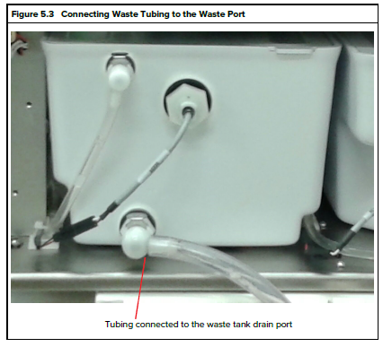  5. After tank is drained and the flow of waste fluid from the tank stops, disconnect the tubing from the waste tank drain port. To disconnect the tubing, press down on the release tab and pull out the quick-disconnect fitting.  NOTE: A small amount of residual water may be in the tubing. When the tubing is pulled out of the waste port, hold the end of the tubing up so that residual water drains out the other end back into the waste container or sink.  NOTE: Any splashes or spills should be cleaned with 10% diluted household bleach, DI water, and 70% ethanol.  6. Rinse the tubing well with water.  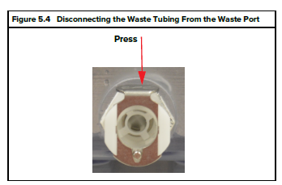  7. Clean waste container with a 10% bleach dilution followed by 70% ethanol and DI water.  8. Close the front access door.  9. Discard the waste down a “dirty” sink.  10. Clean the waste collection container with a 10% bleach dilution followed by DI water and 70% ethanol.  Power Cycling the Instrument  - Click the Stop RT Processes icon on the computer desk top.  - Close any other applications.  - Select shutdown from the start menu.  - Once the computer has shut down, turn off the MassArray column and CPM by flipping the switches on the back of the instruments.  - Wait 20 seconds.  - Flip the switches back on.  - Log onto the computer (Password: biomass), and open Analyzer Control, Chip Prep Control and SpectroACQUIRE programs.  Monthly Maintenance  Cleaning the supply and waste tanks.  NOTE: Drain waste tank before starting.  1. Open the front access door.  2. Remove the top access cover.  3. Remove the supply tank lid and funnel.  4. Disconnect the quick disconnect tubes and floating level sensor connectors.  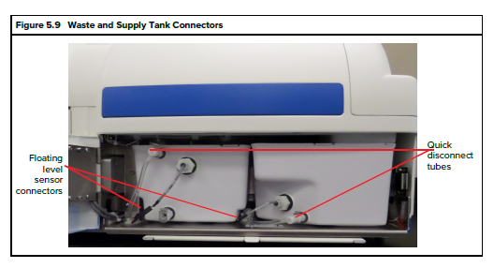  5. Take out the supply and waste tanks  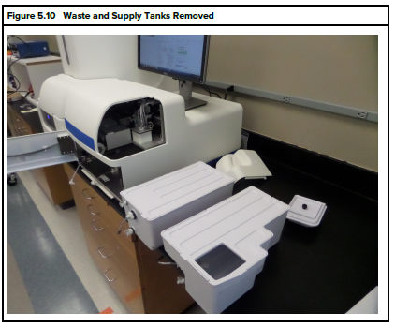  6. Empty the tanks, then rinse thoroughly with Type 1 or deionized water.  7. Replace the tanks in the Chip Prep Module.  8. Re-plug the quick disconnect tubes and floating level sensor connectors.  9. Replace the supply tank funnel and lid, replace the top access cover, and close the front access door.  Remote Tune Scheduling and Performance  - Email Ben Vollmer, Gabe Armstrong, or Technical Support to schedule the Tune.  ben.vollmer@agenabio.com  gabe.armstrong@agenabio.com  - Set up the instrument and plate:  - Add 75 uL 3 pt calibrant to wells A1, A2, A3, B1, B2, and B3 to a new 96 well PCR plate.  - Load the plate and a new chip onto the CPM.  - Open Team Viewer, and notify Agena support.  As Needed:  Washing the pin Heads  1. Under normal operating conditions there is no need for the user to initiate a pin head wash. The Chip Prep Module is set to do an automatic wash once per day. By default this will happen at midnight.  2. If there is an issue such as contamination, you may manually start a wash cycle at any time by selecting Tools > Schedule Immediate Autowash in the Chip Prep Control (CPC) software. The wash will start immediately.  3. Periodically it may be necessary to clean the pin heads with an isopropanol solution. Contact Agena Bioscience Customer Support for assistance.  Troubleshooting  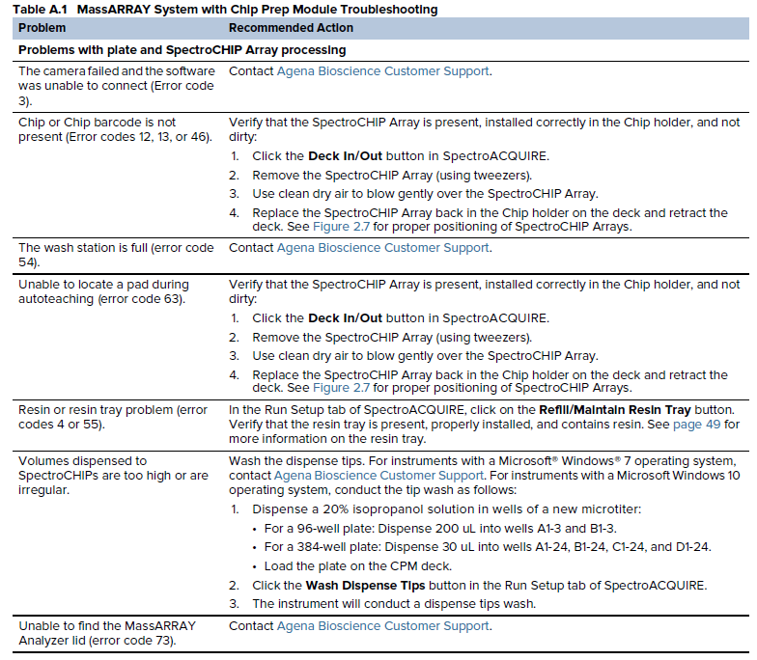  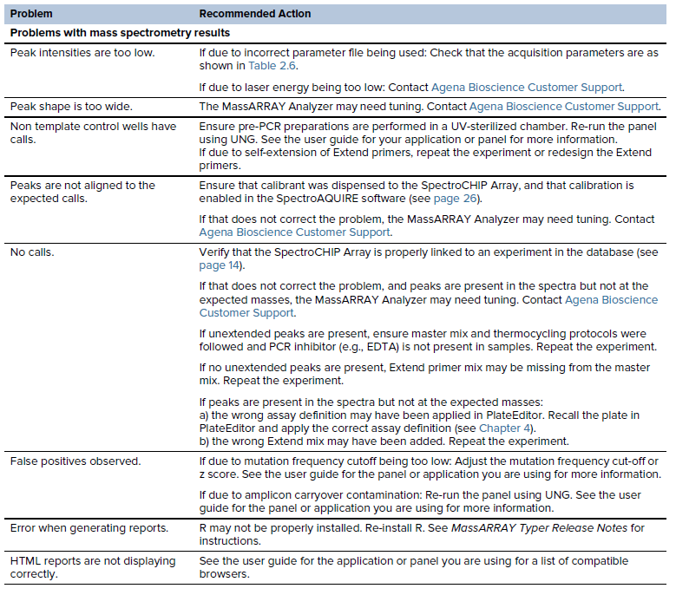  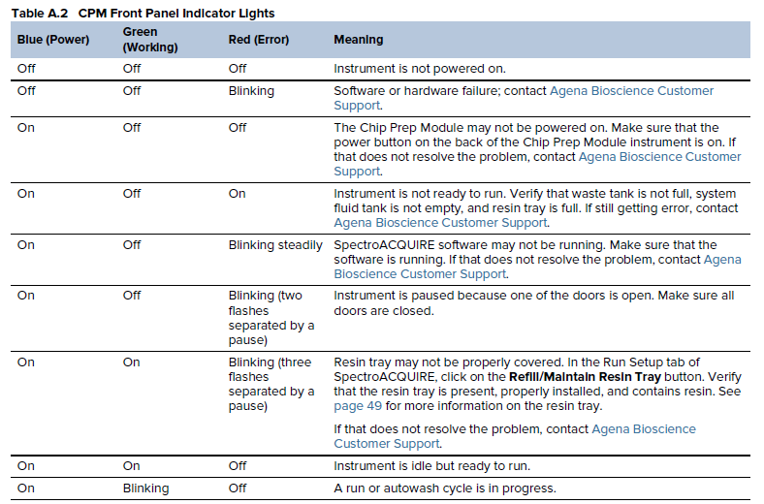  Rerunning a sample set that has already had resin added  1. When setting plate up to run, select normal, but deselect “Transfer Resin to MTP1” or MTP2  NOTE: plates may be frozen after spotting. To rerun, thaw, quick spin at ~1,200 – 1,500 x g for 10 to 15 seconds.  Rerunning a chip after it has been spotted  1. If a chip has to be rerun for any error (ex: Chip Transfer failed: Excessive slip on robot motor. Error code 56: Contact Customer Support.) after it has been spotted, load the chip.  2. Deselect all boxes except Transfer chips to analyzer and Analyze chips.  3. Press Start Chip Prep Module.  Sending xml Run Data to Technical Support  1. Open the Typer Analyzer software.  2. Insert a USB thumb drive into the Agena MassArray computer.  2. Pull up the run data from the appropriate chip, and select the chip by double clicking and checking it in the box below.  3. Go to file and select save all well to file.  4. Save file to USB thumb drive location.  5. Send xml data and run files (excel sheet with results) to Technical Support.  NOTE: for guidance on saving run files see the “Analyzing data” section of the specific assay SOP  Customer and Technical Support  For Technical Support contact Agena Bioscience at  Help Desk: (+1) 877-443-663  E-mail: helpdesk@AgenaBio.com
Result Reporting | Record completion of maintenance tasks on the Maintenance Log.
References | - Agena Bioscience: MassARRAY System with Chip Prep Module 96 User Guide, DOC. USG-CUS-069 R09, 11/22/19.
Historical Record
 | Version | Written/Revised by: | Effective Date: | Summary of Revisions
 | 1 | Julie Laramie | 10/29/2020 | Initial Version
 | 2 | Julie Laramie | 06/29/2021 | Added remote tune and power cycle instructions
 | Archived by: |  | Archived Date:

