Issuing of Tissue Products

Purpose | This procedure provides instructions for the issue of tissue products through Sunquest and the transport of frozen tissues to surgery.
Policy Statements | - Tissue products will be inspected as part of the tissue process.  - Verification of the agreement of all identifying information on patient record, the selected product,  and the tissue request shall occur  - All tissue products need to be verify by two techs and each techs need to enter tech codes into the  Function BPI.  - Tissue will be transported in a manner to maintain product integrity.  - Frozen bone or tissue will be issued/transported in it’s frozen state.  - Surgery personnel will manually transport frozen bone or tissue from the Transfusion Service to  the surgery suite.  - Surgical personnel will perform all thawing and processing of frozen bone or tissues.  - Frozen bone or tissues may not be refrozen if removed from the original packaging.  - Styrofoam container may be used repeatedly unless signs of damage or contamination.  - 388.00 Tracking of Tissue for Implantation
Materials | Equipment |  |  |  | Supplies
 | - Styrofoam shipping containers |  |  |  | - Dry ice-Sendouts area  - Tape
Procedure
 | Step | Action
 | 1 | Receive salmon release slip from surgery.
 | 2 | Obtain product. Allocate if not previously done.
 | 3 | Log into the Gateway choosing location: R for Mpls, or SP for STP.
 | 4 | Click on Blood Product Issue folder.
 | 7 | - Click on the Lookup by: drop down arrow and select the accession number or unit number.  - Select accession number if issuing more than one unit.  - Use unit number if issuing only one unit.  - Select or enter the product(s) to issue by:  - Scan or enter the product ID number in the Unit # box.  - Check in the Select column box.  - Click on Select All.  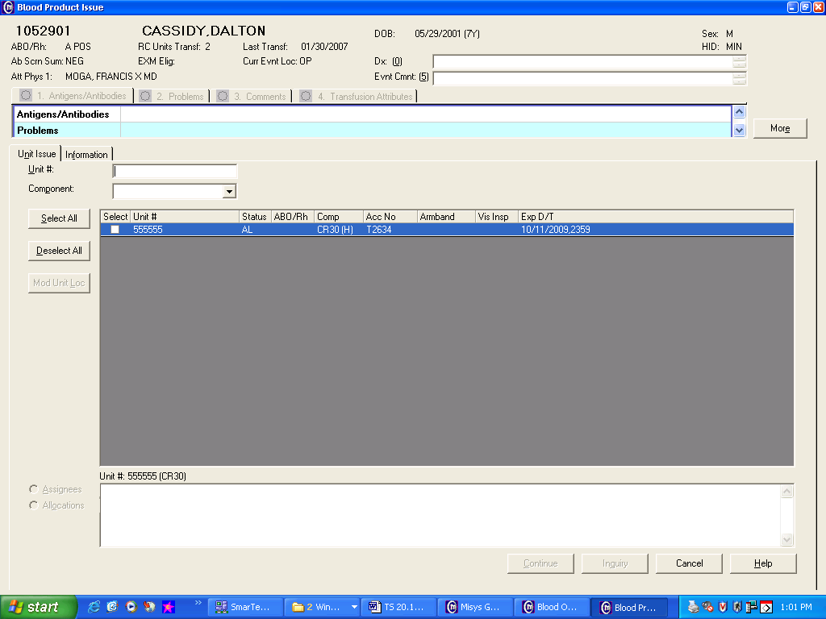
 | 8 | Issue product by: Issue manufacture’s package insert documents with the tissue if applicable.  If Then  Ambient storage products Pneumatic Tube carrier or manual pickup  Products stored at 1-6°C Blood Bank cooler  Frozen products Styrofoam container - Place 1 to 2 inches of dry ice on the bottom of the Styrofoam shipping container. - Place the issued product in its original storage packaging carefully on top of the dry ice. - Place the lid onto the Styrofoam container and secure with tape - Notify surgery that the bone/tissue is ready for pick-up. Mpls: 58287 STP: 66236
References | - Sunquest User Manual, current edition  - AATB Standards for Tissue Banking, current edition
Approval  Workflow | Transfusion Service/Medical Director
Historical Record | Version |  | Written/Revised by: | Effective Date: |  | Summary of Revisions
 | 1 |  | J. Wenzel | 10/01/2006 |  | Initial Version
 | 2 |  | J Wenzel | 11/20/2008 |  | Online Version, added frozen product link
 | 3 |  | N Poupard | 01/04/2010 |  | Added package insert to be issued
 | 4 |  | S. Cassidy | 4/10/2012 |  | Previous TS 20.12. Added policy and steps for second tech confirmation of tissue.
 | 5 |  | S. Cassidy | 07/12/2021 |  | Removed steps for second tech confirmation

