Maintaining Tissue Inventory

Purpose | This procedure provides instructions for reviewing and maintaining sufficient tissue inventory levels to meet patient care needs and control product expiration.
Policy Statements | - The inventory level in Appendix A has been approved by Children’s Surgery Department, and Transfusion Service and shall be assessed and revised as agreed upon by the  surgery department and the transfusion service.  - Available inventory should be compared to the Sunquest inventory record and reconciled a  minimum of monthly.
Procedure
 | Step | Action
Inspecting Tissue Inventory levels | 1 | Inspect and assess the tissue inventory levels according to Appendix A as part of daily tasks.
 | 2 | Review pending tissue orders.
 | 3 | Order additional inventory as needed.
 | Reviewing Monthly Tissue Inventory
 | Step | Action
To print an inventory report | 1 | Prompt Action  Smarterm FUNCTION: Enter BBR  PRINTER: Enter desired printer number (503-MPLS, 306-STP)  SELECT OPTION ? Enter 2 (Product File List)  HOSPITAL ID: Enter Min  AREA: Enter either MIN or STP  ACCEPT, MODIFY, OR REJECT Enter desired response. <cr> until the EARLIEST EXPIRATION DATE prompt  EARLIEST EXPIRATION DATE: <cr> to default to today’s date or enter the date the products will expire on  EARLIEST EXPRIRATION TIME: <cr>  COMPONENT TYPE/GROUP: Enter TISS and <cr> until the STATUS prompt  STATUS: Enter INV to review products in an available, allocated, or unprocessed BB status. <cr> until the ACCEPT, MODIFY, OR REJECT prompt  ACCEPT, MODIFY, OR REJECT Enter desired response.
 | 2 | The printed report shows:  - Total summary of products by Group, Type and Status  - Detailed list of the individual products
 | 3 | Compare the current inventory to the INV report.
To review inventory online | Step | Action
 | 1 | Log into the Gateway choosing location: R for Mpls, and SP for STP
 | 2 | Open the BLOOD INVENTORY/SUPPLIER SEARCH folder
 | 3 | Select the INVENTORY SEARCH or MANUFACTURED PRODUCT SEARCH tab depending on product type entered in BPE.
 | 4 | Enter MIN in the HID field
 | 5 | Enter the group TISS or the individual component type code (e.g. AUTOB, CUBE, DBX5) in the COMPONENT TYPE field.
 | 6 | Enter Unit Loction  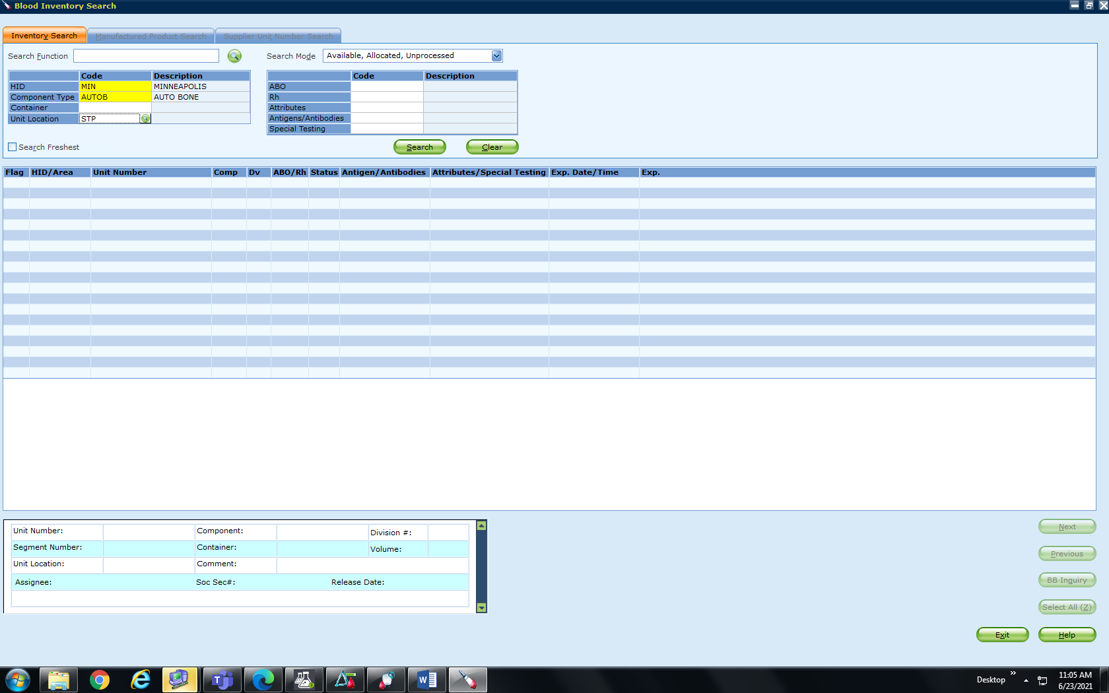
 | 6 | Select a SEARCH MODE (available, allocated, unprocessed, or combination)
 | 7 | Click on SEARCH to display selected inventory.  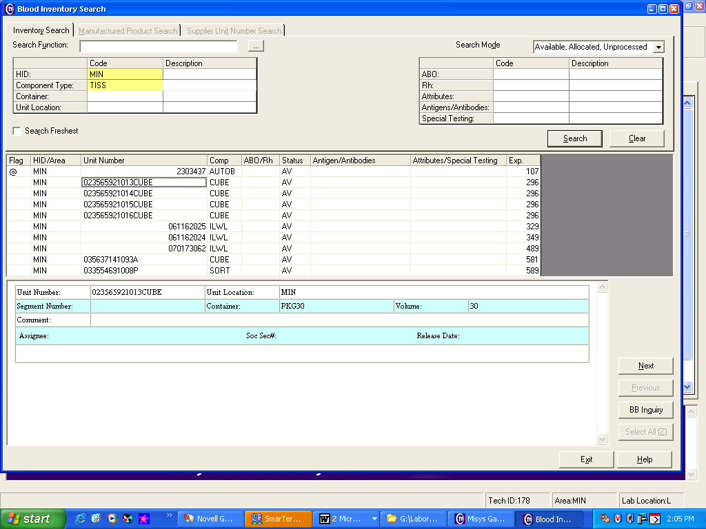
 | 8 | Click on the individual product to view more detail.
 | 9 | Click on NEXT or PREVIOUS to navigate through the available inventory.
 | 10 | Click on BB Inquiry to branch to unit inquiry for even more unit detail.
 | 12 | Compare the current inventory to the screen.
Reconcile Inventory as necessary. | 13 | If Then  No discrepancies found between current inventory and the inventory report No action required. - Discard report - Mark off inventory reconciliation on monthly duties list  Product(s) in physical inventory, but not on inventory report - Contact Supplier for shipping date - Enter product(s) into inventory per procedure.  Product(s) on report but not in physical inventory. - Review product history - Contact surgery as needed - Review daily issue records - Review Supplier Tracking form notebook records - Notify Transfusion/Tissue Service Technical Specialist - If unresolved change product status to LOSTP in Function Blood Status Update
Appendices | Appendix A: Transfusion Service Tissue Inventory
Approval  Workflow | Transfusion Service/Medical Director
Historical Record | Version |  | Written/Revised by: | Effective Date: | Summary of Revisions
 | 1 |  | J Wenzel | 10/1/2006 | Initial Version
 | 2 |  | S. Cassidy/J Wenzel | 11/11/2008 | New Format, new location of forms on g-drive
 | 3 |  | S. Cassidy | 5/30/2012 | Previous TS 20.2. Decrease inventory levels
 | 4 |  | S. Cassidy | 07/12/2021 | Added step to enter unit location

Appendix A-Transfusion Service Tissue Inventory

Product | Minimum Stock
 | Mpls | STP
Cancellous Chips (crushed)  Freeze Dried (30 cc packets) | 2-30cc packets | 2-30cc packets
Cancellous chips (crushed)  Freeze Dried (15 cc crushed) | 2-15cc packets | 0
Cancellous Cubes  Freeze Dried (30 cc packets) | 2-30cc packets | 2-30cc packets
Infuse Bone Graft Kit, Small | 1 | 0
Infuse Bone Graft Kit, Medium | 1 | 0
Infuse Bone Graft Kit, Large | 1 | 0
DBX-Demineralized Bone Matrix Putty 1cc | 2 | 1
DBX-Demineralized Bone Matrix Putty 5cc | 2 | 1

Note: 1 to 2 day turn-around time for products not routinely inventoried

