Returning Tissues to Supplier

Purpose | This procedure provides instructions for returning tissue products to the supplier.
Policy Statements | Tissue may only be returned to supplier upon their request or agreement.
Procedure
 | Step | Action
 | 1 | Log into the Gateway choosing location: R for Mpls or SP for STP.
 | 2 | Click on Blood Status Update folder.
 | 3 | Click on the down arrow in box Update option and select Ship Out status.  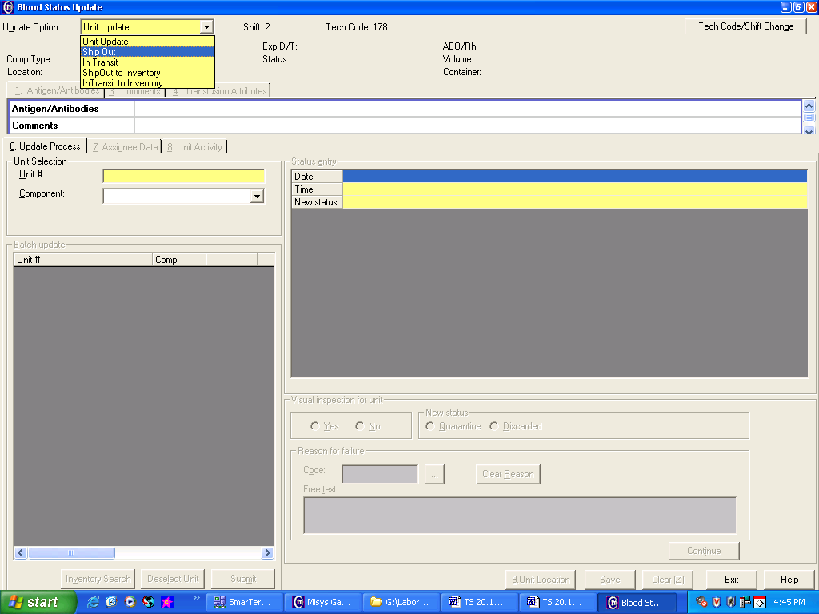
 | 4 | Scan or type unit number being ship out. Repeat for each additional product.
 | 5 | Click the Submit button.
 | 6 | Tab through date and time or enter information if not current.
 | 7 | Type in Supplier code E.g. MTF, RTI, CTS, then Tab.
 | 8 | Click on Yes if pass visual inspection or No if product does no pass visual inspection
 | 9 | Enter free text Reason for ship-out. (e.g. MTF Recall) and click on Add.
 | 10 | Click on Unit location and select either MIN or STP
 | 11 | Click on Continue button then Save.  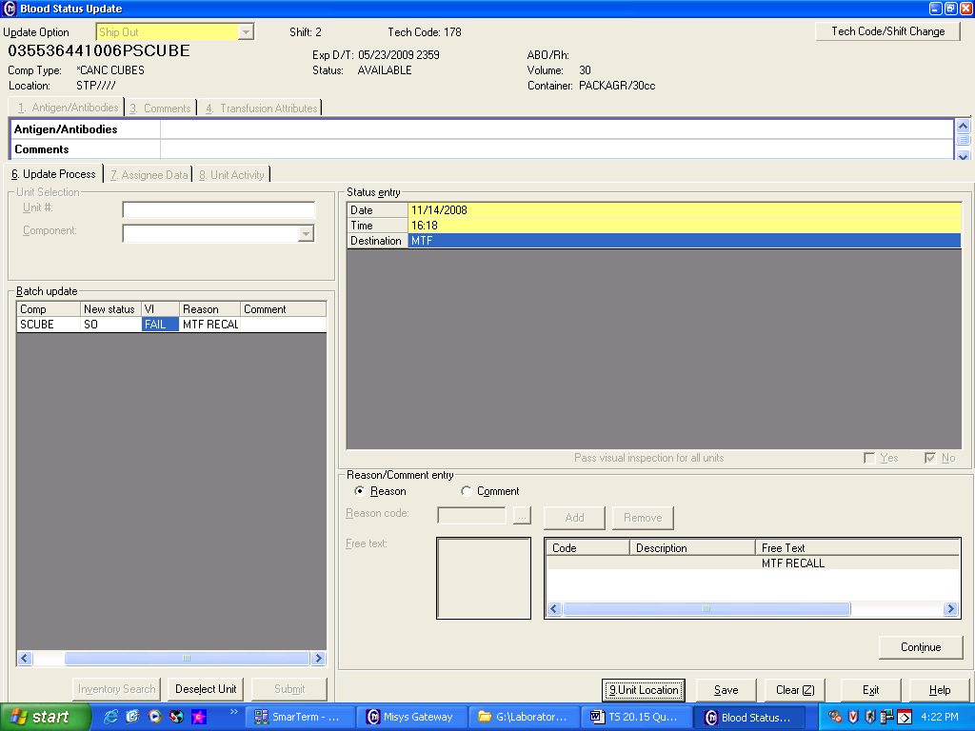
 | 12 | Pack the product(s) for transport according to supplier instructions requirements.
 | 13 | Complete Supplier forms and forward copy to section technical specialist.
 | 14 | Contact the courier and ship according to supplier instructions.
Approval  Workflow | Transfusion Service/Technical Specialist
Historical Record | Version |  | Written/Revised by: | Effective Date: | Summary of Revisions
 | 1 |  | J. Wenzel | 10/01/2006 | Initial Version
 | 2 |  | S. Cassidy/J. Wenzel | 11/18/2008 | Online Version
 | 3 |  | S. Cassidy | 4/10/2012 | Previous TS 20.17.
 | 4 |  | S. Cassidy | 07/12/2021 | Added steps for unit location for one HID

