Expired or Wasted Blood Products (Product Discard)

Purpose | This procedure provides instructions for the management of expired, wasted, or any blood products determined to be unsuitable for transfusion.
Policy Statements | - Blood components shall be handled and discarded in a manner that minimizes the potential for human exposure to infectious agents.  - The final disposition of all blood products must be recorded and maintained.
Related Documents | TS 7.7 Inspection of Blood Products  TS 18.7 Daily Paperwork  TSf 18.2.1 or TSf 18.2.2 Daily Quality Control form
Procedure
 | Step | Action
 | 1 | Identify expired, wasted, or unsuitable for transfusion products by:  - Routine inspection of component inventory.  - Review of printout of BBR4 (Expired Products) BBR #4. [The report lists units that expired on the previous date. e.g., reports printed on 11/19/00 lists products that expired from 0001, 11/18/00 to 2359, 11/18/00]
 | 2 | Bill for component preparation charges associated with expired or wasted products specifically prepared and allocated for a patient but not transfused.
 | 3 | Place expired, wasted or unsuitable for transfusion products on the Quarantined Units shelf of BB Refrigerator until final disposition is determined as part of the daily paperwork process.  Note: Quarantined products or products that are a physical loss will be on the Quarantine shelf but will not have printed out on the Expired Products list unless they have also expired.
 | 4 | Record final disposition of the product in Sunquest.
 | 5 | Record products on the Daily Reagent/Equipment QC worksheet:  - Products that were ordered/prepared for a patient and have expired or were wasted  - Whole units that expired in inventory.
 | 6 | Discard all products as biohazard waste unless requested by the blood center to be returned.
 | Step | Action
Record product discard in Sunquest. | 1 | Log into the Gateway choosing location: R for Mpls,SP for STP and open the Blood Status Update folder from the All or Blood Bank tab.
 | 2 | Select Unit Update in the Update Option box.  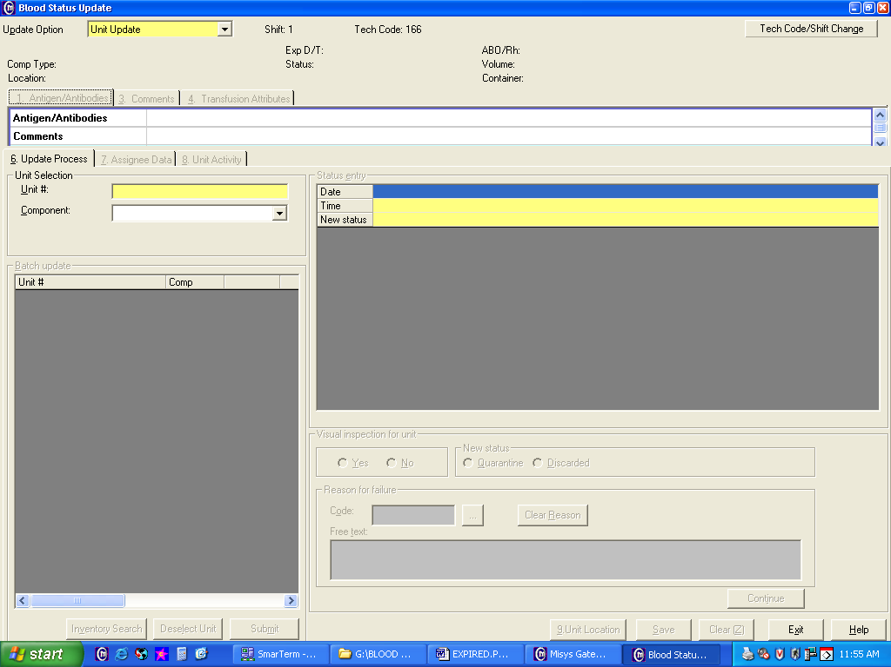
 | 3 | - Scan or enter the product unit number barcode.  - Select the proper component if prompted. (Note: If multiple units with the same unit number in inventory. E.g. Aphereis platelets part one and two.)  - Tab through date and time entry fields or enter a specific time and date.
 | 4 | Click on the drop down box and select new status or type in the appropriate code DS-Discarded or OD-Outdated.  a. Status DS (Discarded).  - For products that are a physical loss (breakage)  - For partial units that expired after being used to make a split or a syringe aliquot  - For products that are used up  - For salvaged Adsol  - Quarantined units, determined not suitable for transfusion. E.g. Returned warm  b. Status OD (Outdated).  - For whole units that have outdated on the shelf.  - Products prepared and not transfused  For products prepared for transfusion that expire instead of being transfused. E.g. Thawed FFP, Syringe aliquots, pooled platelets, Adsol removed RBCs  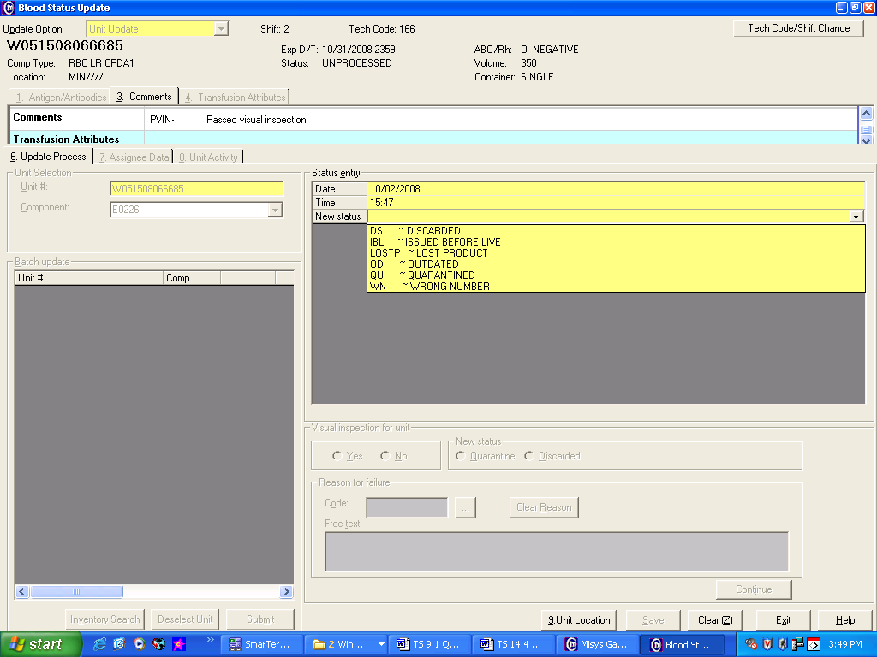
 | 5 | Tab two times to get down to the Reason box and enter an appropriate REASON code (see Appendix A), then click Add.  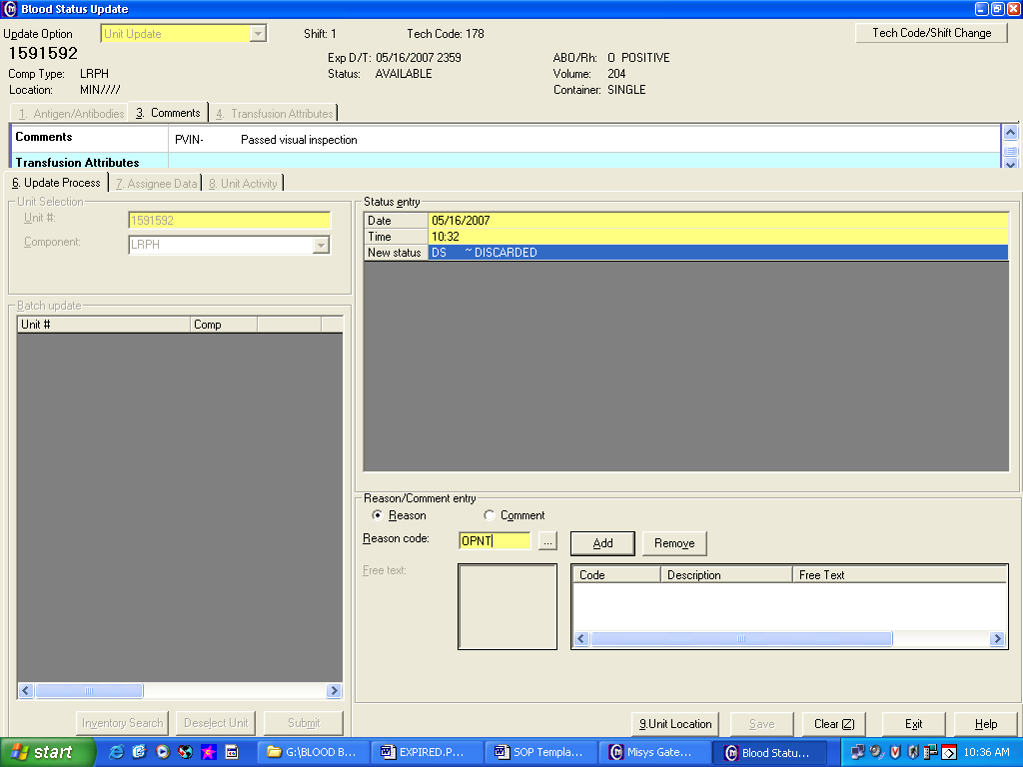
 | 6 | Click on COMMENTS to enter a code or free text additional information. (See Appendix A)  Click Add enter the information.
 | 7 | 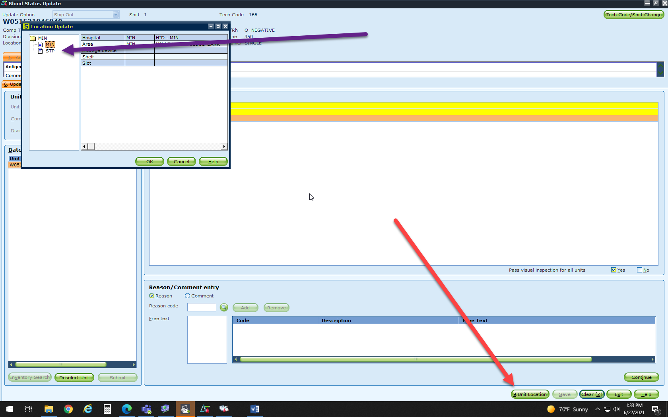  Click on Unit Location then click MIN or STP for unit location
 | 8 | Click Save when all Reason and Comment entries are added.
References | AABB Standards for Blood Banks and Transfusion Services, current edition.  Sunquest User Manual
Appendices | Appendix A: Sunquest Reason and Comment codes Discard and Outdate
Approval  Workflow | Transfusion Service/Technical Specialist
Historical Record | Version |  | Written/Revised by: | Effective Date: | Summary of Revisions
 | 1 |  | J Wenzel | 1/6/1997 | Initial Version
 | 2 |  | J Wenzel | 9/1999 | STP on Sunquest
 | 3 |  | J Wenzel | 5/2001
 | 4 |  | J Wenzel | 2/19/2003
 | 5 |  | J Wenzel | 7/3/2003
 | 6 |  | J Wenzel | 5/22/2007 | SQ Gui format
 | 7 |  | J Wenzel | 7/24/09 | Online format
 | 8 |  | J Wenzel | 4/10/2012 | Combine TS 9.5-SQ instruction.
 | 9 |  | S Cassidy | 7/7/2015 | Removed codabar reference
 | 10 |  | S. Cassidy | 07/12/2021 | Added steps for unit location

Appendix A: Sunquest Reason and Comment codes Discard and Outdate

DS (Discard):
Use For | Reason
Partial units split without SCD - outdated on shelf | SPLT
Partial units split with SCD - outdated on shelf | SCD
Salvaged Adsol | ASOL
Used Up | UUP
FFP bags leak in H2O bath | BWB
Blood products that break | OOPS
Blood products returned too warm | WARM
Non-existent syringes | NEXS

OD (Outdated):
Use For | Reason | Comment
RBC minus Adsol; entire unit, not transfused | ARNT | DSC
Thawed FFP, PFFP, or cryo; complete unit, not transfused | TNT | DSC
Products prepared by the Transfusion Service because of misinterpretation of an order; not transfused | OICB | DSC
Ordered for OR, but not transfused | ORNT | DSC
Ordered by provider, but not transfused | OPNT | DSC
Complete units from general inventory | NIBO | DSC
Complete Autologous Units | AUNT | DSC
Complete Directed Donor units | DDNT | DSC

