Quarantine of Blood Products

Purpose | This procedure provides instruction for quarantining of blood products.
Policy Statements | - The final disposition of all blood products must be recorded and maintained.  - Notify the Technical Specialist of withdrawals/recalls or quarantined products.  - Blood Products return from issue should be placed into an in a Quarantine Status if not meeting return criteria.  - The Medical Director, or Technical Specialist must approve the return units to inventory.
Related Documents | TS 7.7 Inspection of Blood Products  TS 9.4 Product Withdrawl/Recalls
Procedure
 | Step | Action
 | 1 | Blood products unsuitable for transfusion will be identified by:  - Routine inspection.  - Notification from the supplier of product recall or withdrawal.
 | 2 | Physically segregate identified product(s) from the general inventory.  - Place on quarantine shelf in Blood Bank Refrigerator  - Clearly marked on platelet rotator as quarantined
 | 3 | Determine if any other products from the same donor are in inventory or if any portion of the identified unit has been transfused.  - Review unit history in BIQ.  - Notify the technical specialist or pathologist if portion(s) of unit has been transfused.
 | 4 | Notify the Blood Center of products quarantined through blood product inspection process.  Note: The final disposition (return or discard) of blood products found unacceptable for transfusion is at the discretion of the blood supplier.
 | 5 | Follow the Blood Center’s or Technical Specialists instructions for final disposition (discard, return or return to inventory) of product.
 | Step | Action
Record product quarantine in Sunquest. | 1 | Log into the Gateway choosing location: R for Mpls, SP for STP and open the Blood Status Update folder from the All or Blood Bank tab.
 | 2 | Select Unit Update in the Update Option box.  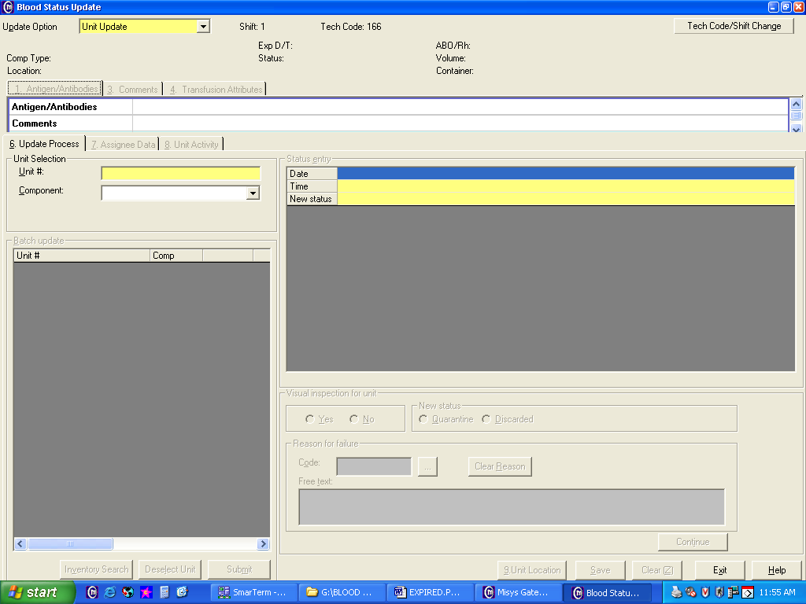
 | 3 | - Scan or enter the product unit number barcode.  - Select the proper component if prompted. (Note: If multiple units with the same unit number in inventory. E.g. Aphereis platelets part one and two.)  - Tab through date and time entry fields or enter a specific time and date.
 | 4 | Click on the drop down box and select new status or type in the appropriate code (QU)  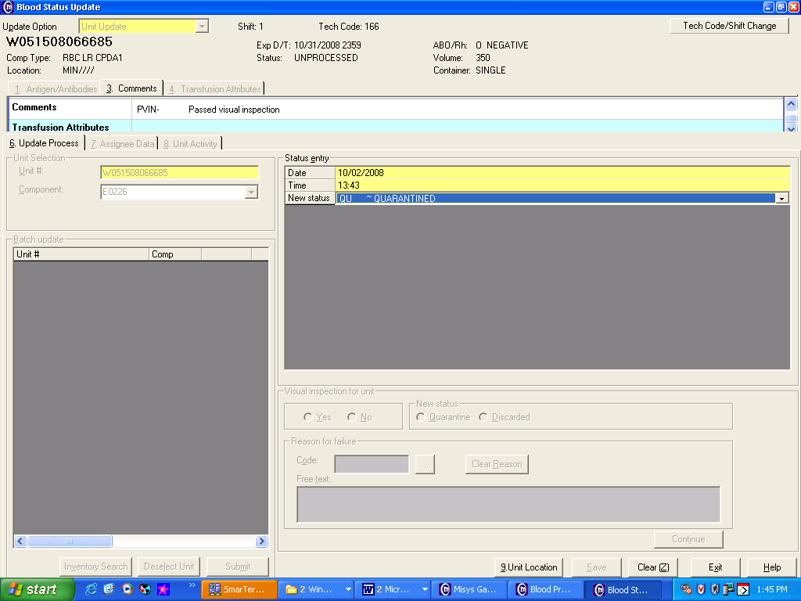
 | 5 | Tab two times to get down to the Reason box
 | 6 | Result REASON with free text explanation of abnormality (e.g., MBC Recall)  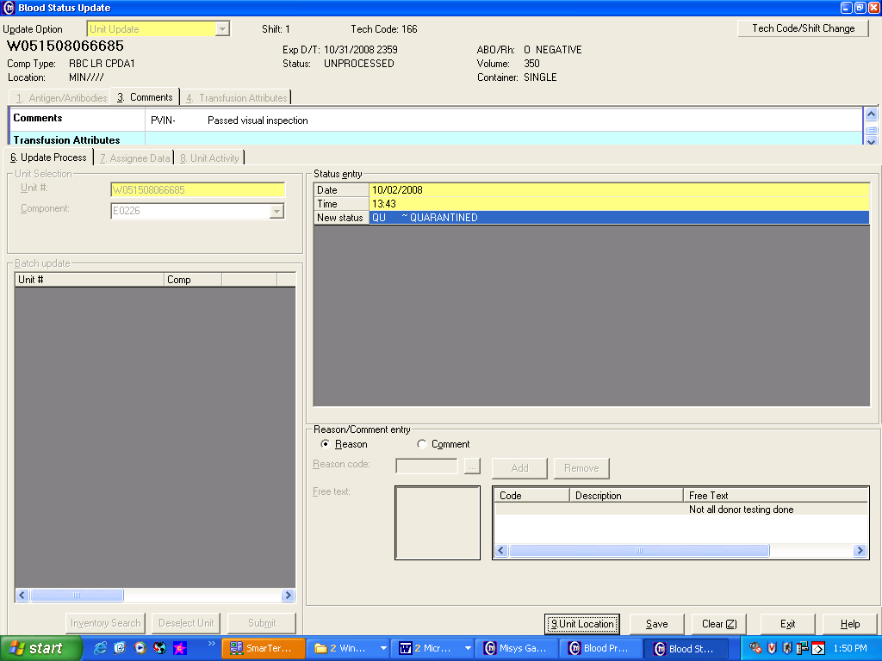
 | 7 | Result COMMENTS with free text for additional information and click Add.
 | 8 | 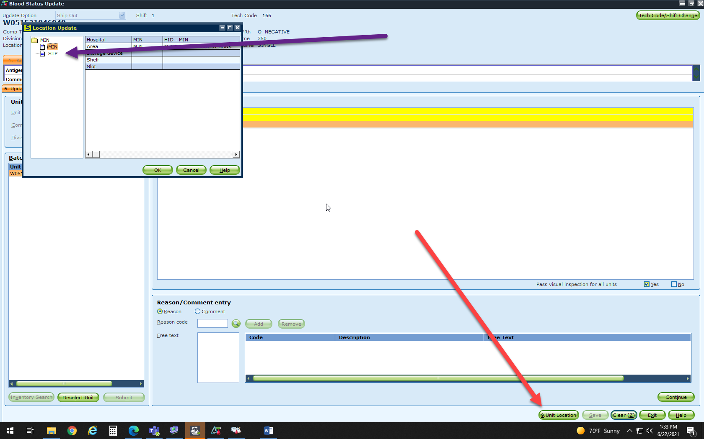  Click on Unit Location, and click on either MIN or STP
 | 8 | Click Save when all Reason and Comment entries are added.
References | AABB Technical Manual, Current edition  AABB Standards for Blood Banks and Transfusion Services, current edition
Approval  Workflow | Transfusion Service/Medical Director
Historical Record | Version |  | Written/Revised by: | Effective Date: | Summary of Revisions
 | 1 |  | J. Wenzel | 12/3/96 | Initial Version
 | 2 |  | J. Wenzel | 9/1999 | Merger
 | 3 |  | J. Wenzel | 5/22/01
 | 4 |  | J. Wenzel | 3/4/2009 | Online Version
 | 5 |  | J. Wenzel | 4/10/2012 | Combine TS 9.4-SQ instruction into TS 9.2 Quarantine Procedure. Added policy statement on returned from issue units.
 | 6 |  | S. Cassidy | 7/7/15 | Removed codabar reference
 | 7 |  | S. Cassidy | 07/12/2021 | Minor update added step for Unit Location, for one HID

