Correcting Product Inventory for Wrong Number or Lost Products

Purpose | This procedure provides instructions for maintaining records for products entered into inventory under the wrong donor identification number or in the event the final disposition of a unit(s) cannot be determined.
Policy Statements | Records shall make it possible to trace any blood component or tissue from its source to final disposition.
Procedure
 | Step | Action
 | 1 | Review unit history under to Blood Bank Inquiry folder to determine unit status and if split products are involved.  If Then  Lost product Proceed to step 3.  Wrong number and product is still in inventory - Proceed to step 3 - Enter the correct product information into BPE  Wrong number and product has been transfused. - Enter the “correct” product information into BPE with a free text comment to document the incorrect number the product was transfused under. E.g. RBC entered and issued as W051509075736 instead of W051509078736 - Discard the “correct unit” in BSU with free text comment. Eg. UNIT ISSUED AS W051509075736 to PATIENT 7771663. *Indicate all recipients if unit was split. - Modify the “incorrect” product information in BPE and add free text comment. E.g. UNIT NUMBER ENTERED AND ISSUED IN ERROR. CORRECT NUMBER IS W051500907536. Unit issued as split B0,Aa and A0.  Wrong number and part of the product has been transfused. - Enter the “correct” product information into BPE with a free text comment in BPE to document the incorrect number the product was transfused under. E.g. RBC entered and issued as W051509075736B0 instead of W051509078736B0. - Discard the remainder of the “incorrect” product in BSU. Add free text comment such as UNIT ISSUED AS W051509075736B0 to PATIENT 7771663. Indicate all recipients.
 | 2 | Open the Blood Status Update folder from the All or Blood Bank tab on the Sunquest gateway.
 | 3 | In the Update Option box select In Unit Update.  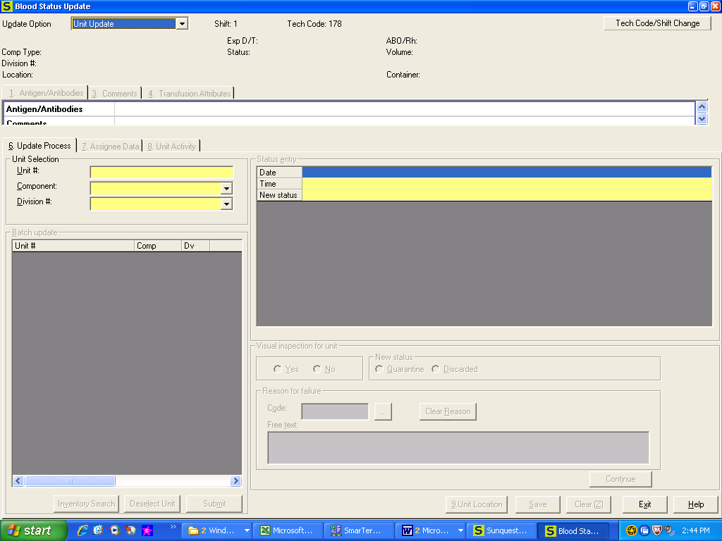
 | 4 | In the Unit # box, scan or enter the unit number.
 | 5 | Select or scan in the Component type and Division # if prompted.
 | 6 | Enter the appropriate Date and Time or Tab through the prompts.
 | 7 | Select the appropriate New Status of WN or LOSTP  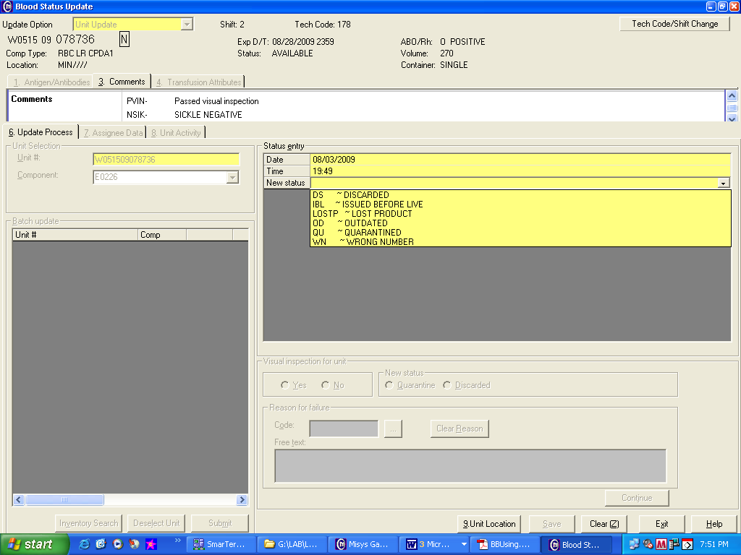
 | 8 | Enter the appropriate Reason or Comment Free Text information.  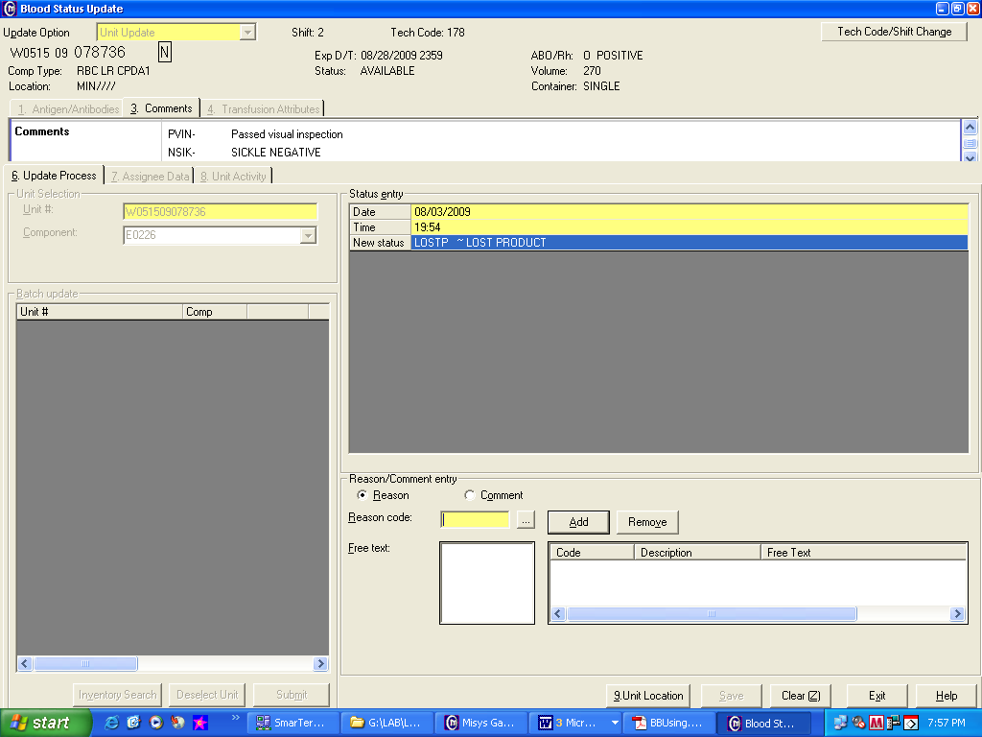
 | 9 | 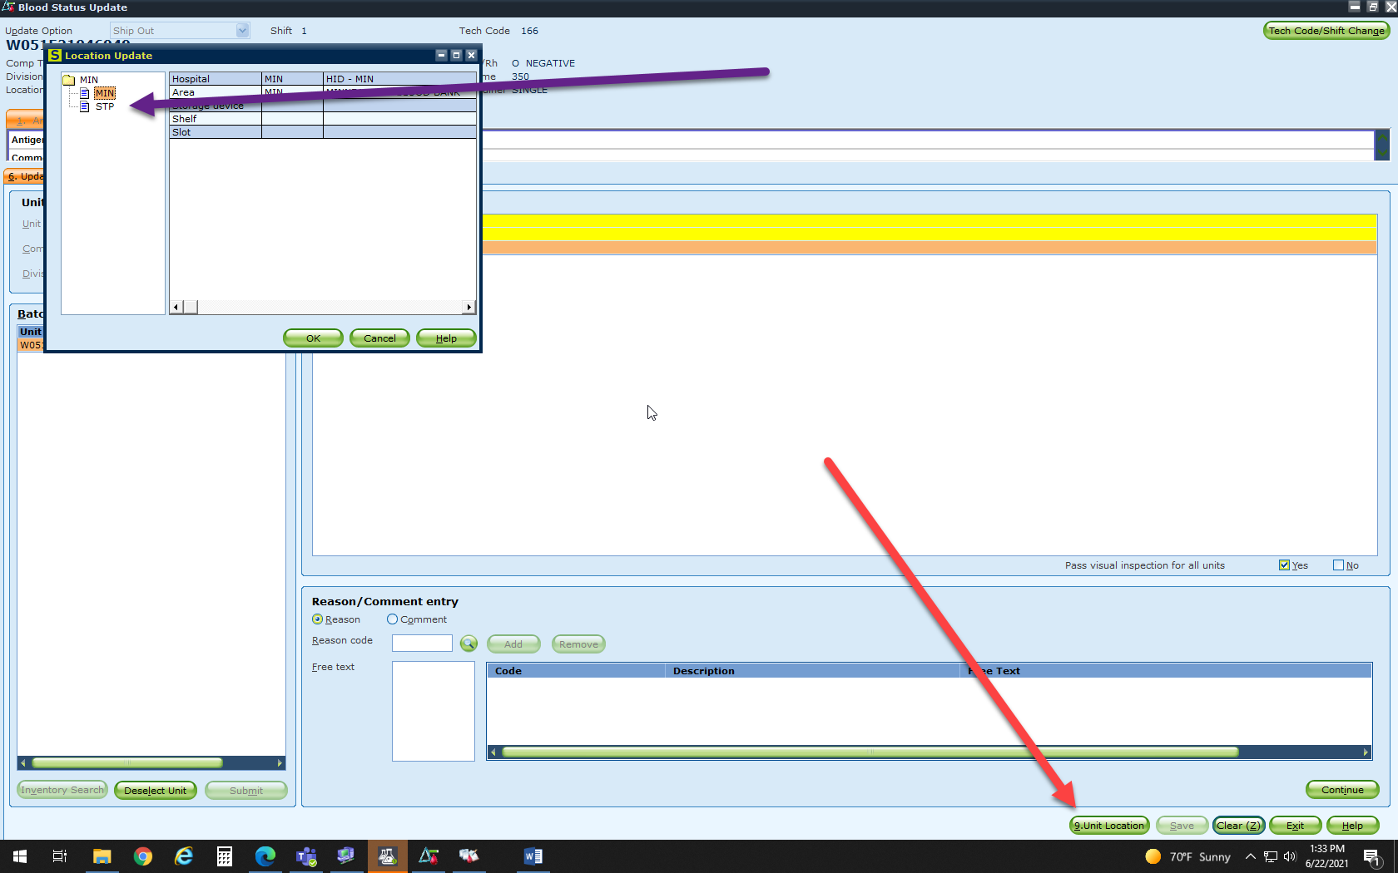  Click Unit Location and then click either MIN or STP
 | 10 | Click on Save.
Approval  Workflow | Transfusion Service/Technical Specialist
Historical Record | Version |  | Written/Revised by: | Effective Date: | Summary of Revisions
 | 1 |  | S Fisher | 8/8/2001 | Initial Version
 | 2 |  | J Wenzel | 8/6/09 | Gui format
 | 3 |  | J Wenzel | 5/11/2012 | Previously numbered as TS 8.11. Added ISBT division # prompts.
 | 4 |  | S. Cassidy | 7/7/2015 | Removed codabar reference
 | 5 |  | S. Cassidy | 07/12/2021 | Updated for unit location for one HID

