Transferring Blood Products to the Other Site

Purpose | This procedure provides instructions for the transfer of blood product(s) to the other Children’s Transfusion Services.  Note: Receiving facility refer to:  - TS 7.5 Receipt of Blood Products  - TS 7.11 Entering Products Transferred from other Children’s Site-Sunquest
Materials | - Wet ice or Ice packs  - Dry Ice  - Blood Center Shipping Containers or Blood Bank Coolers
Related  Documents | - MBC return-transfer form  - MBC Return Guidelines  - Red Cross Packing Guide  - TS 12.11 Transporting of Products in Coolers
Procedure
 | Step | Action
 | 1 | Determine products to be transferred to the other site.
 | 2 | Notify other site of transfer and reason.  Mpls: 56824  STP: 66558
 | 3 | Record transfer of products in Sunquest. (See steps below)
 | 4 | Complete Blood Product Transfer in BloodHub
 | 5 | Pack products according to blood center packing guides or in BB coolers according to the related procedure.
 | 6 | Contact lab courier service or Priority Courier
 | Step | Action
Recording Transfer In Sunquest | 1 | Log into the Gateway choosing location: R for Mpls, SP for STP and open the Blood Status Update folder from the All or Blood Bank tab.  Note: Location B-Mpls and Location BS-STP may be used as alternate locations.
 | 2 | In the Update Option box select In Transit  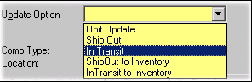
 | 3 | In the Unit # box, scan or enter the unit number.
 | 4 | Select or scan in the component type in the Component box if prompted.  Select Division # if prompted.
 | 5 | Press TAB to enter the unit under the Batch update.
 | 6 | Enter additional units as needed by repeating steps 3-5.
 | 7 | Click on Submit at the bottom of the screen when all units are listed on the batch.  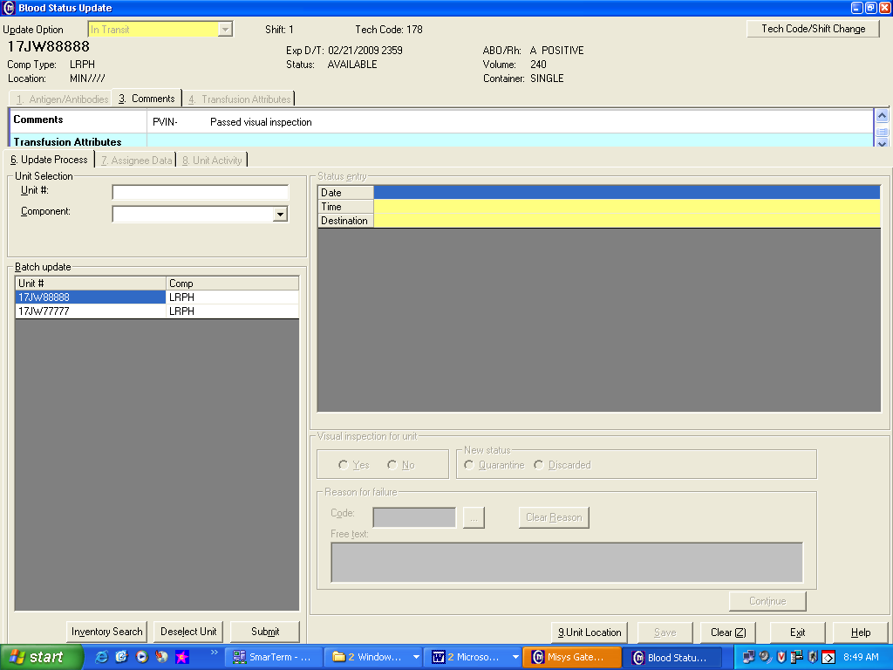  IT will appear the New Status column.
 | 8 | Enter the Date and Time or TAB through the fields.
Enter the appropriate site code in the Destination box.
- CHSP-Children’s St. Paul
- CHMP-Children’s Minneapolis
 | 9 | TAB and enter the Pass Visual Inspection information by clicking Yes or No.  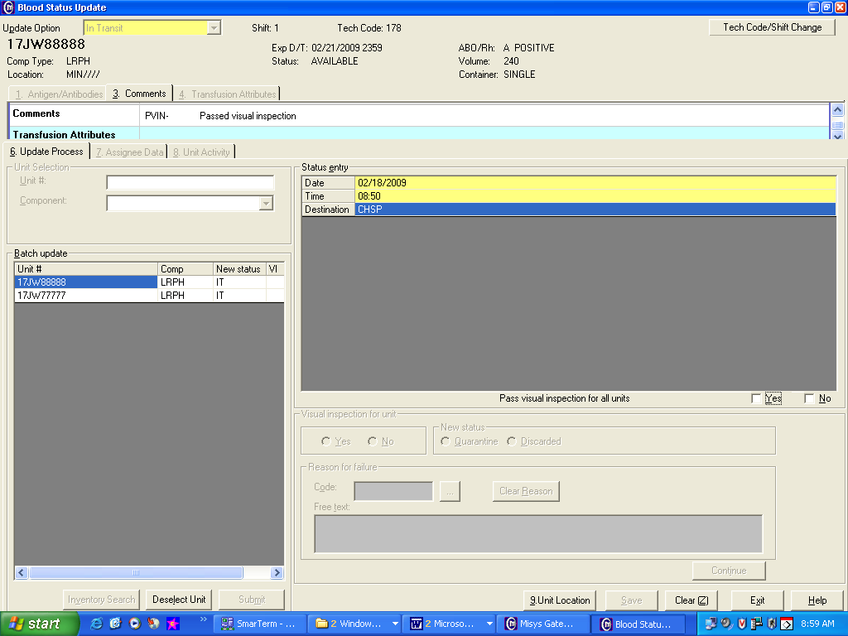
 | 10 | Free Text the Reason for the transfer.  - Then click on ADD.  - Then click on Continue.  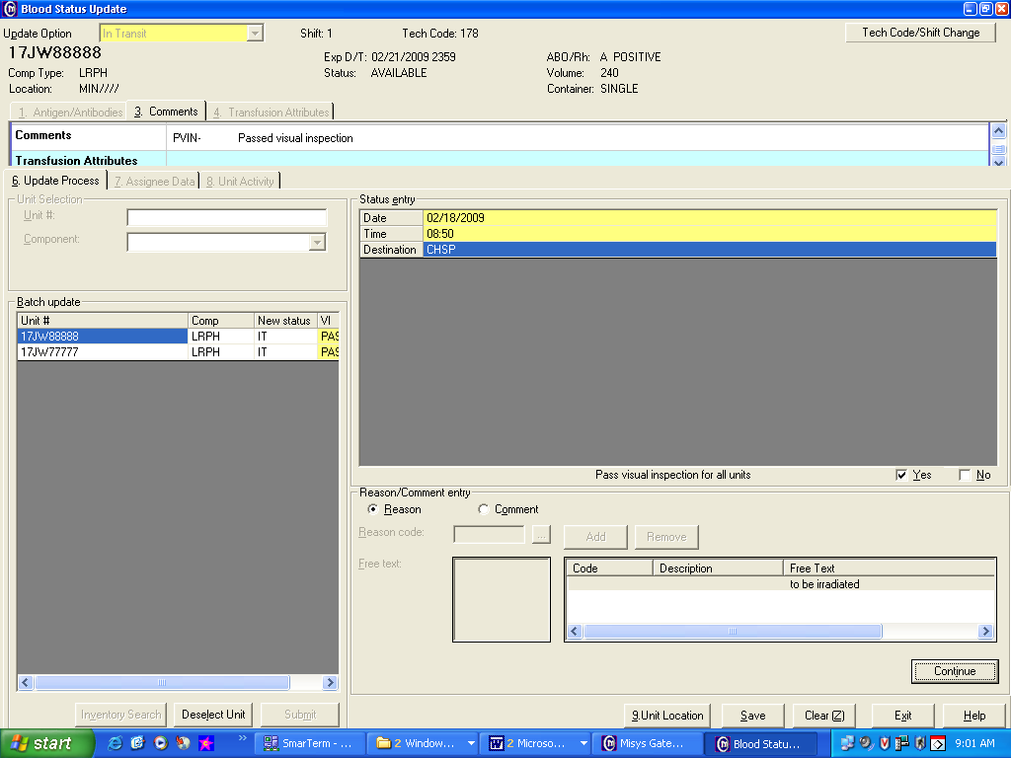
 | 11 | 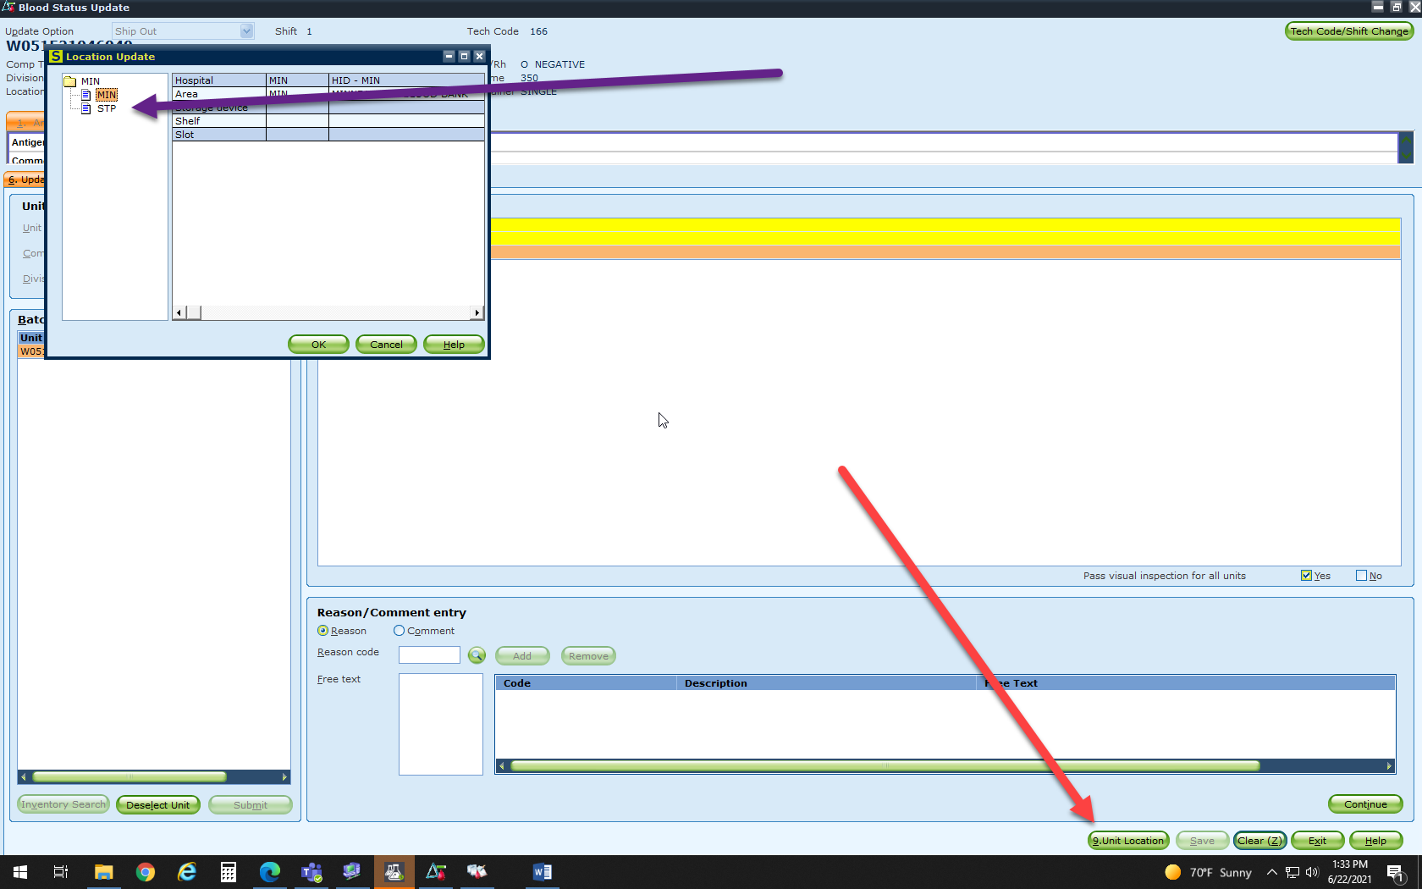  Click Unit Location and Click either MIN or STP (original location unit)
 | 12 | Click on SAVE.
References | Sunquest Users Manual, current edition.
Approval  Workflow | Transfusion Service/Technical Specialist
Historical Record | Version |  | Written/Revised by: | Effective Date: | Summary of Revisions
 | 1 |  | J Wenzel | 7/2001 | Initial Version
 | 2 |  | J Wenzel | 2/20/2003
 | 3 |  | J Wenzel | 3/6/2007 | Gui format
 | 4 |  | J Wenzel | 2/19/2009 | Online format
 | 5 |  | J Wenzel | 5/11/2012 | Updated Related Documents. Merged TS 8.7 to include Sunquest In Transit steps.
 | 6 |  | S. Cassidy | 7/7/2015 | Removed codabar reference and ARC reference
 | 7 |  | S. Cassidy | 07/12/2021

