Reagent Quality Control for ID Panels and Biochemical Tubes

Purpose | This procedure provides instruction for Reagent Quality Control for ID Panels and Biochemical Tubes.
Principal and Clinical Significance | The Remel Reagent QC Kit is recommended for use in qualitative procedures for the quality control of testing of reagents used in the identification of gram negative and gram positive bacteria.  The Reagent QC Kit consists of positive and negative controls used in the evaluation of specific reagents employed in microbiological testing. Reactions are based on biochemical principals and are meant to resemble the conventional reactions found with microorganisms.
Policy Statements | This procedure applies to Microbiologists who perform culture plate reading.
Materials
 | Reagents |  |  | Supplies |  | Equipment
 | • Kovac’s indole (IND). Dade Behring MicroScan® product number B1010-41A.  • 40% potassium hydroxide (VP1). Dade Behring MicroScan® product number B1010-43A.  • α-napthol (VPA), Becton, Dickinson and Company product number 261192.  • 0.8% sulfanilic acid (NIT1). Dade Behring MicroScan® product number B1010-44A.  • 0.5% N, N-dimethylalphanapthylamine (NIT2). Dade Behring MicroScan® product number B1010-45A.  • 10% ferric chloride (TDA). Dade Behring MicroScan® product number B1010-48A.  - Hydrogen peroxide 3% (CAT) |  |  | - Remel Reagent QC Kit Product number REF 21395 30/pk |  | • 2-8° C refrigerator
Special Safety Precautions | Microbiologists are subject to occupational risks associated with specimen handling. Refer to the safety policies located in the safety section of the Microbiology Procedure Manual.  - Biohazard Containment  - Biohazardous Spills  - Safety in the Microbiology Laboratory
Storage | - This product is ready for use and no further preparation is necessary.  - Store product in its original container at 2-8ºC. Do not freeze or overheat.  - Allow product to come to room temperature before use.
Quality Control | - Perform QC with each new lot or shipment before put into service. Record results in Reagent QC manual.  - Once kit is in use, Reagent QC is performed weekly.  - If there is a QC failure; document observation, notify supervisor and call Remel technical service at 1-800-447-3641. www.remel.com email: remel@remel.com
Procedure | - The following table describes the steps necessary to test the reagents used in the identification of microorganisms.  - Add one drop of the appropriate positive control to one well of the tray and 1 drop of negative control to another well.  - Add 1 drop of the appropriate reagent to both wells.  - Read at the appropriate time according to the table.  - Continue to test all necessary reagents.  Table 1  Test Directions for Use Time to Read Reaction  Indole: Add 1 drop of Kovac’s Reagent to 1 drop of positive control. Read at 1 minute.  TDA Add 1 drop of 10% Ferric Chloride to 1 drop of positive control Read at 1 minute.  VP: Add 1 drop of VP Reagent A followed by 1 drop of VP Reagent B to 1 drop of positive control. Read at 3-5 minutes.  NIT: Add 1 drop Nitrate A, then 1 drop of Nitrate B to 1 drop of positive control. Read at 1 minutes.  OXI Add 1 drop of oxidase reagent to 1 drop of positive control. Read immediately  CAT: Add 1 drop of Catalase reagent to 1 drop of positive control. Read immediately  Negative Control: Follow above instructions for each test substituting 1 drop negative control for the positive control. Read as indicated for each test.
Interpretation | - Interpret the wells using table 2 and Image 1.  Table 2  Test Positive Negative  IND Dark pink/red Yellow  TDA Dark brown to brown orange Yellow  VP Red/dark pink Green/Yellow  NIT Pink to Red Colorless  OXI Deep blue to purple Colorless  CAT Bubbling No Bubbling  Negative Control NA Read as indicated for each test  Image 1 IND TDA VP NIT  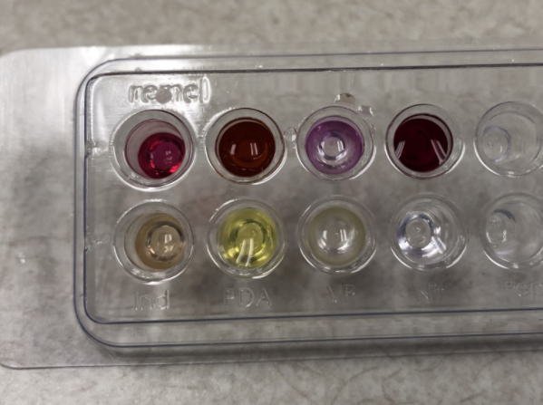  - Record results in QC manual.  - Expected Results are displayed in Table 3.  Table 3  IND TDA VP NIT OXI CAT  Positive Control + + + + + +  Negative Control - - - - - -
Limitations | - If Reagents fail to perform as indicated in the above table, repeat the tests using known positive and negative control organisms.  - Enterobacter cloacae ATCC 13047*  - Proteus vulgaris ATCC 13315*  - Myroides (Flavobacterium) oderatus ATCC 4651*  - *Fresh, 18-24 hour old pure cultures of the recommended organisms isolated on non-selective agar should be used.  - If quality control strains fail to perform satisfactorily, reagents should be discarded.
Method Performance Specifications | - This product should not be used if there is evidence of dehydration, contamination, the color has changed, the expiration has passed or if there are other signs of deterioration.
References | Remel Reagent QC Kit IFU 21395, Revised March 22 2006 Lenexa KS.
Training Plan/ Competency Assessment | Training Plan |  |  |  |  | Initial Competency Assessment
 | - Employee must read the procedure.  - Employee will observe trainer performing the procedure.  - Employee will demonstrate the ability to perform procedure, record results and document corrective action after instruction by the trainer. |  |  |  |  | - Direct observation.
Historical Record
 | Version | Written/Revised by: | Effective Date: |  | Summary of Revisions
 | 1 | Pat Ackerman | 02/02/1992 |  | Initial Version
 | 1.1 | Kristen Renner | 11/20/2003 |  | Reformat to PC version
 | 2 | Becky Carlson | 4/4/2015 |  | Re-format to CMS template and Re-numbered from MC 813
 | 2 | Becky Carlson | 5/1/2017 |  | Updated logo, Updated references, and bioMérieux technical Services contact information.
 | 3 | Susan DeMeyere | 2/26/2018 |  | Biennial review 2/5/2018
 | 4 | Susan DeMeyere | 7/23/2021 |  | Discontinues use of API 20E Reagent QC and replaced with Remel Reagent QC

