QIAcube Connect Maintenance

Purpose | This procedure provides instructions for maintenance tasks performed on the QIAcube.
Policy Statements | This procedure applies to technical staff performing testing on the QIAcube.
Special Safety Precautions | Microbiologists/virologists are subject to occupational risks associated with specimen handling. Refer to the safety policies located in the safety section of the Microbiology and Virology Policy Manual:  - Biohazard Containment  - Safety in the Microbiology/Virology Laboratory  - Biohazardous Spills
Materials | Reagents Supplies Equipment  - 5% Extran - 70% ethanol - RNaseZap RNase Decontamination Solution - DNA-ExitusPlus - Distilled (DI) water - Anti-Corrosion Oil (rotor) cat. No. 9018543 - 100% ethanol - Absorbant Cloths - Paper towels - 1000 μl tip rack - 2 ml safe-lock microcentrifuge tube - Buffer Bottle - Alcohol based disinfection wipes - Pressurized air - Brush - O-Ring change tool - O-Ring - Brush
Procedure | Regular Maintenance  Performed after each protocol run  - Open the waste drawer and empty tips and columns, if necessary, into a waste container.  - Remove used labware and unwanted samples and reagents from the worktable and discard as needed.  NOTE: If robotic arm is in the way, press Move left or Move right, as needed. The hood can be open during this movement. Stay clear of the robotic arm when it is moving.  - Replace the lids of the reagent bottles and close tightly. Store appropriately.  For all following procedures, step-by-step guidance is found under Tools/Maintenance on the software.  Daily Maintenance  Performed after the last protocol run of the day  - Press the Tools icon and then press the Daily subtab under the Maintenance tab.  - Press Start on daily maintenance and follow instructions. Stand clear of moving robotic arm at all times.  - Remove used disposable labware, adapters, and unwanted samples and reagents and discard as required.  - Close buffer bottles tightly and store as indicated.  - Press Done when complete.  - Empty the waste drawer and check that the inlay is clean.  NOTE: clean inlay with 5% extran followed by DI water and 70% ethanol.  - Wipe and clean the worktable with 5% extran followed by DI water and 70% ethanol.  NOTE: Use Dawn dish soap to clean the hood, followed by DI water.  - Press Done. The last performed date will automatically update.  UV decontamination  Must be performed daily after daily maintenance.  - Press the Tools icon and press the UV run subtab under the Maintenance tab.  - In the Cycle field, change the number of cycles. Default cycle number is 1 (approximately 12 minutes).  - Ensure all disposable labware has been removed from worktable and close the hood and press Start.  - Press Done once the UV run is completed. The date of last performed is automatically updated.  Monthly Maintenance  Performed every month after the daily maintenance is performed.  - Press the Tools icon and then press the Monthly subtab under the Maintenance tab.  - Close the hood and press Start.  - Thoroughly clean the worktable with 5% extran followed by DI water and 70% ethanol.  NOTE: Use Dawn dish soap to clean the hood, followed by DI water.  - Clean the touchscreen with alcohol-based disinfection wipes and then wipe dry.  NOTE: Ensure that no liquid runs down the touchscreen.  - Clean the outer hood with an absorbent cloth moistened with 5% extran followed by DI water and 70% ethanol..  - Clean the shaker adapter (grey), shaker tray (metal adapter), buffer bottle rack (and waste drawer in liner if not done in daily maintenance) with 5% extran followed by DI water and 70% ethanol.  - Press Done. The last performed date will automatically update.  - Transfer the run reports from the instrument to the USB stick and remove the run reports from the instrument.  NOTE: Only 200 run reports are saved on the instrument.  - Press the Tools icon and press the Data exchange tab.  - Connect the USB stick to one of the ports on the left of the touchscreen.  - To save all available run reports select All run reports. To enter the number of reports to be saved touch in the Recent reports field.  - If you would like to delete reports after download, press Delete reports after download.  - Press Download to save the reports to the USB stick.  6 Month Maintenance  Cleaning the Robotic Arm Modules  Perform monthly maintenance before cleaning the robotic arm.  - Press the Tools icon and then press the Robotic Arm subtab under the Maintenance tab.  - Press start and follow the instructions on the screen.  NOTE: Make sure used labware, adapters, and reagents are removed from the worktable. Close the hood.  - Press Next to move to cleaning position.  - Remove the waste drawer and open hood.  - Open the waste drawer and moisten a cloth with DI water and carefully clean the optical sensor, tip adapter, gripper unit, rotor adapter stabilization rod and the spin column lid holder. Wipe dry.  - Close the hood and press Done. The last performed date will automatically update.  Cleaning the centrifuge  - Press the Tools icon and then press the Centrifuge subtab under the Maintenance tab.  - Press Start and follow the instructions on the screen.  - The lid must be open. If the lid does not automatically open, close the hood and press the Open Centrifuge Lid button.  - Clean the rotors and buckets  - Switch off the QIAcub Connect.  - Remove all disposable rotor adapters, including the P108  - Clean the centrifuge with 5% extran followed by DI water and 70% ethanol.  - Maintain the rotor nut.  - Install the centrifuge rotor and buckets.  - Turn on the instrument and press the Tools icon and press the Centrifuge subtab under the Maintenance tab.  - Press Start again and then press Done to confirm cleaning. The last performed date will automatically update.  - Next, clean the rotor and buckets by switching off the QIAcube Connect.  - Remove all disposable rotor adapters, including tubes and spin columns, from the buckets.  - Remove the buckets from the rotor. Undo rotor nuts on top of rotor using the rotor key, and lift rotor off rotor shaft.  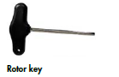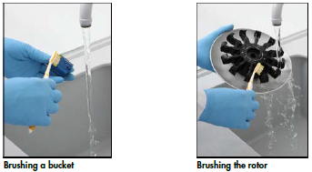  - Submerge the rotor, buckets, and rotor nut in 5% extran.  - Rinse thoroughly with DI water. Use a gentle brush to clean to clean difficult to access parts, including the bucket mount and rotor head. Wipe surfaces dry with absorbent cloth.  NOTE: Buckets and rotor can also be dried with pressurized air.  - Check rotor for damage and do not use if damage is found.  - Apply Anti-Corrosion Oil (rotor) on an absorbent cloth and wipe the bucket mount and rotor claw. A thin, invisible oil film should cover the bucket mount and rotor claw, but no droplets or smear should be apparent.  - Apply oil to the rotor claw and to the bucket mount. Ensure rotor and all buckets are dry before applying oil.  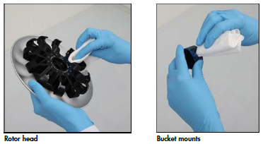  - To clean the centrifuge and lid, moisten an absorbent cloth with 5% extran and clean the inside of the centrifuge and centrifuge gasket. Follow with DI water and 70% ethanol. Wipe dry with lint-free paper towels. Ensure gaskets remain in proper positions.  - Check the centrifuge gasket for damage, contact QIAGEN Technical Services if damaged.  - Next, clean the rotor thread and apply a few drops of Anti-Corrosion Oil (rotor) on an absorbent cloth and wipe the thread. A thin, invisible oil film should cover the thread but no droplets or smear should appear. Repeat this on the inner thread of the rotor nut.  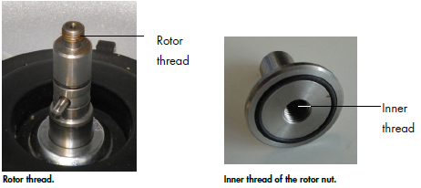  - Next, mount the rotor. It can only be mounted in one orientation. The pin on the rotor shaft fits into a notch on the underside of the rotor directly underneath rotor position 1. Line up position 1 of the rotor with the pin on the rotor shaft and carefully lower the rotor onto the shaft.  - Install the rotor nut on top of the rotor and tighten securely using the rotor key. Ensure the rotor is securely seated.  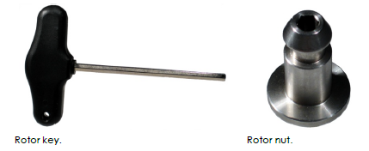  - Replace the rotor buckets. The side of the rotor bucket that must face toward the rotor shaft is marked with a grey line. Hold the bucket at an angle with the grey line facing the center of the rotor and hang the bucket on the rotor. Check that all buckets are properly suspended and can swing freely.  - The centrifuge must be operated independently before starting further runs to check if residual plastic parts are still in the centrifuge. Press the Tools icon and then the Run Modules tab.  - In the Set speed and Set duration fields set to 10,000 g and 1:0 m:s. Press Start.  NOTE: Listen carefully to the sound during centrifugation. If any grinding, rattling, or crunching sounds are heard, repeat the cleaning procedure all cleaning steps above. It may be necessary to repeat the procedure several times to remove all plastic particles. If there are no unusual sounds, the next protocol run can be started.  Tightness Test  Perform to ensure that the tightness of the tip adapter is sufficient for accurate pipetting and after replacing a tip adapter O-ring to verify the replacement is successful.  - Perform daily maintenance and cleaning of the robotic arm procedure before you perform the tightness test.  - Press the Tools icon and then press the Tightness subtab under the Maintenance tab. Press Start and follow the instructions onscreen.  - Open the hood and load a 1000 μl tip rack with at least one 1000 μl tip into tip rack position 1.  - Place an empty 2 ml safe-lock microcentrifuge tube in position 1 of the shaker (shaker type 2).  - Place a buffer bottle filled with at least 10 ml 100% ethanol in position 1.  - Close the hood and press Next to start tightness test.  - Press Next after the test has been completed. Then open the QIAcube Connect hood and remove the buffer bottle and tips and store them accordingly.  - Remove the tube and visually inspect if liquid is present. If no liquid is present, press Yes to record that the test has passed. If liquid is present, press No to record that the test has failed. Repeat the test if the test has failed. If it fails again, replace the O-ring first using the O-ring tab or contact Technical Services.  - Press Done to finalize tightness test procedure. The date of the last performed tightness test is updated automatically.  O-Ring exchange  Perform when the tightness test fails or if there are uneven volume transfers or dripping on the worktable. Perform the daily maintenance and cleaning of the robotic arm procedure before you replace the O-Ring.  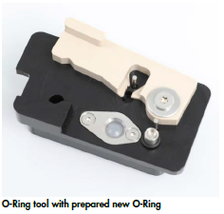  - Press the Tools icon and press the O-Ring Subtab under the Maintenance tab. Close the hood and press Start and follow the instructions onscreen.  - Slide the new O-Ring over the small end of the peg of the O-Ring tool.  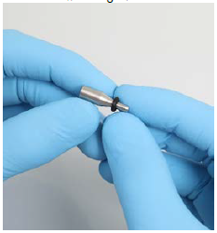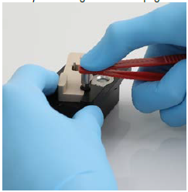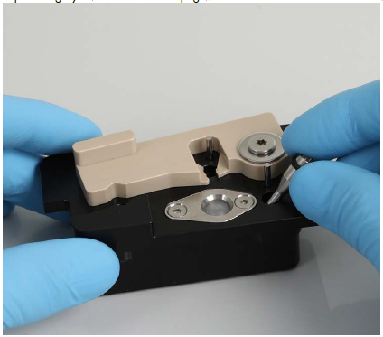  - Push the grey lever until you reach the black stop and insert the small end of the peg into the hole.  - Press the peg down using t he back end of the tweezers until theO-Ring sits in the middle on the larger end of the peg.  - Open the grey lever and insert the peg with the small end first into the hole as shown.  - Press Next to being loading of the O-Ring tool into the QIAcube Connect.  - Load the O-Ring tool by opening the grey lever into tip rack position 1 (nearest to user).  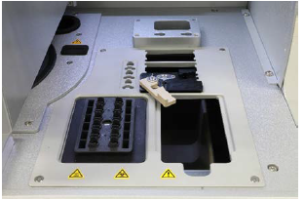  - Close the hood and press Next to begin cutting of the O-Ring.  - To cut the O-Ring, open the hood and rotate the grey lever coutner-clockwise until you reach the black stop.  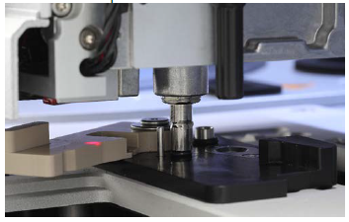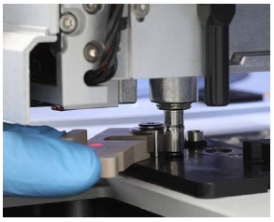  - Open the grey lever and remove the O-Ring by using the tweezers from pipetting channel. If required, repeat cutting process until O-Ring is cut completely and can be removed.  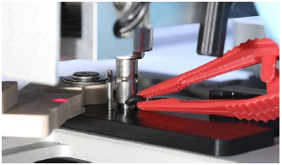  - Close the hood and press Next to pick up the prepared new O-Ring.  - Open the hood and visually check if new O-Ring sits firmly on tip adapter. If O-Ring was not successfully picked up, complete the O-Ring replacement procedure and restart.  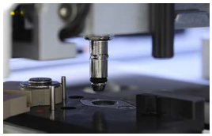  - Close the hood and press Next to remove the O-Ring change tool.  - Open the hood and remove the O-Ring change tool.  - Wipe and clean the O-Ring change tool with 5% extran followed by DI water and 70% ethanol..  - Press Done to complete the O-Ring replacement. The date of last performed will automatically update.  Decontamination  Perform when the QIAcube Connect is contaminated and before shipping. Perform daily, monthly, and periodic maintenance, as well as a UV run with at least 5 cycles as defined in this procedure.  Technical Support:  www.qiagen.com/support/technical-support  1-800-362-7737
Result Reporting | Record completion of maintenance tasks on the Maintenance Log.
References | - QIAcube Connect User Manual, QIAGEN, September 2019.
Historical Record
 | Version | Written/Revised by: | Effective Date: | Summary of Revisions
 | 1 | Julie Laramie/Michelle Merryman | 11/28/2021 | Initial Version
 | Archived by: |  | Archived Date:

